SUBCOURSE EDITION
SS0073 A

US ARMY SIGNAL CENTER AND FORT GORDON

CORPS COMMUNICATIONS

EDITION DATE: SEPTEMBER 1994


CORPS COMMUNICATIONS

Subcourse Number SS 0073

EDITION A

United States Army Signal Center and Fort Gordon
Fort Gordon, Georgia 30905-5000

9 Credit Hours

Edition Date: September 1994

SUBCOURSE OVERVIEW

This subcourse is designed to provide you with the knowledge and skills necessary for performing tasks related to signal support within a corps level unit.

There are no prerequisites for this subcourse.

This subcourse reflects the doctrine which was current at the time it was prepared. In your own work situation, always refer to the latest official publications.

Unless otherwise stated, the masculine gender of singular pronouns is used to refer to both men and women.

TERMINAL LEARNING OBJECTIVE

ACTION: After studying this course, you will be able to do the following:

- Describe corps dimensions, structure, and characteristics. Identify corps electromagnetic environment characteristics.
- Describe the Army Tactical Command and Control System (ATCCS) and each major system that comprises it.
- State the mission, organization, and employment of the corps signal brigade and its subordinate units.

i SS0073
- Identify and describe the elements of the corps signal brigade that provides command and control.

- Describe the mobile subscriber equipment (MSE) network architecture, identify each major site configuration and describe the four main phases of deployment.

CONDITION: Given lesson material, pencil, paper, and no supervision.

STANDARD: To demonstrate competency of this subcourse, you must achieve a minimum of 70 percent on the subcourse examination.

SS0073 ii
TABLE OF CONTENTS

Section Page

Subcourse Overview i

Lesson 1: Corps Organization and Environment 1-1

Part A: Organization and Structure of the United States Corps 1-2

Part B: Corps Headquarters 1-4

Part C: Electronic Battlefield 1-8

Practice Exercise 1-10

Answer Key and Feedback 1-12

Lesson 2: Command and Control Communications Architecture 2-1

Part A: The Army Tactical Command and Control System Network 2-2

Part B: The Area Common-User Voice Network 2-5

Part C: Combat Net Radio 2-15

Part D: The Army Data Distribution System 2-17

Part E: Battlefield Considerations 2-21

Practice Exercise 2-24

Answer Key and Feedback 2-25

Lesson 3: Corps Signal Brigade Structure 3-1

Part A: The Corps Signal Brigade 3-1

Part B: The Corps Area Signal Battalion 3-4

iii SS0073
Section Page

Part C: The Corps Support Signal Battalion 3-11

Practice Exercise 3-18

Answer Key and Feedback 3-20

Lesson 4: Command and Control of the Corps Signal Brigade 4-1

Part A: The Corps Signal Brigade Commander and Staff 4-1

Part B: The Corps Signal Office 4-10

Part C: The Corps Area and Support Signal Battalions 4-15

Practice Exercise 4-19

Answer Key and Feedback 4-20

Lesson 5: Mobile Subscriber Equipment Network Planning 5-1

Part A: Mobile Subscriber Equipment Network Architecture 5-1

Part B: Mobile Subscriber Equipment Site Configurations 5-4

Part C: Operational Deployment 5-15

Part D: Network Management Operations 5-27

Practice Exercise 5-43

Answer Key and Feedback 5-44

Appendix A: Abbreviations and Acronyms A-1

Appendix B: MSE Symbology and Equipment B-1

Appendix C: Airborne Corps Signal Brigade C-1

Appendix D: General Duties by Military Occupational Specialty (MOS) D-1

SS0073 iv
LESSON 1

CORPS ORGANIZATION AND ENVIRONMENT

Critical Task: 01-5840.07-0001

OVERVIEW

LESSON DESCRIPTION:

In this lesson, you will learn to describe the corps organization and its electromagnetic environment.

TERMINAL LEARNING OBJECTIVE:

ACTION: Your objective for this lesson is to—

- Describe corps dimensions, structure, and characteristics.

- Identify corps electromagnetic environment characteristics.

CONDITION: You will be provided this subcourse.

STANDARD: Demonstrate competency of task skills and knowledge by correctly responding to 70 percent of the multiple-choice test covering corps communications.

INTRODUCTION

The corps is the largest tactical unit in the United States (US) Army. It is tailored for the theater and the mission for which it is deployed. Once tailored, it contains all the organic combat, combat support (CS), and combat service support (CSS) capabilities to sustain operations for extended periods. The corps is the link between the operational and tactical levels of war. It plans and conducts major operations and battles. It creates and maintains the conditions for the success of current battles and sets up the conditions for the success of future battles. The corps synchronizes tactical activities including maneuvers, artillery fires, naval fires, supporting tactical air, and actions of the CS and CSS units. These separate activities are brought together in a decisive and timely manner to create success on the battlefield.

1-1 SS0073

PART A - ORGANIZATION AND STRUCTURE OF THE
UNITED STATES CORPS

1. Although the division is the largest US Army organization that trains and fights as a team, divisions usually fight as part of a larger force. Most often this larger force is a corps. In addition to having two to five divisions, a corps will also have as part of its force organic combat: CS, and CSS units. The organization of a corps is very flexible, dependent on the corps' mission and its basic organization of combat forces that .must be supported in the field.

2. A corps and its organic combat, CS, and CSS units are tailored to accomplish specific missions in specific localities. There is a variety of configurations for the corps force, but normally there is a uniformity in the types of units or elements found in any corps organization. The size of each headquarters (HQ) should be the smallest that is capable of providing the required command and control (C²) over subordinate elements. A typical corps is shown in Figure 1-1. (Symbology is explained in Appendix B.)

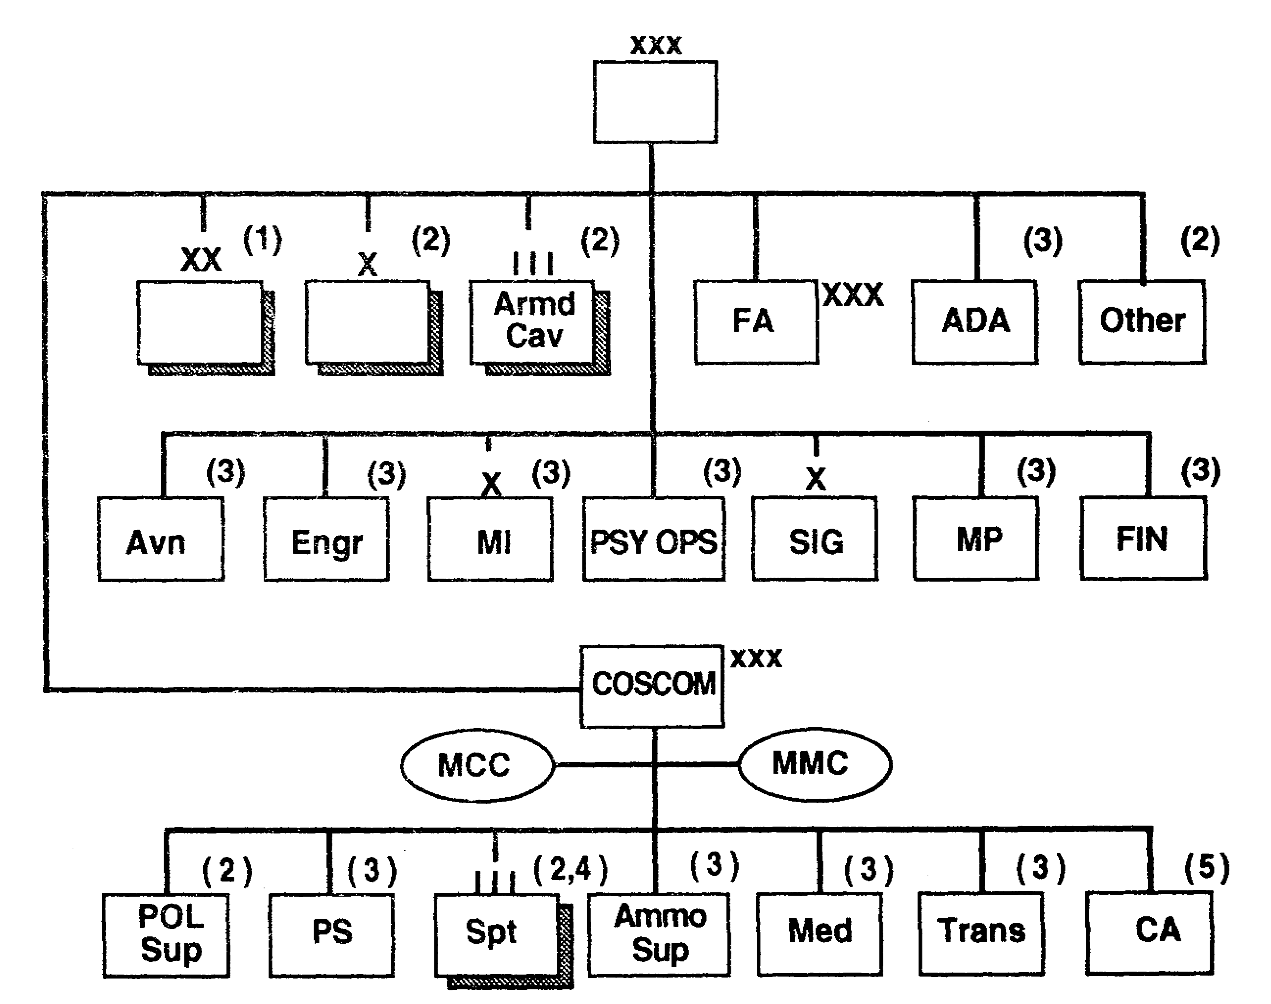

Figure 1-1. Typical corps organization.

SS0073 1-2
3. A corps may be described by the conditions of its visualized employment. It is a task force of combined arms and services, and a tactical unit of execution. The types and numbers of troop units assigned or attached to the corps depends on the mission, characteristics of the area of operations, availability of units, and the enemy situation. The corps is structured for a specific task. Figure 1-2 is one way a corps might be structured.

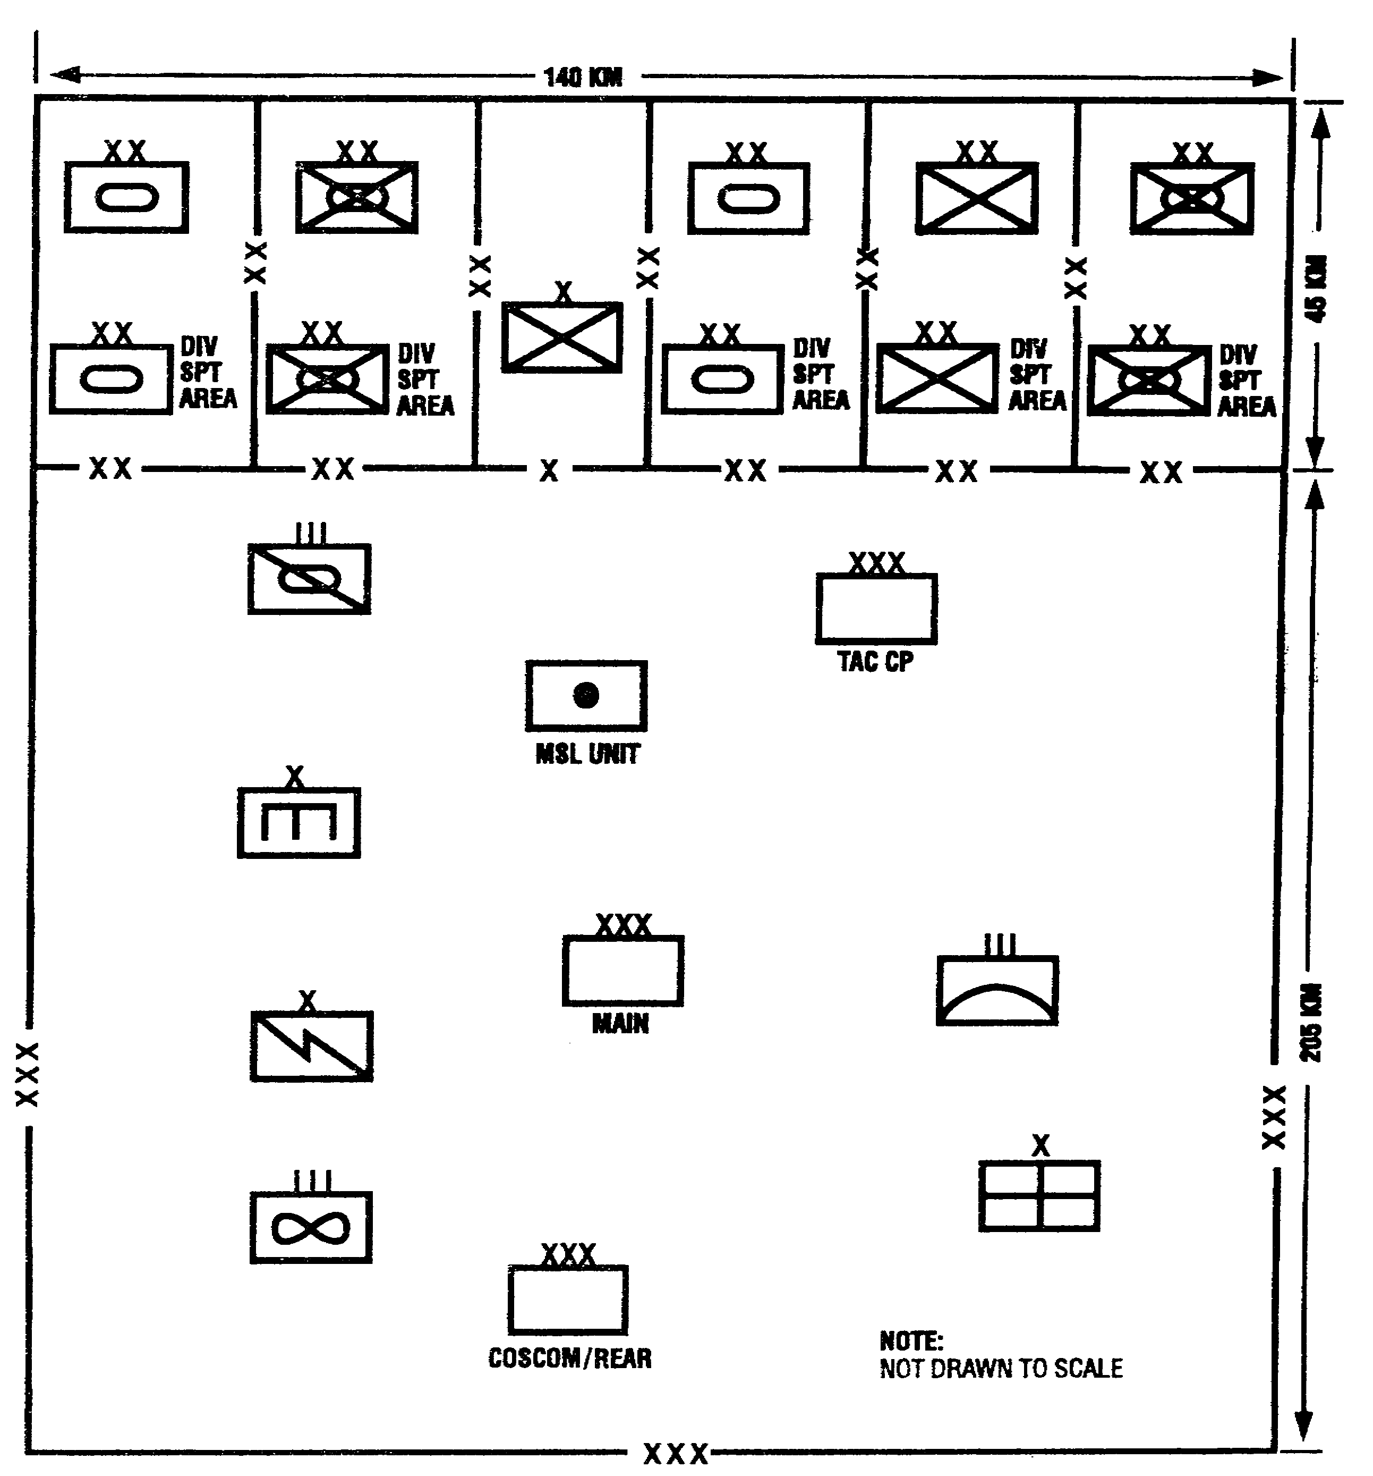

Figure 1-2. Type of corps structure.

1-3 SS0073
4. The corps is a flexible tactical and administrative organization, usually consisting of five divisions, together with supporting arms and services. It is structured for specific operational requirements charged with territorial responsibility for the combat zone.

a. Factors influencing organization are:

- Nature and duration of assigned or visualized mission.

- Characteristics of the area of operations.

- Composition, characteristics, and capabilities of the enemy.

- Availability and realistic need for forces in being.

- CSS concepts and procedures.

- Support provided by other Army forces and other services.

- Available infrastructure in the theater.

b. The corps can be further characterized by the type of division forces in its structure.

- Heavy corps is one that is structured with predominantly armored and/or mechanized divisions and appropriate supporting forces.

- Light corps is one that is structured predominantly with infantry, airmobile and/or airborne divisions, and appropriate supporting forces.

c. In keeping the above information in mind, the corps is structured with essential command, control, and communications systems and support forces to enable the corps commander to provide operational direction to, and support for, the basic unit of combined arms and services fighting force-the division.

PART B -CORPS HEADQUARTERS

1. The corps HQ provides tactical management and direction for organic combat, CS, and CSS units assigned to the corps. It also provides logistical and administrative support for corps units. Figure 1-3 illustrates a corps HQ staff.

SS0073 1-4
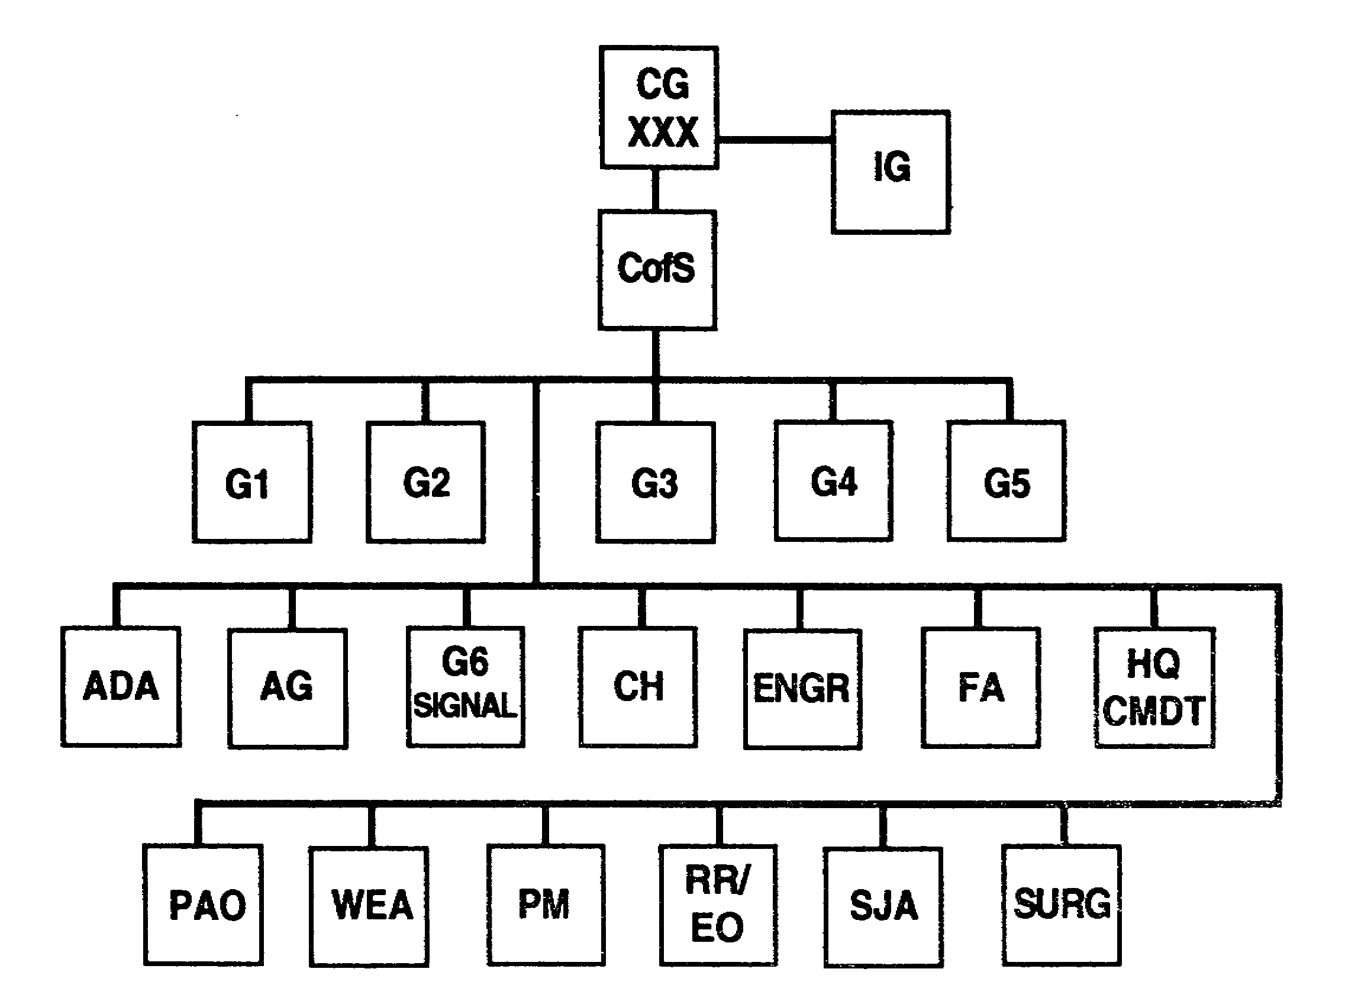

Figure 1-3. Corps HQ staff.

2. The corps commander dominates the process of C². He is supported by a staff that provides him with the essential information required for decision making. The corps commander concerns himself with three primary areas of responsibility:

- Conduct of Army Operations.

- Administrative and logistical support of his corps.

- His political/military role.

3. Echelon of the corps HQ includes a Tactical Command Post (TAC CP), Corps Main CP, and Corps Rear CP. The corps commander may establish a Corps Alternate CP at his discretion.

a. The TAC CP provides the corps commander with a small mobile control capability and essential staff elements that permit him to operate at critical places for short periods of time. It consists of necessary communications equipment and personnel specifically designated by the corps commander. The TAC CP is primarily concerned with directing current combat activities.

1-5 SS0073
b. The Corps Main CP is concerned with the overall planning of combat operations, providing required support of operations, and maintaining current status of all activities of the corps.

c. The Corps Rear CP consists of a small staff and is normally collocated with the corps support command (COSCOM) HQ. The CP has a small tactical element capable of providing continuity of command.

4. Control is essential for success on the battlefield. Control depends on highly effective and survivable signal support.

a. Effective signal support requires integrating and synchronizing the efforts of countless elements and individuals throughout the corps environment. Signal support responsibilities are linked to a commander's authority and responsibility to manage and use his signal support resources. Successful signal support is vital to the corps. To achieve success, signal staffs and organizations, and nonsignal units and staffs must be organized and must function as a team. Figure 1-4 shows the division of responsibility.

b. The corps signal officer (CSO) is a member of the corps HQ special staff and is also the corps signal brigade commander. As a special staff member, the CSO is responsible for accomplishing the corps signal office's mission to perform signal management functions. These functions provide adequate communications to the corps commander for commanding and controlling his forces.

SS0073 1-6
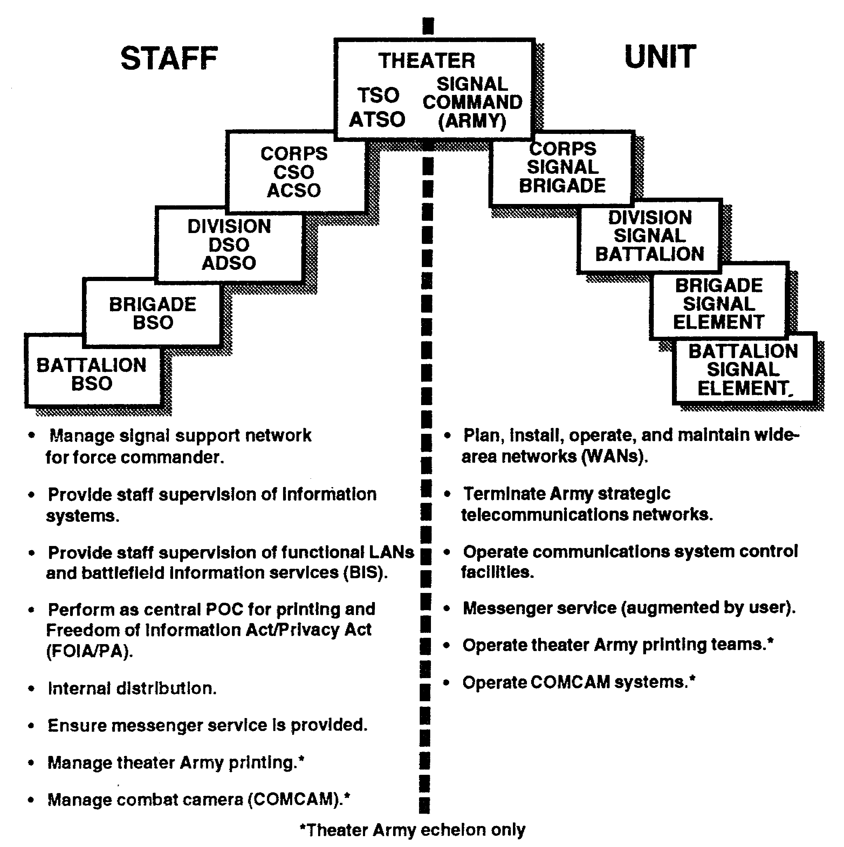

Figure 1-4. Signal Corps responsibilities.

1-7 SS0073
PART C - ELECTRONIC BATTLEFIELD

1. To win the battle, effective electronic warfare (EW) planning and strategy may well become the decisive element for combat victory. Today's commander must view and plan for the modern battlefield with regard to its depth and width, air space overhead, and the electromagnetic spectrum. The electromagnetic spectrum is a new and fourth dimension of combat operations, which consists largely of an invisible medium that will saturate the next battlefield.

2. Since all communications-electronics emitters rely heavily on this medium for successful operation, the US Army must turn to EW as a weapon which will prevent an enemy combat force from gaining superiority and control of the electromagnetic spectrum. In this type of environment, any unit seen or heard electronically, faces a high probability of being destroyed.

3. Four characteristics of the modern battlefield are:

- It will be more lethal than ever before.

- The US Army will fight outnumbered.

- Integration of combat power and EW may well be a deciding factor of success.

- What can be seen or heard electronically can be targeted and destroyed.

4. The above facts present a new EW challenge to the corps commander-one that demands new tactics and preplanned operational techniques. To effectively fight and win in this environment, our forces cannot afford to give away lucrative intelligence information because of poor signal security (SIGSEC) and electronic counter-countermeasures (ECCM) practices. The corps commander views the battlefield totally in abstract. He relies on his communications and data flow to prevent being surprised by enemy forces, and to maneuver his own combat elements-to gain advantage over a weakened enemy situation. He must provide the proper mixture of EW resources that support jamming and target acquisition, and complements both corps and divisional artillery fire.

5. Threat forces have extensive radio electronic combat (REC) capabilities and will attempt to deny us using the electromagnetic spectrum. All signal leaders must aggressively use ECCM to ensure our success during Army Operations.

SS0073 1-8
LESSON 1

PRACTICE EXERCISE

The following items will test your grasp of the material covered in this lesson. There is only one correct answer for each item. When you complete the exercise, check your answers with the answer key that follows. If you answer any item incorrectly, study again that part of the lesson which contains the portion involved.

1. What is the largest tactical formation in the US Army?

A. Brigade

B. Division

C. Corps

D. Army

2. Which corps CP is responsible for directing current combat activities?

A. Corps Main CP

B. Corps Rear CP

C. Corps TA-C; CP

D. Corps Alternate CP

3. Which of the following is not a characteristic of the modern battlefield?

A. What can be seen or heard electronically can be targeted and destroyed.

B. The Army will have time to deploy forces to areas of conflict.

C. It will be more lethal than ever before.

D. The US Army will fight outnumbered.

SS0073 1-10
4. The Corps Rear CP is normally located with which HQ?

A. Lead division HQ

B. COSCOM

C. Alternate Corps CP

D. Theater Forward CP

5. The corps signal brigade commander is also on the corps commander's primary staff.

A. True

B. False

1-11 SS0073
LESSON 1

PRACTICE EXERCISE

ANSWER KEY AND FEEDBACK

Item Correct Answer and Feedback

1. C. Corps

The corps is the largest tactical unit in the US Army. (Introduction, page 1-1)

2. C. Corps TAC CP

The TAC CP is primarily concerned with directing current combat activities. (page 1-5, para 3a)

3. B. The Army will have time to deploy forces to areas of conflict.

Four characteristics of the modern battlefield are:

- It will be more lethal than ever before.

- The US Army will fight outnumbered.

- Integration of combat power and EW may well be a deciding factor of success.

- What can be seen or heard electronically can be targeted and destroyed.

(page 1-8, para 3)

4. B. COSCOM

The Corps Rear CP consists of a small staff and is normally collocated with the corps support command (COSCOM) HQ. (page 1-6, para 3c)

5. A. True

The corps signal officer (CSO) is a member of the corps HQ special staff and is also the corps signal brigade commander. (page 1-6, para 4b)

SS0073 1-12
LESSON 2

COMMAND AND CONTROL COMMUNICATIONS ARCHITECTURE

Critical Task: 01-5881.04-0006

OVERVIEW

LESSON DESCRIPTION:

In this lesson, you will learn to describe the ATCCS and its components.

TERMINAL LEARNING OBJECTIVE:

ACTION: Describe the ATCCS and each major system that comprises it.

CONDITION: You will be provided this subcourse.

STANDARD: Demonstrate competency of task skills and knowledge by correctly responding to 70 percent of the multiple-choice test covering corps communications.

INTRODUCTION

The term Army Operations combines two fields of combat and suggests the vastness and dynamic activity of the anticipated combat environment. FM 100-5 details the four tenets of Army Operations: initiative, agility, depth, and synchronization. Synchronization depends on reliable and flexible communications. The Signal Corps' mission is to provide the field commander with quality communications. This allows him to exercise C² over the forces needed to seize and retain the initiative which leads to defeating threat forces. (See Figure 2-1.)

2-1 SS0073
SYNCHRONIZATION

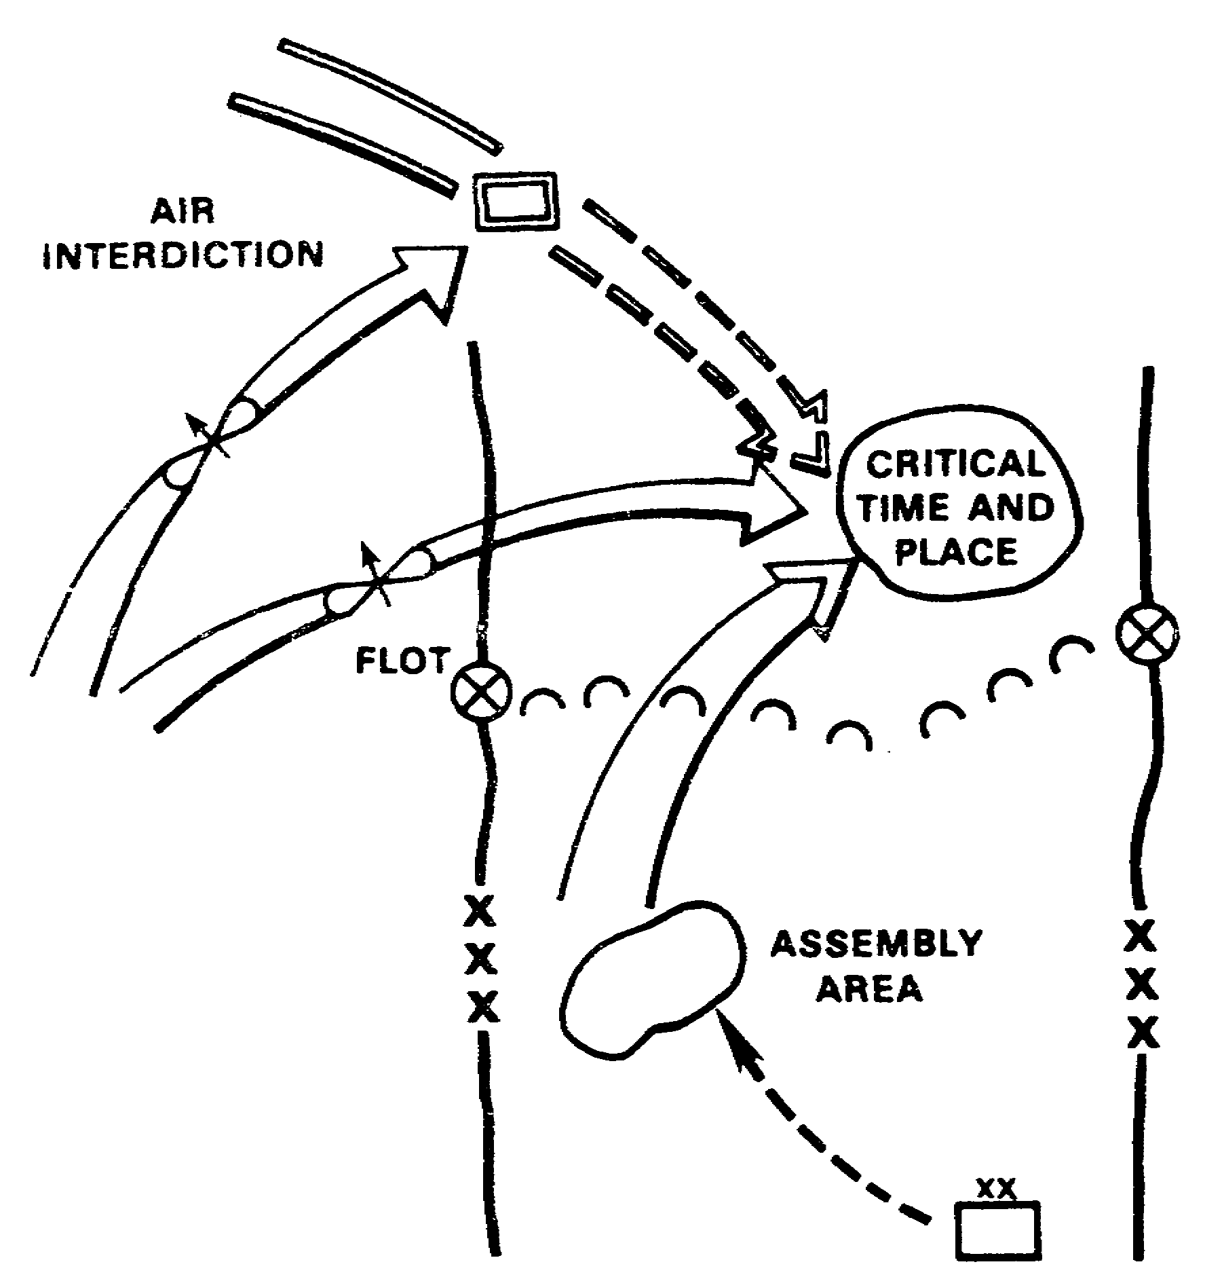

Figure 2-1. Synchronization.

PART A - THE ARMY TACTICAL COMMAND AND CONTROL SYSTEM NETWORK

1. The only purpose of C² is to implement the commander's will in pursuit of the unit's objective. The system must be reliable, secure, fast, and durable. It must collect, analyze, and present information rapidly. It must communicate orders, coordinate support, and provide direction to the force in spite of enemy interference, destruction of CPs, or loss and replacement of commanders. The ultimate measure of C² effectiveness is whether the force functions more effectively and more quickly than the enemy.

2. Force level information is exchanged by means of the network. The ATCCS is an integrated system of equipment, software, information, and staff. This system allows tactical commanders and staff at each of the five battlefield functional areas to plan and

SS0073 2-2
control their operations and to coordinate these with other functional commanders. ATCCS consists of the automated C² systems for the battlefield functional areas and the communications links between and among the control systems. (See Figure 2-2.)

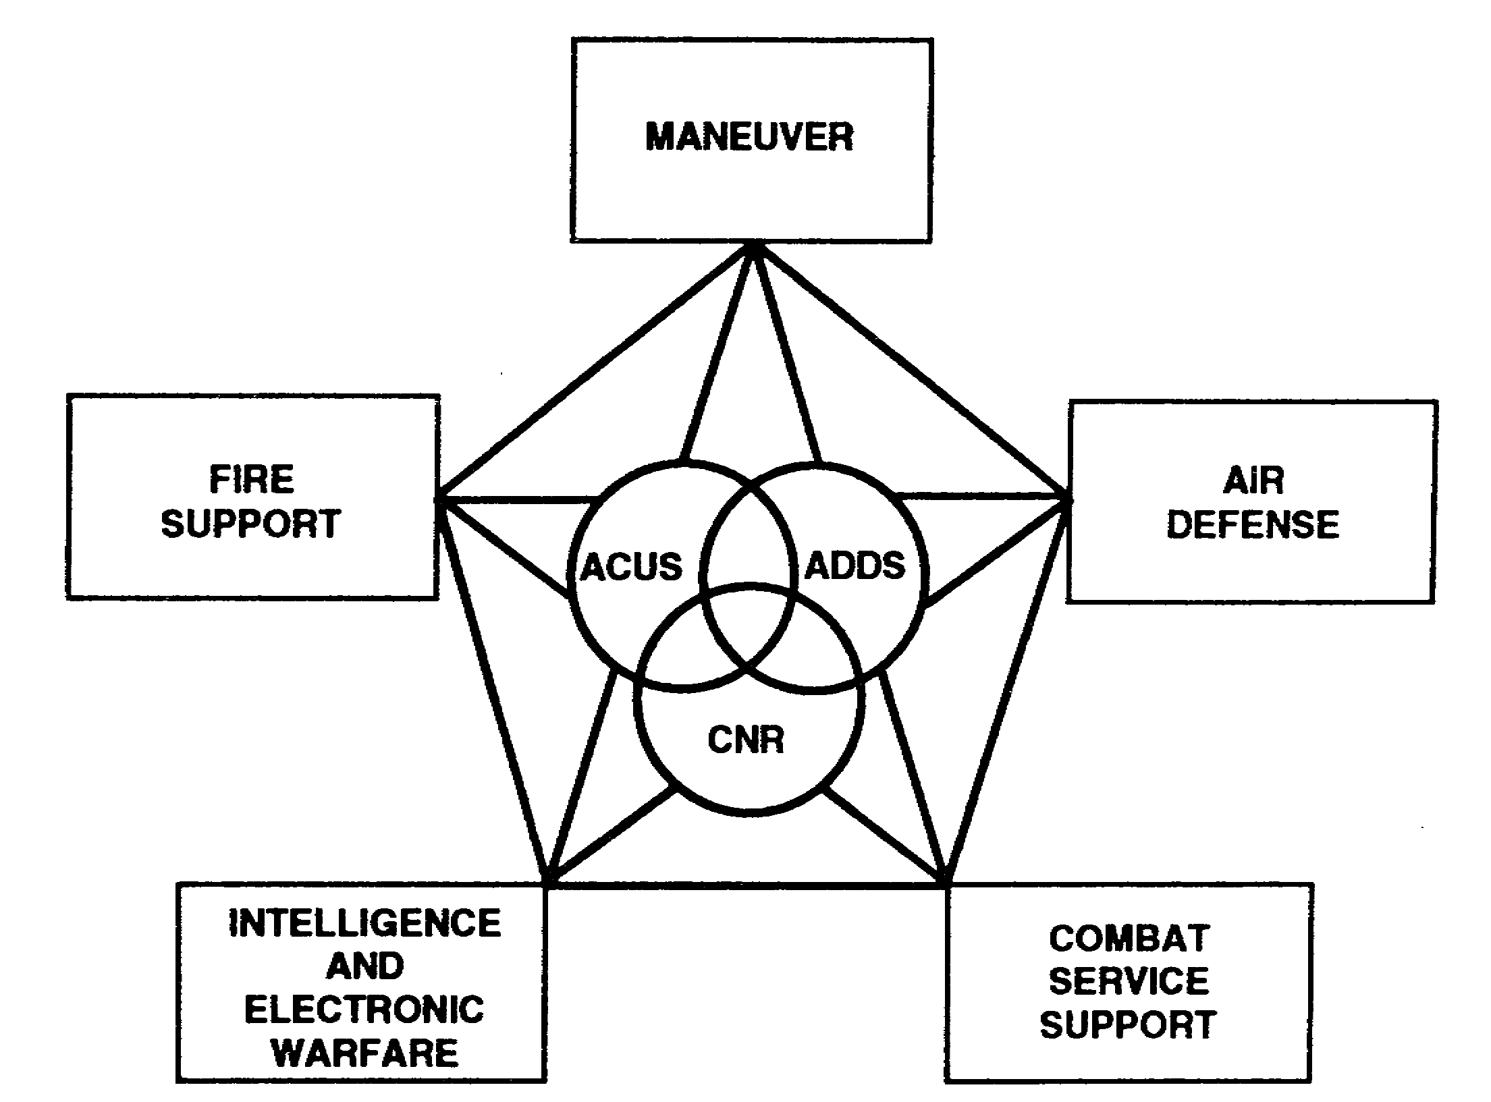

Figure 2-2. ATCCS network.

3. Information management is the policy, process, and procedures used to manage information systems and services. It includes, but is not limited to, resources and activities that create, gather, manipulate, classify, store, display, retrieve, secure, transmit, disseminate, or access elements of information. Elements of information may be visual, aural, or electrical. Information management occurs at strategic, theater/tactical, and sustaining base levels.

a. Strategic information is required by theater Army, joint or combined commands, defense, and other federal agencies to execute national policies and theater goals.

b. Theater/tactical information is used in the theater of operations, normally at corps level and below, and is required to conduct maneuver warfare. Tactical information includes unit

2-3 SS0073
status; unit employability; fire support capabilities; supply routes; key terrain; avenues of approach; and threat disposition, capabilities, and intentions. It includes information systems needed to direct, coordinate, and support combat power during peace, transition to war, and conflict. This information is processed from the fighting position to the successive command HQ of the joint, unified, specified, or combined commands.

c. Sustaining base information is primarily concerned with base operations and training. Sustaining base information systems function during peace, mobilization, deployment, employment, and sustainment of the fighting force.

4. Personnel responsible for information management coordinate, process, and manage information vertically between the strategic, theater/tactical, and sustaining base; and horizontally and vertically between the five major functional areas. The effectiveness of this force level information exchange network is the key to the Army's success to fight in accordance with (IAW) the five basic tenets of Army Operations. The tenets are initiative, agility, depth, synchronization, and versatility. The Army Operations C² system must facilitate the commander's ability to operate, delegate authority, and exert leadership from any critical point on the battlefield.

5. The Information Mission Area (IMA) has five disciplines: automation, communications, visual information, records management, and printing and publications. As defined below, the five disciplines encompass strategic, theater/tactical, and sustaining base information. The IMA responsibilities of the assistant division signal officer (ADSO) address only those aspects of the tactical environment, systems, and services and is referred to as signal support.

a. Automation is implementing processes or procedures using automated electronic equipment in tactical and nontactical environments. The technologies include, but are not limited to micrographics, word processing, copiers, printing, communications, decision aids, and general-purpose data processing.

b. Communications is disseminating information through transmission, emission, or reception of signs, signals, writing, images, sounds or data of any nature using audio, visual, electro-optical, or electromagnetic systems.

c. Visual information is using sound and visual material or processes to communicate information. Visual information includes, but is not limited to, motion pictures, still and motion photography (combat camera (COMCAM)), television, audio, graphic art, and audiovisual libraries.

d. Records management is managing and maintaining documentation. It includes distribution, use and disposition, storage, declassification, and the implementation of responsibilities under the freedom of information and privacy acts. Media includes correspondence, reports, forms, directives, publications, electronic mail/messages, mail, magnetic tape/disk, and electro-optical storage/retrieval. The Information Services Support Office (ISSO) was formerly the administrative services branch/division. The ISSO is responsible for the Battlefield Information Services (BIS).

SS0073 2-4
e. Printing and publications is the process for producing documents on media such as micropublishing, plate making, press work, photocomposition, and binding for issue and distribution. For the most part, this is accomplished through Signal Corps channels to the garrison/wartime director of information management.

6. C² communications is not limited to mobile subscriber equipment (MSE). MSE is only one part of the equation. The Army provides the commander with the tactical communications architecture to support corps and division C² on the battlefield. This architecture consists of—

- The Area Common-User Voice Network.

- The combat net radio (CNR) system.

- · The Army Data Distribution System (ADDS).

PART B -THE AREA COMMON-USER VOICE NETWORK

1. MSE is the area common-user voice communications system in the corps. It is the backbone of the corps communications system and provides voice and data communications from the corps rear boundary forward to the division maneuver battalions' main CP and rear CP. It also provides commanders and staffs with a switched communications system which includes—

- Secure telephone service.

- Secure facsimile service.

- Secure mobile radiotelephone service.

- Secure data transmission.

- CNR network access.

2. There is no messenger service at the corps or division level. When messenger service is required, the signal office is responsible for determining routes and schedules. The Assistant Chief of Staff, Operations and Plans (G3) is responsible for tasking units for vehicles and personnel. To compensate for the lack of a record traffic system, user-owned and -operated terminals are relied on to transfer messages through the area common-user system (ACUS). Subscribers dial the intended recipient and send the message.

2-5 SS0073
3. MSE operations consist of five functional areas-* -Area coverage.

- Wire subscriber access.

- Subscriber terminals.

- Mobile subscriber access.

- Systems control.

The five functional areas represent the major roles and capabilities of the system. The first four describe equipment and capabilities available to the user for unit C². The fifth provides the signal commander with facilities to C². The fifth provides the signal commander with facilities to C² MSE assets.

a. Area coverage. The network of line-of-sight (LOS) multichannel radios and the interconnected local and long-distance switching nodes provide area coverage. Covering the battlefield with network access points and facilities to route communications to the desired subscriber provides wide-area communications to commanders and staffs for C², sustainment, operations, and intelligence. Each MSE corps network includes at least two gateway connections to the echelons above corps (EAC) communications network and adjacent corps. Adjacent divisions in different MSE corps networks maintain at least one link between themselves. (See Figure 2-3.)

(1) The heart of the MSE network is the node center (NC). Each NC consists of—

- One AN/TTC-47 node switch (NS). An operations group (OG) shelter and a switching group (SG) shelter comprise the NS.

- One node management facility (NMF).

- Four LOS AN/TRC-190(V3) ultra high frequency (UHF) radio assemblages.

- One radio access unit (RAU).

- One node support vehicle (NSV).

- Two 10 kW diesel generators.

- Five 5 kW diesel generators.

(2) The NS provides network tandem switching with flood search routing. The NS also can provide technical management of nodal communications facilities.

SS0073 2-6
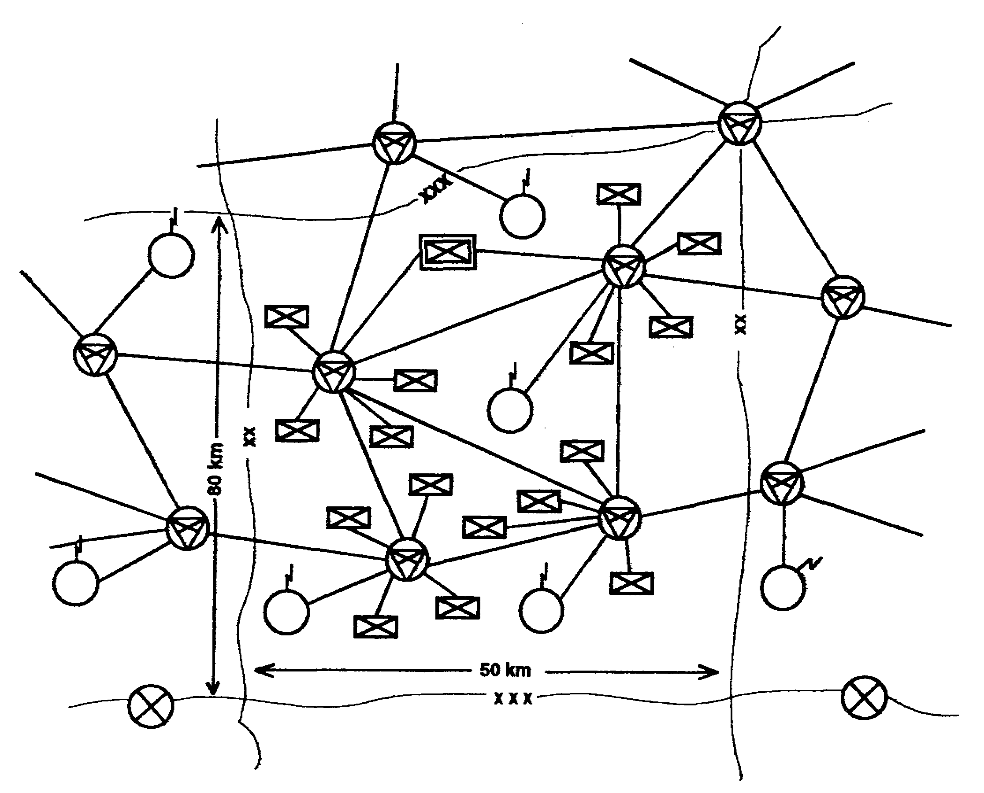

Figure 2-3. Typical division deployment.

(3) LOS radios (AN/TRC-190(V)) provide the transmission media between NCs and the NS with its extension nodes. LOS radios also link the remote RAU to the NS. Substitute radio systems can be used for the AN/TRC-190 in specific applications where terrain is restrictive or extended range is desired. These substitutes can be either tactical satellite (TACSAT) or digital troposcatter (TROPO).

(4) The RAU (AN/TRC-191) provides network access to mobile radiotelephone subscribers. The RAU can be deployed adjacent to an NC (local) or can be removed by means of the LOS radio (AN/TRC-190(V1)).

2-7 SS0073
(5) MSE can interface with TACSAT (AN/TSC-85A and AN/TSC-93A) which can extend radio transmission range when LOS radio is unavailable or radio range is insufficient. TACSAT can provide an internodal link between widely separated NCs in the same corps or can install a gateway link between NCs of adjacent corps. TACSAT provides secure analog and digital transmission. Signal network managers can use TACSAT to deploy transmission assets forward during exploitation or penetration operations in the deep battle. TACSAT can provide a communications link with higher echelon elements such as theater Army or continental United States (CONUS).

(6) TROPO radio terminals (AN/TRC-170(V)) from EAC can be substituted for MSE LOS radios. The terminals provide secure transmission of analog and digital traffic over ranges from LOS to 240 kilometers (150 miles). Each of the two terminals can transmit one system of 8 to 144 trunks. Signal organizations use the terminals for node bypass and extended range communications. TROPO companies (heavy and light) are assigned to EAC units. TROPO (heavy) companies use the (V2) model with an optimum transmission range of 240 kilometers (150 miles). TROPO (light) companies use the (V3) model with an optimum range of 160 kilometers (100 miles). Transmission ranges largely depend on propagation factors.

b. Wire subscriber access. This functional area provides network access to static terminal users. The AN/TTC-46 large extension node switch (LENS) or the AN/TTC-48 small extension node switch (SENS) provides this service. Signal support of wire subscribers consists of installation, operation, and maintenance (IOM) of the NS, LOS radios, cable (CX-4566 and CX-11230/G), and junction equipment (J-1077 distribution box or TD-1234 remote multiplexer combiner (RMC)). The user is responsible for connecting the WF-16 field wire to the junction equipment and providing power for the RMC.

(1) LENS provides local switching and network access for up to 176 digital subscribers. A LENS provides service for large concentrations of users, such as COSCOM/division support command (DISCOM) or corps/division main. The LENS consists of an OG shelter and an SG shelter. The AN/TRC-190(V4) LOS radio provides network connectivity.

(2) SENS provides local switching and network access for 26 subscribers (AN/TTC-48(V1)) or 41 subscribers (AN/TTC-48(V2)). A habitual relationship may be established and maintained between extension nodes including LOS teams and the division CP. The same relationship may be established with corps combat units CPs; that is, armored cavalry regiment (ACR), artillery brigades, or air defense artillery (ADA) brigades. While a habitual relationship may be desired for tactical familiarity and ease in support, MSE extension nodes do not revert to a reserve role when the supported CP/unit assumes a reserve role. In these situations, MSE extension nodes are assigned a revised support role. Habitual relationships may be reestablished when the affected elements return to an active role. In the corps area of operations, essential C² of facilities (division main CP, corps main CP, corps rear and tactical CP) should be provided dual LOS network connectivity. This entails assigning additional and redundant extension facilities (SENs and LENs). (See Figures 2-4 and 2-5.)

SS0073 2-8
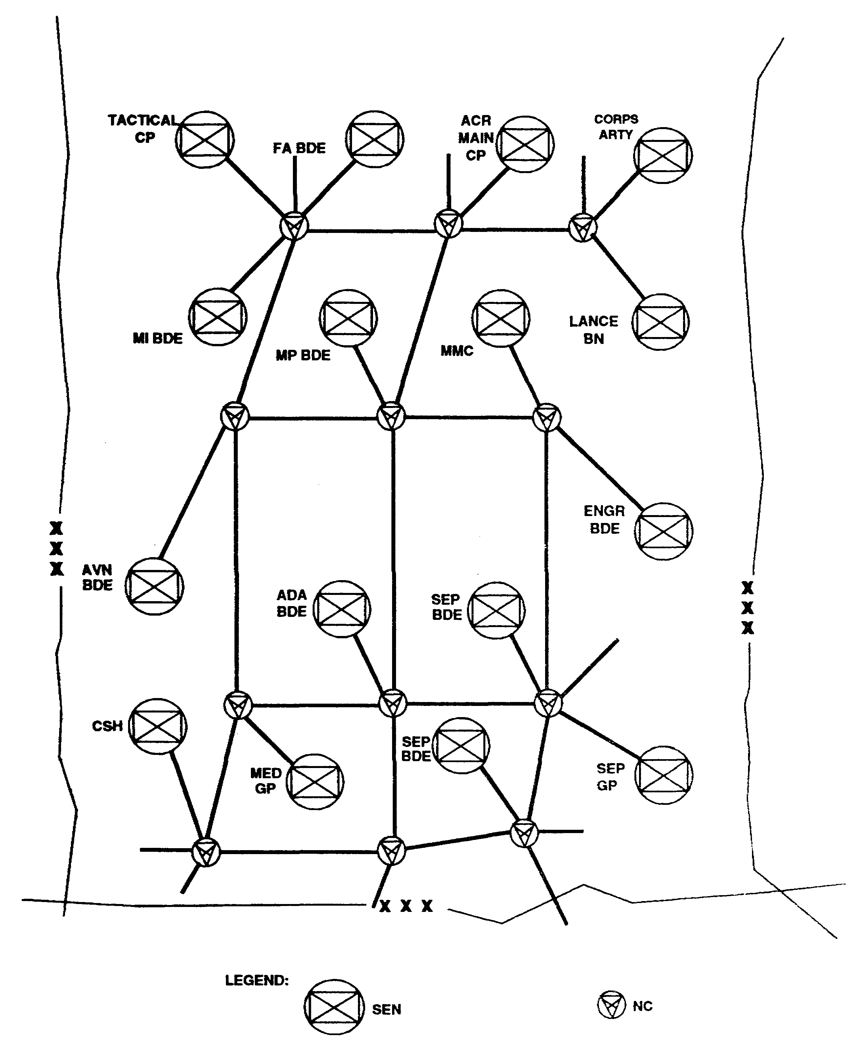

Figure 2-4. Typical corps SEN deployment.

2-9 SS0073
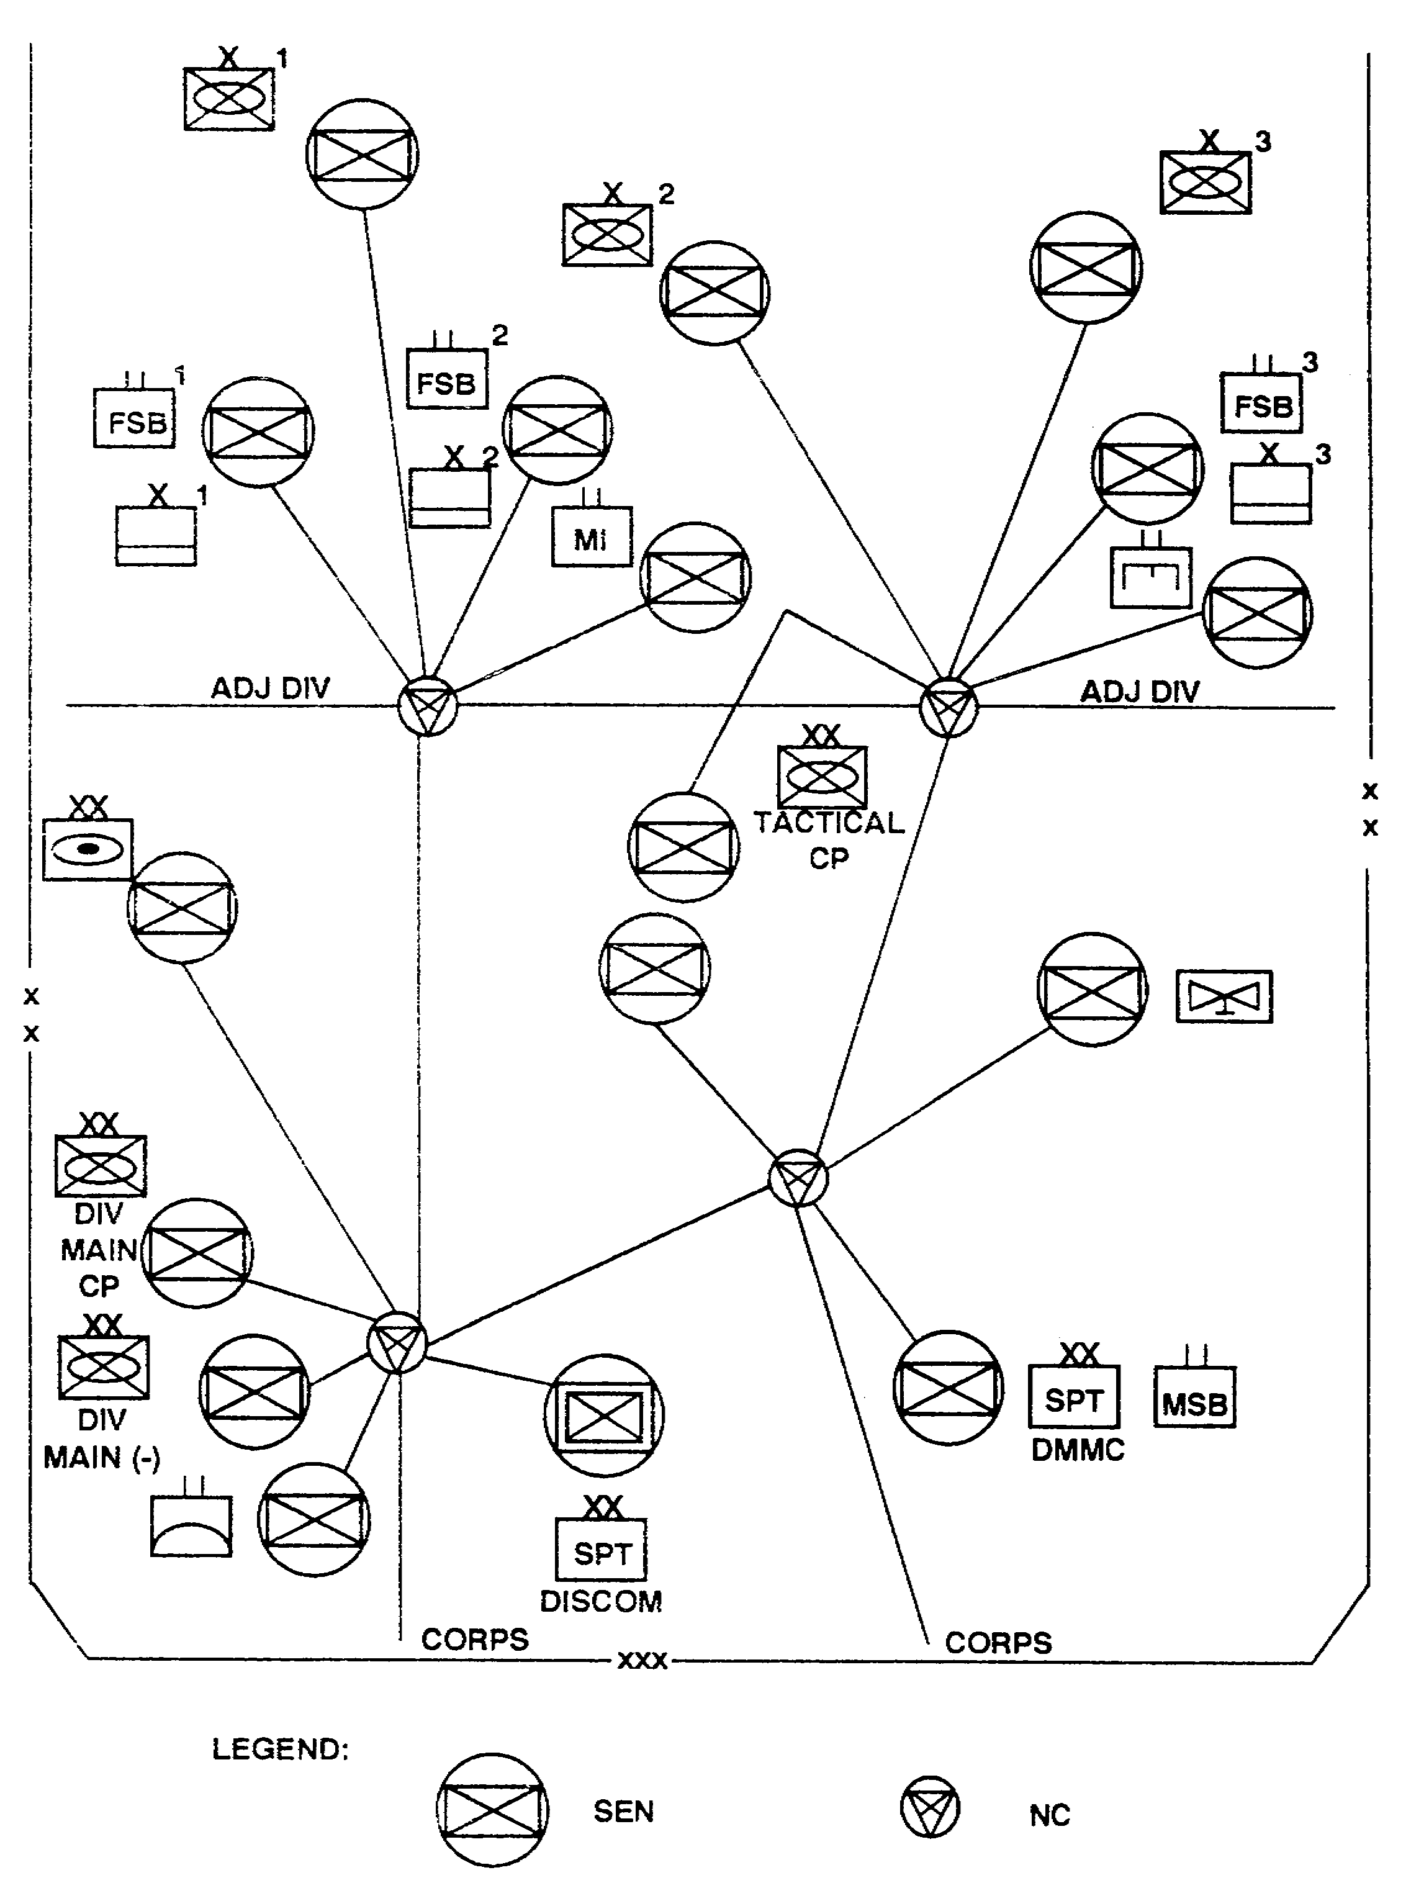

Figure 2-5. Typical division extension switch deployment.

SS0073 2-10
(3) The AN/GRC-224 super high frequency (SHF) radio may be used to enhance CP survivability by remoting the LOS radio from the extension node switch and the supported unit.

c. Subscriber terminals. This functional area covers user-owned and -operated MSE equipment. Subscriber terminal equipment includes—

- TA-1035 digital nonsecure voice terminal (DNVT).

- TSEC/KY-68 digital subscriber voice terminal (DSVT).

- AN/UGC-144 communications terminal (CT).

- AN/UXC-7 lightweight digital facsimile (LDF).

- AN/VRC-97 mobile subscriber radiotelephone terminal (MSRT).

(1) Users are responsible for installing, operating, and maintaining their subscriber terminal equipment. The user is responsible for connecting and maintaining wire lines to the distribution box or RMC installed by the supporting signal extension node. Signal soldiers and leaders are responsible for ensuring the user is knowledgeable in procedures for completing connections and assisting with troubleshooting.

(2) Subscriber terminals provide the user voice and data access to the MSE network. Data terminals interface with the network through 16 kb/s data ports in the DSVT or DNVT.

d. Mobile subscriber access. This functional area consists of signal and user equipment. This enables the commander and staff to communicate while moving throughout the battlefield.

(1) The user-owned component is the MSRT which provides the user the capability to dial up and communicate with any discretely addressed MSE subscriber. The MSRT (AN/VRC-97) consists of a DSVT and an RT-1539(P) /G very high frequency (VHF) radio with a vehicle antenna kit.

(a) The RT-1539(P) /G MSRT radio and the RAU's radio are identical and interchangeable. In the MSRT or RAU, the radio operates in a full duplex mode with a high and low frequency band for transmit and receive channels. In the RAU, the radio transmits in the high band and receives in the low band. This procedure is reversed when the radio is used in the MSRT configuration. The MSRT has the following capabilities:

- Automatic random channel selection for each call.

- Automatic radio frequency (RF) transmit level adjustment.

- Automatic receiver sensitivity adjustment.

2-11 SS0073
- Stand-alone field kit (SAFK).

- DSVT remote capability.

- Range extension using elevated antenna.

(b) The mobile subscriber uses the DSVT as the primary access terminal. The DSVT provides cryptographic facilities for the MSRT and has a 16 kb/s data port for interface of data devices (facsimile, CT). The MSRT can be removed from the vehicle and operated using the SAFK.

(2) The mobile subscriber gains network access through the RAU. The signal planner deploys RAUs to provide battlefield coverage. One RAU can provide a 15 kilometer (9.3 mile) radius area coverage (planning range) in the area of operations. Following initial affiliation, mobile subscriber affiliation is maintained automatically as he moves from one RAU's range to another. If the mobile subscriber is engaged in a telephone conversation and leaves the servicing RAU's range, the conversation is terminated and must be redialed. (See Figures 2-6 and 2-7.)

e. Systems control. System control center (SCC) AN/TYQ-35 is the primary signal C² facility for MSE network operations. It is the primary automated tool used by the systems control (SYSCON) to control the network. It provides the signal commander automated facilities to aid in network planning, systems engineering, network management, and dynamic operational management of all MSE materiel and personnel. Corps SCC assets are deployed on the basis of one per division and two per corps. FM 11-38 provides detailed information on SCC facilities and network management and control procedures.

(1) Corps SYSCON, including subordinate division MSE assets, controls the MSE network when deployed as a corps system. The concept of a corps-managed area network is a major change in signal doctrine. The divisions normally control their own assets; however, as MSE is a corps system, it is charged with securing the entire network functions.

(a) In a corps network, the network management/control element is the CSO's/brigade commander's HQ. The CSO is responsible for ensuring area communications support throughout the maneuver area of operations. It is expected that division MSE assets will require corps augmentation to fulfill this requirement.

(b) The division signal officer is responsible for using his unit's assets to support the C² needs of the division.

(c) The network manager designates one primary SCC and one alternate SCC. The primary SCC is responsible for corps network management and control functions. This is accomplished by using multiple-netted SCCs. Each one is responsible to the primary SCC as a potential alternate SCC and for discrete management/planning functions; for example, planning, frequency management, or team status. The corps SCC AN/TYQ-35(V2) consists of a technical shelter, management shelter, and planning shelter.

SS0073 2-12
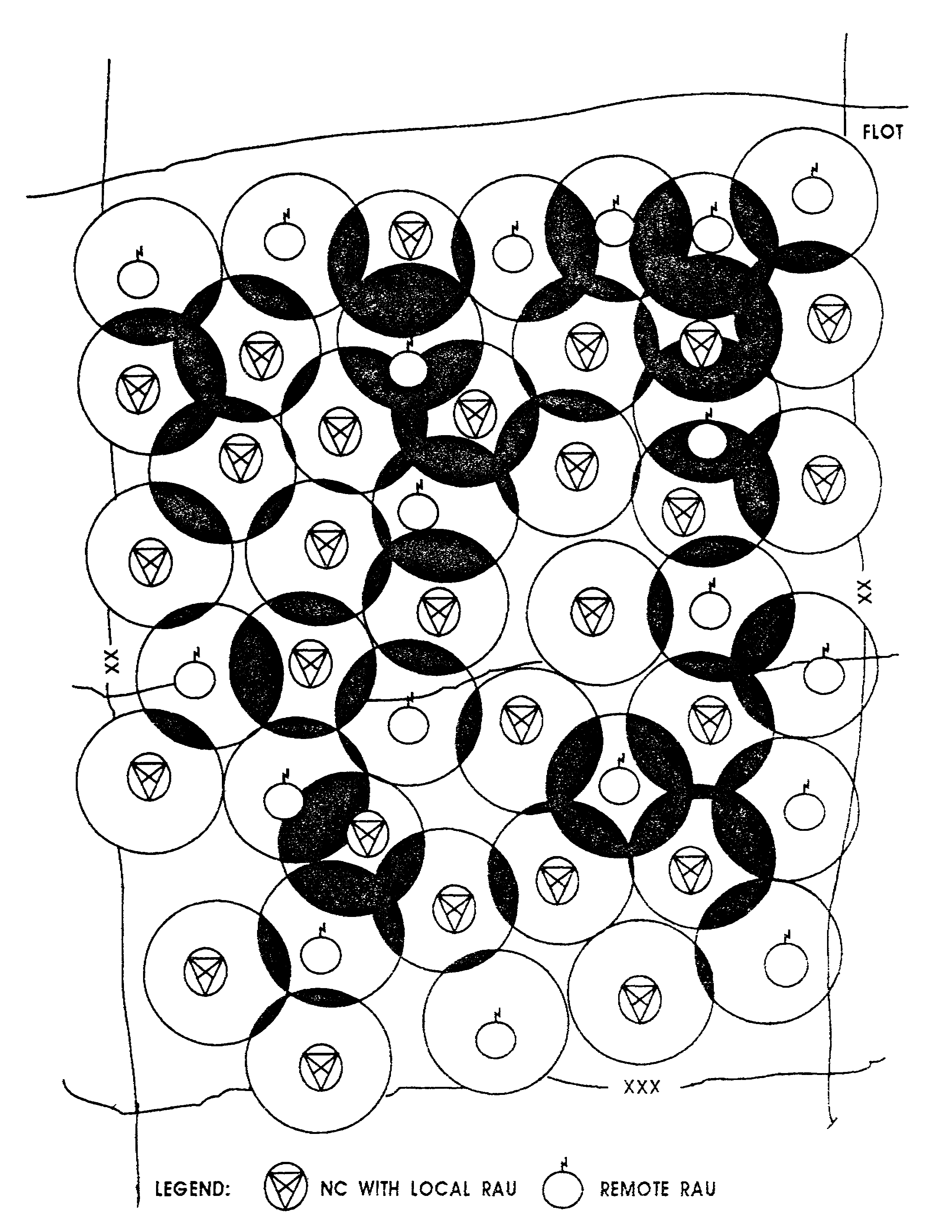

Figure 2-6. RAU deployment within a corps.

2-13 SS0073
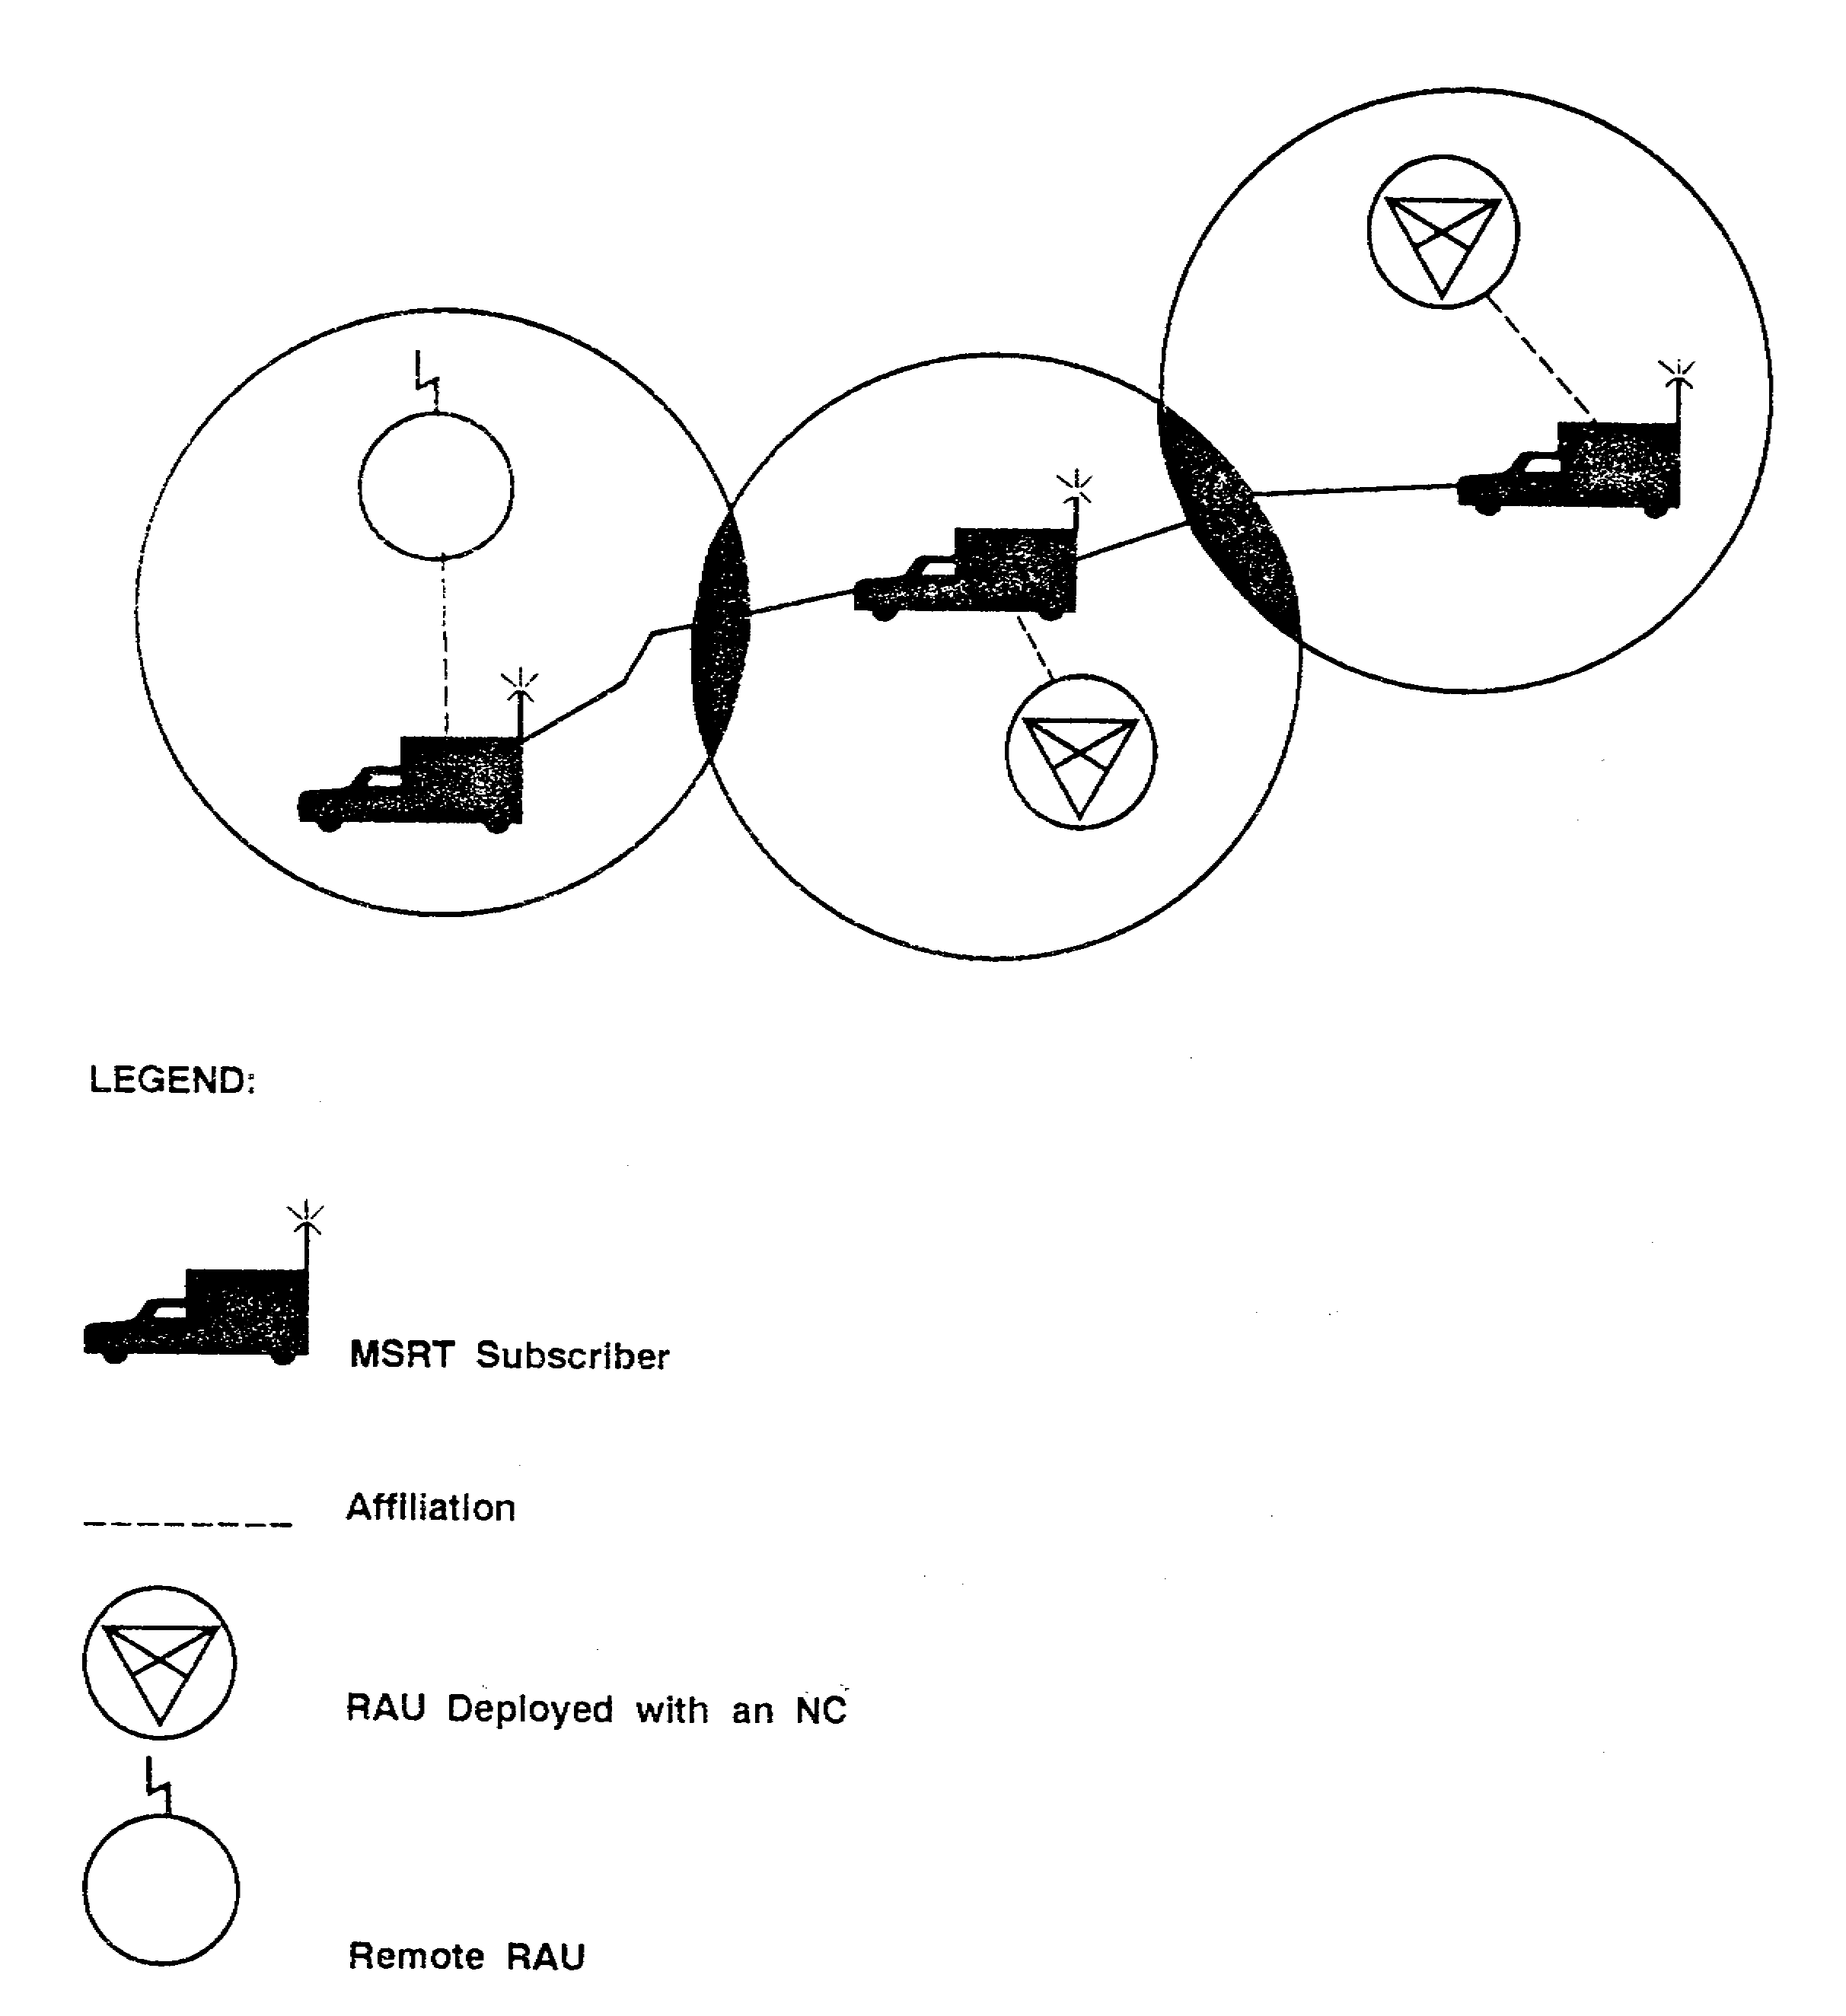

Figure 2-7. MSRT automatic reaffiliation.

SS0073 2-14
(2) The division SCC AN/TYQ-35(V1) consists of a technical shelter and a management shelter. When the division deploys independent of the corps, the management/control element is in the HQ of the division signal battalion. The division SCC assumes the role of primary SCC when deployed without corps SCC support.

(3) The SCC deploys with an NC and gains network connectivity through the NS. The SCC is normally connected to the NS by a .4 kilometer (.25 mile) CX-11230/G cable. Corps level SCC assets deploy with one SCC operating in the primary role and one in the alternate role to provide redundancy. The primary SCC updates the network data base in the alternate SCC automatically every seven minutes.

(4) The NMF AN/TSQ-154 provides the node commander (platoon leader) a shelter from which to direct nodal operations. The NMF contains a data terminal used for sending reports to and receiving orders from the SCC. The NMF is the network interface between the SCC, the NCs, and the LENs.

(5) The network control terminal (NCT) AN/GGC-66 is the corps area signal battalion (ASB) commander's interface with MSE system management operations. It is the means by which the commander follows the movement and status of his teams when they are deployed in the MSE network. The NCT is issued on the basis of one per corps ASB.

PART C -COMBAT NET RADIO

1. The CNR system provides a communications means, independent of MSE, for C² within the corps in the division maneuver brigades, CS units, and CSS units. The primary role of the CNR is voice C² for the commander at brigade and below. The secondary role of the CNR is to provide a means of data transmission. When a CNR net is used for voice and data traffic, transmission quality may be degraded. If this occurs, consider designating the unit CNR nets as data-only or voice-only nets. The CNR architecture is based on having two types of single-channel systems: amplitude modulated (AM) and frequency modulated (FM). Examples of such radios include the AN/VRC-12 and the AN/GRC-106. The future CNR architecture is also designed around two separate radio systems, each having unique characteristics and capabilities. These are the—

- Improved high frequency radio (IHFR).

- Single Channel Ground and Airborne Radio System (SINCGARS).

2. IHFR provides the commander a tactical high frequency (HF) radio for C² in the corps and division. IHFR extends and complements the VHF-FM communications network. At this time, there is no requirement or capability for IHFR to interface with MSE. IHFR supports secure

2-15 SS0073
voice systems requiring a long-range capability and replaces the AN/PRC-47, AN/PRC-74, AN/GRC-165, and the stand-alone AN/GRC-106 radios. IHFR is fielded in three configurations:

- AN/GRC-193A, 100 or 400 watt selectable (vehicular) HF radio.

- AN/GRC-213, 20 watt manpack radio.

- AN/PRC-104, 20 watt manpack radio.

3. SINCGARS is a new family of VHF-FM radio sets which provide secure voice and data transmission capability to the commander. SINCGARS radio sets replace VRC-12 series radios on a one-for-one basis. The Battlefield Electronic CEOI System (BECS) is the frequency management tool for SINCGARS. SINCGARS can transmit voice and data across a broad frequency spectrum using a frequency-hopping technique. This technique results in a decreased threat of degradation associated with nuclear/nonnuclear combat and electronic countermeasures (ECM). SINCGARS interfaces with MSE through the net radio interface (NRI) located in selected SENs or LENs. Table 2-1 shows the SINCGARS replacement plan, as determined through the operational facility (OPFAC) process.

Table 2-1. SINCGARS replacement plan.

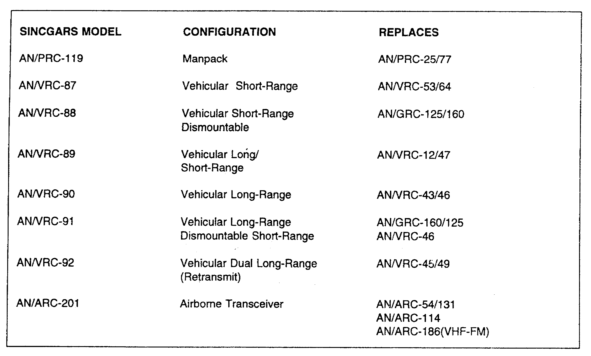

SS0073 2-16
4. CNR operations in the MSE signal brigade/battalion are conducted in six networks. These nets provide the signal commander a means to communicate C² information and engineering of signal assets. Companies operate their own command/engineering nets but may not have their own SENs and RAUs operating in the same net. SENs and RAUs operate in the net of the company operating the NS to which they are connected. Node management communications are always accomplished on the company command/engineering net of the company to which they are assigned operational control (OPCON). NS and LENs normally operate on their battalion's engineering net. The structure of radio nets in the corps and division signal battalion are shown in Figures 2-8 through 2-13.

PART D -THE ARMY DATA DISTRIBUTION SYSTEM

1. Enhanced Position Location Reporting System (EPLRS) is a system for data distribution on the battlefield. EPLRS is a computer-based communications system designed to provide secure jam-resistant, contention free, near real-time data transmission and distribution to subscribers. Additionally, EPLRS provides unit identification, navigational aids, and the automatic location reporting of tactical combat and CS forces. EPLRS uses integral dual level (CONFIDENTIAL/SECRET) cryptographic security with over-the-air rekeying (OTAR), frequency hopping, and error correction encoding as ECMI protection. An EPLRS community consists of a net control station-EPLRS (NCS-E) and up to 460 EPLRS user units (EPUU) operating on eight UHF frequencies from 420 to 450 megahertz (MHz).

a. Three host computer interfaces are available to connect data transfer devices to the EPUU. This allows direct information transfer from the sending computer to the receiving computer at data rates of up to 1.2 kb/s. These interfaces are—

- Standard interface X.25, most Army users and all new automated systems.

- Single-channel frequency shift keying (FSK), tactical fire direction system (TACFIRE), TPQ-36/37, automatic target hand off system.

- Data bus interface 1553, tracked vehicle, and aviation applications.

b. Division EPLRS architecture calls for 4 NCS-E and 12 EPLRS grid reference units (EGRU) to support a four EPLRS community array where each community covers a brigade-sized area. The NCS-E and grid reference units (GRUs) are division signal battalion assets.

2. Joint Tactical Information Distribution System (JTIDS) is an advanced radio system. It provides information distribution, position location, and identification capabilities in an integrated form for application to tactical military operations. The system distributes encrypted information at high rates and is resistant to jamming in a hostile electromagnetic environment. It can interconnect scattered sources and users of information. JTIDS also provides surface and airborne elements

2-17 SS0073
with a position location capability, within a common position reference grid, and a basic identification capability through the distribution of secure position and identity information.

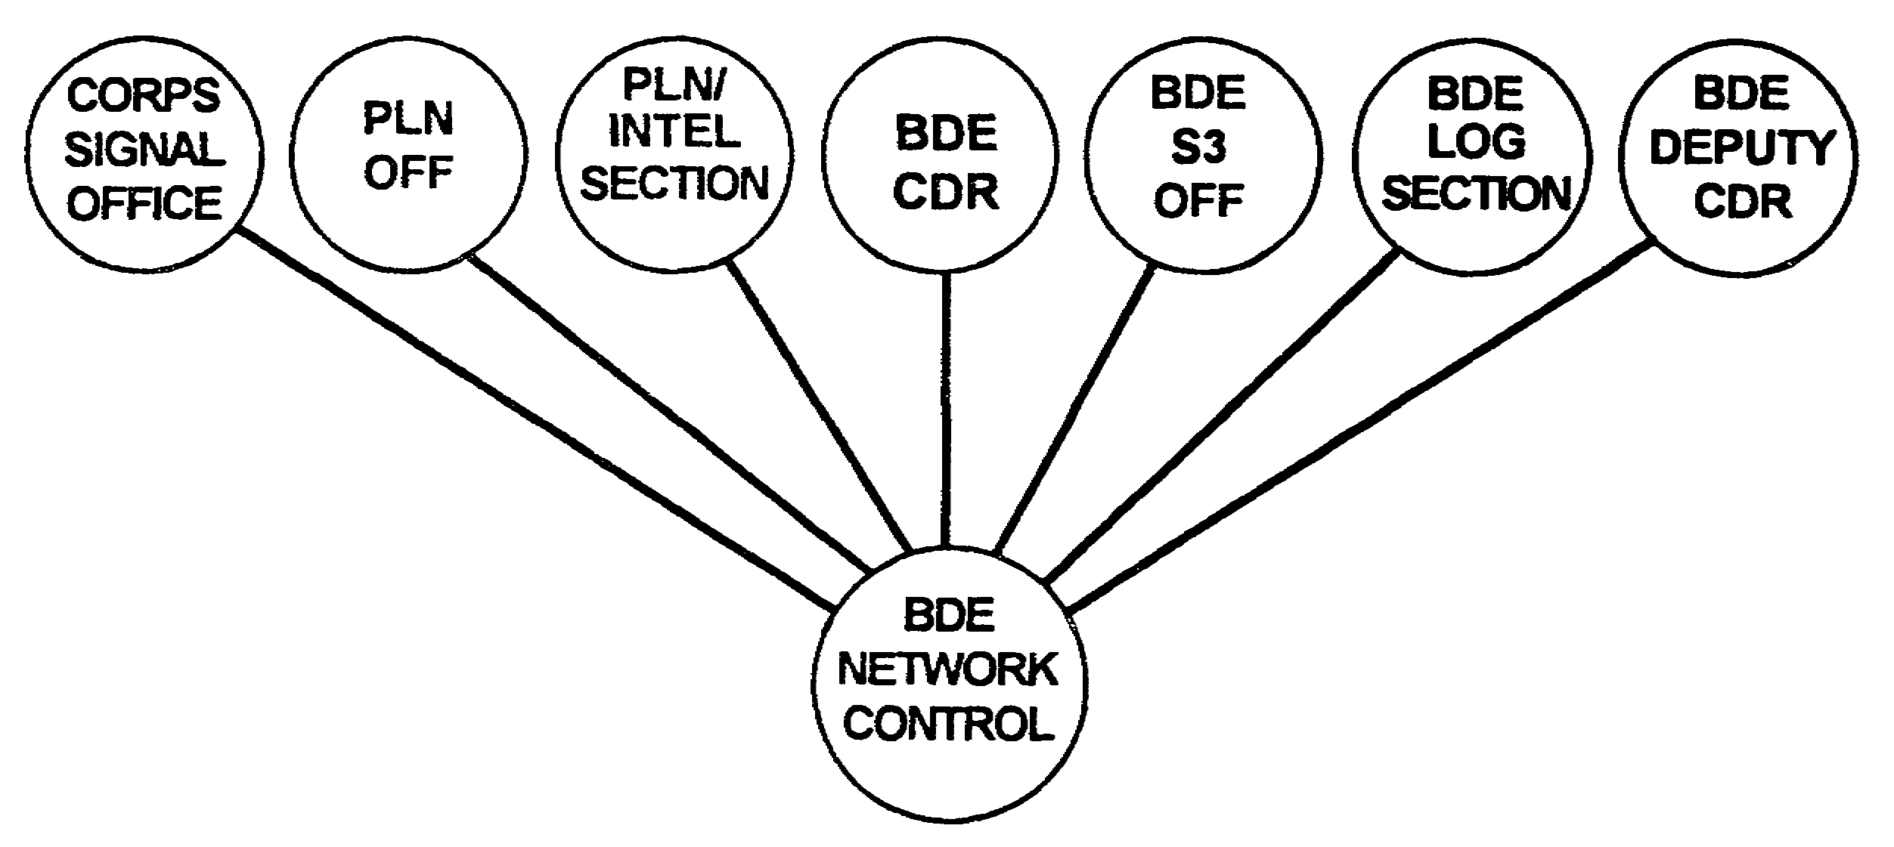

Figure 2-8. Corps signal brigade command/operations FM net.

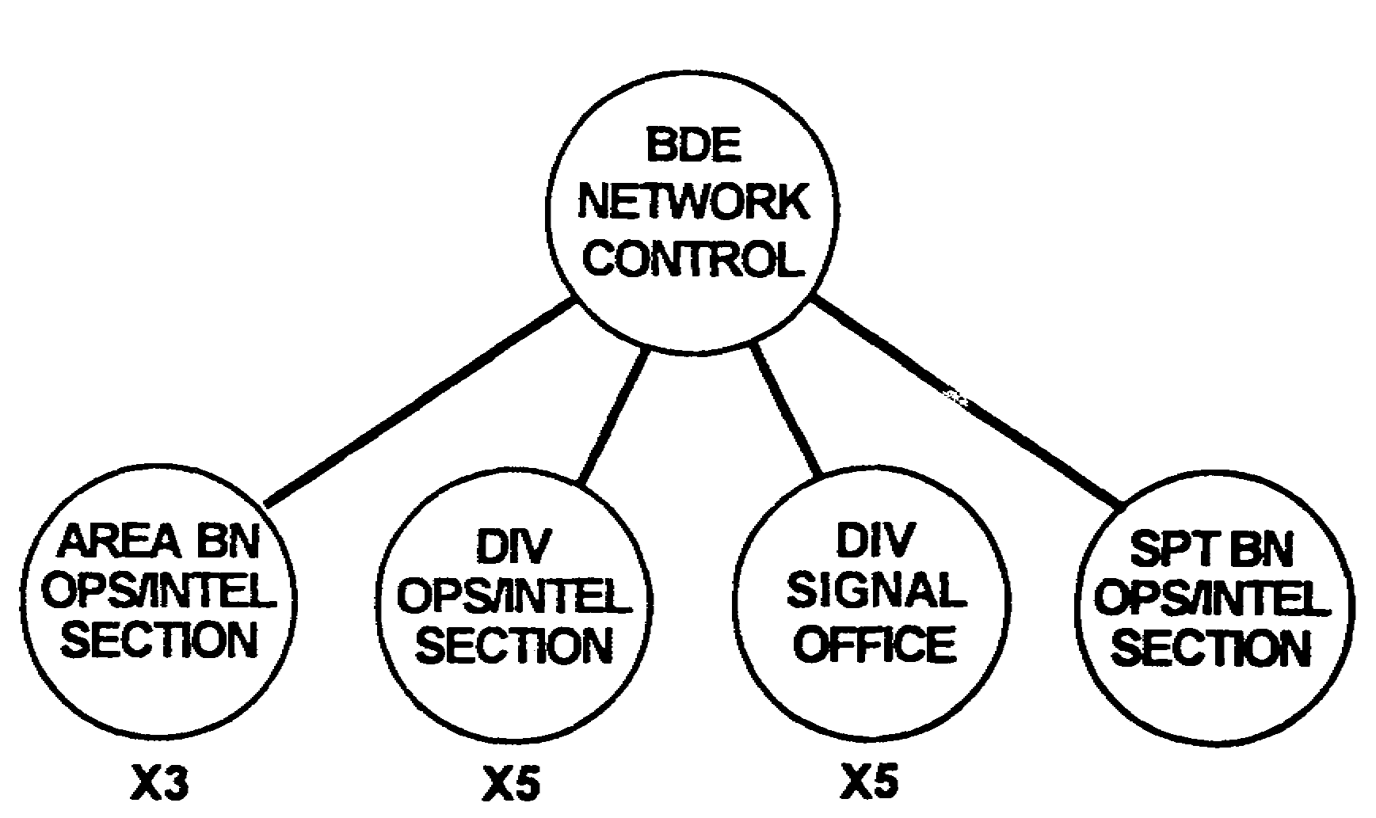

Figure 2-9. Corps signal brigade operations (HF) net.

SS0073 2-18
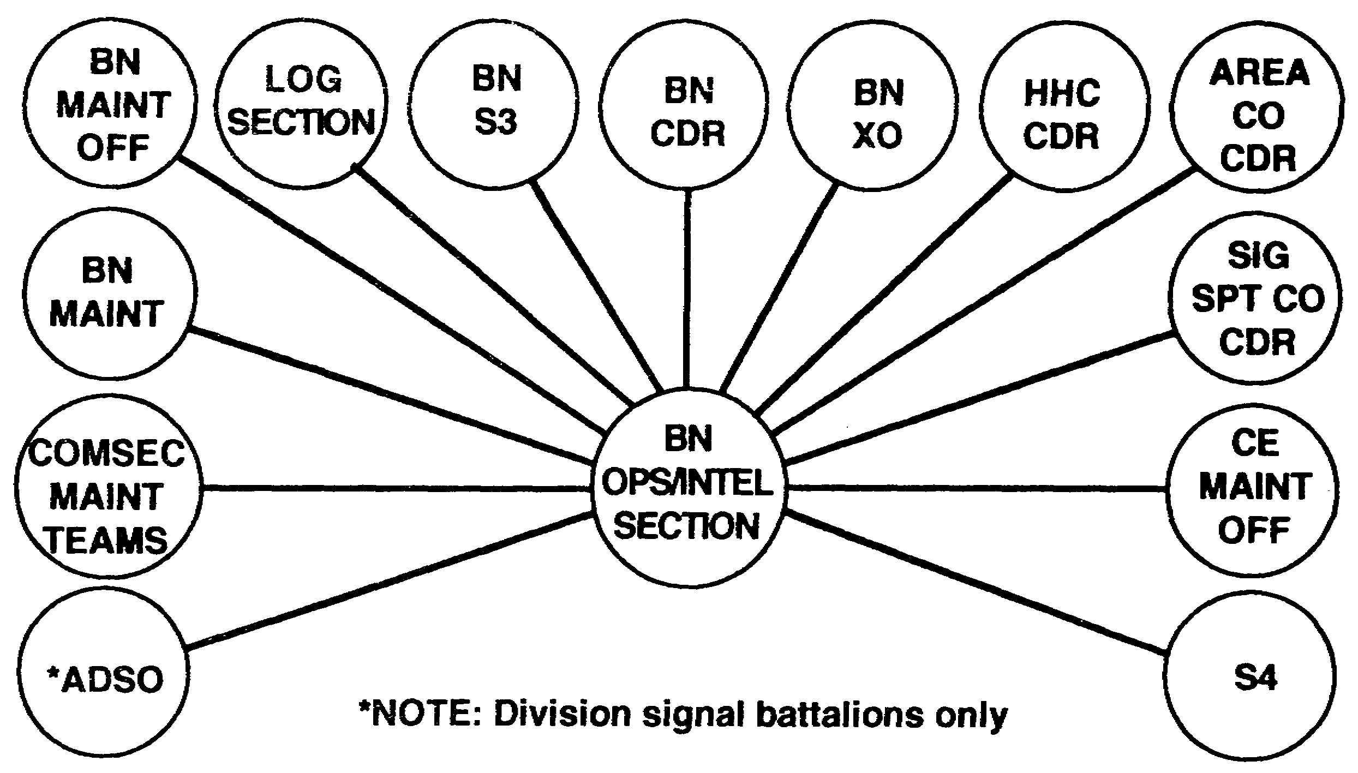

Figure 2-10. Corps and division MSE battalion
command/operations FM net.

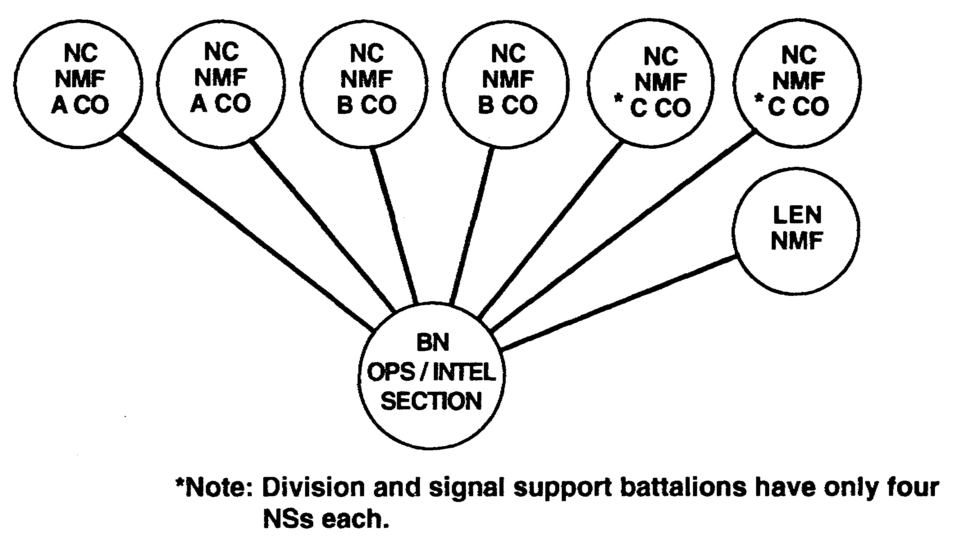

Figure 2-11. Corps and division MSE battalion's engineering net.

2-19 SS0073
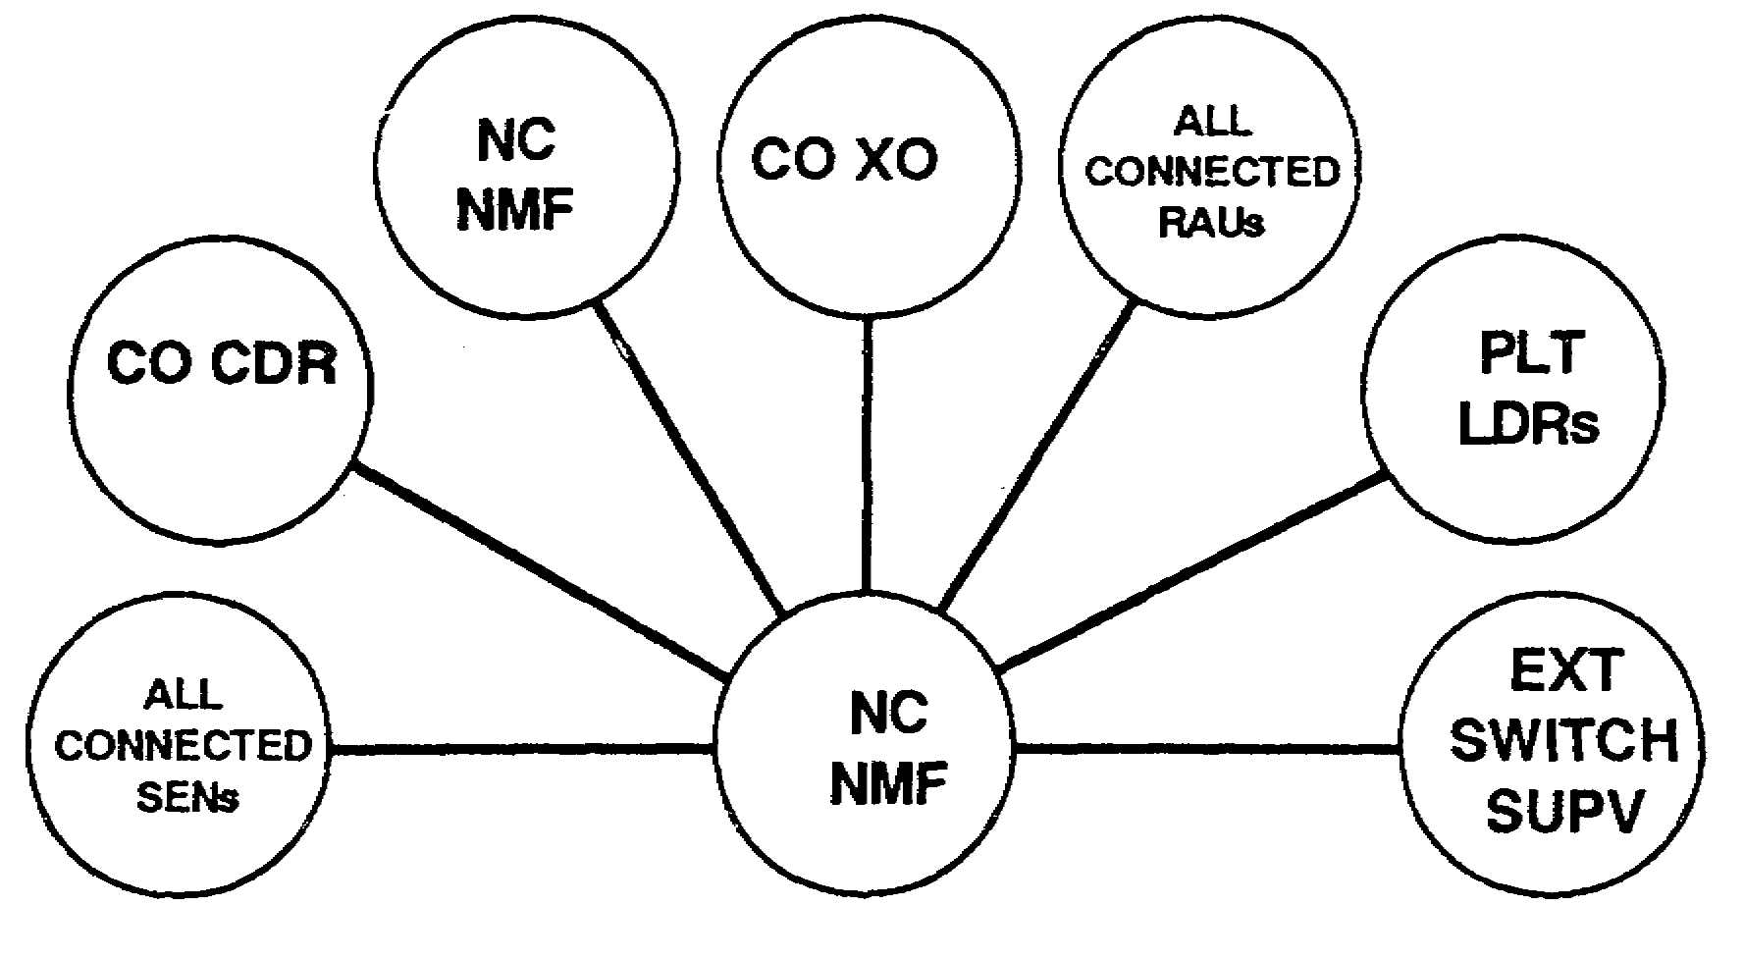

Figure 2-12. MSE company command/engineering net.

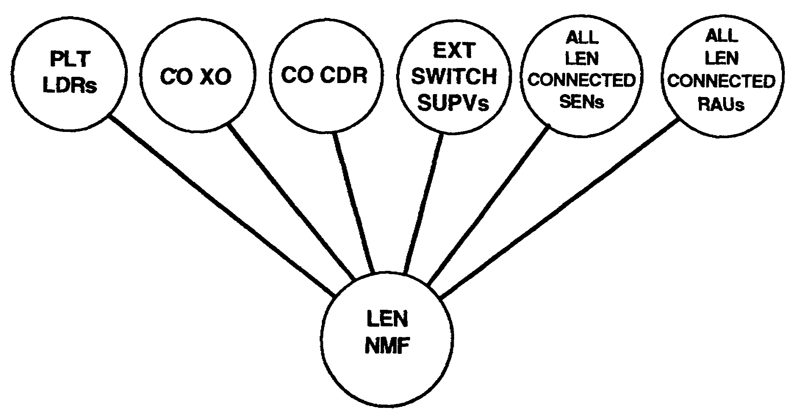

Figure 2-13. All MSE signal support companies command/engineering nets.

SS0073 2-20
3. The MSE packet network (MPN) is an ADDS using packet switching technology overlaid on the MSE area common-user voice network. With so many battlefield automated systems (BAS) within Army Operations and their immediate need for a viable, responsive means of transmission, MSE was given the mission. The MPN will consist of packet switch nodes (PSNs) in each SENs, LENs, and NS. The PSNs form a network dedicated to data traffic. The user connects his BAS to the PSN at his location and sends data traffic to other authorized systems. Gateways connect the corps network to adjacent corps and EAC. Current plans require the BAS to use X.25 (standard) and transmission control protocol/internet protocol (TCP/IP) to ensure compatibility between systems/networks. The MSE system dedicates four trunks between NCs, two trunks on each link to a LEN, and one trunk to each SEN for connectivity. This allows a 16 kb/s flow of data from the SENS and a 64 kb/s flow from LENSs and NCs.

PART E -BATTLEFIELD CONSIDERATIONS

1. Deep operations are hampered by maneuver, fires, or command, control, and communications countermeasures (C³CM). Complicated problems occur when the corps/division communications system must support a large maneuver unit with the mission of deep operations. Figure 2-14 shows a technique for extending MSE to provide C² for deep operations. MSE connectivity can be extended to the enclaves (islands of activity) through multichannel TACSAT, multichannel HF, TROPO, or host nation assets. There is an implied mission of enhanced site security in this scenario. Given the vulnerability of ISE sites to enemy action, communications redundancy becomes the key to success. TACSAT, HF, and FM must be included to complement MSE communications.

2. Close operations take place in the most lethal area of the battlefield. Because of the high potential for battle damage, signal planners must consider plans for renewal/recovery. MSE's flexibility and the SCC planning capability help signal leaders meet this challenge.

3. Rear operations present the signal leader with the most challenging problems within Army Operations. These challenges exist in the need to provide area and site defense. CPs and signal sites have a greater responsibility for site defense. This means that all signal leaders must be tactically and technically proficient. Signal soldiers must reflect this tactical excellence. When the rear CP is deployed separately within the corps or division area, rear support can be provided by using a SEN from corps or division assets. Force CS and CSS are coordinated using a combination of MSE (area), FM and HF CNR, and EPLRS (data).

4. MSE is only one part of a three-part force communications architecture. While corps and divisions require three types of tactical communications, MSE will carry the vast majority of the voice and data transmissions for these units to support C² and sustainment. MSE provides very limited support for corps and division deep operations. Its main contribution is to corps and division close and rear operations. With advice from the signal staff, the commander is responsible for using communications systems to best support his units. This support maximizes the unit's chances for mission success.

2-21 SS0073
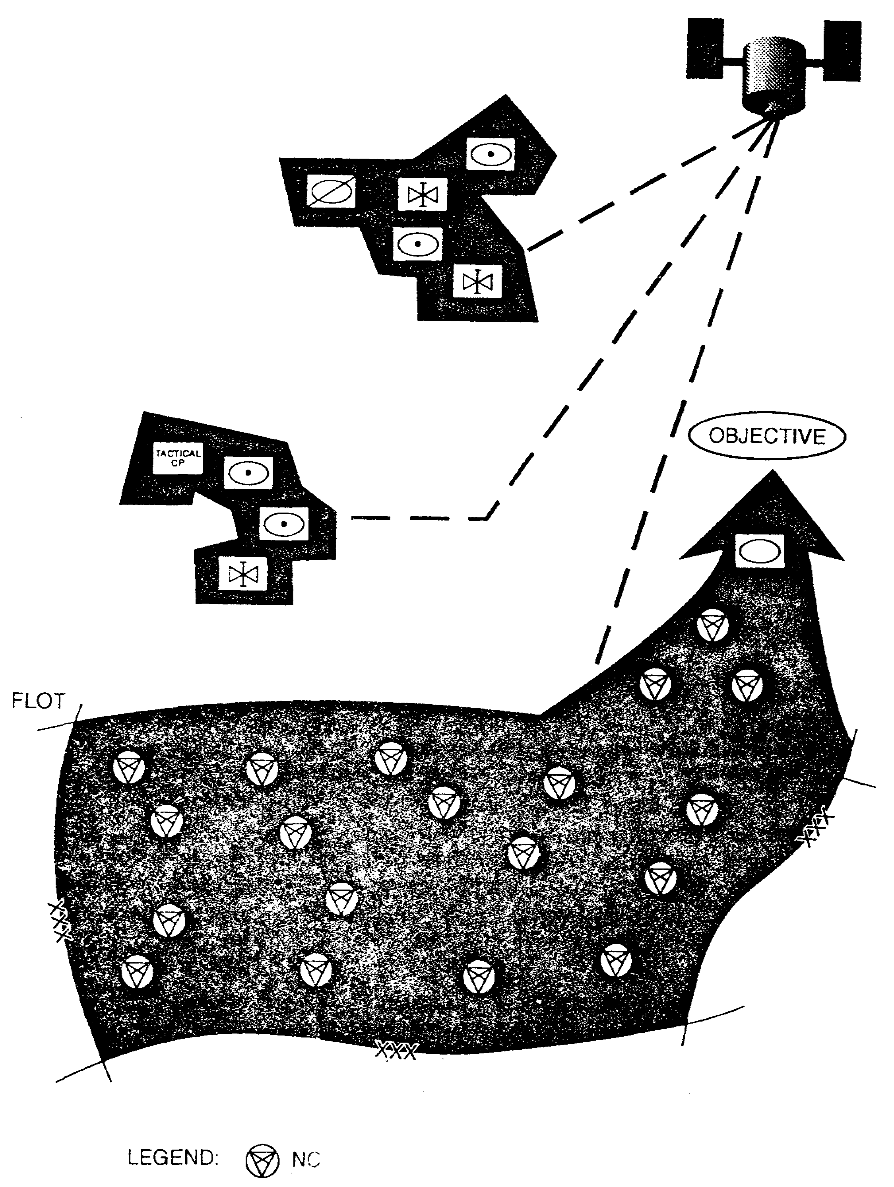

Figure 2-14. Extended MSE for C².

SS0073 2-22
LESSON 2

PRACTICE EXERCISE

The following items will test your grasp of the material covered in this lesson. There is only one correct answer for each item. When you complete the exercise, check your answers with the answer key that follows. If you answer any item incorrectly, study again that part of the lesson which contains the portion involved.

1. Name the five functional areas between which the ATCCS allows coordination.

2. What are the five disciplines of IMA?

3. What is the corps ACUS?

A. ADDS

B. CNR replaced by SINCGARS

C. ATCCS

D. MSE

4. A corps level SCC consists of how many shelters?

A. Two

B. Three

C. Four

D. Five

5. What is the frequency management tool used by SINCGARS?

A. OPFAC

B. NRI

C. BECS

D. EPLRS

SS0073 2-24
LESSON 2

PRACTICE EXERCISE

ANSWER KEY AND FEEDBACK

Item Correct Answer and Feedback

1. Maneuver, air defense, combat service support, intelligence and electronic warfare, and fire support. (page 2-3, Figure 2-2)

2. Automation, communications, visual information, records management, and printing and publications. (page 2-4, para 5)

3. D. MSE

MSE is the area common-user voice communications system in the corps. It is the backbone of the corps communications system and provides voice and data communications from the corps rear boundary forward to the division maneuver battalions' main CP and rear CP. (page 2-5, para 1)

4. B. Three

The corps SCC AN/TYQ-35(V2) consists of a technical shelter, management shelter, and planning shelter. (page 2-12, para e(l)(c))

5. C. BECS

The Battlefield Electronic CEOI System (BECS) is the frequency management tool for SINCGARS. (page 2-16, para 3)

2-25 SS0073
LESSON 3

CORPS SIGNAL BRIGADE STRUCTURE

Critical Task: S1-7113.04-0021

OVERVIEW

LESSON DESCRIPTION:

In this lesson, you will learn the composition of the corps signal brigade.

TERMINAL LEARNING OBJECTIVE:

ACTION: State the mission, organization, and the employment of the corps signal brigade and its subordinate units.

CONDITION: You will be provided this subcourse.

STANDARD: Demonstrate competency of task skills and knowledge by correctly responding to 70 percent of the multiple-choice test covering corps communications.

INTRODUCTION

MSE network provides corps area communications in an Army Operations environment. A corps network can support up to a five-division corps or a geographic area spanning 23,250 miles.

PART A -THE CORPS SIGNAL BRIGADE

1. The standard corps signal brigade is the center of the corps MSE network. It consists of a headquarters and headquarters company (HHC), three corps ASBs, and a corps support signal battalion. It provides system control of the corps area MSE network and provides technical control of the division signal battalion's installed components.

3-1 SS0073
(See Figure 3-1.) The airborne corps signal brigade is slightly different in terms of organization and equipment. (See Appendix C.) The advantages of this arrangement are—

- Greater operational flexibility.

- Increased logistic support efficiency.

- Easier personnel management.

- Centralized MSE assets control.

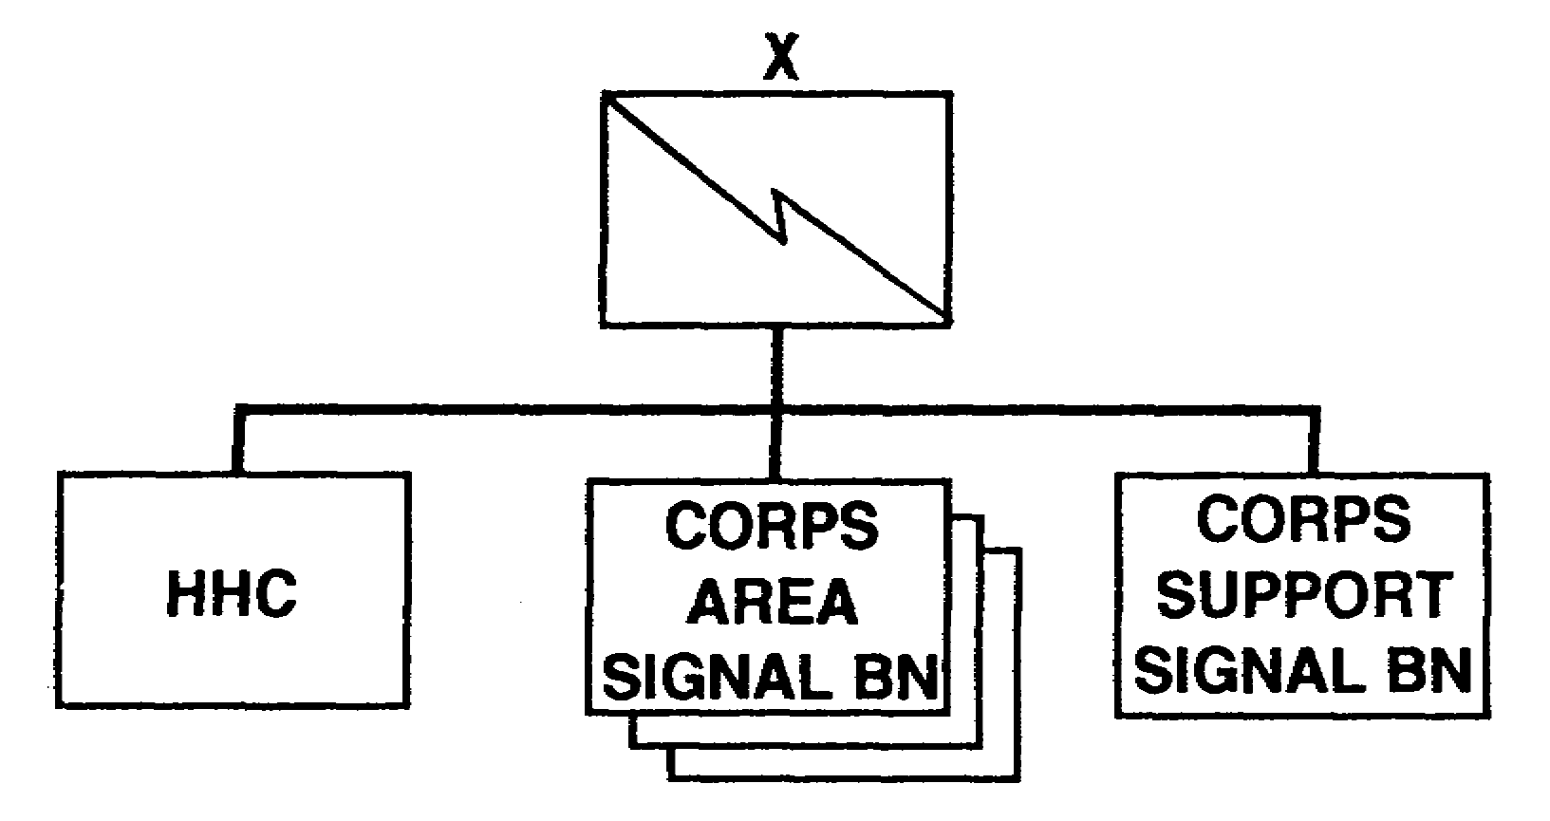

Figure 3-1. Corps signal brigade.

2. The HHC consists of the brigade headquarters, the headquarters company, and the corps signal office. (See Figure 3-2.) a. The brigade headquarters has a command section, administrative section, operations/intelligence section, and logistics section. The operations/intelligence section consists of the signal engineering branch, the network control branch, the plans/intelligence section, and the brigade communications security (COMSEC) office of record.

SS0073 3-2
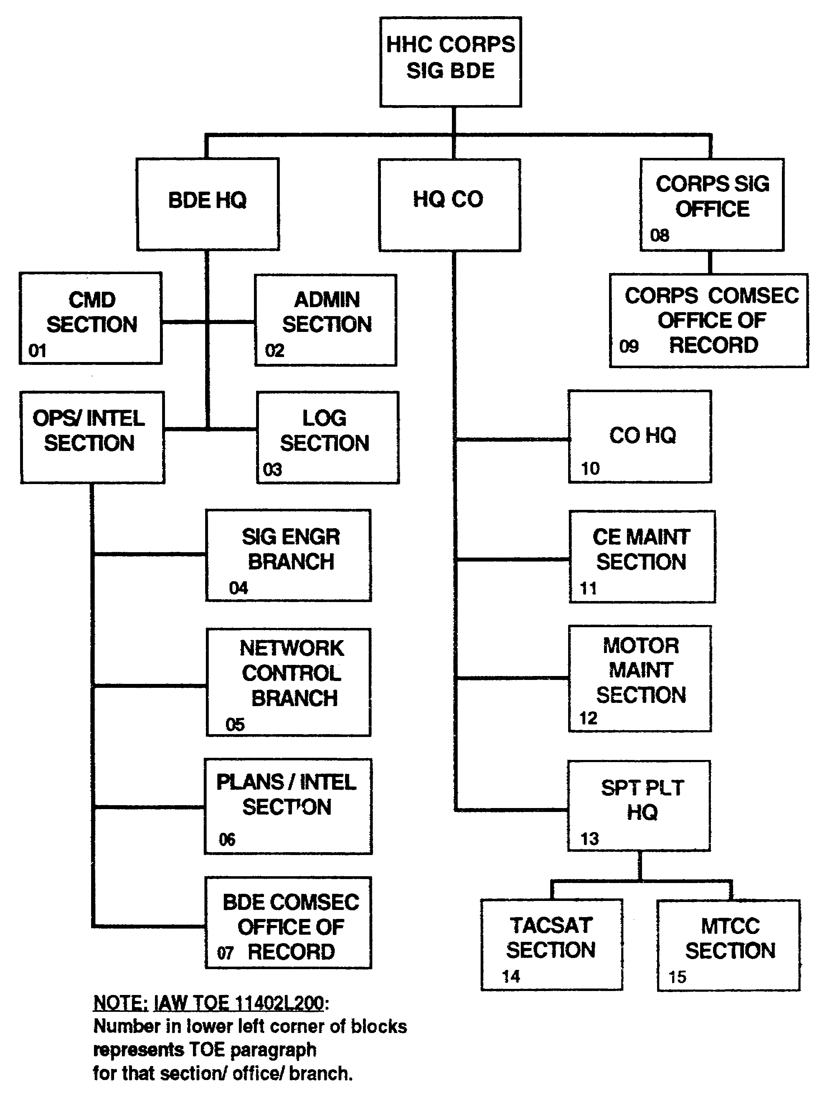

Figure 3-2. HHC corps signal brigade.

3-3 SS0073
(1) The network control branch concerns itself with the MSE network. This branch installs, operates, and maintains two SCCs, one primary and one alternate. The SCCs facilitate network management and control tasks with computer-assisted tools. These tools issue operational orders and directives to node managers, and receive and process return messages and reports from node managers. They also help in managing radio frequencies, COMSEC, equipment/personnel status reports, system activation/deactivation and reconfiguration including network radio links.

(2) The corps signal brigade manages and controls the MSE network when deployed in a corps area. The SCCs cannot operate alone, they must be physically linked by CX-11230/G cable to an NS. The ASB within the corps provides this NS. The SCC gains network access through the NS.

b. The HQ company has a company headquarters, communications-electronics (CE) maintenance section, and motor maintenance section. It also may contain TACSAT CTs. Terminal integration with MSE communications assets extends area coverage throughout the corps, to and from the divisions, and during special contingencies.

PART B -THE CORPS AREA SIGNAL BATTALION

The standard corps ASB consists of an HHC, three standard area signal companies that are identical in equipment and personnel at the corps and division level, and a signal support company. For the airborne corps ASB organization, see Appendix C. (See Figure 3-3.)

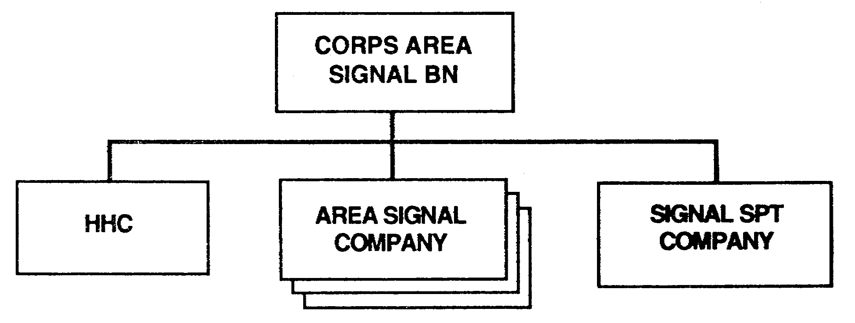

Figure 3-3. Corps ASB.

SS0073 3-4
a. The HHC consists of the battalion headquarters and a company headquarters. Battalion headquarters consists of a command section, administrative section, logistics section, operations/intelligence section, CE maintenance section, motor maintenance section, and a battalion COMSEC maintenance section. (See Figure 3-4.)

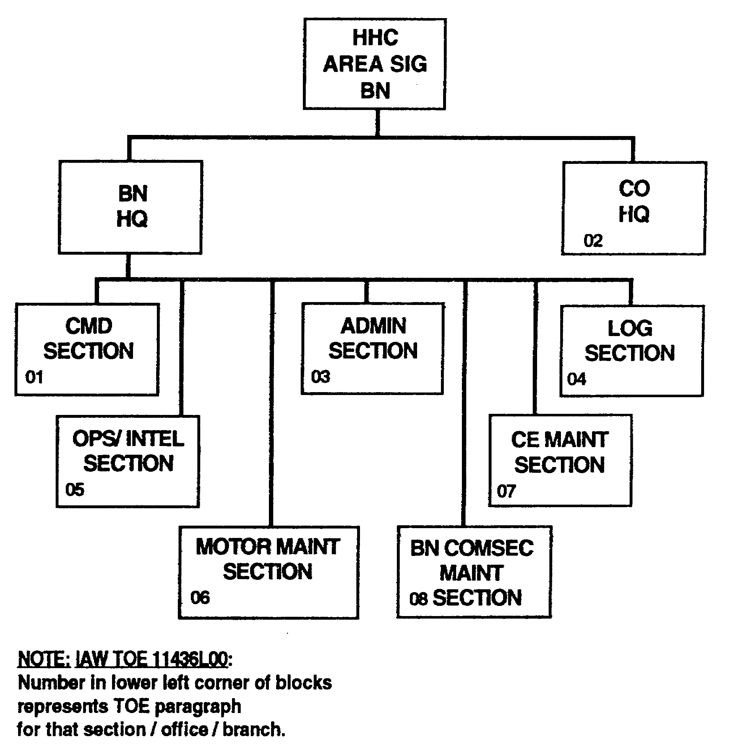

Figure 3-4. HHC corps ASB.

b. Each area signal company consists of a company headquarters and two nodal platoons. Each nodal platoon provides a management shelter and team in the platoon headquarters and has an NC section and extension switch section. (See Figure 3-5.)

3-5 SS0073
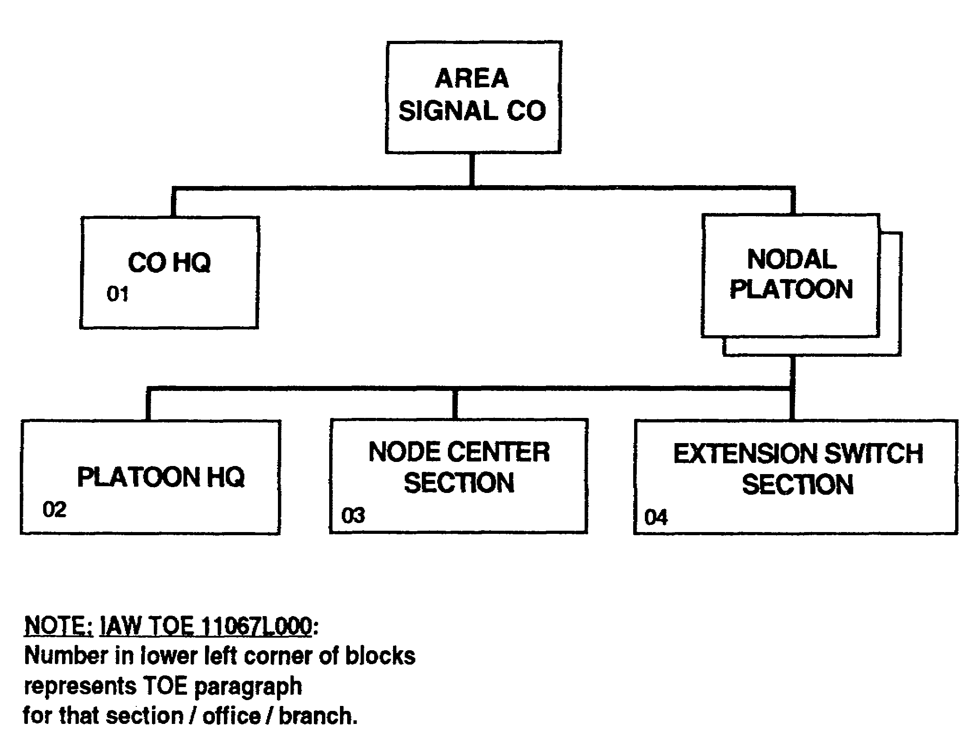

Figure 3-5. Area signal company.

(1) The NC section has seven teams. (See Figure 3-6.)

(a) One NS team consists of an operations facility, switching facility, and a support vehicle. The NS team installs all NS interconnecting cables.

(b) Four transmission system teams deploy four LOS AN/TRC-190(V3) assemblages to support the NS.

(c) One RAU (AN/TRC-191), considered a local RAU in this section, and appropriate personnel.

SS0073 3-6
(d) One wire system team lays out cable from the LOS assemblages and the RAU to the NS. The wire team also installs the CX-4566 26-pair cable and the J-1077 distribution boxes.

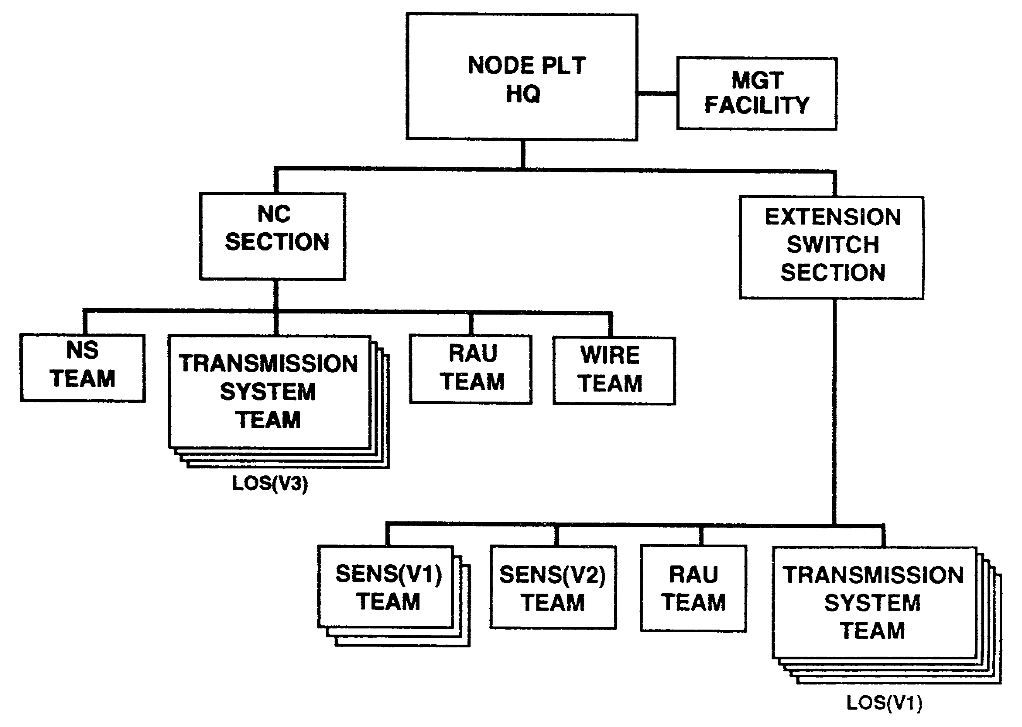

Figure 3-6. NC section and extension switch section.

(2) Extension switch section has 10 teams.

- Three SENS(V1) teams.

- One SENS(V2) team.

- One RAU team (usually deploys in a remote configuration).

- Five transmission system teams (deploy five LOS(V1) (AN/TRC-190(V1)) assemblages, one for each SENS and one for the RAU).

3-7 SS0073
c. Signal support companies differ in the authorized number of equipment and personnel. The signal support company in the corps ASB has a company headquarters, a large extension switch platoon, and an extension switch support platoon. (See Figure 3-7.) The large extension switch platoon has a large extension switch section and a cable/wire section. The extension switch support platoon has an extension switch support section and a cable/wire section. (See Figure 3-8.)

(1) The large extension switch section has 20 teams.

- One management shelter team.

- One LENS (AN/TTC-46) team.

- Eight SENS (AN/TTC-48) teams.

- One wire system team.

- Nine transmission system teams.

(a) The management shelter team provides a technical supervisory facility for the platoon command element.

(b) The LENS team consists of an operations facility, a switching facility, and a support vehicle.

(c) The SENS teams consist of six SENS(V1) s and two SENS(V2) s.

(d) The wire system team installs and maintains the CX-11230/G cables between the LENS and LOS radio shelters.

(e) Eight LOS(V1) assemblages and teams deploy with the SENS teams. One LOS(V4)(AN/TRC-190(V4)) assemblage and team provide connectivity between the LEN and two NCs.

(2) The cable/wire section has three cable/wire installation teams. These teams install the RMC TD-1234, CX-11230/G cables, CX-4566 26-pair cables, and J-1077 distribution boxes.

SS0073 3-8
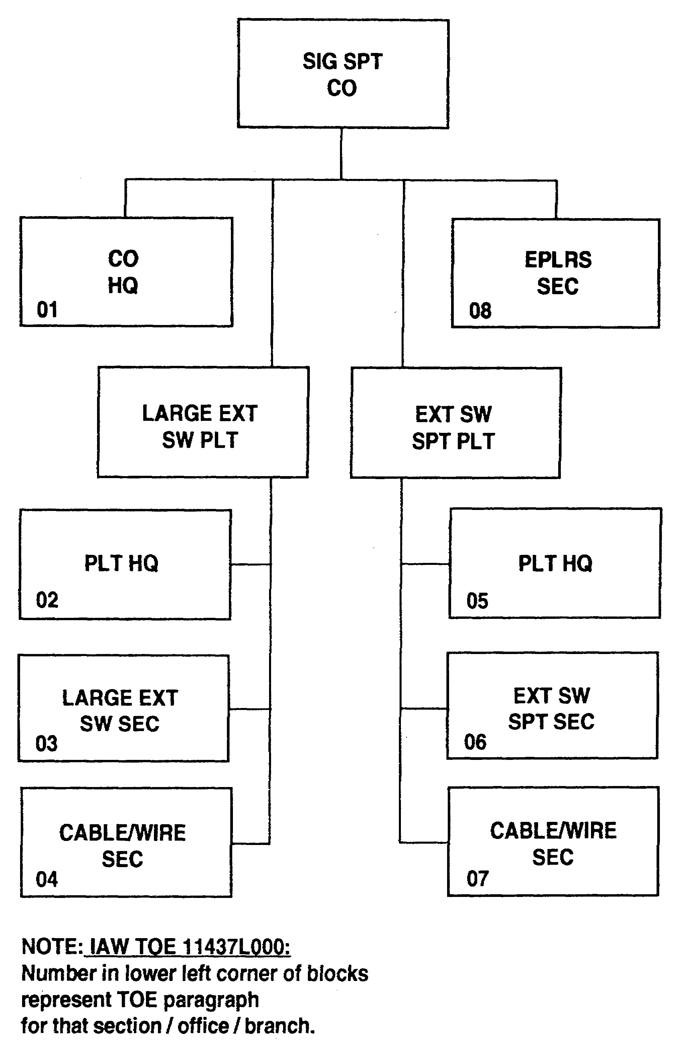

Figure 3-7. Corps ASB signal support company.

3-9 SS0073
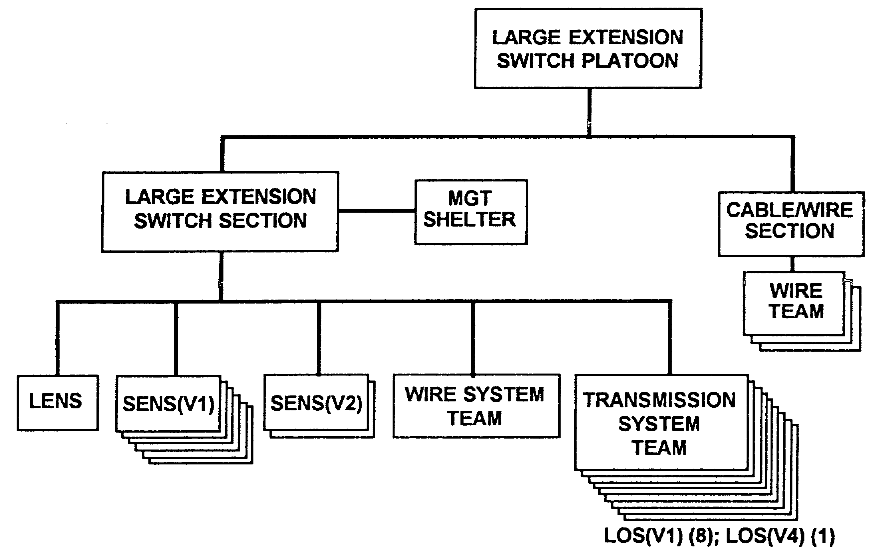

Figure 3-8. Large extension switch platoon.

d. The extension switch support platoon has an extension switch support section and a cable/wire section. It will expand to include an EPLRS section when fielded. (See Figure 3-9.)

(1) The extension switch support section has 19 teams.

- Eight SENS teams.

- One RAU team.

- Ten transmission system teams.

(a) The SENS teams have six SENS(V1) s and two SENS(V2) s.

(b) The RAU generally deploys as a remote RAU.

SS0073 3-10
(c) Eight LOS(V1) s support the small extension switches and one LOS(V1) supports the RAU. One LOS(V2)(AN/TRC-190) is available with two NATO analog interface (NAI) converters CV-4002.

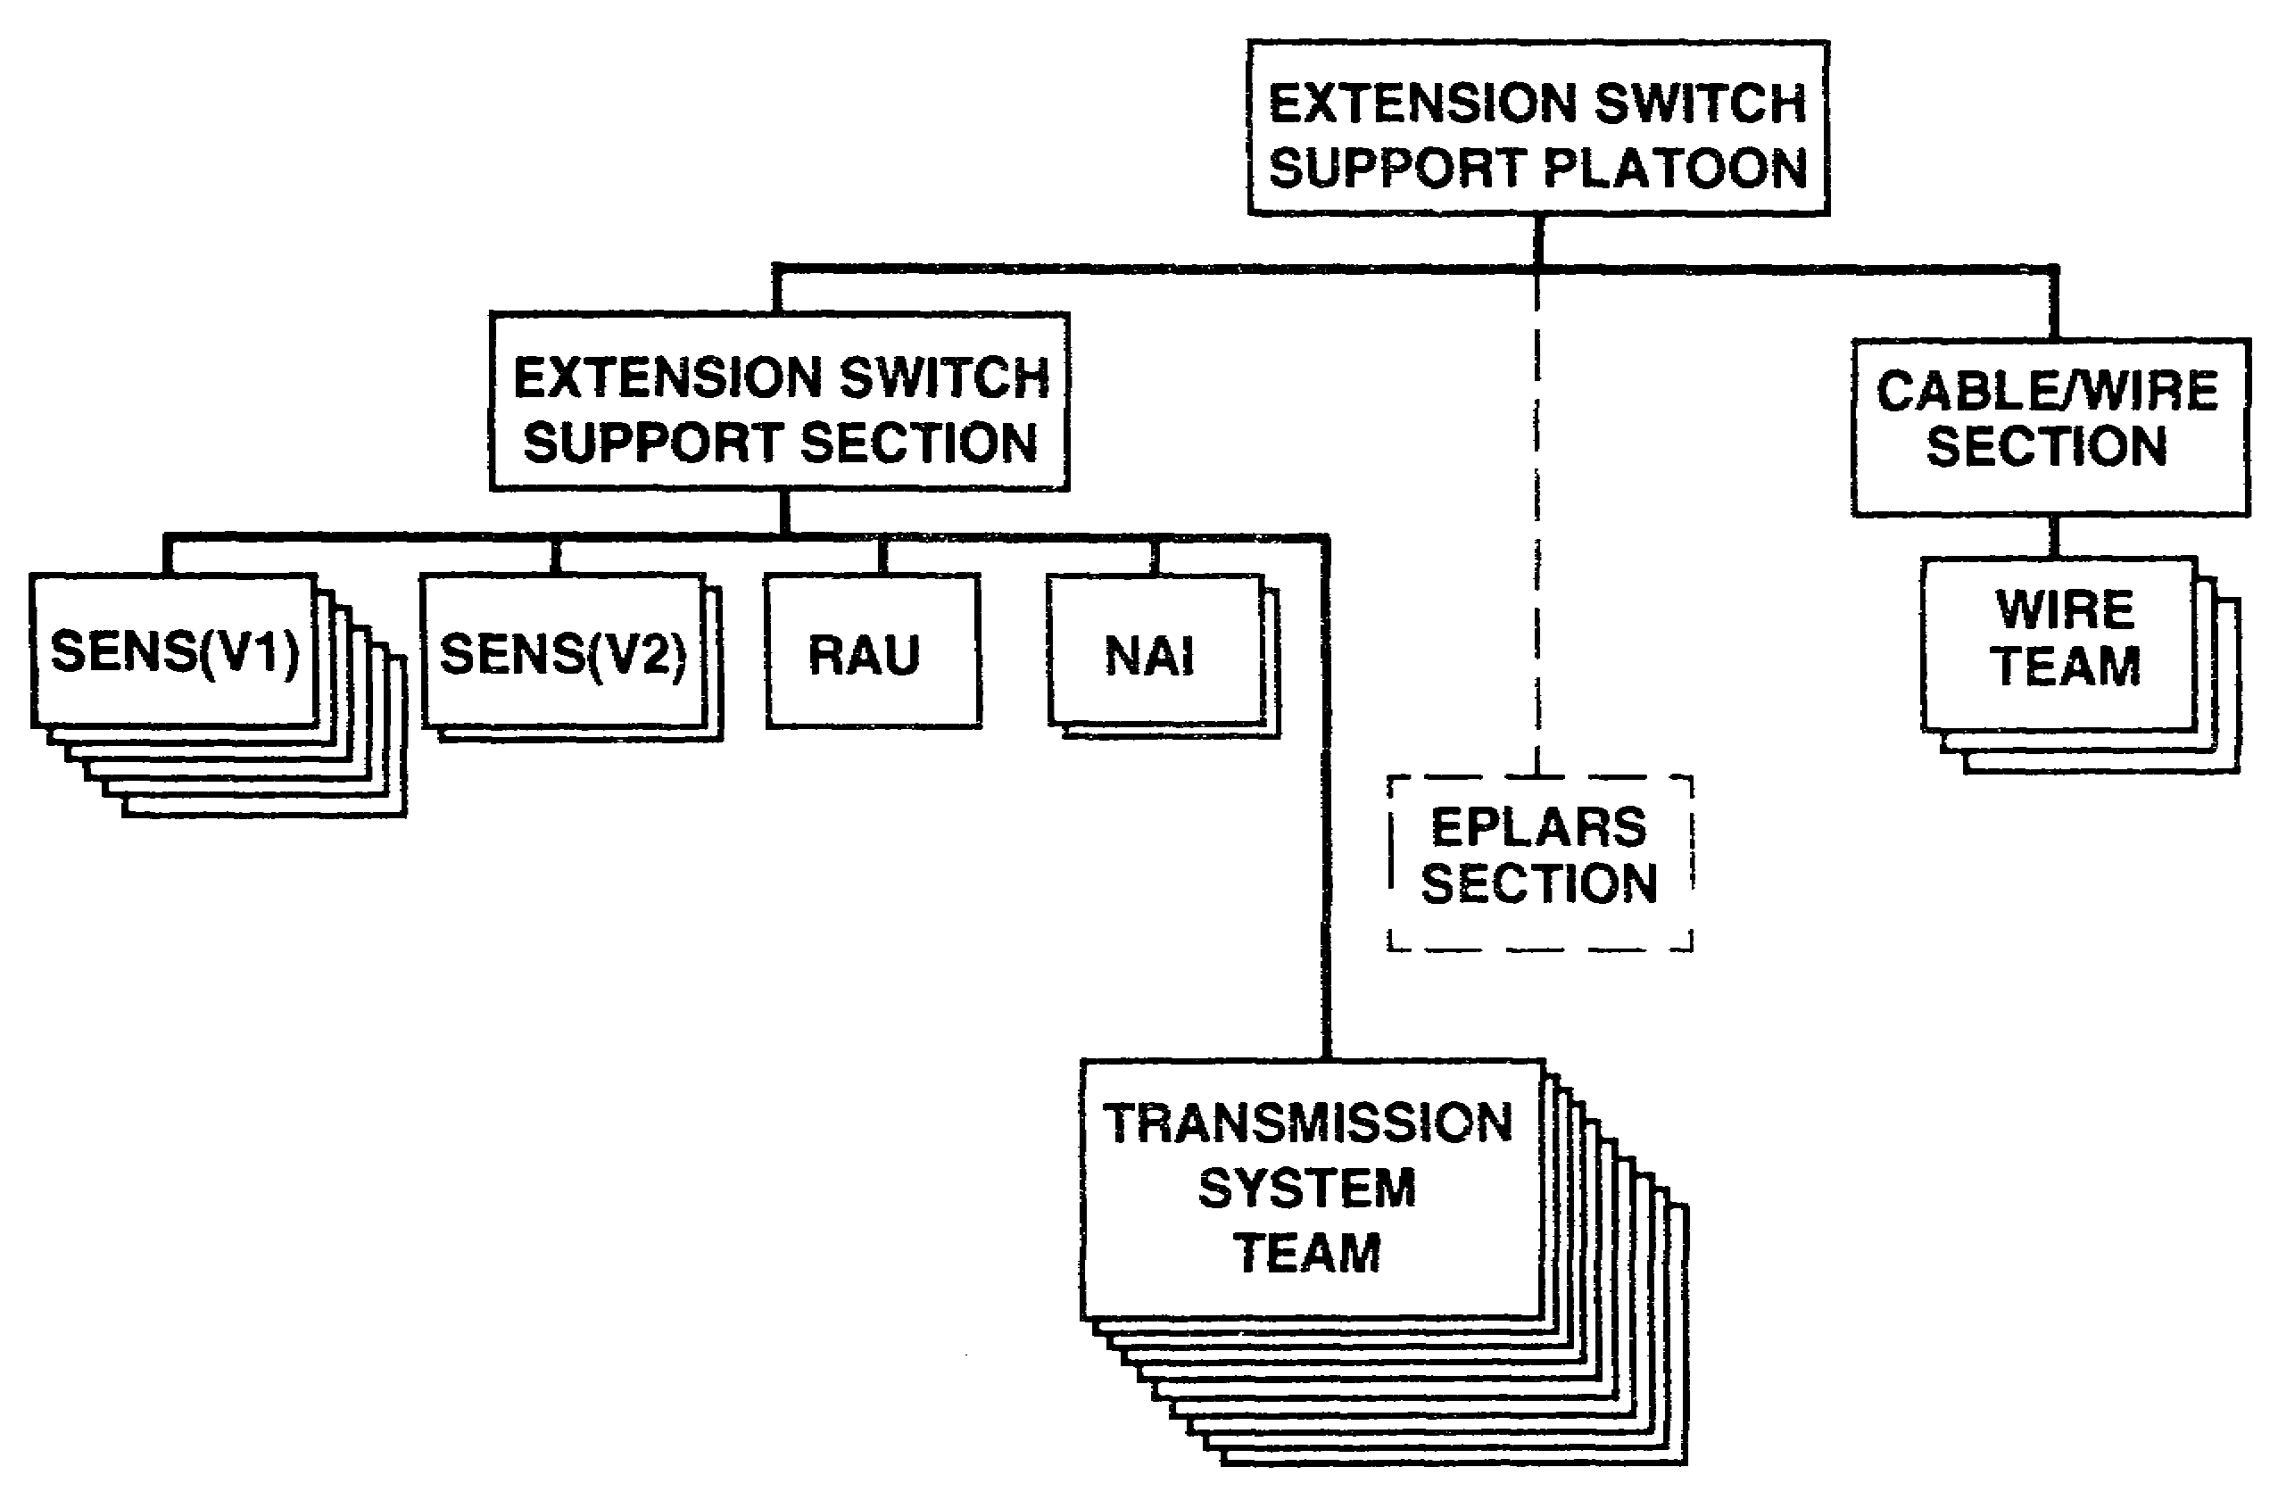

Figure 3-9. Extension switch support platoon.

(2) Cable/wire section has three cable/wire installation teams. They install the CX-11230/G cables, CX-4566 26-pair cables, and J-1077 distribution boxes.

PART C -THE CORPS SUPPORT SIGNAL BATTALION

1. In addition to the three ASBs, the corps signal brigade has a corps support signal battalion. (See Figure 3-10.) This battalion has an HHC, two area signal companies, and a signal support company.

3-11 SS0073
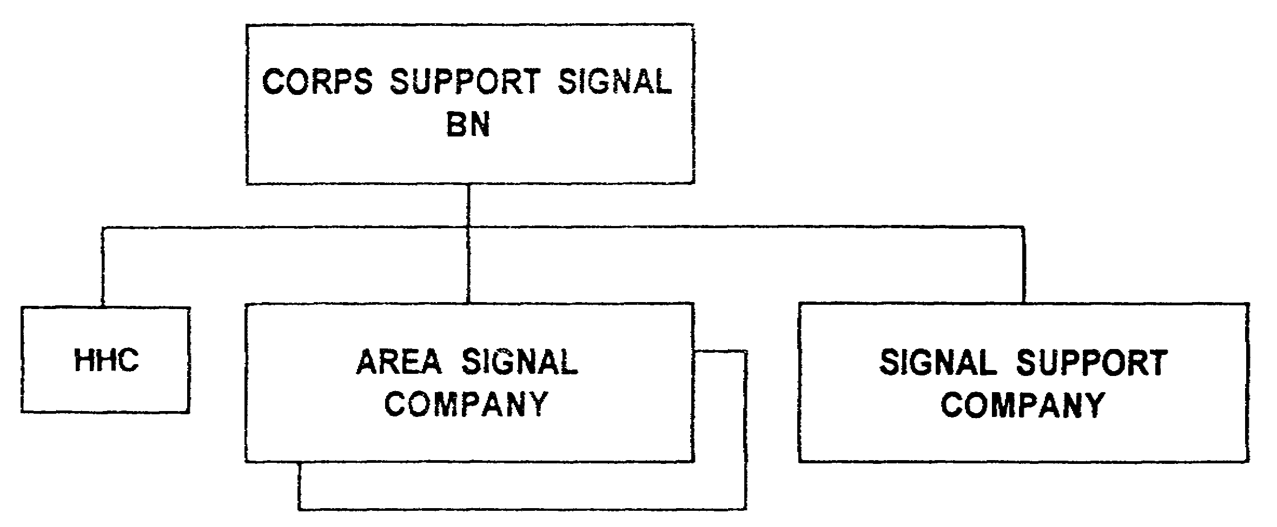

Figure 3-10. Corps support signal battalion.

a. The HHC consists of a battalion headquarters and a company headquarters. (See Figure 3-11.) The battalion headquarters consists of a command section, administrative section, logistics section, operations/intelligence section, CE maintenance section, motor maintenance section, and a battalion COMSEC maintenance section. The corps support signal battalion provides communications throughout the corps area of operations through the efforts of the area signal companies.

NOTE: All area signal companies are identical throughout the corps and division regardless of battalions they are assigned to.

SS0073 3-12
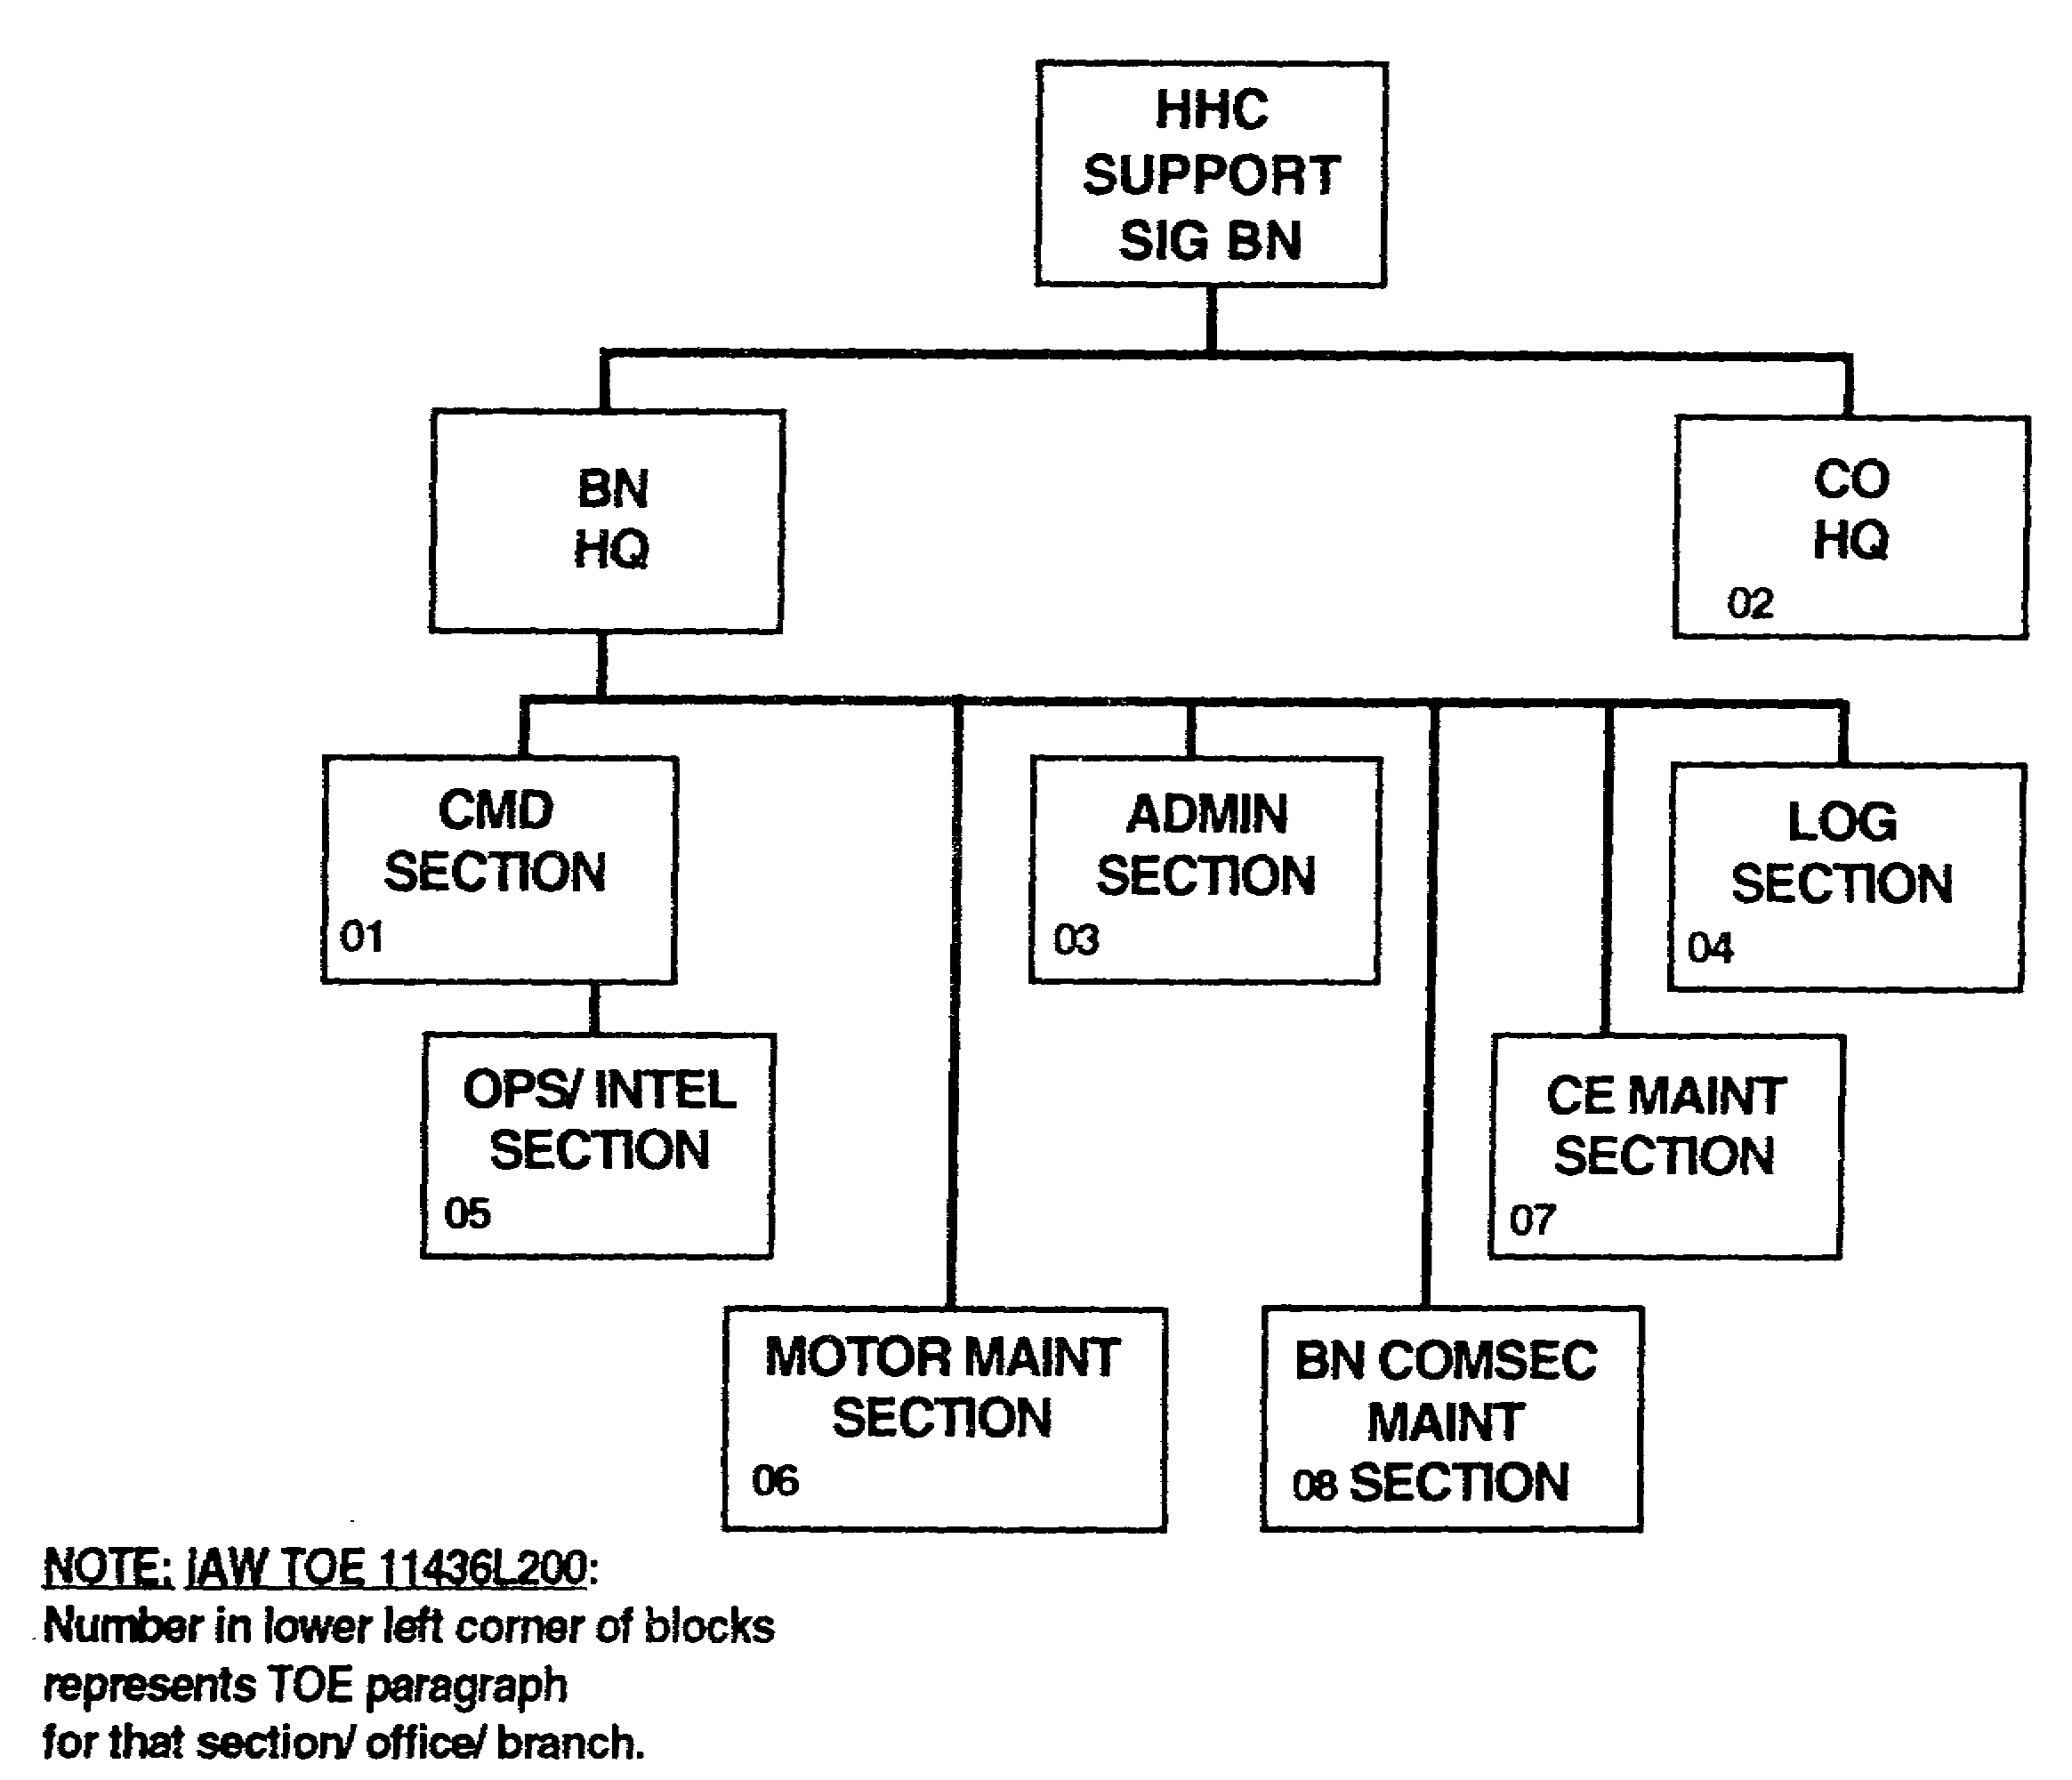

Figure 3-11. HHC support signal battalion.

b. The signal support company has a large extension switch platoon and an extension switch support platoon. The structure and capabilities of these platoons are similar to those of the ASB support company's. The large extension switch platoon has a large extension switch section and two cable/wire sections. The management facility provides a technical supervisory facility for the platoon command element. (See Figures 3-12 and 3-13.)

3-13 SS0073
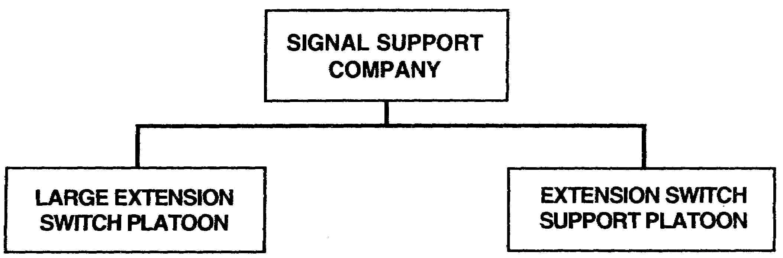

Figure 3-12. Signal support company.

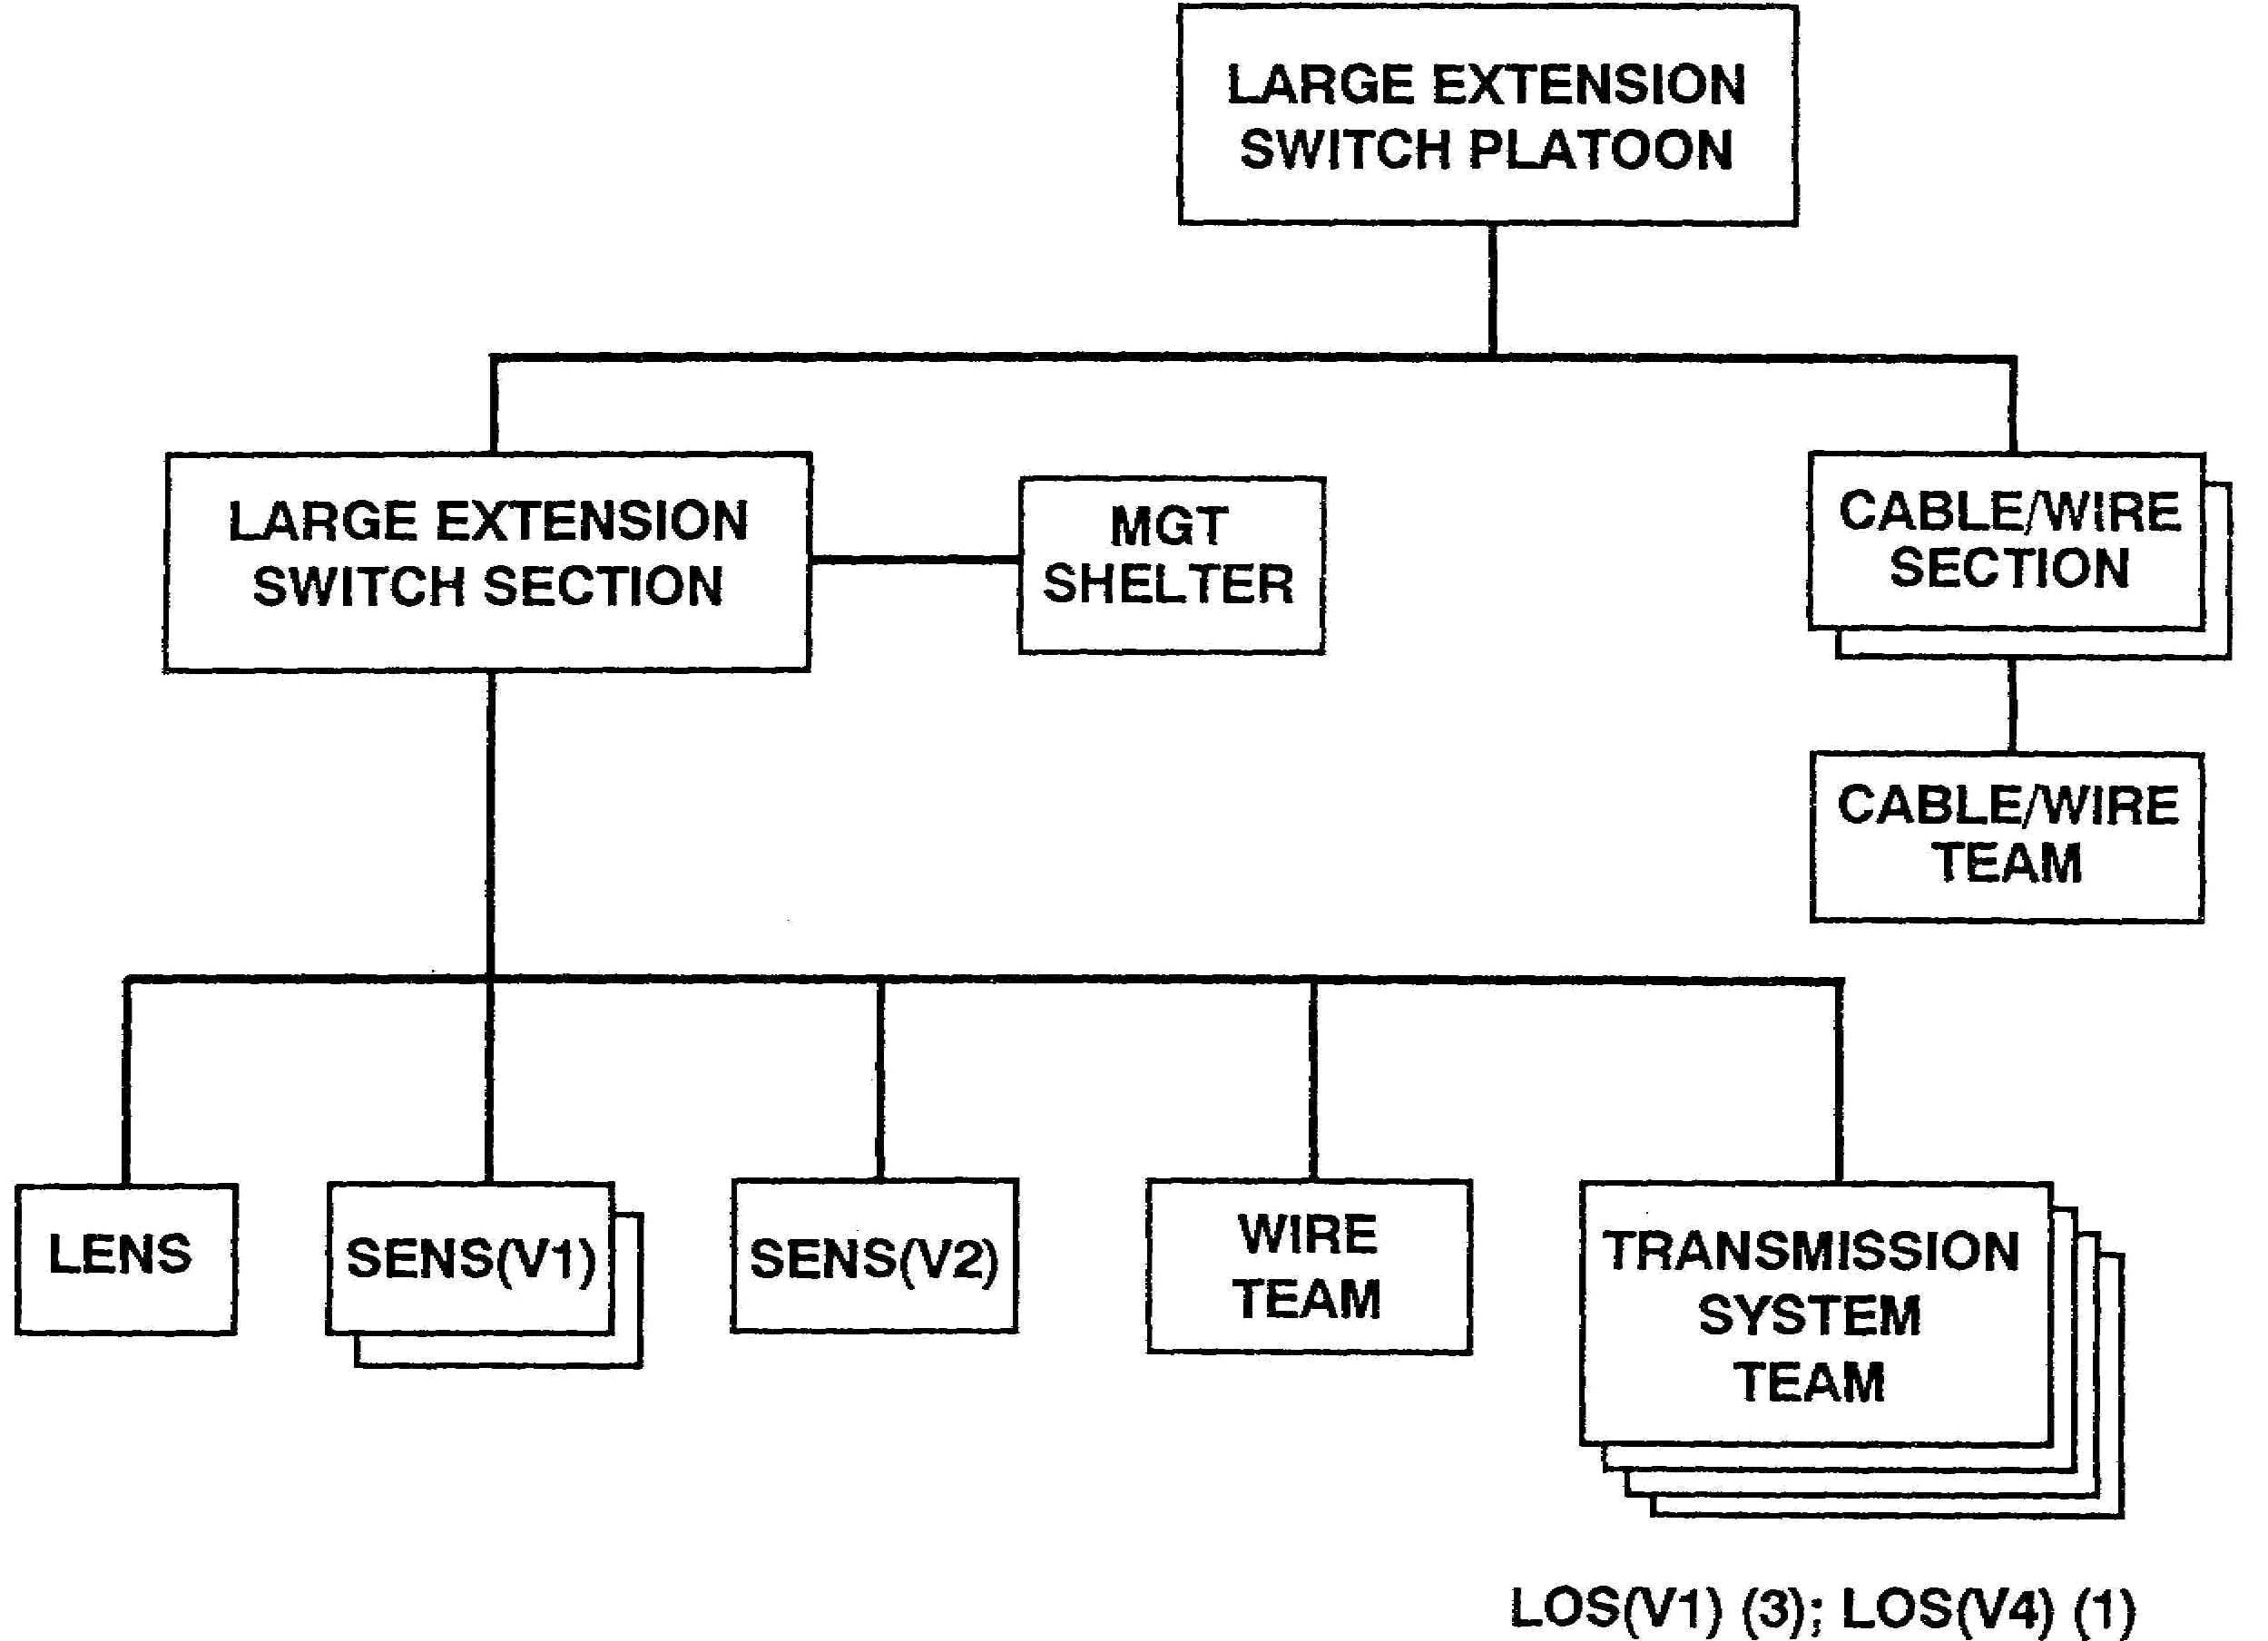

Figure 3-13. Large extension switch platoon.

SS0073 3-14
(1) The large extension switch section has nine teams.

- One LENS team.

- Three SENS teams.

- · One wire team.

- Four transmission system teams.

(a) The LENS team consists of the switching and operations shelters and a support vehicle.

(b) The SENS teams consist of two SENS(V1) s and one SENS(V2).

(c) The wire team deploys the CX-11230/G cables between the LENS and the LOS radio shelters.

(d) Three LOS(V1) s deploy with the SENS and one LOS(V4) deploys with the LENS.

(2) Each cable/wire section has a cable/wire installation team. These teams install the RMCs, CX-11230/G cables, CX-4566 26-pair cables, and J-1077 distribution boxes.

(3) The extension switch support platoon has an extension switch support section and two cable/wire sections. (See Figure 3-14.)

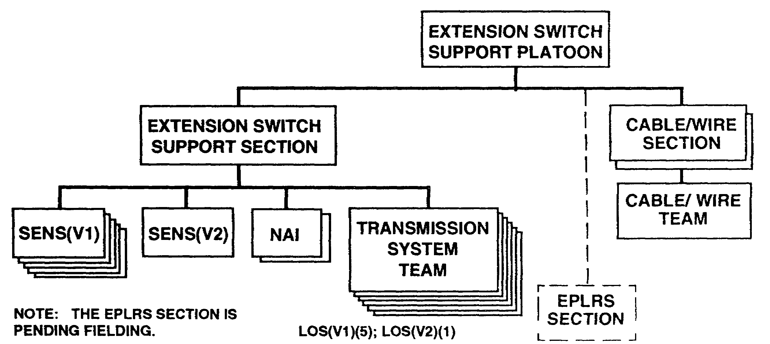

Figure 3-14. Extension switch support platoon.

3-15 SS0073
(a) Each extension switch support section has 11 teams:

- Five SENS teams (consist of four SENS(Vl) s and one SENS(V2)).

- Six transmission system teams (five LOS(Vl) s deploy to support the SENS and one LOS(V2) deploys with the NAI converters).

(b) The two cable/wire sections have a cable/wire installation team. They install CX-11230/G cables, CX-4566 26-pair cables, and J-1077 distribution boxes.

(c) EPLRS section will become an integral member of the extension switch support platoon when fielded.

SS0073 3-16
LESSON 3

PRACTICE EXERCISE

The following items will test your grasp of the material covered in this lesson. There is only one correct answer for each item. When you complete the exercise, check your answers with the answer key that follows. If you answer any item incorrectly, study again that part of the lesson which contains the portion involved.

1. A standard corps signal brigade consists of an HHC and how many battalions?

A. Three

B. Four

C. Five

D. Six

2. Which company is standard throughout all MSE battalions?

A. HHC

B. Area signal company

C. Signal support company

3. How many node centers are within an area signal company?

A. One

B. Two

C. Three

D. Four

4. How many transmission system teams of the NC section support the NS?

A. One

B. Two

C. Three

D. Four

SS0073 3-18
5. The standard corps ASB consists of how many area signal companies?

A. One

B. Two

C. Three

D. Four

3-19 SS0073
LESSON 3

PRACTICE EXERCISE

ANSWER KEY AND FEEDBACK

Item Correct Answer and Feedback

1. B. Four

The standard corps signal brigade is the center of the corps MSE network. It consists of a headquarters and headquarters company (HHC), three corps ASBs, and a corps support signal battalion. (page 3-1, para 1)

2. B. Area signal company

NOTE: All area signal companies are identical throughout the corps and division regardless of battalions they are assigned to. (page 3-12, NOTE)

3. B. Two

Each area signal company consists of a company headquarters and two nodal platoons. (page 3-5, para b)

4. D. Four

Four transmission system teams deploy four LOS AN/TRC-190(V3) assemblages to support the NS. (page 3-6, para (1)(b))

5. C. Three

The standard corps ASB consists of an HHC, three standard area signal companies that are identical in equipment and personnel at the corps and division level, and a signal support company (Part B, page 3-4).

SS0073 3-20
LESSON 4

COMMAND AND CONTROL OF THE CORPS SIGNAL BRIGADE

Critical Task: S1-7113.04-0021

OVERVIEW

LESSON DESCRIPTION:

In this lesson, you will learn the composition of the corps signal brigade staff organizations and the elements that provide C² within the signal brigade.

TERMINAL LEARNING OBJECTIVE:

ACTION: Identify and describe the elements of the corps signal brigade that provides C².

CONDITION: You will be provided this subcourse.

STANDARD: Demonstrate competency of task skills and knowledge by correctly responding to 70 percent of the multiple-choice test covering corps communications.

INTRODUCTION

The corps commander's communication needs are met through the organization of the signal brigade into mission-oriented communications packages, such as NCs, LENS, SENs, RAUs, and respective LOSs. Current tables(s) of organization and equipment (TOEs) directly support the mission-oriented package structure. Using these packages/teams requires proper planning and direction by the corps signal brigade C². The corps signal brigade commander and his staff are responsible for issuing directions from the corps SCC to these teams.

PART A - THE CORPS SIGNAL BRIGADE COMMANDER AND STAFF

1. The corps signal brigade commander fulfills a dual-hat role as corps signal brigade commander and as corps signal staff officer (a member of the special staff of the corps headquarters). (See Figure 4-1.)

4-1 SS0073
a. The corps signal brigade commander—

- Commands, directs, and supervises the corps signal brigade.

- Directs the IOM of the corps communications systems and facilities required to implement plans developed by the corps signal staff and to support unit communications requirements.

- Advises the corps commander on all communications matters.

- Supervises corps signal communications use.

- Coordinates corps subordinate units and allied services/forces integration with the total corps communications system.

b. The corps signal staff officer-* Ensures adequate and continuous area coverage throughout the corps area.

- Provides additional nodal assets when expansion is required.

- Coordinates with the G1, G2, G3, and G4 in the same manner as the division signal officer.

2. The corps signal brigade staff provides guidance for corps communications network implementation. Staff sections are organized to plan and implement communications network design, OPCON, and administrative and logistics direction. The staff uses the corps communications plan taskings to develop the communications network. Active monitoring of the network's operational status ensures that it meets the corps' changing requirements. (See Figures 4-2 and 4-3.) These responsibilities belong to the operations/intelligence section, in the brigade HQ, which consists of four staff elements and personnel:

- Corps signal engineering branch.

- Network control branch.

- Plans/intelligence section.

- Brigade COMSEC office of record.

SS0073 4-2
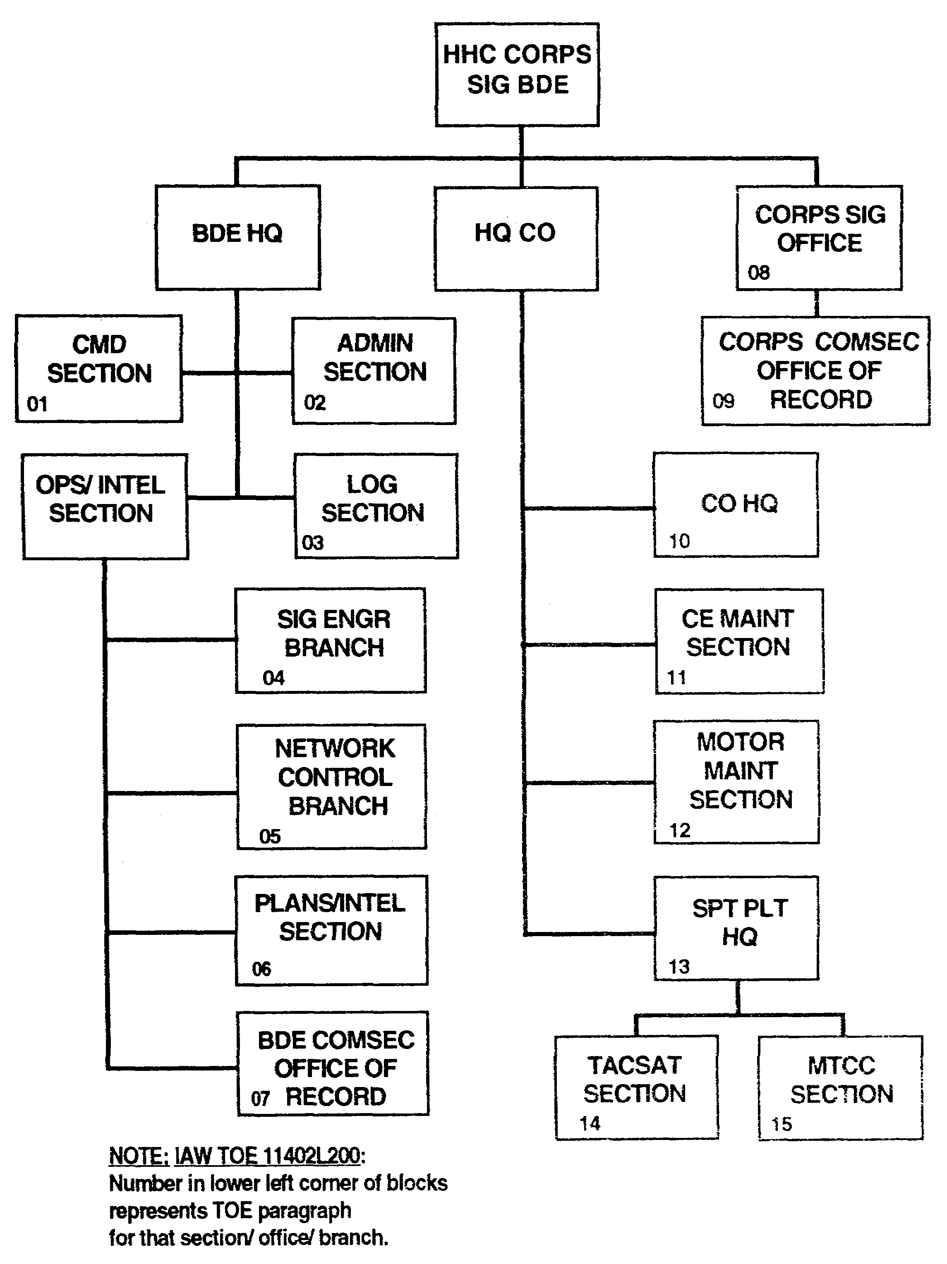

Figure 4-1. HHC corps signal brigade.

4-3 SS0073
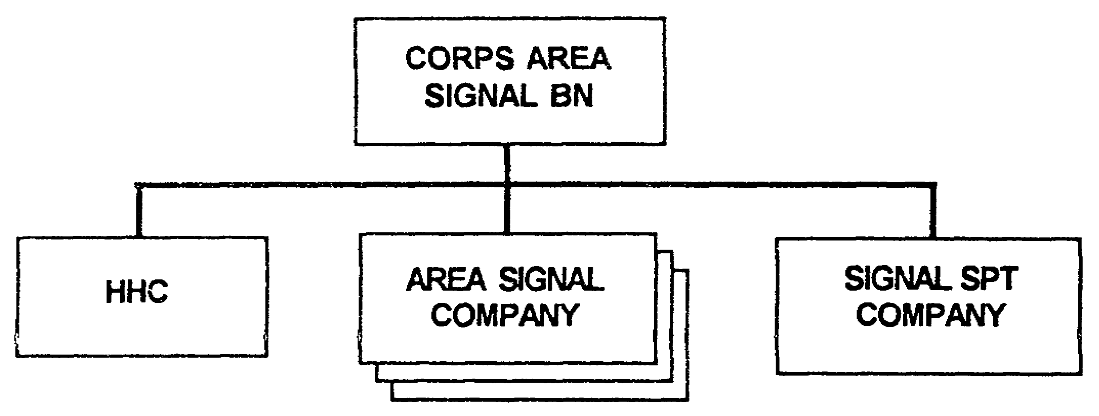

Figure 4-2. Corps ASB.

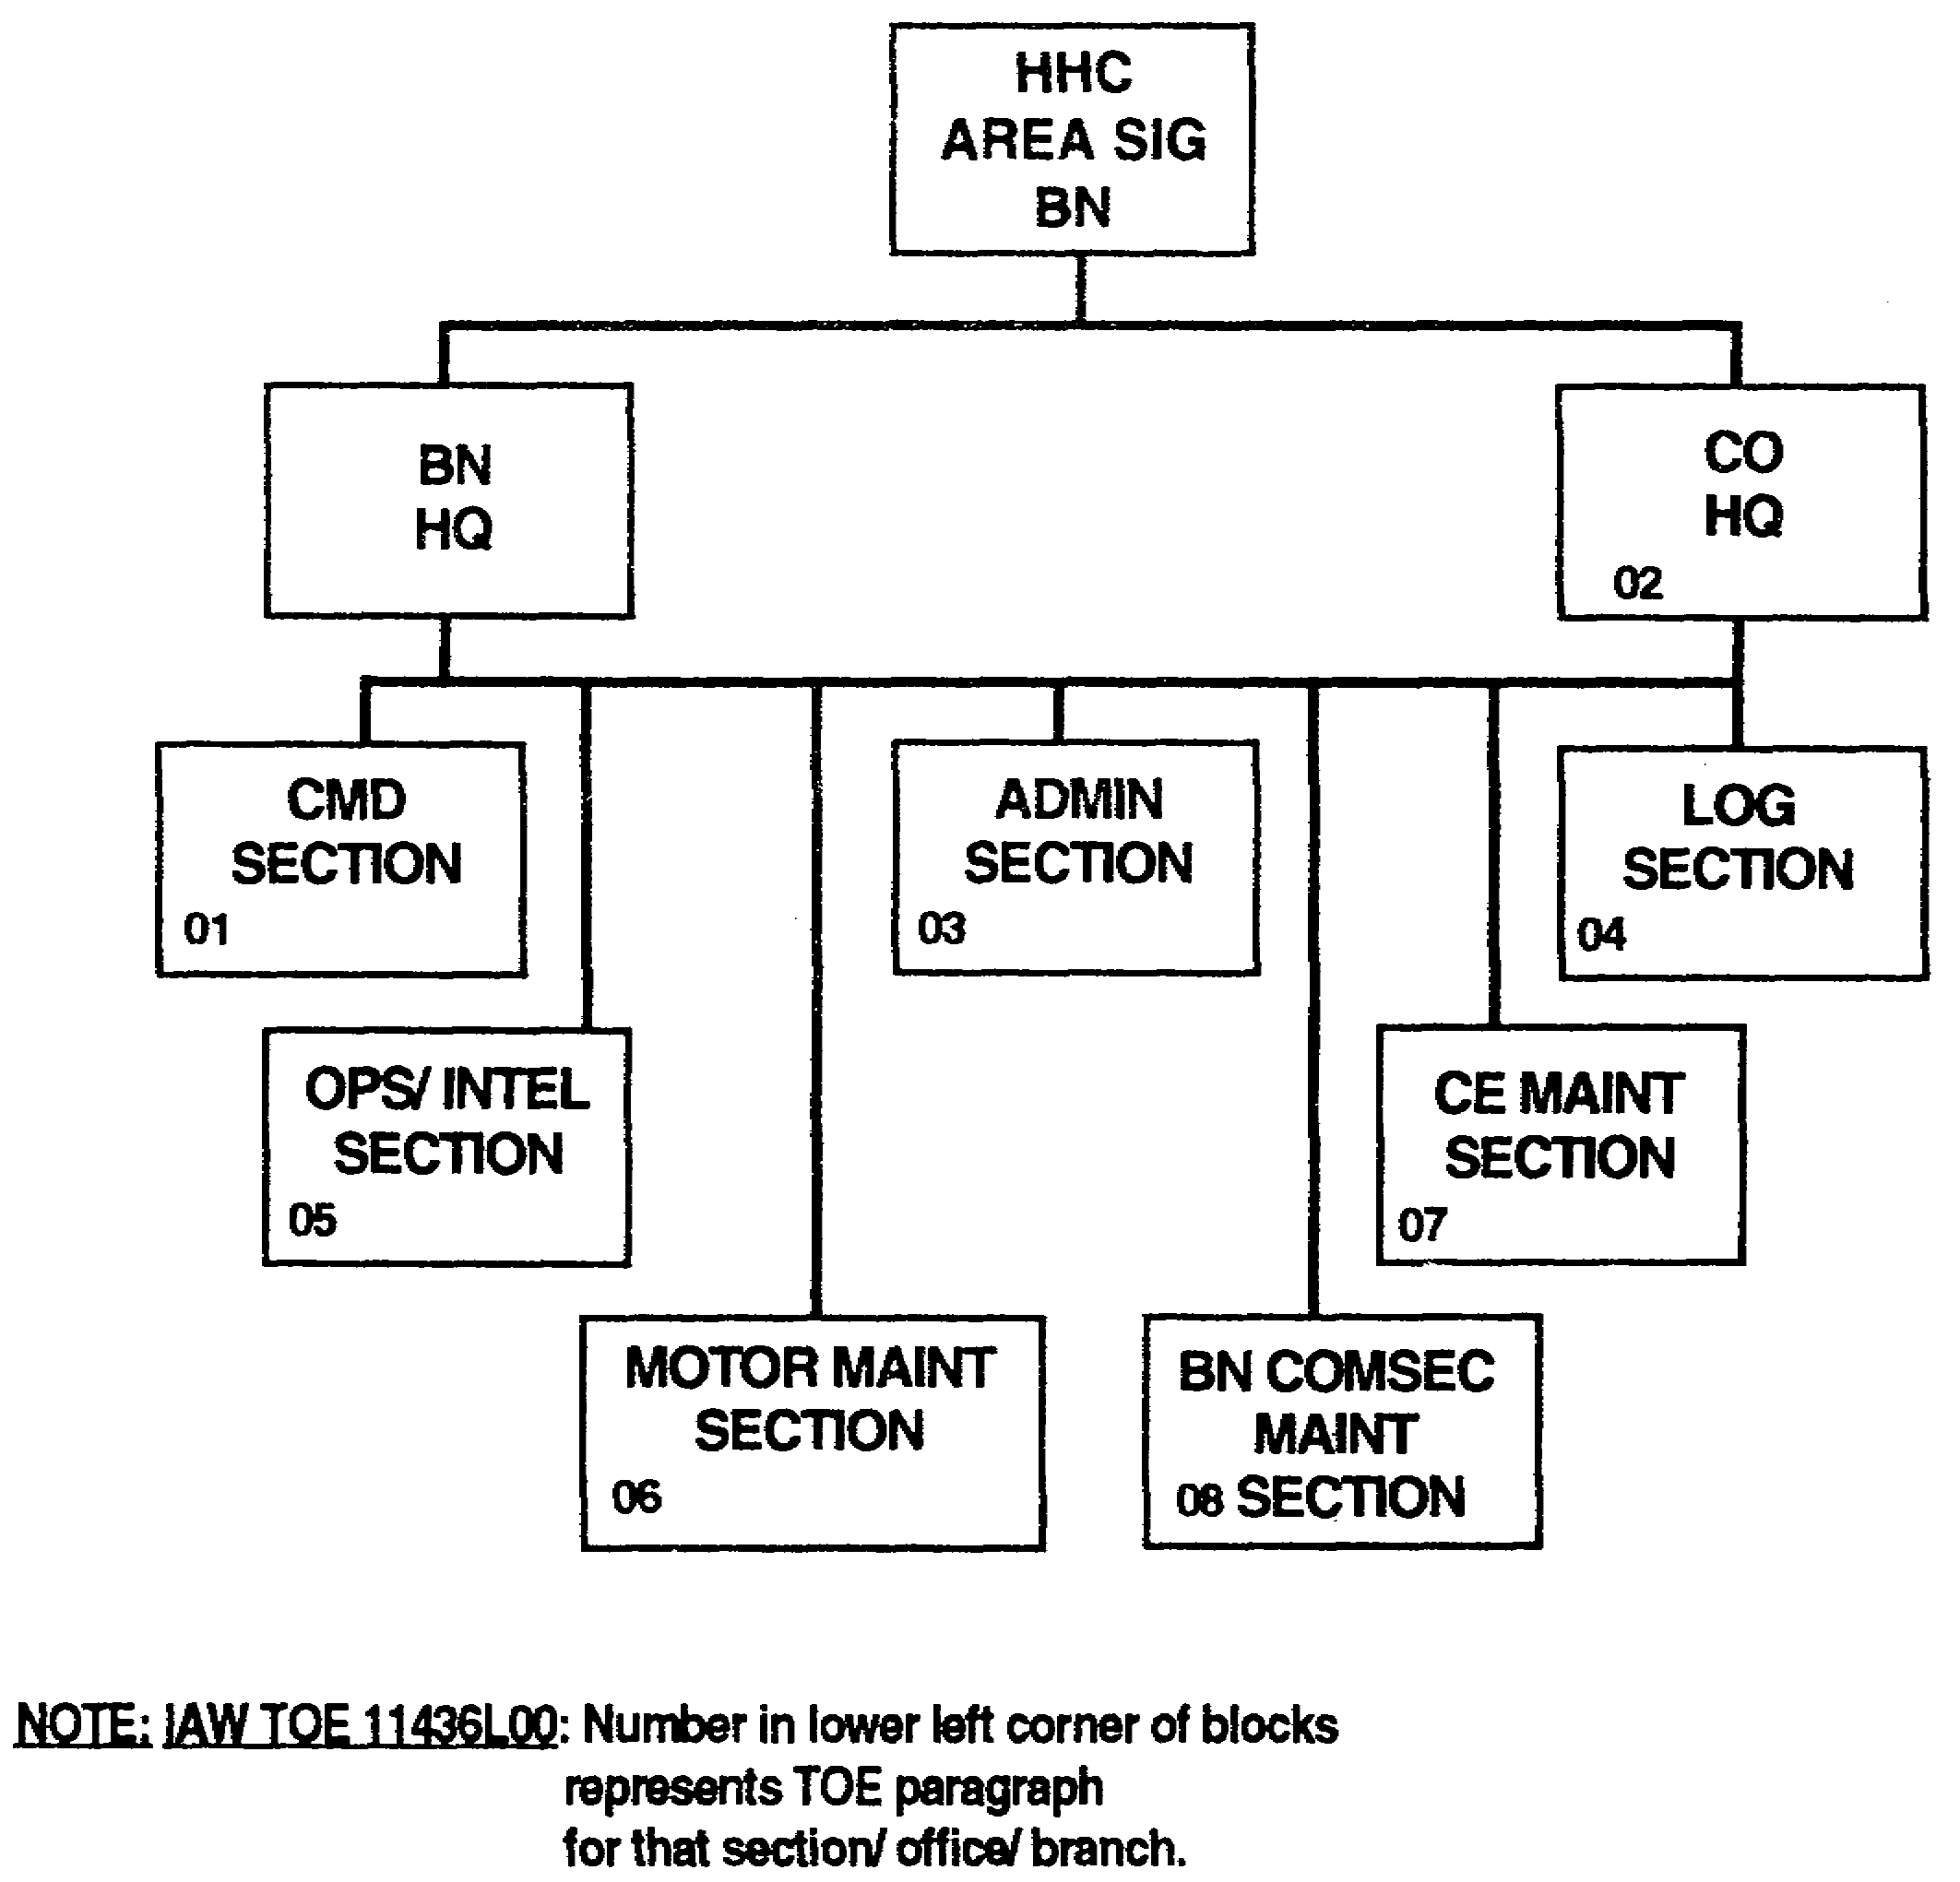

Figure 4-3. HHC corps ASB.

SS0073 4-4
3. The corps signal engineering branch is part of the Operations and Training Officer (US Army), S3/SYSCON.

a. The signal engineering branch—

- Conducts detailed systems engineering studies.

- Develops plans for establishing communications systems.

- Determines equipment suitability, adaptability, and compatibility with existing military communications systems.

- Determines installation and employment required to provide quality transmission over installed systems.

- Responds to frequency requests and maintains associated records for the brigade units.

- Integrates allied, joint, and commercial communications into the corps communications network.

- Analyzes traffic status reports.

- Maintains direct coordination with the SCC/SYSCON in the network control branch.

- Informs the SCC/SYSCON of current and future facilities' needs throughout the corps communications network.

b. Key personnel and their responsibilities are shown below.

(1) Systems engineer, MAJ (25E), analyzes all traffic status reports and studies to optimize system capabilities.

(2) Traffic officer, MAJ (25E)—

- Determines the information network architecture supporting battlefield operations.

- Exercises network control.

- Conducts network analysis.

4-5 SS0073
(3) Signal officer, CPT (25B); telecommunications officers, CPT (25B) and (25D); traffic officer, CPT (25E); and data processing technician, CW4 (251A)—

- Assist the branch chief in engineering communications in their respective fields.

- Determine equipment suitability, adaptability, and compatibility with existing military and local communications systems.

- Verify the capabilities and limitations of equipment.

- Verify the quality of transmission facilities.

(4) Radio officer, CPT (25C)—

- Evaluates radio propagation data to determine RF allocation.

- Allocates frequencies to units in the brigade.

- Coordinates RF requirements.

- Maintains records, prepares reports, and initiates correspondence to corps headquarters on all frequency matters.

- Is responsible for engineering radio communications systems.

(5) Operations sergeant, MSG (31W)—

- Assists the branch chief and other officers.

- Coordinates and supervises the efforts of the enlisted technical specialists.

(6) Frequency management noncommissioned officer (NCO), SFC (31W)—

- Assists the RF officer with frequency responsibilities.

- Assists the communications engineer officers in preparing detailed engineering plans.

(7) Programmer/systems analyst, SFC, SSG (74F)—

- Supervises, prepares, analyzes, edits, and tests computer programs.

- Conducts data system studies involving investigation, evaluation, and development of data processing systems.

SS0073 4-6
- Prepares specifications and proposals documentation.

- Implements new or modified systems.

(8) Programmer analyst, SPC (74F), assists the programmer/systems analyst(s).

(9) TACSAT radio section chief, SFC (31Y) –

- Supervises, directs, coordinates, and manages the IOM of TACSAT systems.

- Plans and provides technical guidance for TACSAT use, maintenance, and logistics support.

- Prepares and interprets orders, system diagrams, related technical matrixes, and reports.

(10) Clerk typist, SPC, and clerk, PFC (71L), perform all typing and clerical work in the section.

(11) Graphics document specialist, PFC (25Q), draws charts, graphs, and other aids.

4. The network control branch provides the SCCs for the MSE system.

a. It provides the following capabilities:

- MSE radio automated frequency management.

- Terrain analysis and path profiling.

- Automated system engineering functions.

- Equipment status reporting.

- COMSEC key management.

- Link and network load status.

- Personnel management data base.

- System traffic flow and grade of service.

4-7 SS0073
b. Key personnel and their responsibilities are shown below.

(1) Operations officer, MAJ (25E)—

- Supervises the network control branch and the functions referred to above.

- Accepts responsibility as the regulator (authority and implementer) of essential networkwide operating parameters; for example, frequencies, COMSEC keys, nodal connectivity, ECCM, interfaces, and network software.

- Is accountable for planning, engineering, controlling, and maintaining network operating parameters.

- Assigns or reassigns variable network operating parameters.

- Distributes all operating parameters network; for example, signal operation instructions (SOI), signal standing instructions (SSI), operation orders (OPORDs), and SCC orders.

- Establishes relationships among network components; for example, leader-follower, master-slave, or controlling terminal.

(2) Network officers, CPT (25E) and LT (25C)(4 each) respectively, and the telecommunications officer, CPT (25B), assist the operations officer in executing his duties.

(3) Operations sergeant, SGM (31W)—

- Provides technical assistance, supervises, and assists in communications system control.

- Supervises the work activities of other enlisted personnel assigned to the branch.

(4) MSE SCC supervisors, MSG (31W)(4 each) and MSE network controllers, SFC (31W)(4 each), are responsible for the 24-hour operation of the SCC.

(5) MSE SCC operators, SSG (31F)(4 each), provide 24-hour system operation.

(6) Clerk typists, SPC (71L)(3 each), perform all typing and clerical work in the section.

SS0073 4-8
5. The plans/intelligence section provides the planning, coordination, and supervision of plans and intelligence requirements for the brigade. Key personnel and their responsibilities are shown below.

a. Plans officer, MAJ (25C) and CPT (25B)—

- Responsible for operating the section.

- Reports directly to the S3.

b. Chemical officer, MAJ (74B)—

- Develops the training plans for the brigade's defensive chemical operations.

- Assesses chemical operations and training situations.

c. Operations NCO, MSG (31W)—

- Coordinates the efforts of the enlisted technical specialist.

- Supervises the illustrator and clerical personnel.

d. Plans NCO, SFC (31W)—

- Assists the branch officers in preparing plans and orders.

- Assists in all brigade training requirements.

e. Chemical operations NCO, MSG (54B)—

- Assists the chemical officers in appraising chemical operations and training situations.

- Collects, prepares, and distributes material for chemical operations and training.

f. Senior intelligence analyst, SSG (96B)—

- Assists in all brigade intelligence requirements.

- Provides technical assistance in preparing intelligence annexes.

g. Clerk typists, SPC (71L)(2 each), prepare, distribute, and file the paperwork required to prepare extensive plans and training requirements.

h. Graphics document specialist, SPC (25Q), prepares graphs, charts, and other visual aids for training or intelligence activities.

4-9 SS0073
6. Brigade COMSEC office of records is responsible for the brigade COMSEC account. It also provides COMSEC logistics support for the control and distribution of internal brigade and subordinate battalion COMSEC material. Key personnel and their responsibilities are shown below.

a. COMSEC security technician, CW4 (250A)—

- Responsible for operating the office.

- Serves as the signal brigade commander's COMSEC technical advisor.

- Receives distribution of COMSEC material from the material management section.

- Provides drop-off/pick-up point(s) for subordinate accounts.

b. COMSEC material management supervisor, SFC (72E), and the COMSEC material manager, SSG (72E), assist the brigade COMSEC office of record technician with his responsibilities.

PART B -THE CORPS SIGNAL OFFICE

1. The corps signal office's primary mission is to perform the signal management functions. These functions ensure adequate communications are provided to the corps commander for commanding and controlling his forces.

a. The corps signal office-* Advises the corps commander, his staff, and subordinate commanders on command signal matters.

- Prepares signal estimates, plans, and orders for guiding and directing subordinate commanders and signal units.

- Exercises technical supervision of signal activities within the command.

- Manages all operational and contingency COMSEC matters.

- Aids development of COMSEC operational plans and policy.

b. Key personnel and responsibilities are shown below.

(1) Assistant CSO, COL (25E)

- Oversees the operation of the corps signal office.

- Represents the CSO in corps HQ actions.

SS0073 4-10
- Assists the CSO in planning corps communications operations.

- Assists in preparing the signal annex of the corps OPORD.

- Assists in planning the corps' standing operating procedure (SOP).

- Provides signal assistance to the corps HQ staff elements.

- Assists in planning automated systems and the corps telephone directory.

- Controls RF allocation and provides RF management for the corps.

- Coordinates host nation and allied signal interface.

- Manages/controls actions and responsibilities of the ISSO.

(2) ISSO responsibilities are related to the functions of—

- Correspondence.

- Classified document control policies and procedures.

- Printing.

- Forms/files management.

- Publications management.

- Official mail.

- Reproduction.

- Privacy Act/Freedom of Information Act.

- Distribution.

2. Only three BIS require central execution or a central point of contact (POC). These are distribution, printing, and the Privacy Act/Freedom of Information Act. The other BIS occur at the user level and are the responsibility of the user to execute.

a. The automation management officers, LTC (53C) and MAJ (53C)(2 each)—

- Plan, organize, and coordinate tactical automation support to the corps commander's C² systems.

4-11 SS0073
- Integrate cryptographic, automation, and data transmission means to support automated C² systems.

- Provide technical direction for installing, operating, and maintaining data base and teleprocessing systems. This includes hardware and software interoperability for automated telecommunications and teleprocessing systems.

b. Operations officer, LTC (25C)—

- Plans and supervises communications support for corps HQ.

- Prepares signal plans to incorporate into corps plans and orders.

- Coordinates with other HQ staff sections regarding their communications needs.

- Makes recommendations for signal troops procurement, use, and allocation to support the command.

- Determines signal training requirements for nonsignal units.

3. The networking officer, MAJ (25E), plans, designs, and manages the integration and interconnectivity of tactical and nontactical information networks and communications systems.

a. Radio officers, MAJ (25C) and CPT (25C) -

- Exercise staff supervision over radio communications activities.

- Prepare signal plans, orders, and radio communications SOI items.

- Coordinate frequency allocation assignment and use.

- Report and process interface problems.

b. Systems integration officers, MAJ (25B) and CPT (25B) -

- Manage force integration of information systems resources.

- Plan and coordinate with higher headquarters for information systems upgrade, replacement, elimination, and/or integration within units.

- Plan BAS and information systems integration.

- Provide staff supervision of analysis and software support and troubleshooting of automated systems.

- Manage and supervise automatic data processing (ADP) related areas.

SS0073 4-12
- Design and develop command information systems.

- Monitor unique application program development.

- Supervise maintenance of tactical data bases.

- Plan newly assigned or attached unit data base integration.

- Provide automated resources security training.

c. CE officer, MAJ (25C), publishes the corps SOI items pertaining to message service, authentication tables, and CT routing indicators.

d. Data processing technician, CW4 (25A1A0)—

- Manages personnel, facilities, and equipment assets in ADP sections.

- Conducts data systems analysis.

- Designs or redesigns data systems.

- Develops computer programs.

- Supervises and coordinates activities of personnel.

- Consults with staff officers and commanders to define priorities of tentative and continuing projects.

e. Chief signal NCO, SGM (31W) -

- Assists the signal officer.

- Manages the signal office.

- Supervises and inspects the work of enlisted personnel in the section

- Assists the signal staff in the technical appraisal of signal operations and training.

f. Data processing NCO, SGM (74Z), assists the automation management officer in data transmission means to support C² systems.

g. Operations sergeant, SFC (31W) -

- Assists the operations officer in collecting, preparing, and distributing material and data pertaining to signal operations and training.

- Assists in preparing signal orders and plans.

4-13 SS0073
h. Frequency management NCO, SFC (31W), assists the RF engineering officer with frequency allocation and control.

i. Programmer/systems analyst, SSG (74F) -

- Supervises, prepares, analyzes, edits, and tests computer programs.

- Conducts data system studies involving investigation, evaluation, and development of data processing systems.

- Prepares specifications and proposals documentation.

- Implements new or modified systems.

j. Programmer analyst, SPC (74F), assists the programmer/systems analyst.

k. Clerk typist, SPC (71L), performs all typing and clerical work.

1. Graphics document specialist, SPC (25Q), draws charts, graphs, and other aids.

4. Corps COMSEC office of record maintains supervisory control over corps COMSEC assets through reporting channels for corps COMSEC accounts and reports to the theater COMSEC office of records as required.

a. It also does the following:

- Establishes priorities for issuing COMSEC materiel.

- Receives, processes, and controls all accounting transactions which affect COMSEC accounting records within the corps.

- Serves during crisis/contingency operations as a holding area for bulk-sealed Armed Forces Courier System shipments destined for COMSEC accounts operated by corps subordinate units.

- Provides consolidated semiannual inventory reports.

- Provides central accounting for all classified COMSEC material in the corps and reports to the theater central office of record.

b. Key personnel and their responsibilities are shown below.

(1) COMSEC security technician, CW4 (250A)—

- Serves as a cryptographic staff officer and supervises the corps COMSEC office of records.

- Provides centralized accountability reporting for corps COMSEC items.

SS0073 4-14
- Receives distribution of COMSEC materiel from the Armed Forces Courier System.

- Provides drop-off/pick-up points(s) for subordinate accounts.

- Assists the signal officer by advising him on cryptographic matters.

- Conducts corps cryptographic facility inspections.

(2) Telecommunications supervisor, SFC (72E), and the telecommunications shift supervisor, SSG (72E), assist the COMSEC security technician in the responsibility for the corps account and oversight of the subordinate accounts within the corps.

(3) Telecommunications senior operators, SGT (72E)(3 each), and tactical telecommunications center operators, SPC and PFC (72E)(3 of each rank), apply correct procedures for cryptographic material storage, receipt, and use.

PART C - THE CORPS AREA AND SUPPORT SIGNAL BATTALIONS

1. Corps area and support signal battalions provide signal facilities that support plans developed by the corps signal staff and the corps signal brigade staff to support unit communications requirements. The corps ASBs operations/intelligence staff section coordinates the installation of the 6 NCs, 1 LENS, 40 SENSs, and 13 RAUTs. The corps support signal battalion's operations/intelligence staff section coordinates the installation of 4 NCs, 1 LENS, 24 SENSs, and 8 RAUs. The SCC generates the orders to deploy these assets, but the S3 section oversees carrying out those orders. It also coordinates support for any assets from another signal battalion OPCON to their area of operation. (See Figures 4-4 and 4-5.)

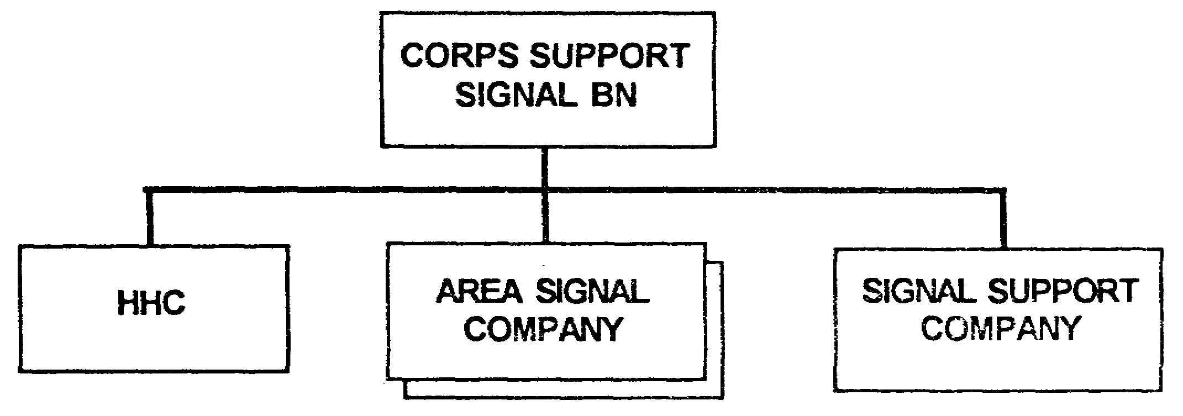

Figure 4-4. Corps support signal battalion.

4-15 SS0073
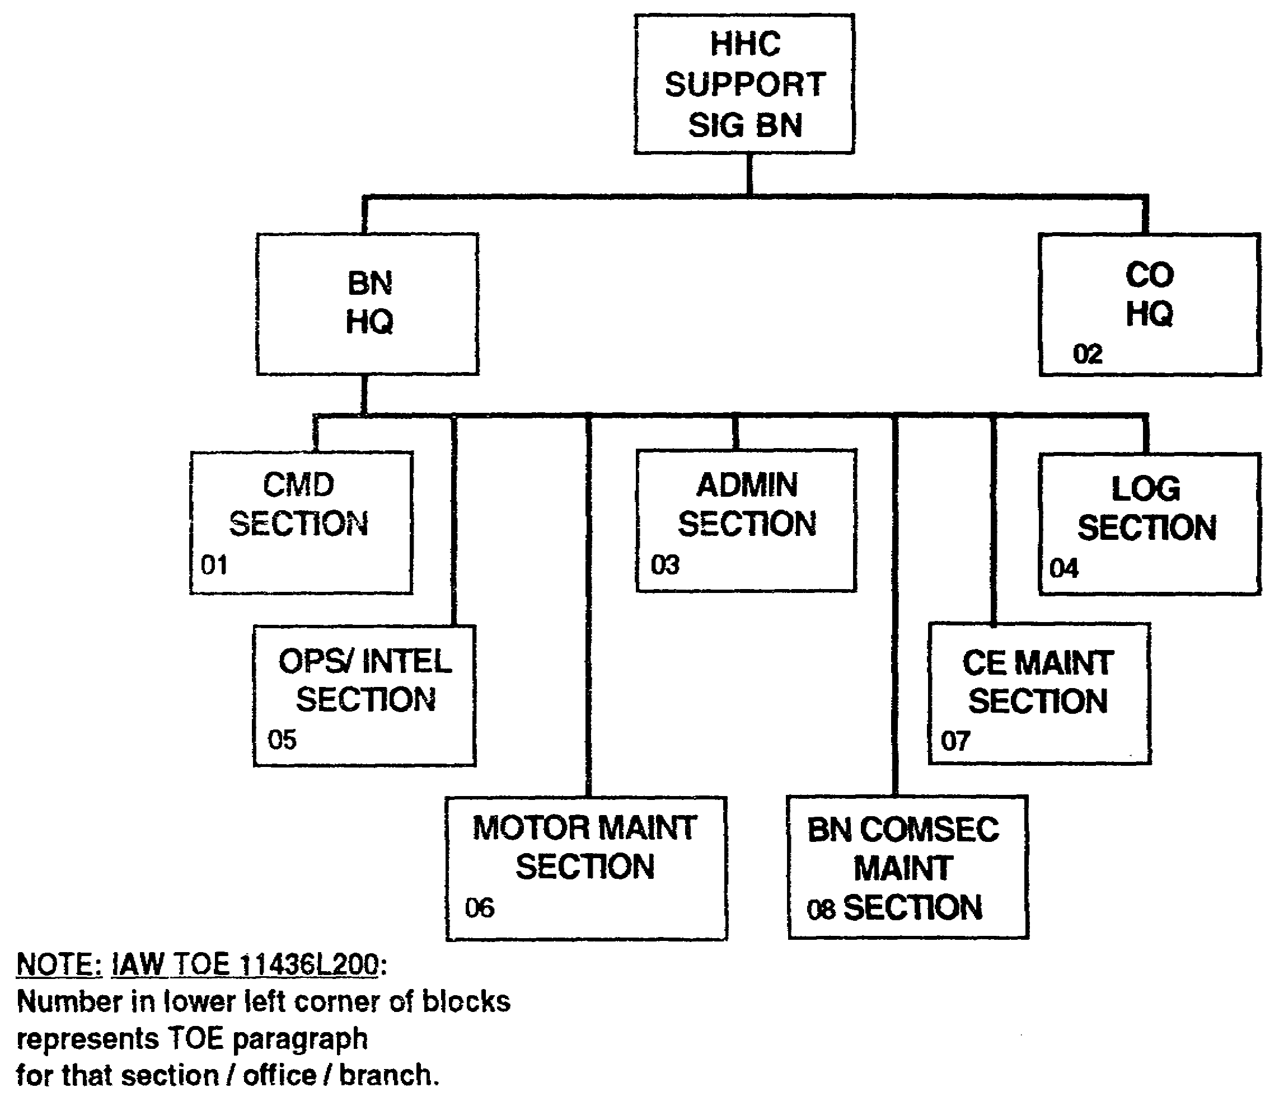

Figure 4-5. HHC support signal battalion.

2. Key personnel of the two battalions are identical and are shown below.

a. Battalion commander, LTC (25C) -

- Commands, directs, and supervises the ASB.

- Directs the IOM of battalion communications systems and facilities for implementing plans developed by the corps signal staff to support unit communications requirements.

- Advises the brigade commander on all communications matters.

SS0073 4-16
b. Signal officer, CPT (25C)—

- Responsible for the operation of the operations/intelligence section.

- Plans and coordinates staff supervision of the master plans, requirements, and the battalion training program.

- Plans and supervises communications support for the signal brigade plan.

- Prepares signal plans for incorporation into signal brigade plans and orders.

- Coordinates with other headquarters staff sections regarding their communications needs.

c. Radio officer, LT (25C) -

- Exercises staff supervision over radio communications activities.

- Prepares signal plans, orders, and radio communications SOI items.

- Coordinates frequency allocation assignment and use.

- Reports and processes interface problems.

d. Systems integration officer, LT (25C) -

- Manages force integration of information systems resources.

- Plans and coordinates with higher headquarters for information systems upgrade, replacement, elimination, and/or integration within units.

- Plans BAS and information systems integration.

- Provides staff supervision of analysis and software support and automated systems troubleshooting.

- Manages and supervises ADP related areas.

- Designs and develops command information systems.

- Monitors unique application program development.

- Supervises maintenance of tactical data bases.

- Plans newly assigned or attached unit data base integration.

- Provides automated resources security training.

4-17 SS0073
e. Operations NCO, MSG (31W)—

- Is the senior NCO.

- Provides technical assistance; supervises and assists in communications system control.

- Supervises the work activities of other enlisted personnel assigned to the section.

f. MSE network NCO, SFC (31W)—

- Provides technical assistance; supervises and assists in communications system control.

- Provides technical assistance to section concerning NC switches.

- Supervises the work activities of other enlisted personnel assigned to the section.

g. Nuclear, biological, chemical (NBC) NCO, SFC (54B)—

- Assists the S3 in appraising chemical operations and training situations.

- Collects, prepares, and distributes material for chemical operations and training.

h. Intelligence NCO, SGT (96B)—

- Assists in all battalion intelligence requirements.

- Provides technical assistance in preparing intelligence annexes.

i. Clerk typists, SPC (71L)(2 each), perform all typing and clerical work.

j. Graphics document specialist, SPC (25Q), draws charts, graphs, and other aids.

SS0073 4-18
LESSON 4

PRACTICE EXERCISE

The following items will test your grasp of the material covered in this lesson. There is only one correct answer for each item. When you complete the exercise, check your answers with the answer key that follows. If you answer any item incorrectly, study again that part of the lesson which contains the portion involved.

1. The corps signal engineering branch is part of the S3/SYSCON.

A. True

B. False

2. In which branch are the SCCs located?

A. Signal engineering branch

B. Network control branch

C. COMSEC officer of record

D. Corps signal office

3. Doctrinally, what MOS is the frequency management NCO?

A. 31Y

B. 31M

C. 31W

D. 31F

4. Who is responsible for coordinating the host nation frequency support?

A. Brigade S3

B. Affected units in theater

C. Corps signal office

4-19 SS0073
LESSON 4

PRACTICE EXERCISE

ANSWER KEY AND FEEDBACK

Item Correct Answer and Feedback

1. A. True

The corps signal engineering branch is part of the S3/SYSCON. (page 4-5, para 3)

2. B. Network control branch

The network control branch provides the SCCs for the MSE system. (page 4-7, para 4)

3. B. 31W

Frequency management NCOC SFC (31W). (page 4-6, para (6))

4. C. Corps signal office

Assistant corps signal officer. COL (25E). (pages 4-10 and 4-11, para b(1), bullets inclusive)

SS0073 4-20
LESSON 5

MOBILE SUBSCRIBER EQUIPMENT NETWORK PLANNING

Critical Task: 01-7113.07-0011

OVERVIEW

LESSON DESCRIPTION:

In this lesson, you will learn about the MSE network architecture, site configurations, and the four main phases of deployment.

TERMINAL LEARNING OBJECTIVE:

ACTION: Describe the MSE network architecture, identify each major site deployment, and describe the four main phases of deployment.

CONDITION: You will be provided this subcourse.

STANDARD: Demonstrate competency of task skills and knowledge by correctly responding to 70 percent of the multiple-choice test covering corps communications.

PART A - MOBILE SUBSCRIBER EQUIPMENT NETWORK ARCHITECTURE

1. NCs are the backbone of the MSE network. These NCs are usually located on or near high points. They provide the entire corps with connectivity and switching capability. These NCs are somewhat independent of existing command structures and provide communications to the user on an area basis.

a. As the corps commander maneuvers the combat units, the MSE network deploys to support these elements. The direction of maneuver and the location of combat, CS, and CSS units dictate the placement of communications units. RISE supports subscribers at echelons from corps through battalion level CPs. It does not replace the data distribution or CNR architectures.

b. As the corps commander's concept of maneuver evolves, NCs and extension nodes are deployed to support this concept. As the corps battlefield requires less communications support, the NCs and extension nodes are redeployed to an area requiring more support or maintained in reserve to meet future requirements. (See Figure 5-1.)

5-1 SS0073
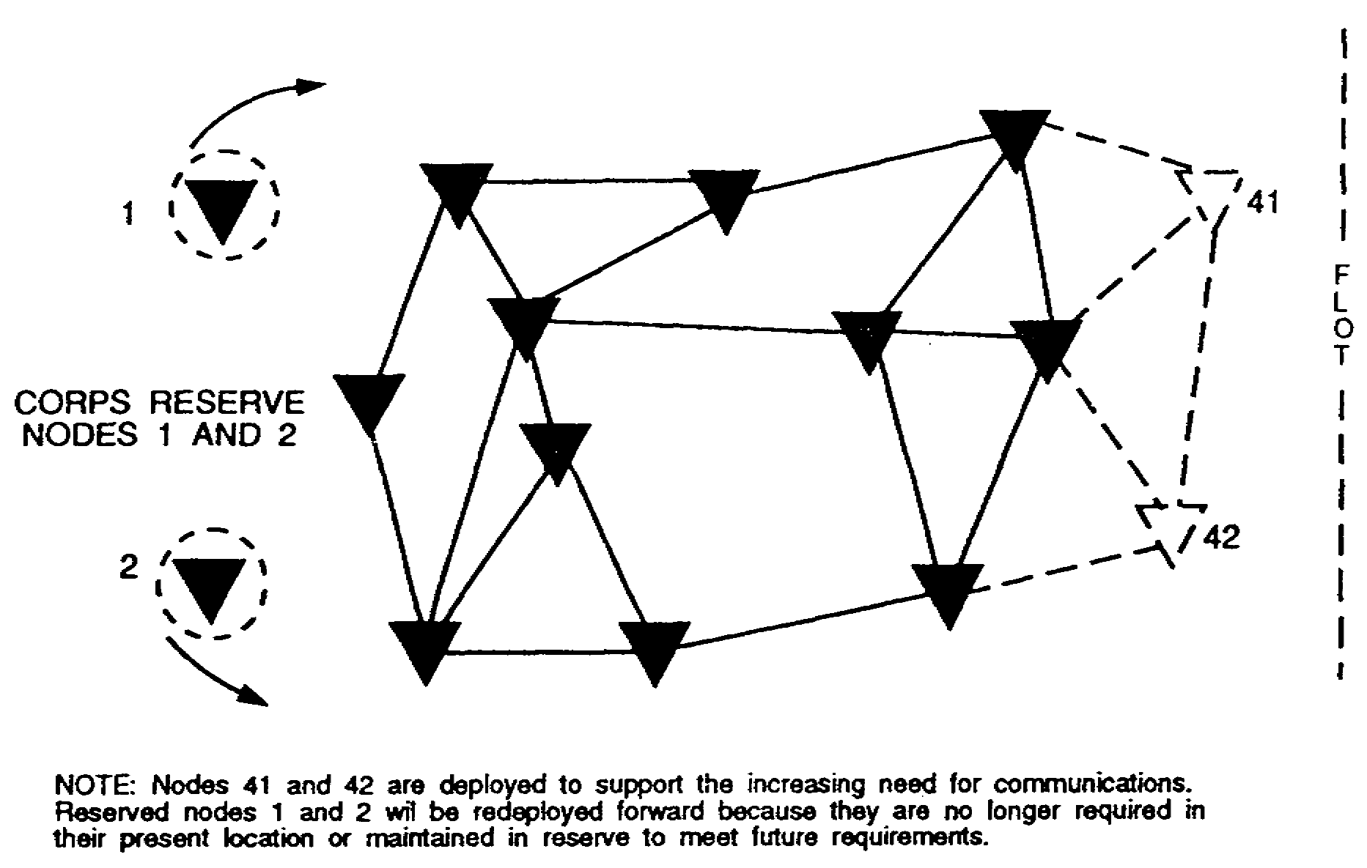

Figure 5-1. Node deployment.

2. The MSE network provides area communications to a corps made up of three to five divisions and covering an area of 37,500 square kilometers (15,000 square miles). The network covering this area consists of up to 42 NCs and 92 RAUs. In total, the system provides service for up to 1,900 mobile subscribers and 8,500 wire subscribers. (See Figure 5-2.)

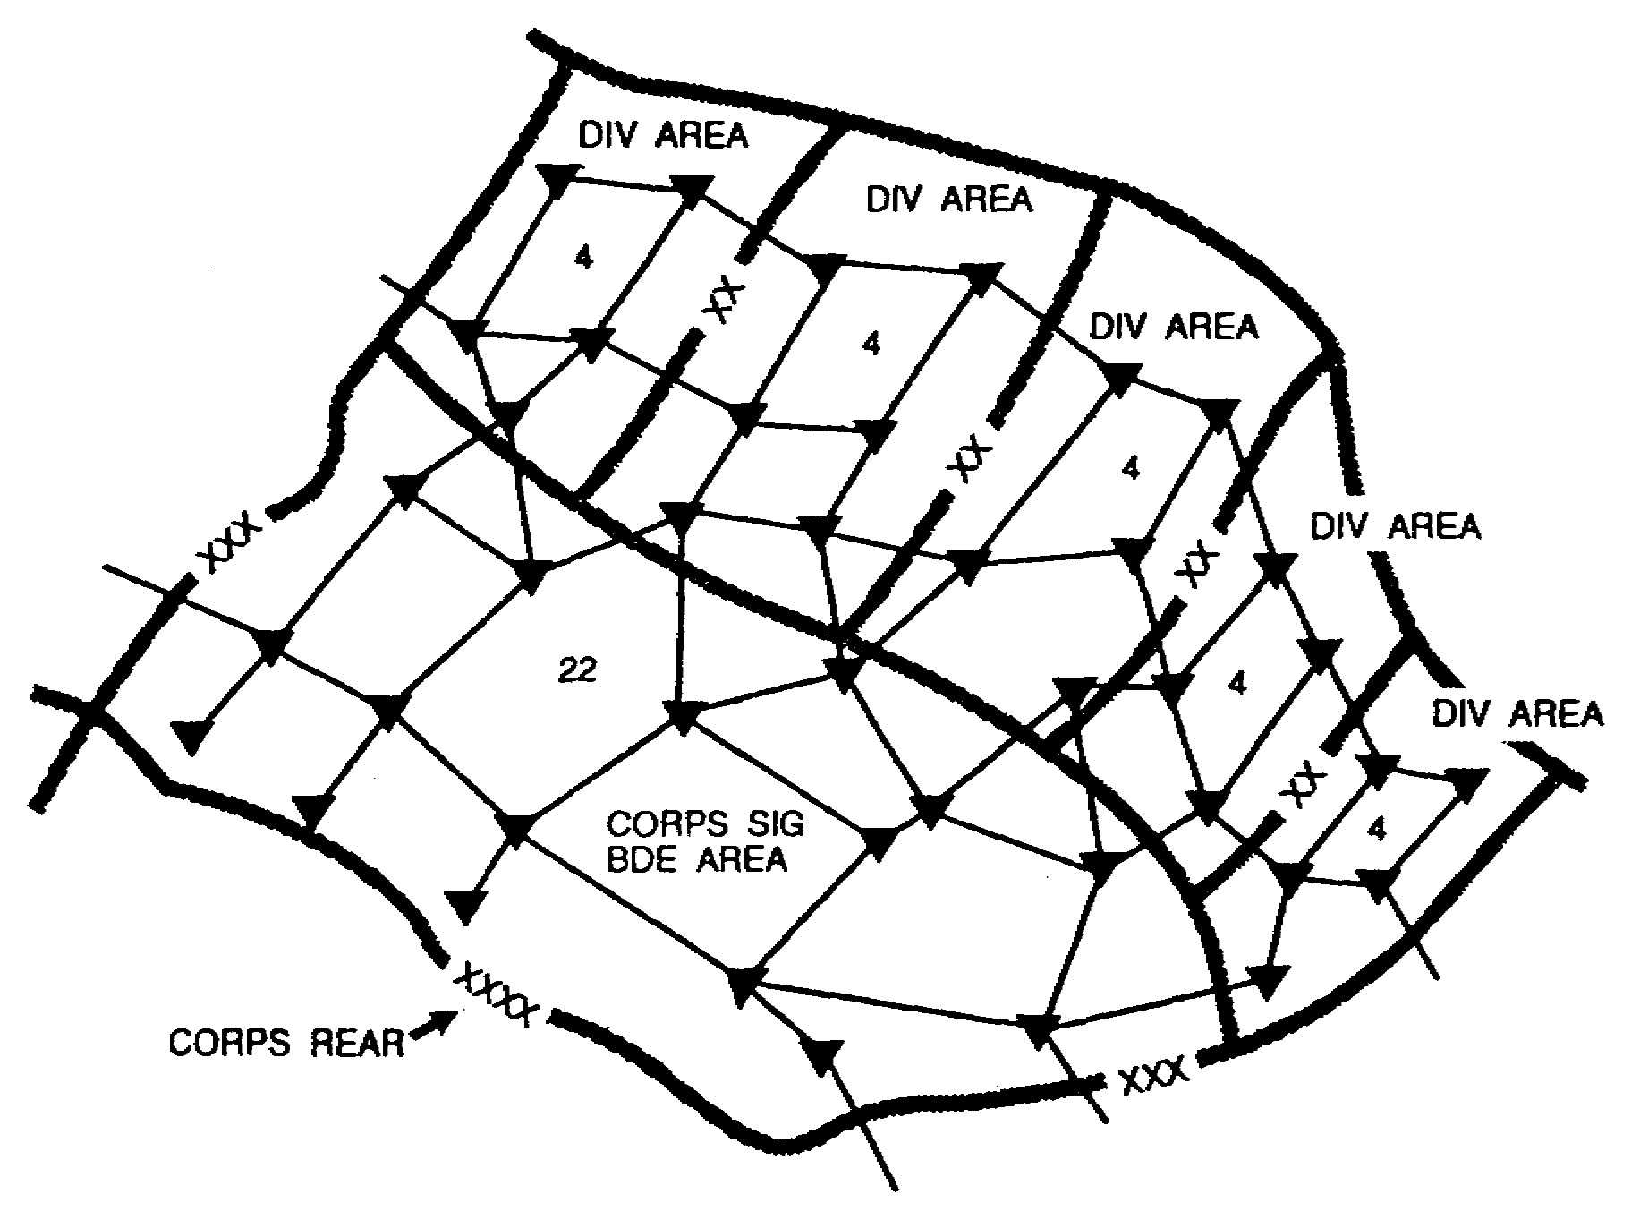

Figure 5-2. MSE deployment.

SS0073 5-2
3. MSE architecture is described by dividing it into three layers. The upper layer is the network's backbone structure, consisting of interconnected NCs. The middle layer consists of LENs and SENs which provide CPs with network access. The bottom layer consists of the system's static (wire line) and mobile subscribers. (See Figure 5-3.)

a. The NCs serve as hubs for the entire nodal system. The LENs and SENs are branched off these NCs. The extension nodes provide voice, data, and facsimile communications to corps, division, and brigade level CPs. Each NC platoon has NRI capability. The SYSCON determines where the NRI can best serve the subscriber. The NRI can be installed in a LEN or SEN. LOS UHF radio links provide connectivity among NCs and from NCs to LENs and SENs. This furnishes all MSE subscribers with automatic switching.

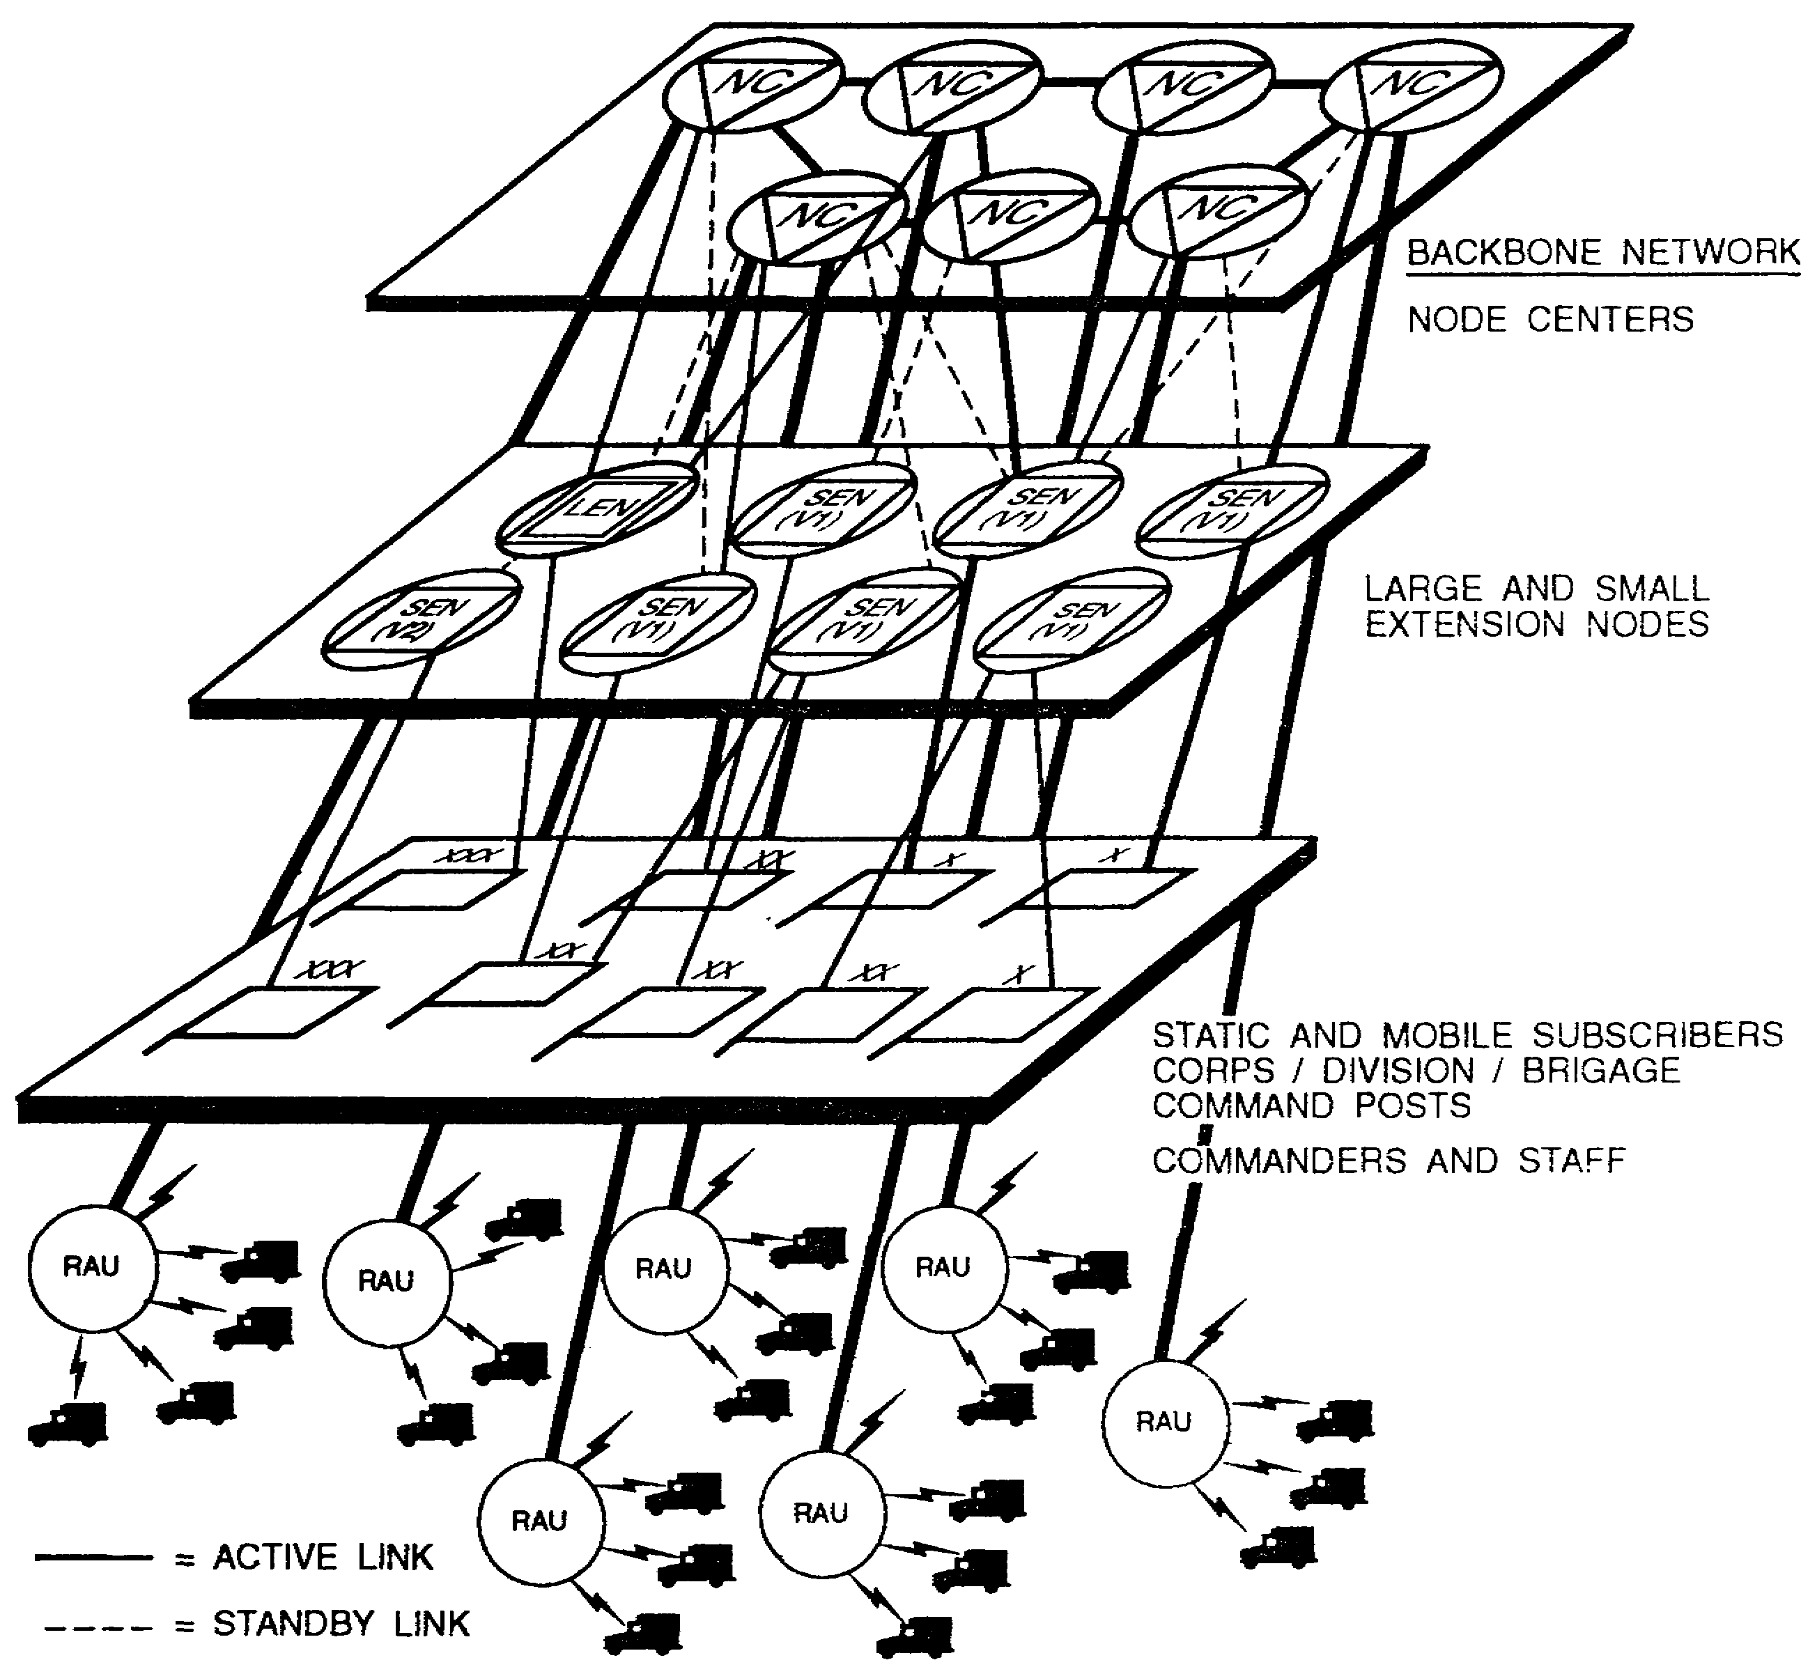

Figure 5-3. MSE architecture.

5-3 SS0073
b. Mobile subscribers are equipped with MSRTs. The mobile subscriber accesses the MSE network via an RAU. He can call any other subscriber in the network without knowing the other's location. He must simply know the other's telephone number. The mobile subscriber can talk while on the move, as long as he is within radio coverage of one of the corps' deployed RAUs. While moving from one RAU's range to another, the MISRT in the user's vehicle automatically searches for the nearest RAU's beacon signal to maintain affiliation. This does not require operator intervention.

4. MSE network control is highly centralized. There are seven SCCs in a five-division corps. The SCC staff plans, deploys, maneuvers, and reconfigures the MSE corpswide network. The) y accomplish this mission to support the corps commander's maneuver concept. The SCC uses automated features to perform many tasks formerly done manually. Among these tasks are frequency management LOS, VHF, and SHF key management, high-point surveys, and signal path profiling. The SCCs maintain system logistics and personnel status reports. OPCON of the MSE NCs belongs to the SCC's staff.

5. MSE provides secure, automatic digitized voice, data, and facsimile communications to the user, whether static or mobile. Using flood search based routing eliminates the need for extensive system planning. This makes MSE more responsive to the user, easier to install, and more mobile. Because equipment is similar at every echelon, there are no problems with equipment compatibility. MSE is lighter and complies with US Air Force weight limitations. Because setup and teardown times are reduced, the signal elements can better support highly mobile users. While on the move, mobile communications service enhances C² for subscribers having MSRTs.

6. All MSE terminal devices are user-owned, -connected, -operated, and -maintained. MSE system and employment doctrine are designed to facilitate the user-owned and -operated concept.

PART B -MOBILE SUBSCRIBER EQUIPMENT SITE CONFIGURATIONS

1. The NCs are the hub of the MSE network providing internodal connectivity. The NS is the main element of the NC. It provides network access to 24 subscribers; that is, node and network management personnel, and to mobile subscribers through the RAU (local/remote) and MSRT. It provides network access for LENS and SENS. When providing a gateway between an adjacent MSE network or to the EAC network, at least two trunk connections are made. Division establishes at least one link to adjacent division(s). NC deployment is based on serviced CPs (extension nodes) deployment, topographical considerations; such as, site availability and accessibility, and to LOS requirements and network interconnectivity requirements. (See Figure 5-4.)

2. Rapid initial network deployment requires installing a preprogrammed connectivity system. The assistant corps-signal officer (ACSO) and the S3/SYSCON plan the backbone system, the SCC issues the orders for execution, and the designated area signal companies provide the assets to install, operate, and maintain the NCs.

SS0073 5-4
a. NCs form a structure on which system extensions are built. The LENs, SENs, and RAUs provide the subscriber with access to the corps network. They depend on the NSs for tandem switching capability. The NC extensions depend on network strength for communications. The network is only as strong as the radio links that make up its basic structure. (See Figure 5-5.)

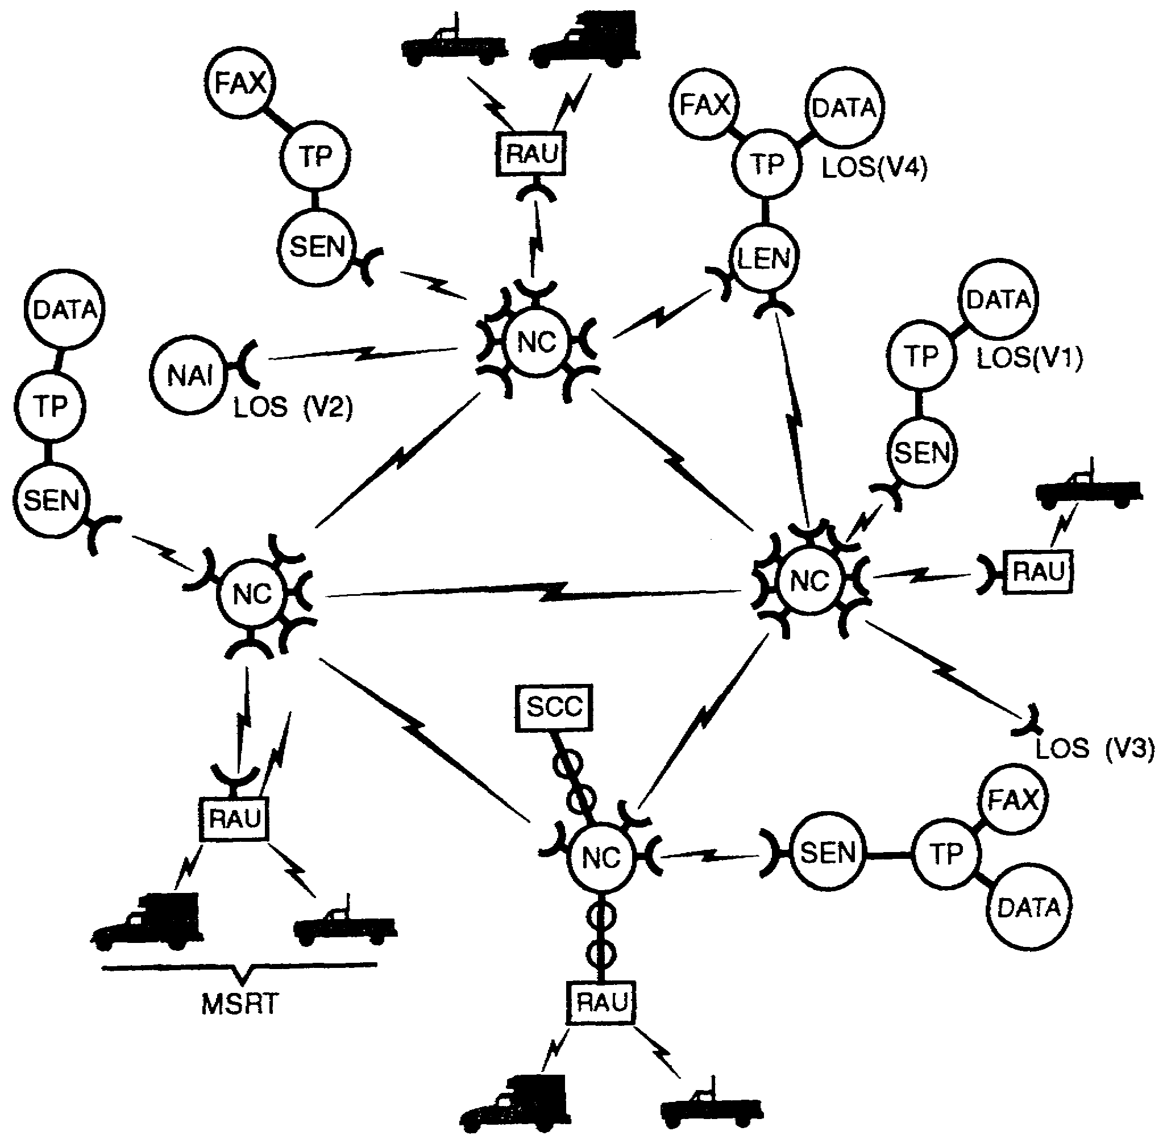

Figure 5.4. Internodal connectivity.

5-5 SS0073
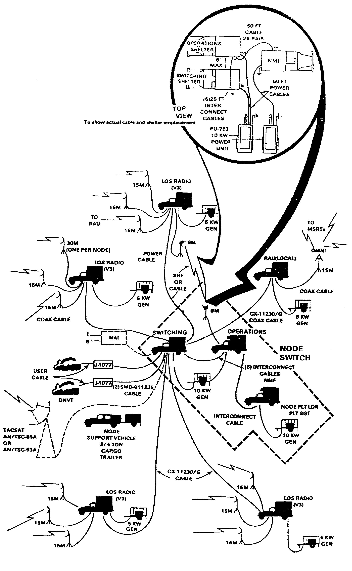

Figure 5-5. NC site configuration.

SS0073 5-6
b. The LEN provides wire line service for up to 176 subscribers and usually deploys to support large CPs such as the COSCOM and the DISCOM. Subscribers serviced by the LEN access the MSE network via RMCs and J-1077 distribution boxes. The maximum number of subscribers connected by RMCs is 80. User-owned equipment supplies power for the RMCs. The maximum number of subscribers connected via J-1077 distribution boxes is 96. There are nine LENs in the corps, one per division signal battalion (DSB) and four in the corps signal brigade. (See Figure 5-6.)

(1) The LOS(V4) radio connects the LEN to two NCs. If one link fails, the second link provides communications connectivity. The LOS(V4) radio provides two 32-channel digital transmission groups (DTGs). Thirty channels of each link are available for subscriber use. The LOS(V4) radio can be remoted from its associated switch using an SHF radio link. Normally, the LEN should establish two active radio links going to two different nodes.

(2) The LEN can also furnish a SENS with network access. When connected to a SEN with CX-11230/G cable, the LENS functions as a tandem switch for that SENS. In some cases, the LEN can host a local RAU. The LEN can also host an SCC and an NS.

c. The SEN consists of an AN/TTC-48(V1) or (V2) switch and an AN/TRC-190(V1) LOS UHF radio system. Normally, the SEN connects to an NC or to an LEN via an LOS(V1) radio. The SEN team, as directed by the SCC, plans for two radio links to two NCs. Because each SEN has only one 15-meter antenna mast, one link can be primary and the other alternate. Each LOS has two radio stacks and two RF heads using band 1 and band 3. The SEN can be remoted from its LOS by a maximum of .4 kilometers (1;4 mile) using cable up to a nominal 5 kilometers (3.1 miles) when using the AN/GRC-224(P) SHF radio. The SHF radio allows the switch to be close to its supported CP, yet removed from the LOS(V1) radio signature. If the SENS is within .4 kilometers (1/4 mile) of the supporting NC, it can be cabled to the NC using CX-11230/G cable. (See Figures 5-7 and 5-8.)

d. Two RAUs are deployed with each NC platoon. One of the RAUs is employed locally. It is connected to the NS with CX-11230/G cable. The second RAU is remoted and connected to an NS via LOS(V1) radio. The remoted RAU is deployed according to the subscribers' support requirements, local terrain feature constraints, and to fill in voids left by the NC's or local RAU's deployment. Areas with a greater density of customers naturally require more RAU support. The planning distance for RAU coverage is a 15-kilometer (9.3-mile) radius. Each RAU can provide support for 25 subscribers. When the RAU is on the move, the whip antenna is mounted and the DSVT is patched to the number eight RT-1539(P) /G radio. In this way, the RAU's DSVT and RT-1539(P) /G function as an MSRT and provide the RAU with mobile communications and a CNR in the support vehicle for their FM net. (See Figures 5-9 and 5-10.)

5-7 SS0073
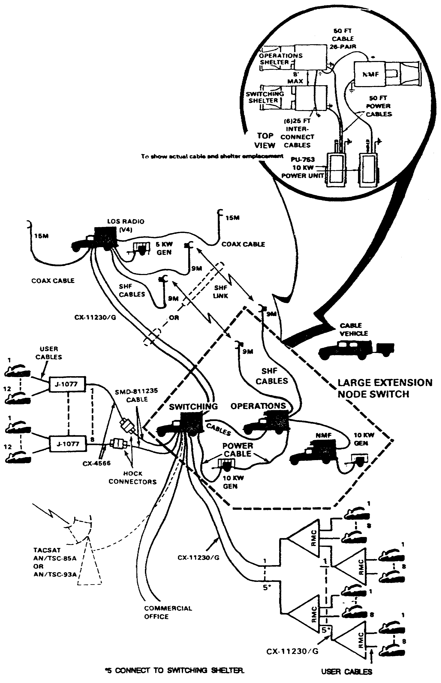

Figure 5-6. LEN site configuration.

SS0073 5-8
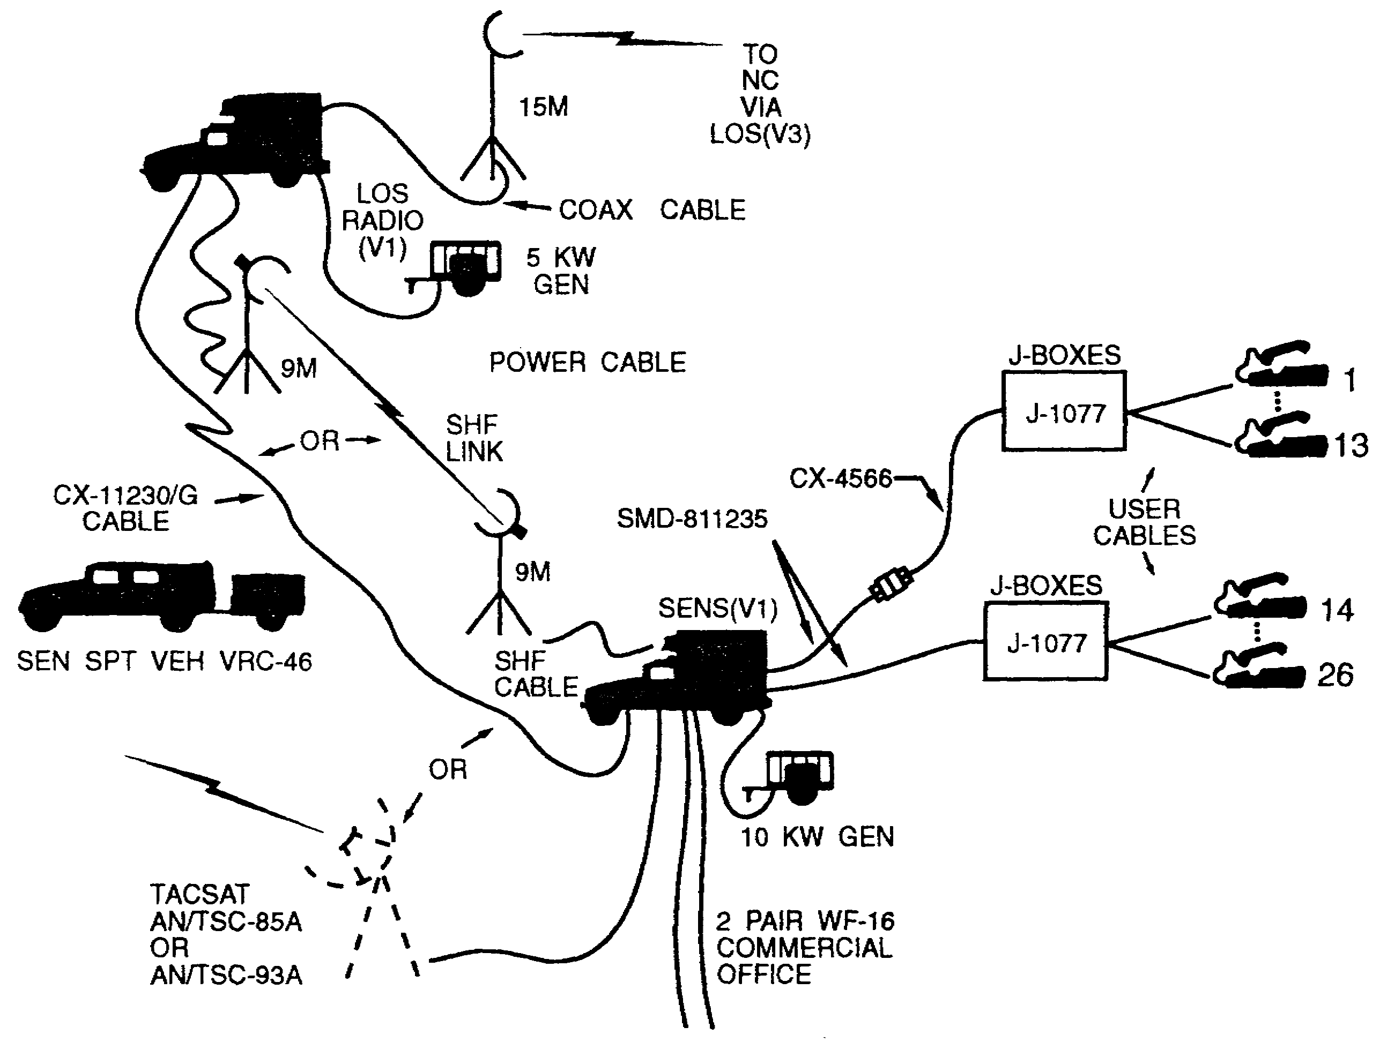

Figure 5-7. SEN(V1) site.

e. There are several options for internal communications among the signal elements. The area signal company commander and the NC platoon leader have MSRTs and CNRs in their vehicles. The MSRT can be used when the platoon deploys, and it allows the NC platoon leadership to communicate with anyone in the network.

(1) An unsecured analog engineer orderwire (EOW) is available in all LOS (AN/GRC-226) radios. The EOW permits LOS operators to communicate with one another during initial engineering or restoring failed LOS links. Once contact has been established between the two assemblages, the LOS operators change to the secure digital voice orderwire (DVOW).

5-9 SS0073
(2) DVOW is transmitted over the LOS radio system. The orderwire control unit (OCU-4) or the communications modem (CM) MD-1270 is located in all manned assemblages except the NMF and the SCC. The OCU-4/MD-1270 allows the signal operator to talk in a secure mode with other signal-elements in the network.

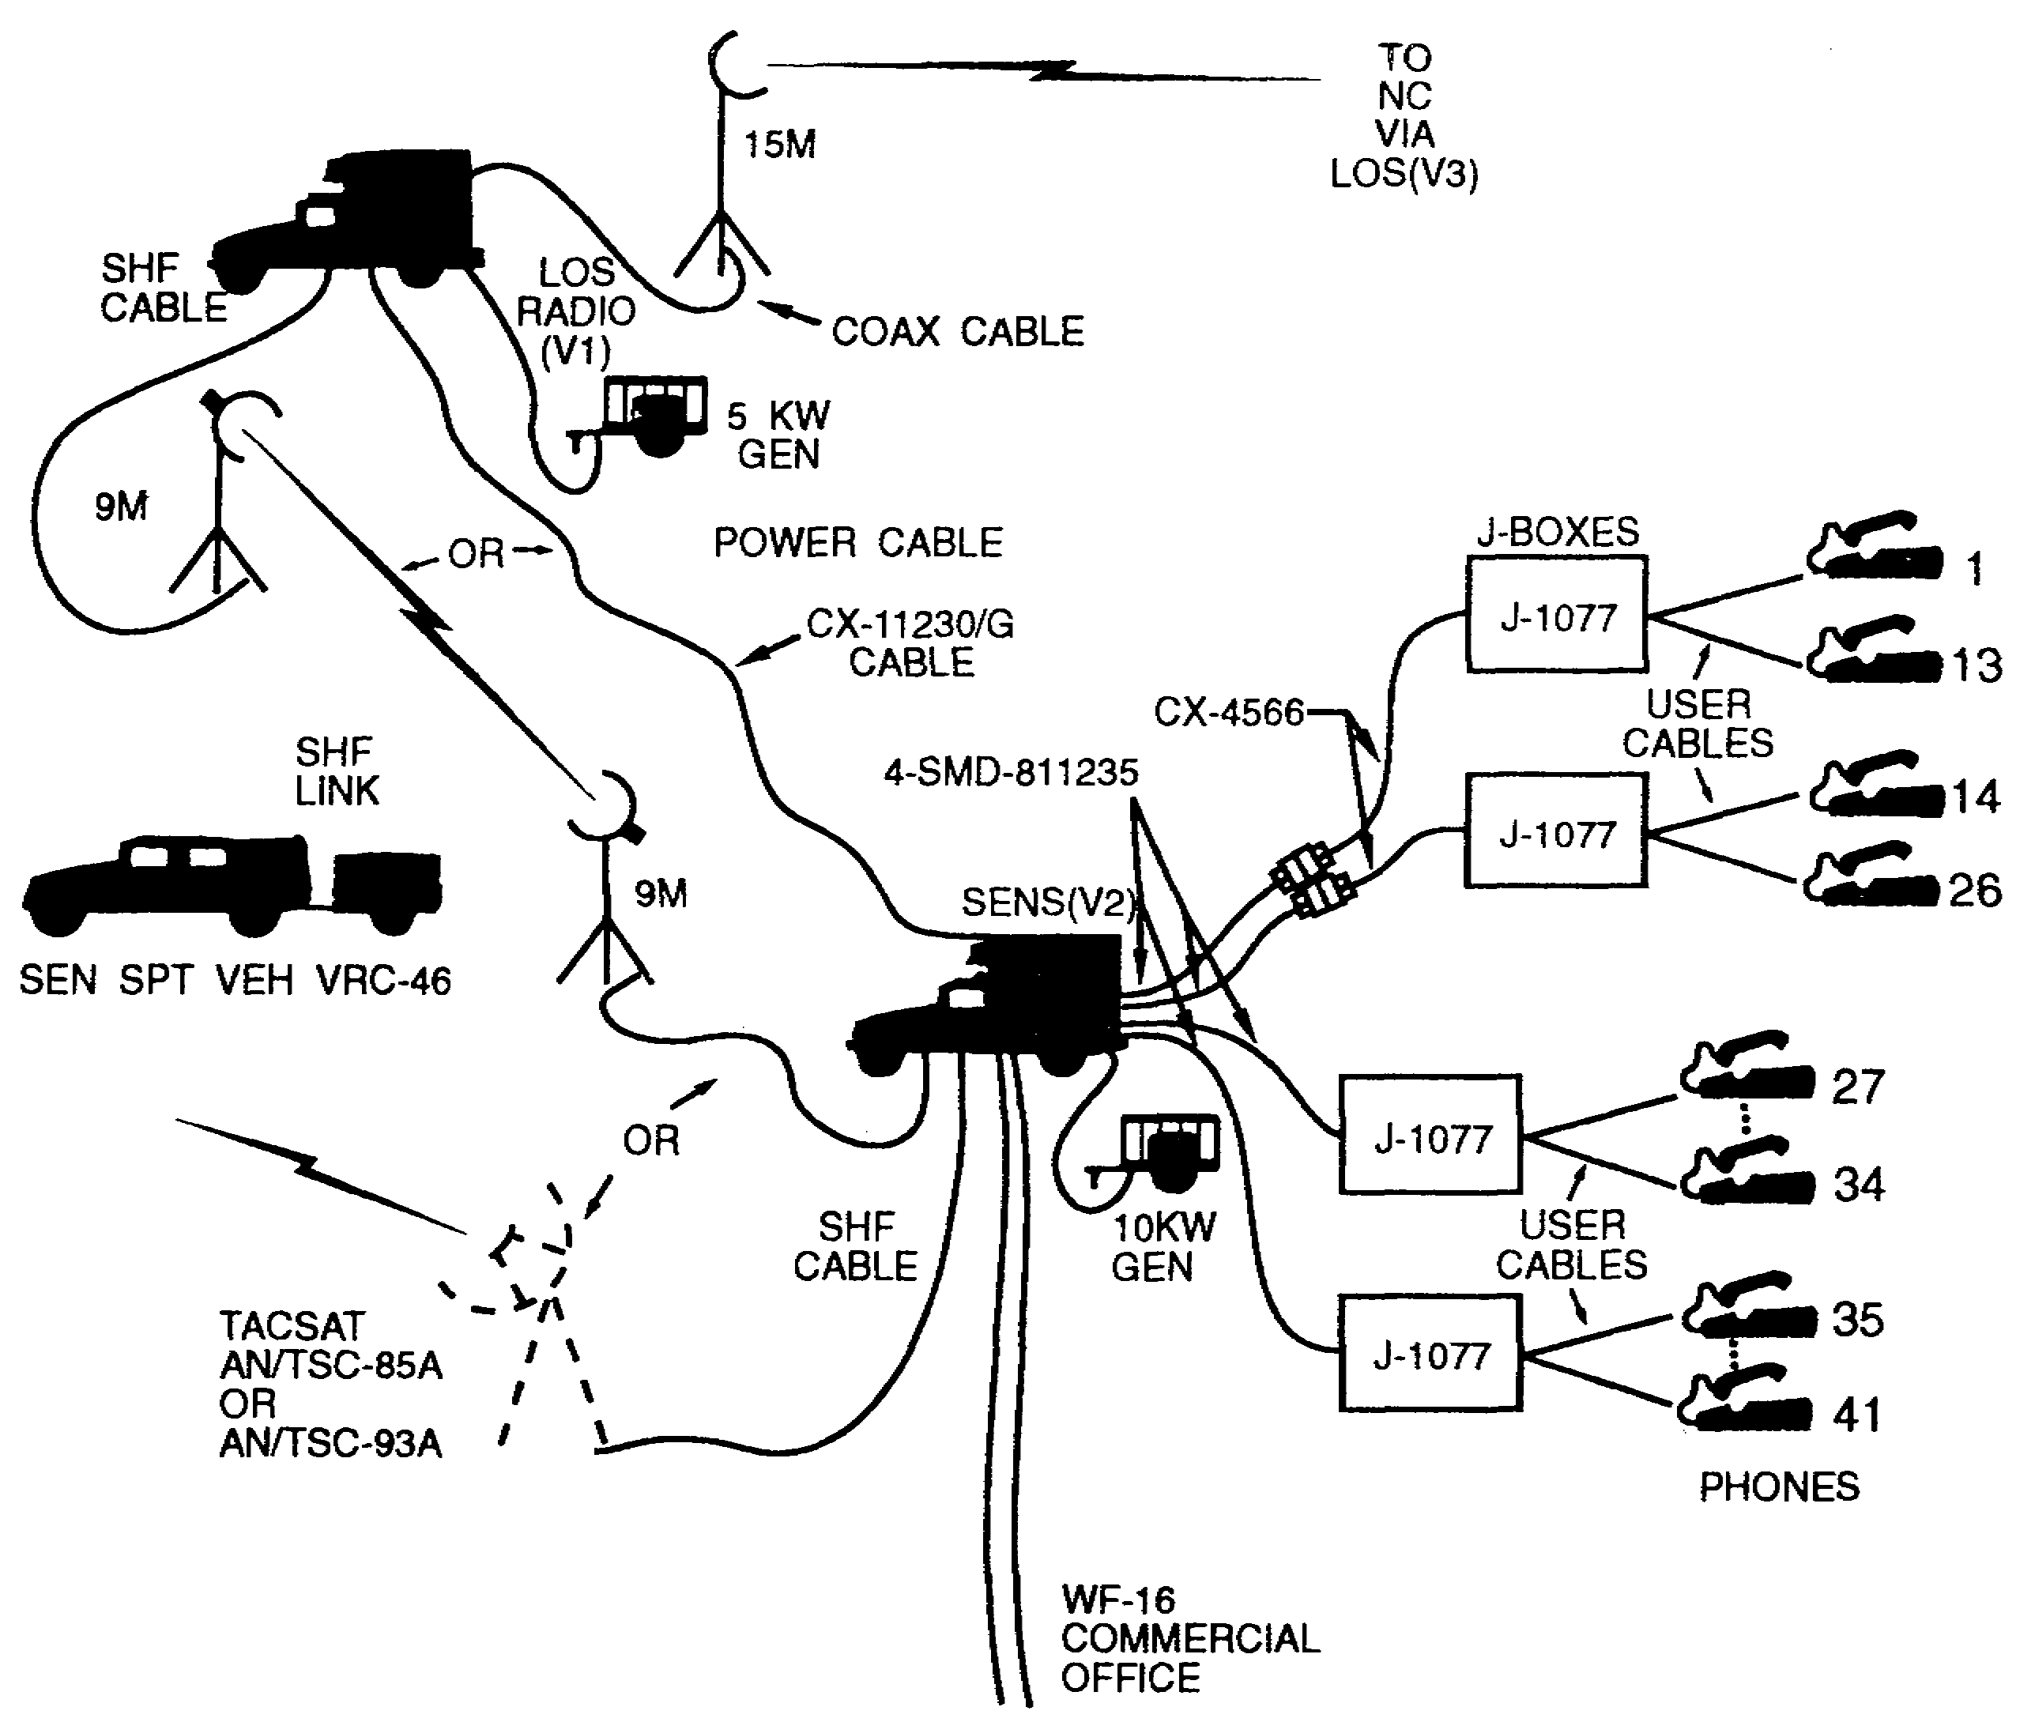

Figure 5-8. SEN(V2) site.

SS0073 5-10
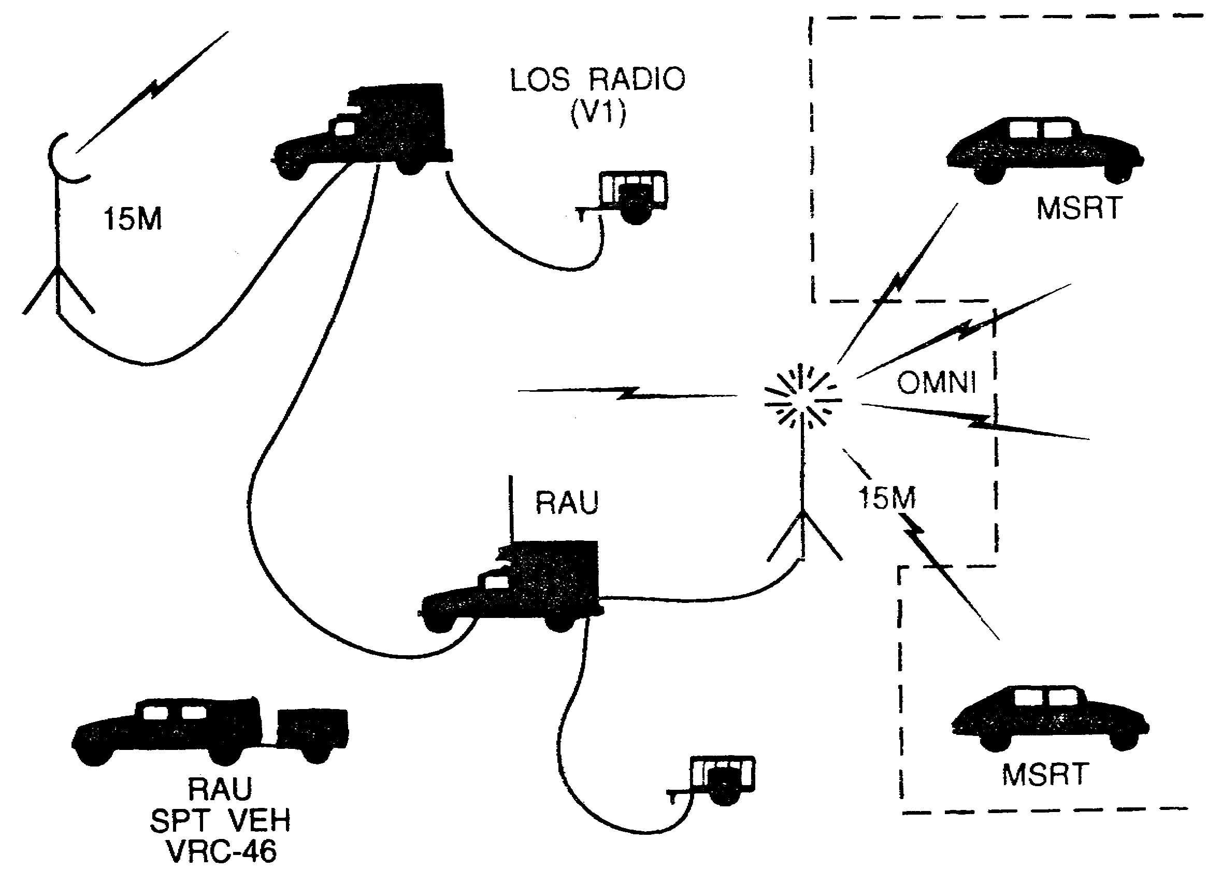

Figure 5-9. Remote RAU site.

5-11 SS0073
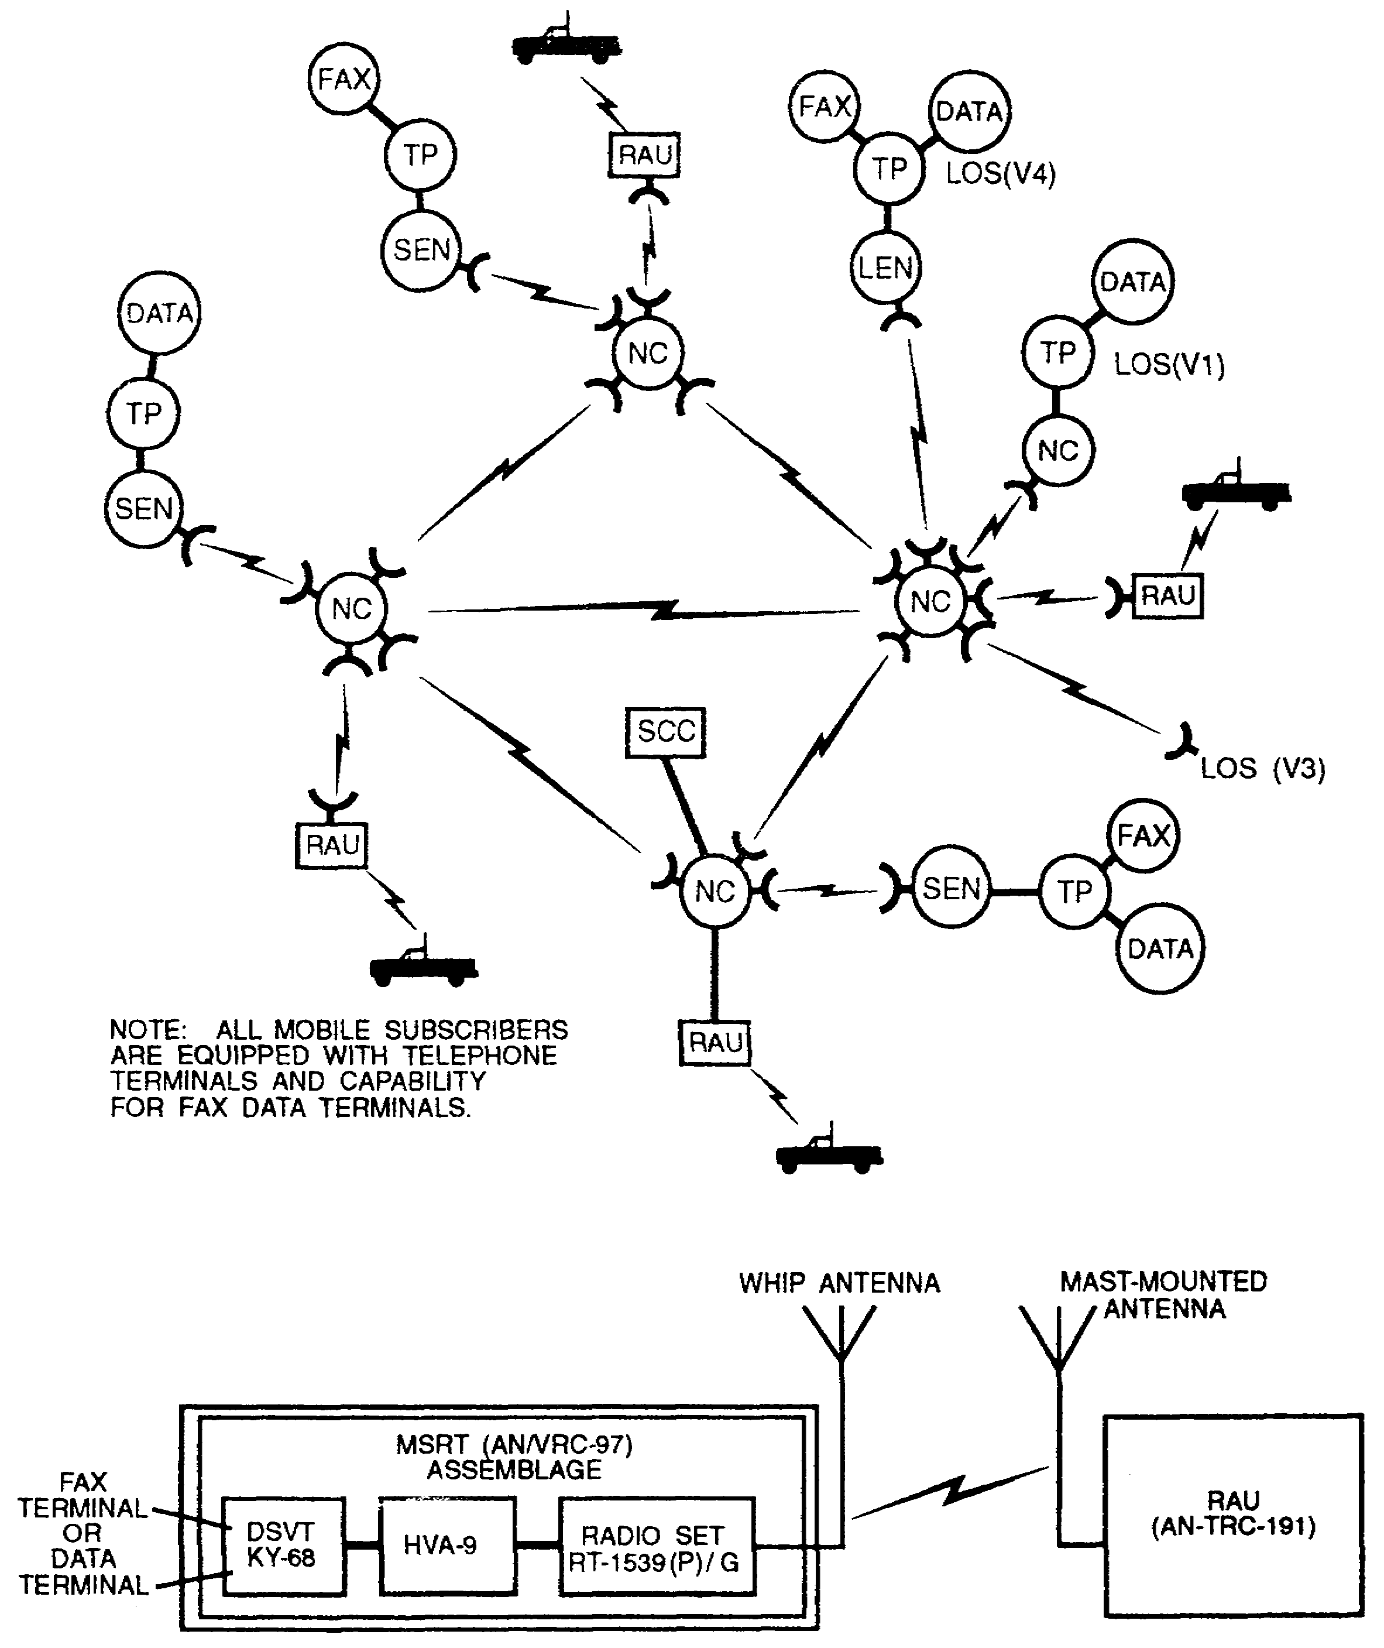

Figure 5-10. Mobile subscriber interface.

SS0073 5-12
3. System control.

a. The corps signal brigade manages and controls the corps MSE network by and through the system control center 2 (SCC-2). The SCC is merely a computer-assisted, automated tool made available to network management cells to aid them in their efforts to manage such an extensive network in a timely manner. The SCC is dependent on human input that comes from the DSB operations/intelligence section and/or the corps signal brigade operations/intelligence section. (See Figure 5-11.)

b. The SCC-2 may be found operating in one of four different modes depending upon the size and type of network it is in. The four modes of operation are corps active (primary), corps standby (alternate), division, and division stand-alone.

(1) The corps SCCs' (active and standby) control the corps signal brigade's slice of the MSE network and any division for which it has assumed responsibility. It is responsible for planning and controlling all inter-area links; such as, corps to adjacent division, corps to division, and division to division within the same corps. The corps standby SCC, although on-line, is in a passive mode. It is ready to assume control of the network with a minimum of disruption. To assume control, it reaffiliates itself with the active SCC's directory number.

(2) The division's SCCs are subordinate to the corps' active SCC and are responsible for controlling and managing all of the elements of their respective networks and any adjacent division assets of which they have assumed control.

(3) The division's stand-alone SCC performs all management and control functions for its division MSE network. Its capabilities and responsibilities reflect those of the corps SCC.

c. The SCCs are organized into SCC control groups (SCG). The control groups are organized with the SCC network in mind, such as one corps SCG with up to seven divisions SCGs or one stand-alone division SCG. This organization of SCGs only permits SCC data base changes to be made to MSE elements within its control group.

d. The SCCs cannot operate on their own, rather they are required to operate and interface with a node or LEN switch. The connected NS and SCC automatically assumes the title of primary NS. It is through these NSs that the SCCs gain access to the network to establish the SCC network.

5-13 SS0073
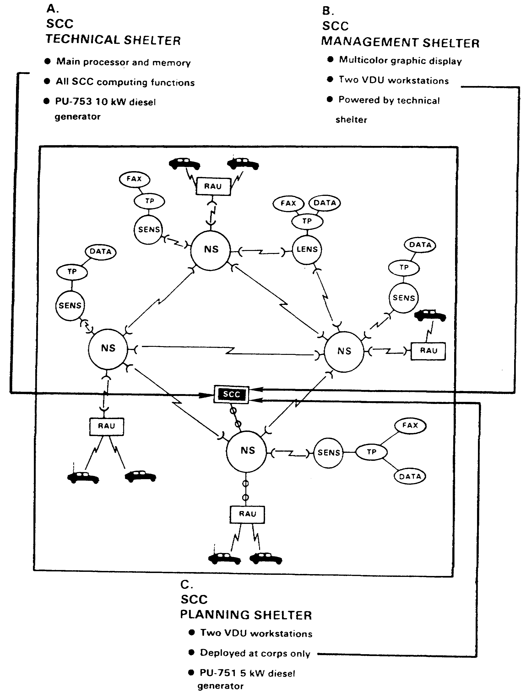

Figure 5-11. System control center.

SS0073 5-14
PART C - OPERATIONAL DEPLOYMENT

1. The base requirement for establishing and controlling communications remains from higher to lower, left to right, and supporting to supported. With MSE, this goes beyond just establishing network connectivity. The element in the higher, left, or supporting category also supplies the equipment, coordinates frequency plans, COMSEC keys, software, and edition and control mechanisms. Corps signal elements will be scattered throughout the division area. Divisions will support other divisions; thus, signal unit areas become interlocked and interconnected.

a. The CSO is responsible for adequate and continuous area coverage throughout the corps area. In the division area, the organic four nodes often require augmentation. The CSO is responsible for providing more assets to ensure area coverage. Normally, this requires two nodes. Allocation to the division depends on corpswide commitments. The division signal officer employs his assets to support the C² needs of the division and to conform with the technical direction of the corps network controller.

b. Some divisions are authorized six organic nodes. This is accomplished by giving the signal battalion an extra area signal company. MSE is a corps network and, when required, assets are allocated to accomplish the mission.

c. Each MSE NS should connect to at least three other NCs. Connecting to four internodal links is preferred. An internodal link is the first link established at each node.

d. Each MSE corps network should have at least two gateway connections to the EAC communications network. There should be at least one link between adjacent divisions and one between adjacent corps. The physical link connections are independent of the physical boundaries between adjacent units/echelons. Gateways are based on electronic boundaries.

e. Corps and division signal battalions are responsible for providing service to major subscribers in their assigned areas. Deploying nodes to support extension assets provides this service. Within the corps, the CPs controlling close, deep, and rear operations may be provided dual network connectivity. Normally, this requires assigning multiple extension assets to the division main CPs, the division tactical CP, the corps' main CPs, and the corps tactical CP. MSRT and SEN or LEN access provides all other CPs dual connectivity. A habitual relationship may be established and maintained between extension nodes and CPs, especially within the division and for corps units like ACRs, artillery brigades, and ADA brigades.

f. Network management and control are exercised through the SCC/SYSCON. In the corps network, the network management and control element designates a primary and an alternate SCC. In a stand-alone division network, the single organic SCC/SYSCON assumes the primary role.

g. The primary SCC/SYSCON manages the planning, engineering, and control functions for a corps. This is technically supported by multiple netted-SCCs. Each is subordinate to the primary SCC.

5-15 SS0073
h. In a corps network, at least two SCCs must simultaneously possess the primary network data bases, displays, and processing services. Although one SCC actively manages the network, the alternate SCC must be ready to assume the primary SCC's role at any time. The alternate SCC's data base is automatically updated as NCs/LENs update the primary SCC. For the alternate SCC to assume the role of primary, it must be involved in the physical planning and monitoring of the network. In this way, the alternate SCC completely understands and can execute the commander's intent when it becomes the primary. Network control should be transferred often to keep the SCC teams proficient.

i. The network planner should divide the battlefield into node switch groups (NSGs) with a signal battalion responsible for each. The ASB and the DSB are responsible for providing all logistic support for the signal teams within their areas of control. This normally aligns with the NSG. (See Figure 5-12.)

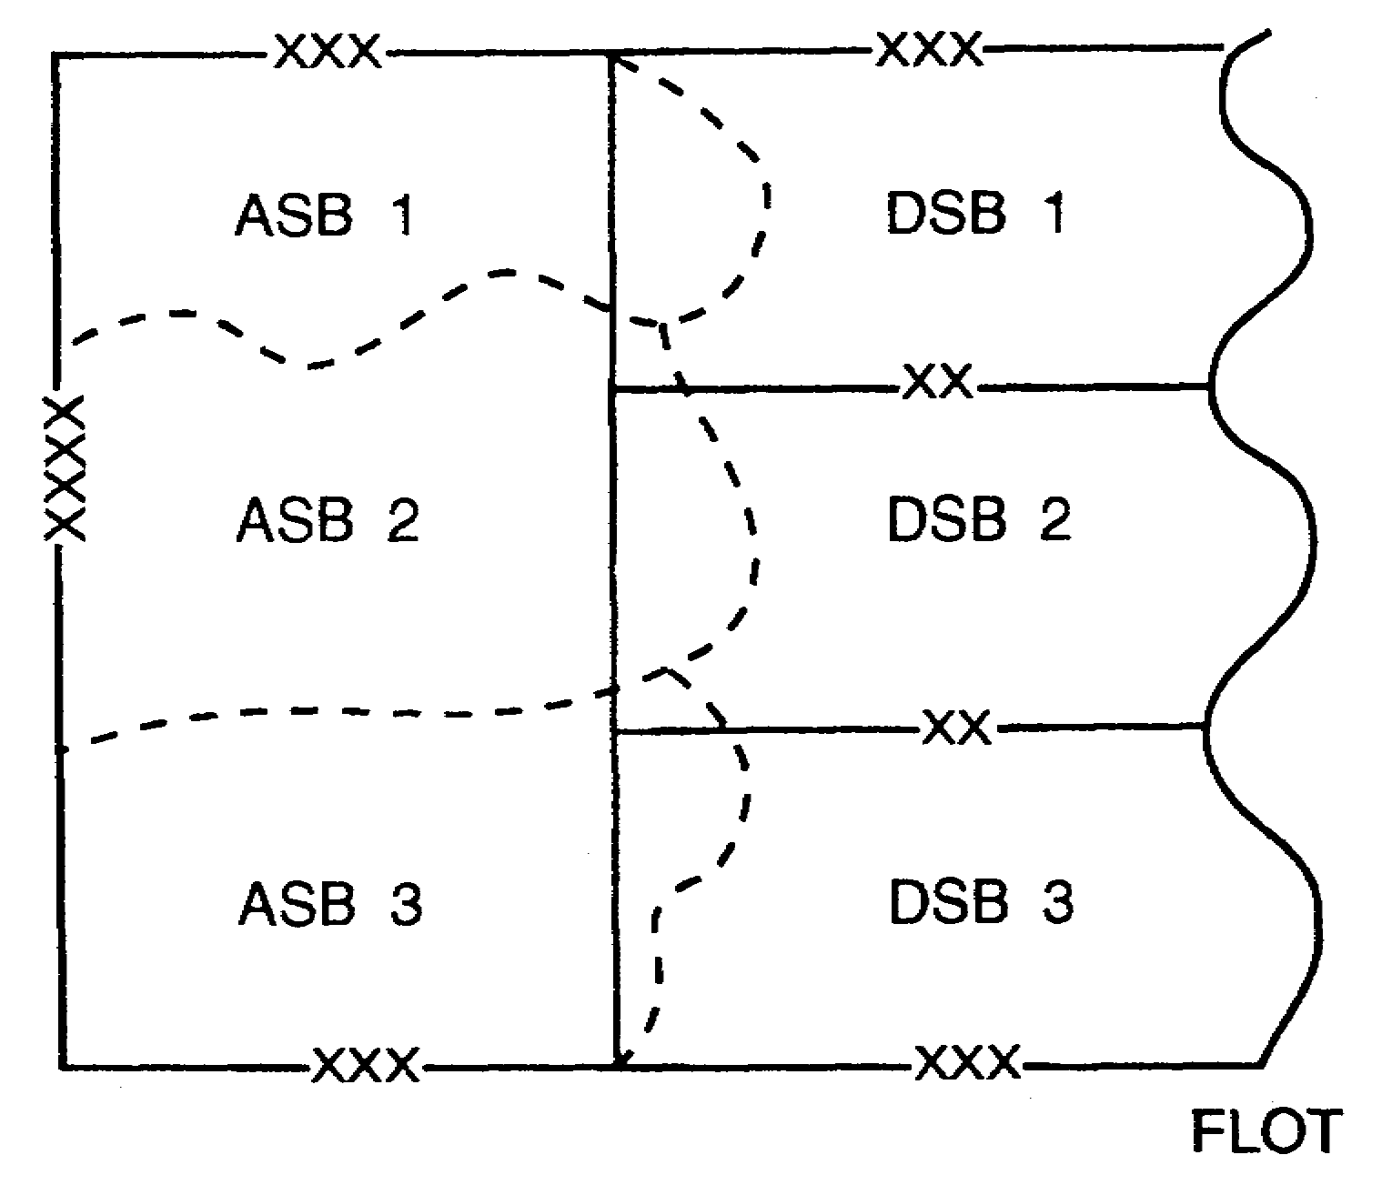

Figure 5-12. The ASB and the DSB.

SS0073 5-16
2. Phased deployment.

a. MSE deployment requires carefully coordinated procedures throughout the corps. From lessons learned, the phased deployment concept is the best organized way to plan the network.

b. The lock step procedure for deployment is broken down into four main phases which are broken down into subphases. This chapter covers only predeployment.

(1) Predeployment is broken down into the following subphases:

- User requirements.

- Interfaces.

- RAU/MSRT deployment plan.

- Other system considerations.

- Team packets.

- COMSEC.

- OPORD.

- Site reconnaissance.

(2) Installing the backbone includes the following subphases:

- NC to NC connectivity.

- Duplication and bypass.

- Bulk transfer COMSEC.

(3) Installing extensions includes the following subphases:

- RAU local and remote.

- SEN and LEN.

(4) Operational management includes the following subphases:

- COMSEC.

- Subscribers.

- Frequencies.

5-17 SS0073
- Switch.

- Teams and equipment.

3. Predeployment Phase I. During the predeployment phase, the planners assess the tactical situation, mission, and commander's intent. This information is developed into an overlay. It contains corps and division boundaries, maneuver units down to battalion level, and dispersed support units down to platoon level. The planner uses this overlay to allocate equipment and to support the following predeployment subphases.

a. User requirements.

(1) Signal planners, based on command guidance, must determine which headquarters will receive support. This determines the method or type of signal support to satisfy C³CM requirements including connectivity with adjacent units, EAC, and host nation's communications resources.

(2) CP priorities must be established and published in the OPORD or unit SOP. Installing the backbone has top priority. Once the backbone has good connectivity, local and remote RAUs are connected followed by the major HQ. Examples are, the corps main CP, corps tactical CP, division main CP, and the division tactical CP. Only the SCC/SYSCON can direct deviating from the assigned priorities.

(3) The planner needs the initial locations of all units needing support and, if possible, any planned jump locations.

(4) The planner also needs to know all special requirements of the supported units; such as, commercial access, TACSAT, special telephone features, profiles, and fixed telephone directory changes.

(5) The SCC/SYSCON ensures that backbone priorities are established for each NC. The planner must ensure an NC is not scheduled to establish two links at the same time. (See Figure 5-13.)

b. Interfaces. The MSE system can connect with various non-MSE hardware. Connections are called interfaces and require changes to the standard data base. Internal and external are two types of interfaces. Both interfaces have special considerations. The network planner must determine the requirements for data base changes to the units involved in the interface. Normally, this is done at a technical conference before deployment. Habitual relationships will result in standard procedures required to change the data base.

(1) Internal interfaces are simply non-MSE within our MSE networks. Examples are combat net radio interface (CNRI), commercial access, and TROPO or TACSAT as a transmission means. The network planner must consider the requirements for interfaces and plan accordingly. Some critical planning factors for internal interfaces are covered below.

SS0073 5-18
(a) CNRI locations must be carefully plotted due to the wide dispersion of users and scarcity of equipment.

(b) Commercial access locations must be plotted to ensure they are accessible to the SEN and LEN for authorized user access. Time is required for coordination and reconnaissance.

(c) MSE locations are determined by the corps signal brigade to ensure support for all the CTs located throughout the corps.

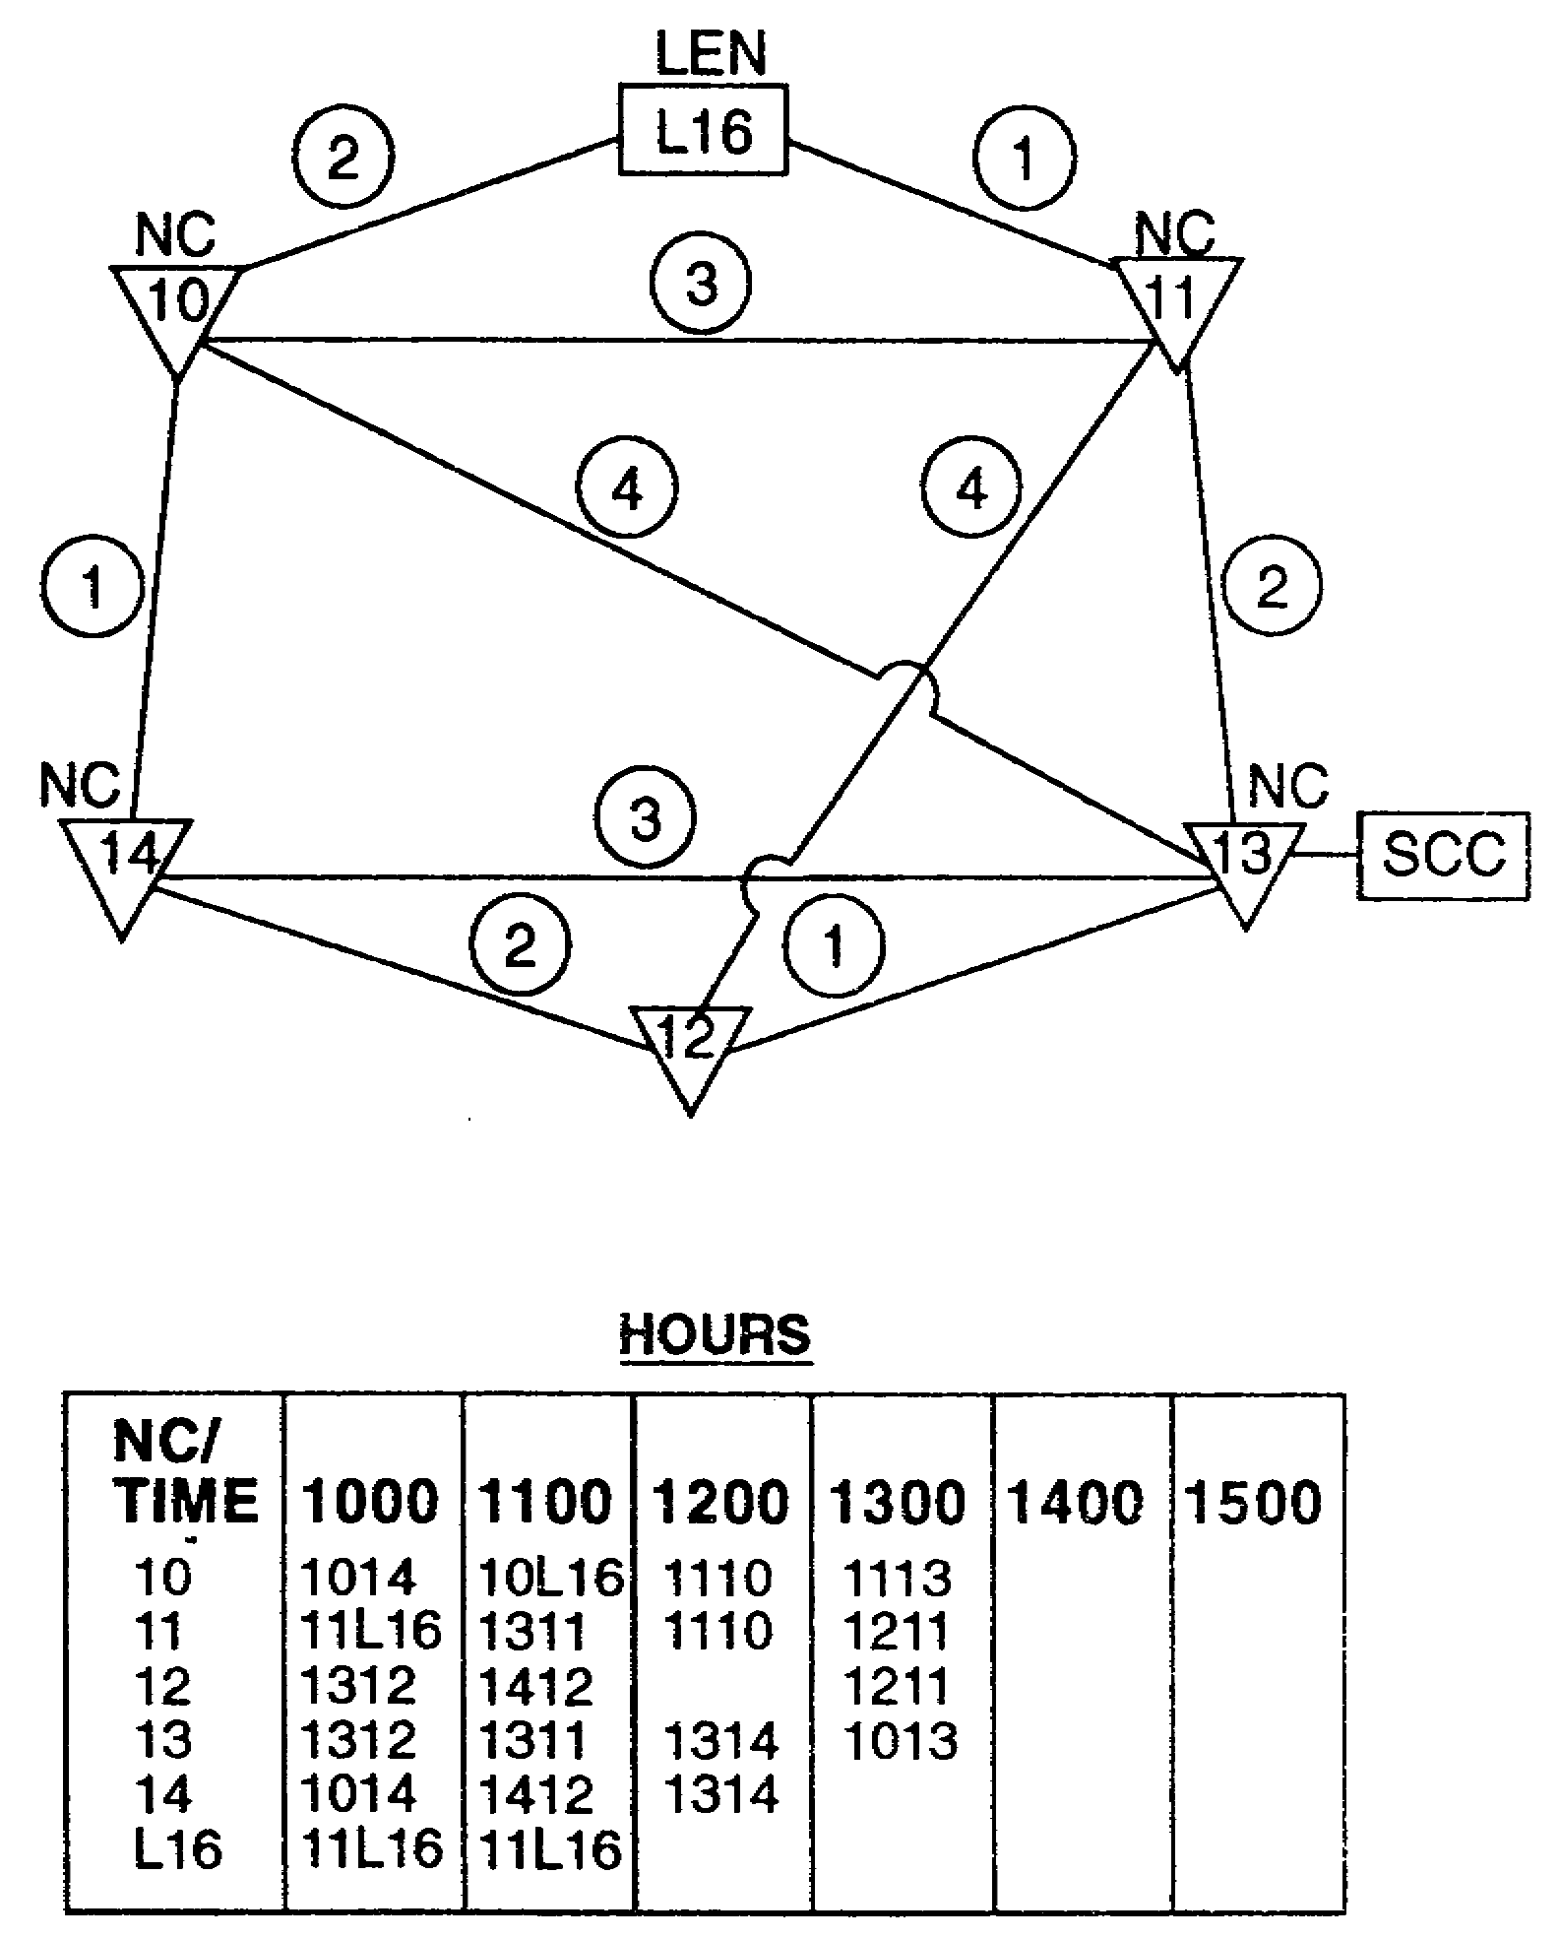

Figure 5-13. Priority listing.

(d) TROPO and TACSAT support is coordinated by the corps signal brigade for all requirements. Data rates and multiplex digital transmission group (MDTG) and DTG terminations must be determined to leave NCs with maximum flexibility.

5-19 SS0073
(2) External interfaces are links between various echelons such as EAC or allies. External interfaces or interfacing with other systems or echelons requires detailed planning and coordination. Examples of these systems are EAC/adjacent corps through the Improved Army Tactical Command and Control System (IATCCS), TROPO or TACSAT, and North Atlantic Treaty Organization (NATO). The following are critical planning issues:

(a) TACSAT planning includes—

- Date and time the satellite is available to support the mission from the approved satellite access request (SAR).

- Type of satellite terminals used in the link and point-to-point or hub-spoke relationship.

- Type of link (MSE, Tri-Service Tactical Communications (TRI-TAC), Army Tactical Communications System (ATACS)) terminating equipment or switches, group rates, and any required data base changes.

- Coordination of trunk encryption device (TED) keys, common interswitch rekey (CIRK), and area interswitch rekey (AIRK) for MSE or TRI-TAC/EAC links. ATACS links are secured by the KG-27 and require the proper key list. There is no trunk encryption internal to the satellite terminals for MSE and TRI-TAC links.

- For timing, the NS and LENS have a very stable atomic timing source and should normally be designated as master when master/slave relationships are required.

(b) TROPO planning includes—

- Type of link (MSE, TRI-TAC), terminating equipment or switches, group data rates, cable modulation, and any required data base changes.

- Coordination of TED keys, CIRK, and AIRK for MSE or TRI-TAC/EAC links.

- Location of each terminal, propagation mode (LOS, diffraction, TROPO), transmit and receive frequencies, bandwidth (3 or 7 MHz), antenna azimuth, and horizon angle.

- The AN/TRC-170 (TROPO) which does not require timing from a slave source and normally should be allowed to act as the master.

(3) Internal and external interfaces require close coordination between gateways to ensure signal timing relationship, DTG numbering and channel assignments, digital editing, and COMSEC exchange to ensure successful switch interface.

SS0073 5-20
c. Echelon links. Other considerations for links into other echelons are physical location of both terminals and frequencies. Every effort should be made to provide maximum flexibility for both ends of the system. There is no substitute for close coordination.

d. RAU/MSRT deployment plan. The RAU network provides system access to mobile subscribers in planned corridors or areas. MSRT density is greatest along main routes of march and around CP locations down to the maneuver battalion CP level. The MSRT planning factor is 20 to 25 MSRTs per RAU.

(1) Before deployment, an SCC generates the frequency plan and transmits it to one or several RAUs for distribution.

(2) The SCC can generate up to 16 different plans (00 through 15). Only four plans are downloaded to the RAUs and MSRTS; and only one plan is in effect at any given time. Of the four plans downloaded, one plan is active, one is preactive, and the last two are in reserve.

(3) The downloaded RAUs are then positioned to serve as filling stations allowing the brigade signal officers (BSOs) to pick up the plans.

(4) BSOs are responsible for downloading the frequency plans to their unit MSRTs.

(5) After deployment, the RAU's marker beacon is turned on only at the direction of the SCC/SYSCON. The RAU's marker beacon must be turned off if the NS or RAU's extension link fails. This allows the MSRTs affiliated off the RAU to automatically reaffiliate with an operational RAU.

e. Other systems considerations.

(1) The NSs present software has a standard data base. This data base determines the allocation of the DTGs at the NS. Assigning DTGs is the basis for planning the NC site layout for cabling and antenna configurations. (See Figure 5-14.)

(a) The configuration established by the standard data base also defines the assignment of the nine channel mux-demux (NCMD) cards. The NCMD assignment determines the number or channels in each trunk group cluster (TGC). This assignment can be altered within limits to meet operational requirements. The limitations are defined in the NS operator's manual and in the switch initialization procedures. Data base changes should be the exception not the rule because changes cause control and troubleshooting confusion.

(b) All possible data base modifications should be done before leaving the motor pool. The operator of a large switch can store up to five data base modifications on a local data base tape. When doing a data base modification, always go from like data rate DTGs such as SEN to RAU or RAU to SEN, or higher to lower if possible.

5-21 SS0073
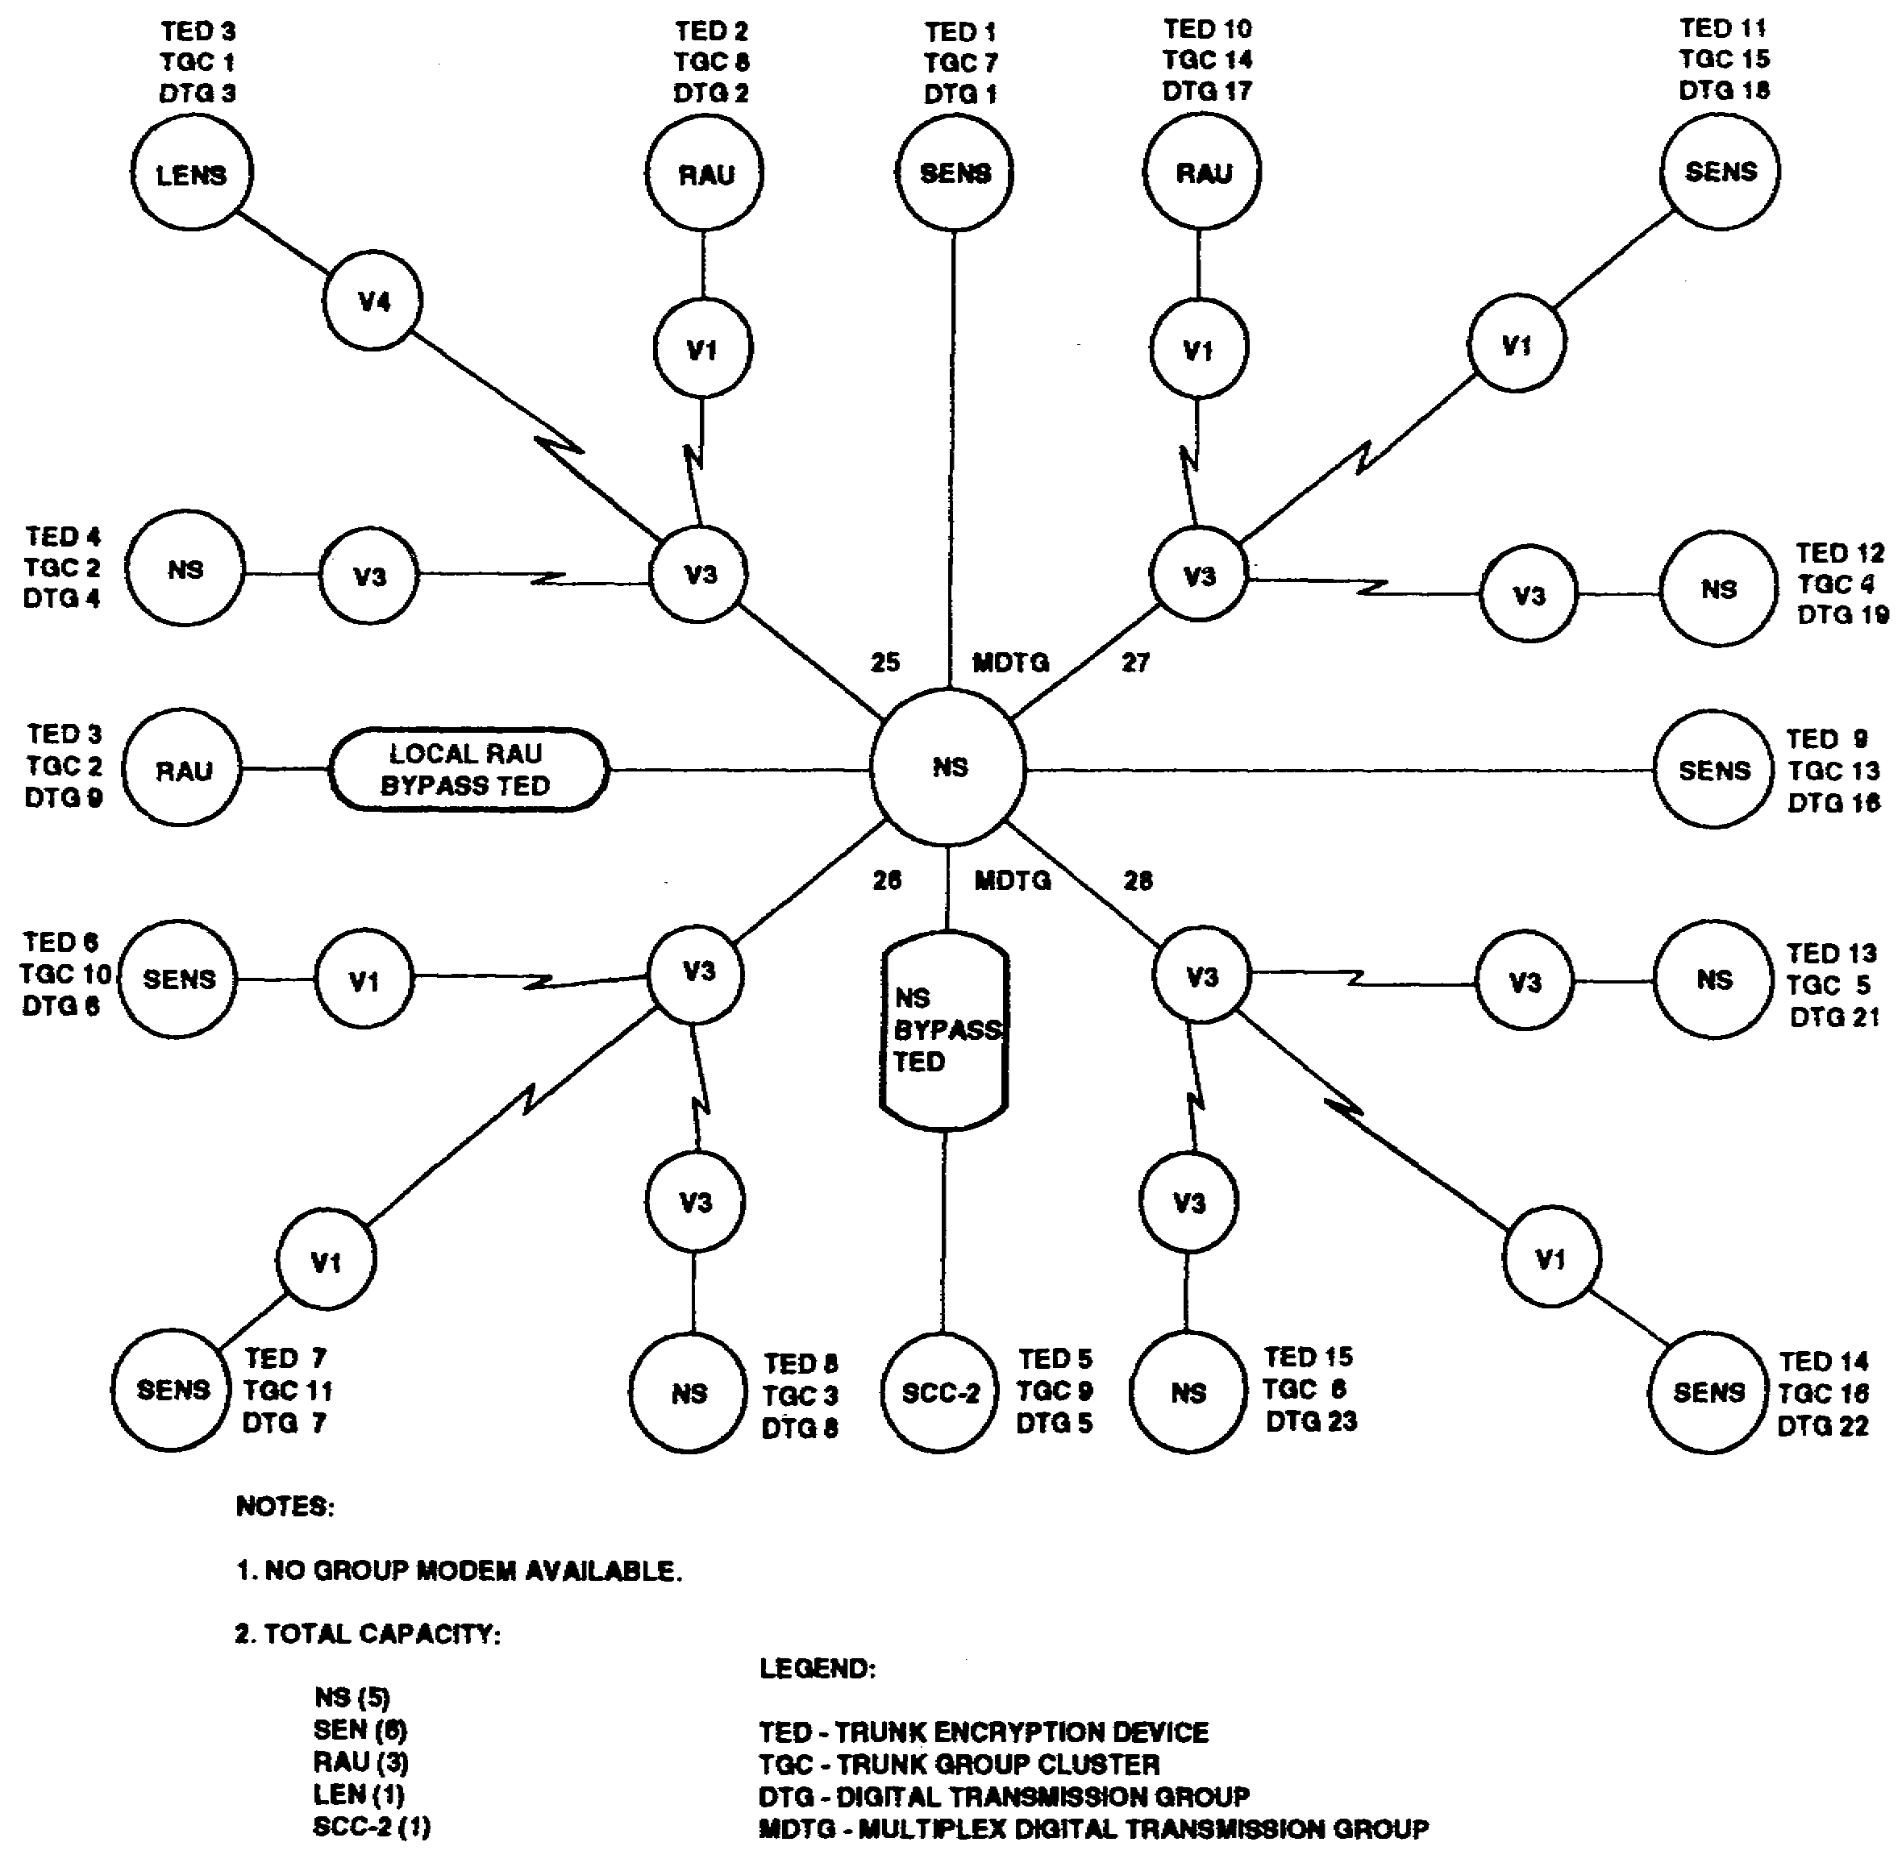

Figure 5-14. NS DTG/TGC standard data base.

(2) The LENS also has a standard data base which determines the allocation of its DTGs. Assigning DTGs is the basis for planning the LEN site layout for cabling and antenna configurations. (See Figure 5-15.)

SS0073 5-22
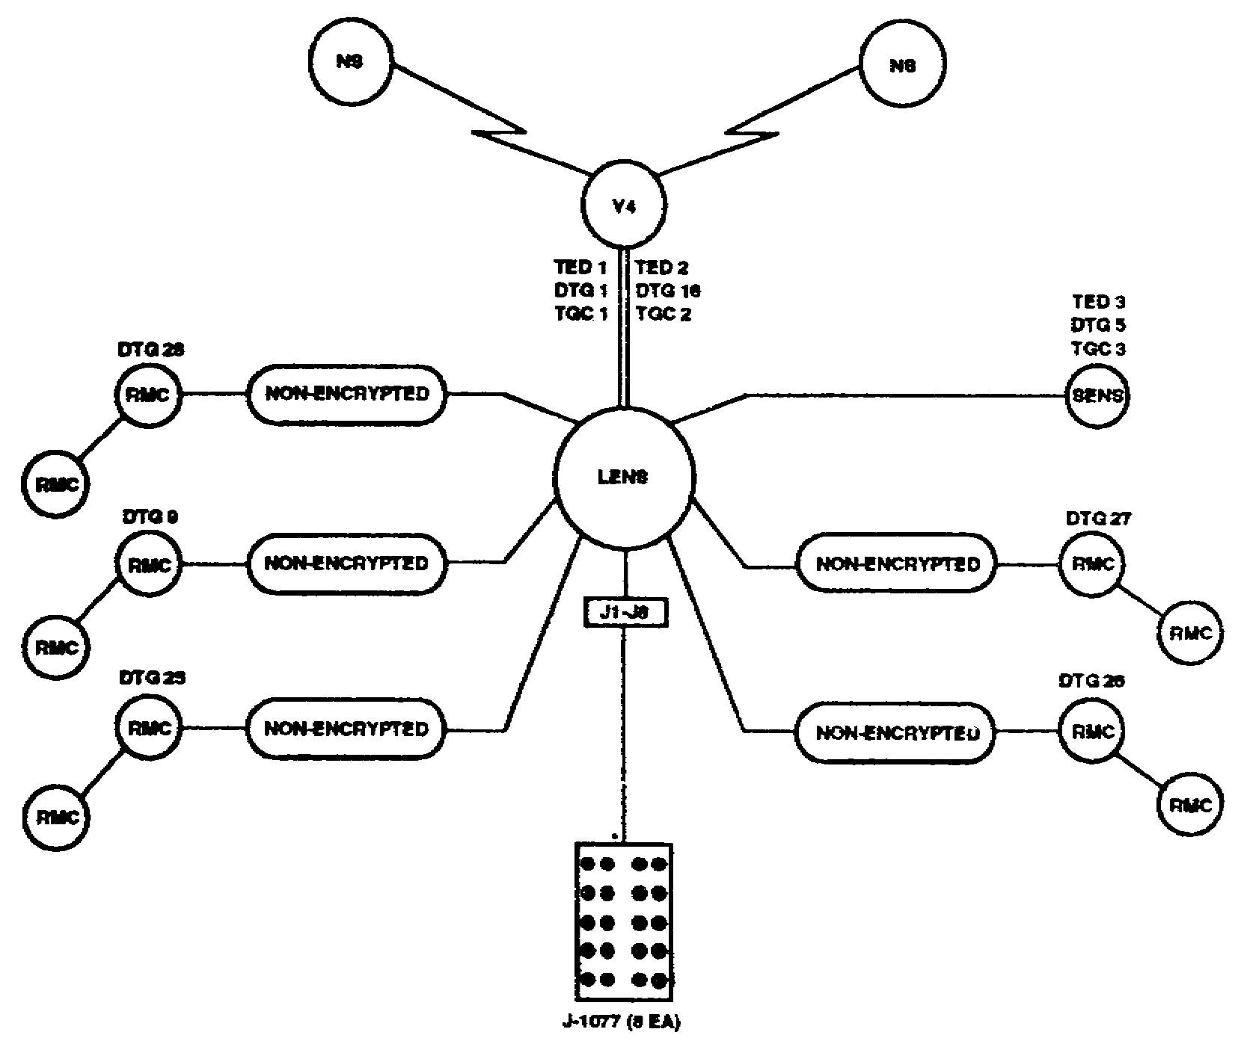

Figure 5-15. LENS DTG/TGC standard data base.

The configuration established by the standard data base also define, the assignment of the NCMD cards. The NCMD assignment determines the number of channels in each TGC. This assignment can be altered within limits to meet operational requirements. The limitations are defined in the LENS operator's manual and in the switch initialization procedures. The reassignment ability should be used only when needed. (See Figure 5-16.)

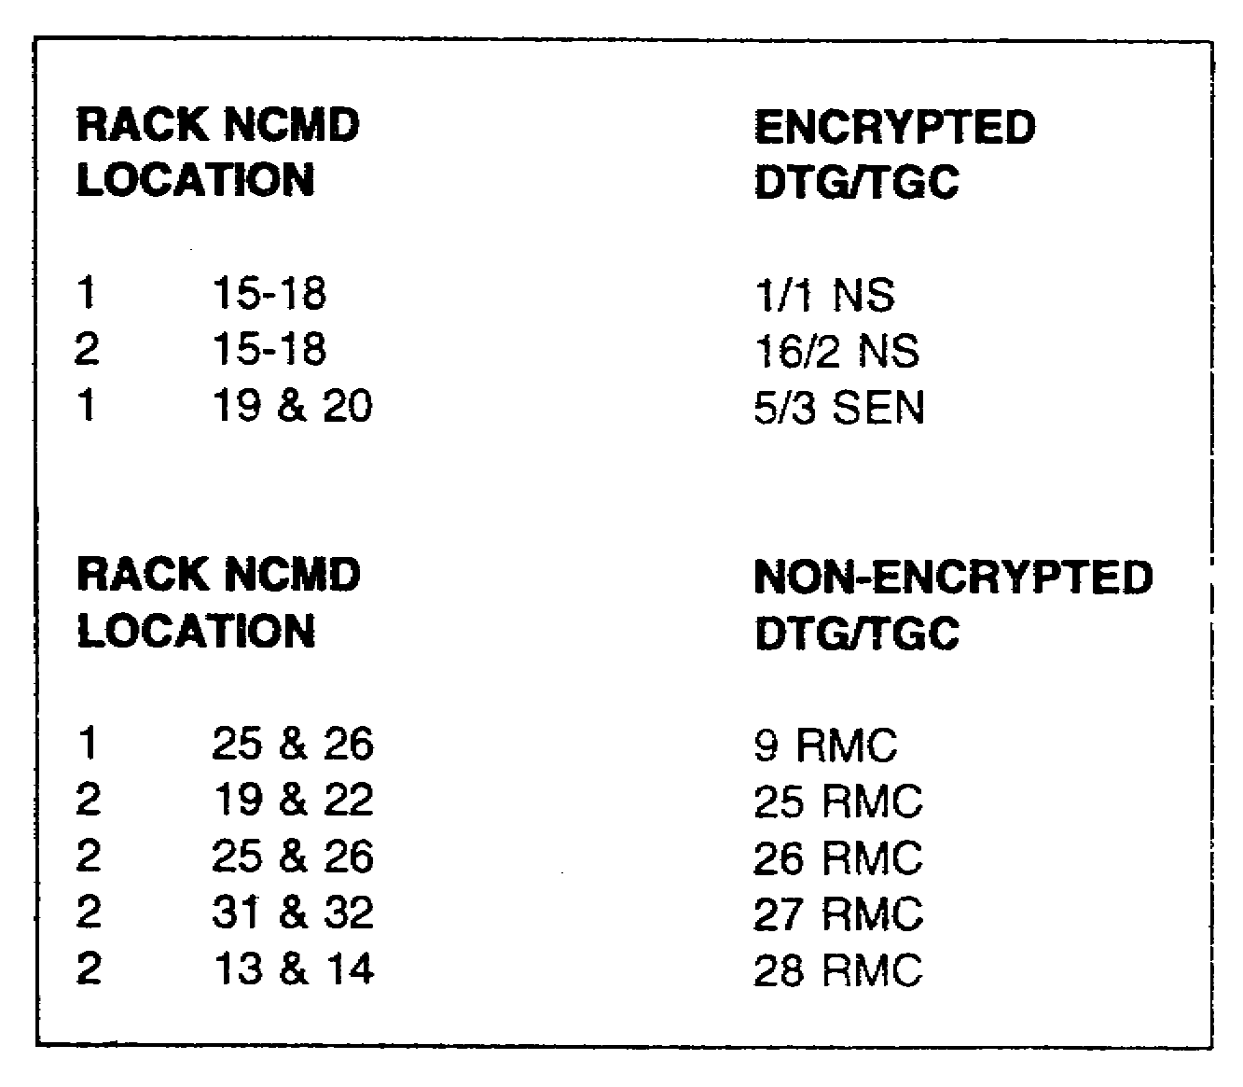

Figure 5-16. LENS NCMD cards.

5-23 SS0073
(3) Loading the permissive action link (PAL) can have major impacts on the MSE network. If the same PAL is loaded into two different switches, it can cause switch crashes or lost telephone numbers throughout the network. The SCC/SYSCON, OPORD, or unit SOP directs the loading of the PALs.

(4) Trouble numbers should be published in the telephone directory. This allows subscribers with: a problem to contact a centralized point for help without disrupting the large switch operators. The S3/SYSCON operates and staffs a help trouble number to assist subscribers with affiliation, COMSEC, or other related problems. This number should be located in the SYSCON thus providing a network perspective. The BSO consolidates trouble calls in his unit and forwards them to the SYSCON.

(5) The DVOW provides secure digital voice communications between local and distant LOSs, NSs. LENS, and SENS. Managing the DVOW's 16 ring tones and 6 DVOW or 8 CM channels is critical to keep the system running smoothly. The following management rules should be followed:

(a) The primary SCC/SYSCON develops the initial ring code assignments for all links. After deployment, the SCC/SYSCON may allow the NCs to manage their own ring codes.

(b) Any ring code conflicts or duplications that affect the DVOW system must be referred to the primary SCC/SYSCON.

(c) All NMFs must keep local diagrams showing all ring code assignments and changes to channel connections.

f. Team packets. Update team and equipment files before creating team packets. This prevents assigning systems that cannot be established. The SCC/SYSCON should generate and issue team ,packets at least two days before deployment. They contain the information needed to open and install the different elements of the MSE network. NCs may exercise OPCON over extension nodes outside their company. Team packets for these teams must be initially distributed to their organizational unit. Team packets should be issued by company to each NC, LEN, remote RAU, and SEN team. As a minimum, team packets should include the items shown below.

(1) Open team and open link orders for NCs, SENs, and RAUs assigned to the same company. Open team and open link orders provide—

- LOS frequencies.

- Azimuths and polarizations.

- Locations.

- Activation .times.

- System profile or margin.

SS0073 5-24
(2) Copy of OPORD for each NC and LEN.

(3) NC system recapitulation (RECAP) for platoon leaders.

(4) Team locations RECAP for each battalion administrative/logistics operations center (ALOC).

g. COMSEC.

(1) The planner must ensure the brigade network technician distributes the pre-positioned key set to the battalion network technicians. MSE will not work unless the correct keys are in the correct places in all equipment. Planners must coordinate with adjacent corps and EAC for gateway keys before deployment. A sound key management plan must be understood and practiced by all operators and taught to all subscribers.

(2) Issue pre-positioned keys IAW COMSEC to teams on the day of deployment or in the staging area. The ACSO and ADSO coordinates COMSEC key distribution to all corps and division MSRT users.

(3) COMSEC accountability must be maintained for all keys distributed to each element in the network. Pre-positioned COMSEC keys at specified locations ensure the switches and users have their respective keys needed to operate the specific pieces of equipment such as switches, MSRTs, and RAUs. The accountability process provides the feedback required to accurately determine where keys are located throughout the network. COMSEC manager work sheets are designed to help network managers plan and conduct orderly distribution of COMSEC keys to MSE teams. Completed work sheets also provide an accounting record for initial key distribution.

h. OPORD.

(1) At the end of the planning phase, the OPORD is produced and distributed. The SCC with its automated abilities can greatly increase the efficiency of this process. For example, each successful LOS path profiling project that was completed during the planning phase can be printed and distributed to units responsible for installation.

(2) A schedule of events should be planned so the command knows exactly what is expected. The schedule should include the items below:

- A concept briefing to commanders and staff.

- A technical control meeting with platoon leaders, platoon sergeants, and switch supervisors. This meeting should cover how to perform MSE and non-MSE interfaces.

- A back brief to brigade/battalion operations.

- A final OPORD briefing to commanders, staff, and NC leadership. (At this time, issue the OPORD.)

5-25 SS0073
- The final team packets are issued to battalions for distribution to teams.

(3) The five paragraph format of the OPORD is still used. The following key points are mandatory when publishing MSE plans or annexes:

- Edition of data base tapes.

- COMSEC key distribution.

- Number of RAU/MSRT frequency plans and designation of the active plan.

- Location, distribution, loading, and priorities for PALs.

- Gateway area codes.

- Priority of where RAUs should provide coverage.

- SCC locations.

i. Site reconnaissance. As soon as the team knows where it will deploy, it conducts a thorough reconnaissance. For an NC, this usually includes the platoon leader, platoon sergeant, LOS supervisor, and NBC team. The NC's reconnaissance must be extremely detailed as site selection and layout are critical to network success. NC reconnaissance is considered complete when the platoon leader can fill out the NC. diagram showing at least—

- Antenna and LOS(V3) locations.

- RAU location.

- NS/NMF locations.

The LOS has first priority of siting, the local RAU second, and the NS/NMF last. The platoon leader also determines if the data base needs modifying. He also needs to back brief his command on his site layout.

(1) The platoon leader should try to keep an LOS(V3) in reserve. MDTG 28 should not be held in reserve because it can connect to two NCs. This is the bulk of internodal transmission paths available to the NC.

(2) Platoon leaders should always inform the SCC/SYSCON of situations that may affect the network and limit their site's flexibility. If the SCC/SYSCON is not notified, it has no way of knowing what is occurring on the ground. Consequently, the SCC/SYSCON will operate using false assumption and incorrect data. This will result in network failure.

SS0073 5-26
PART D - NETWORK MANAGEMENT OPERATIONS

1. Network operations begin when planning is complete and the OPORD is distributed. The MSE network must be responsive to the fluid needs of the Army Operations, and it must support the maneuver commanders. The MSE SCC's automation abilities aid network management operations. Signal managers use the SCC as the primary network engineering tool.

2. The signal brigade commander has technical control of all MSE assets in the corps slice. His area battalion commanders do not directly manage their assets. However, they are informed of their movement and status. This is unlike the DSB commanders who have an SCC.

a. The DSB commander manages and controls his own assets. The CSO may designate certain areas of the battlefield to be technically controlled by a DSB commander and consequently his SYSCON.

b. The corps area and signal support battalions have the NCT (AN/GGC-66). It sends and receives messages to and from the SCC. The battalion may request information from the SCC at any time. When an action takes place concerning one of the MSE teams, an information copy of the message is sent to the NCT. (Refer to FM 11-30 for more information.)

3. The SYSCON's primary mission, whether at corps or the division level, is to manage the MSE network including COMSEC keys. The COMSEC key manager is responsible for directing the initialization, generation, and activation of keys and for maintaining records on their use and location.

a. The SCC cannot generate or distribute keys. It must direct the primary node switch (PNS) to generate and transfer COMSEC keys. Normally, it is the NS to which the SCC is directly connected. The corps also designates an alternate NS. Normally, this is where the alternate SCC is connected.

b. The divisions must designate an alternate NS for key generation. The second NS must be informed or designated as possible backup if the PNS cannot perform bulk transfer due to equipment or hardware problems. However, the COMSEC manager must ensure the alternate NS has all the COMSEC keys needed to perform bulk transfer for each NS.

4. Installing the backbone (Phase II). This includes NS to NS connectivity, duplication and bypass, and bulk transfer (COMSEC).

a. In the MSE's operation, establishing and sustaining the backbone network (NC to NC link) is the most critical element. The objective is for a strong multilink system that allows the direct bulk transfer of key sets to all NSs/LENSs and RAU/MSRT frequency plans to all RAUs. Ensuring that a strong backbone is established before allowing subscriber connectivity

5-27 SS0073
alleviates work-arounds due to switch software, hardware, or COMSEC problems. This is also true for loading the permissive action link (PAL). All network managers, NS supervisors, and node officers in charge (OICs) must remember that a PAL is loaded only once. Network managers must designate which NSs load the PALs and keep track of PALs when they are loaded. (See Figure 5-17.)

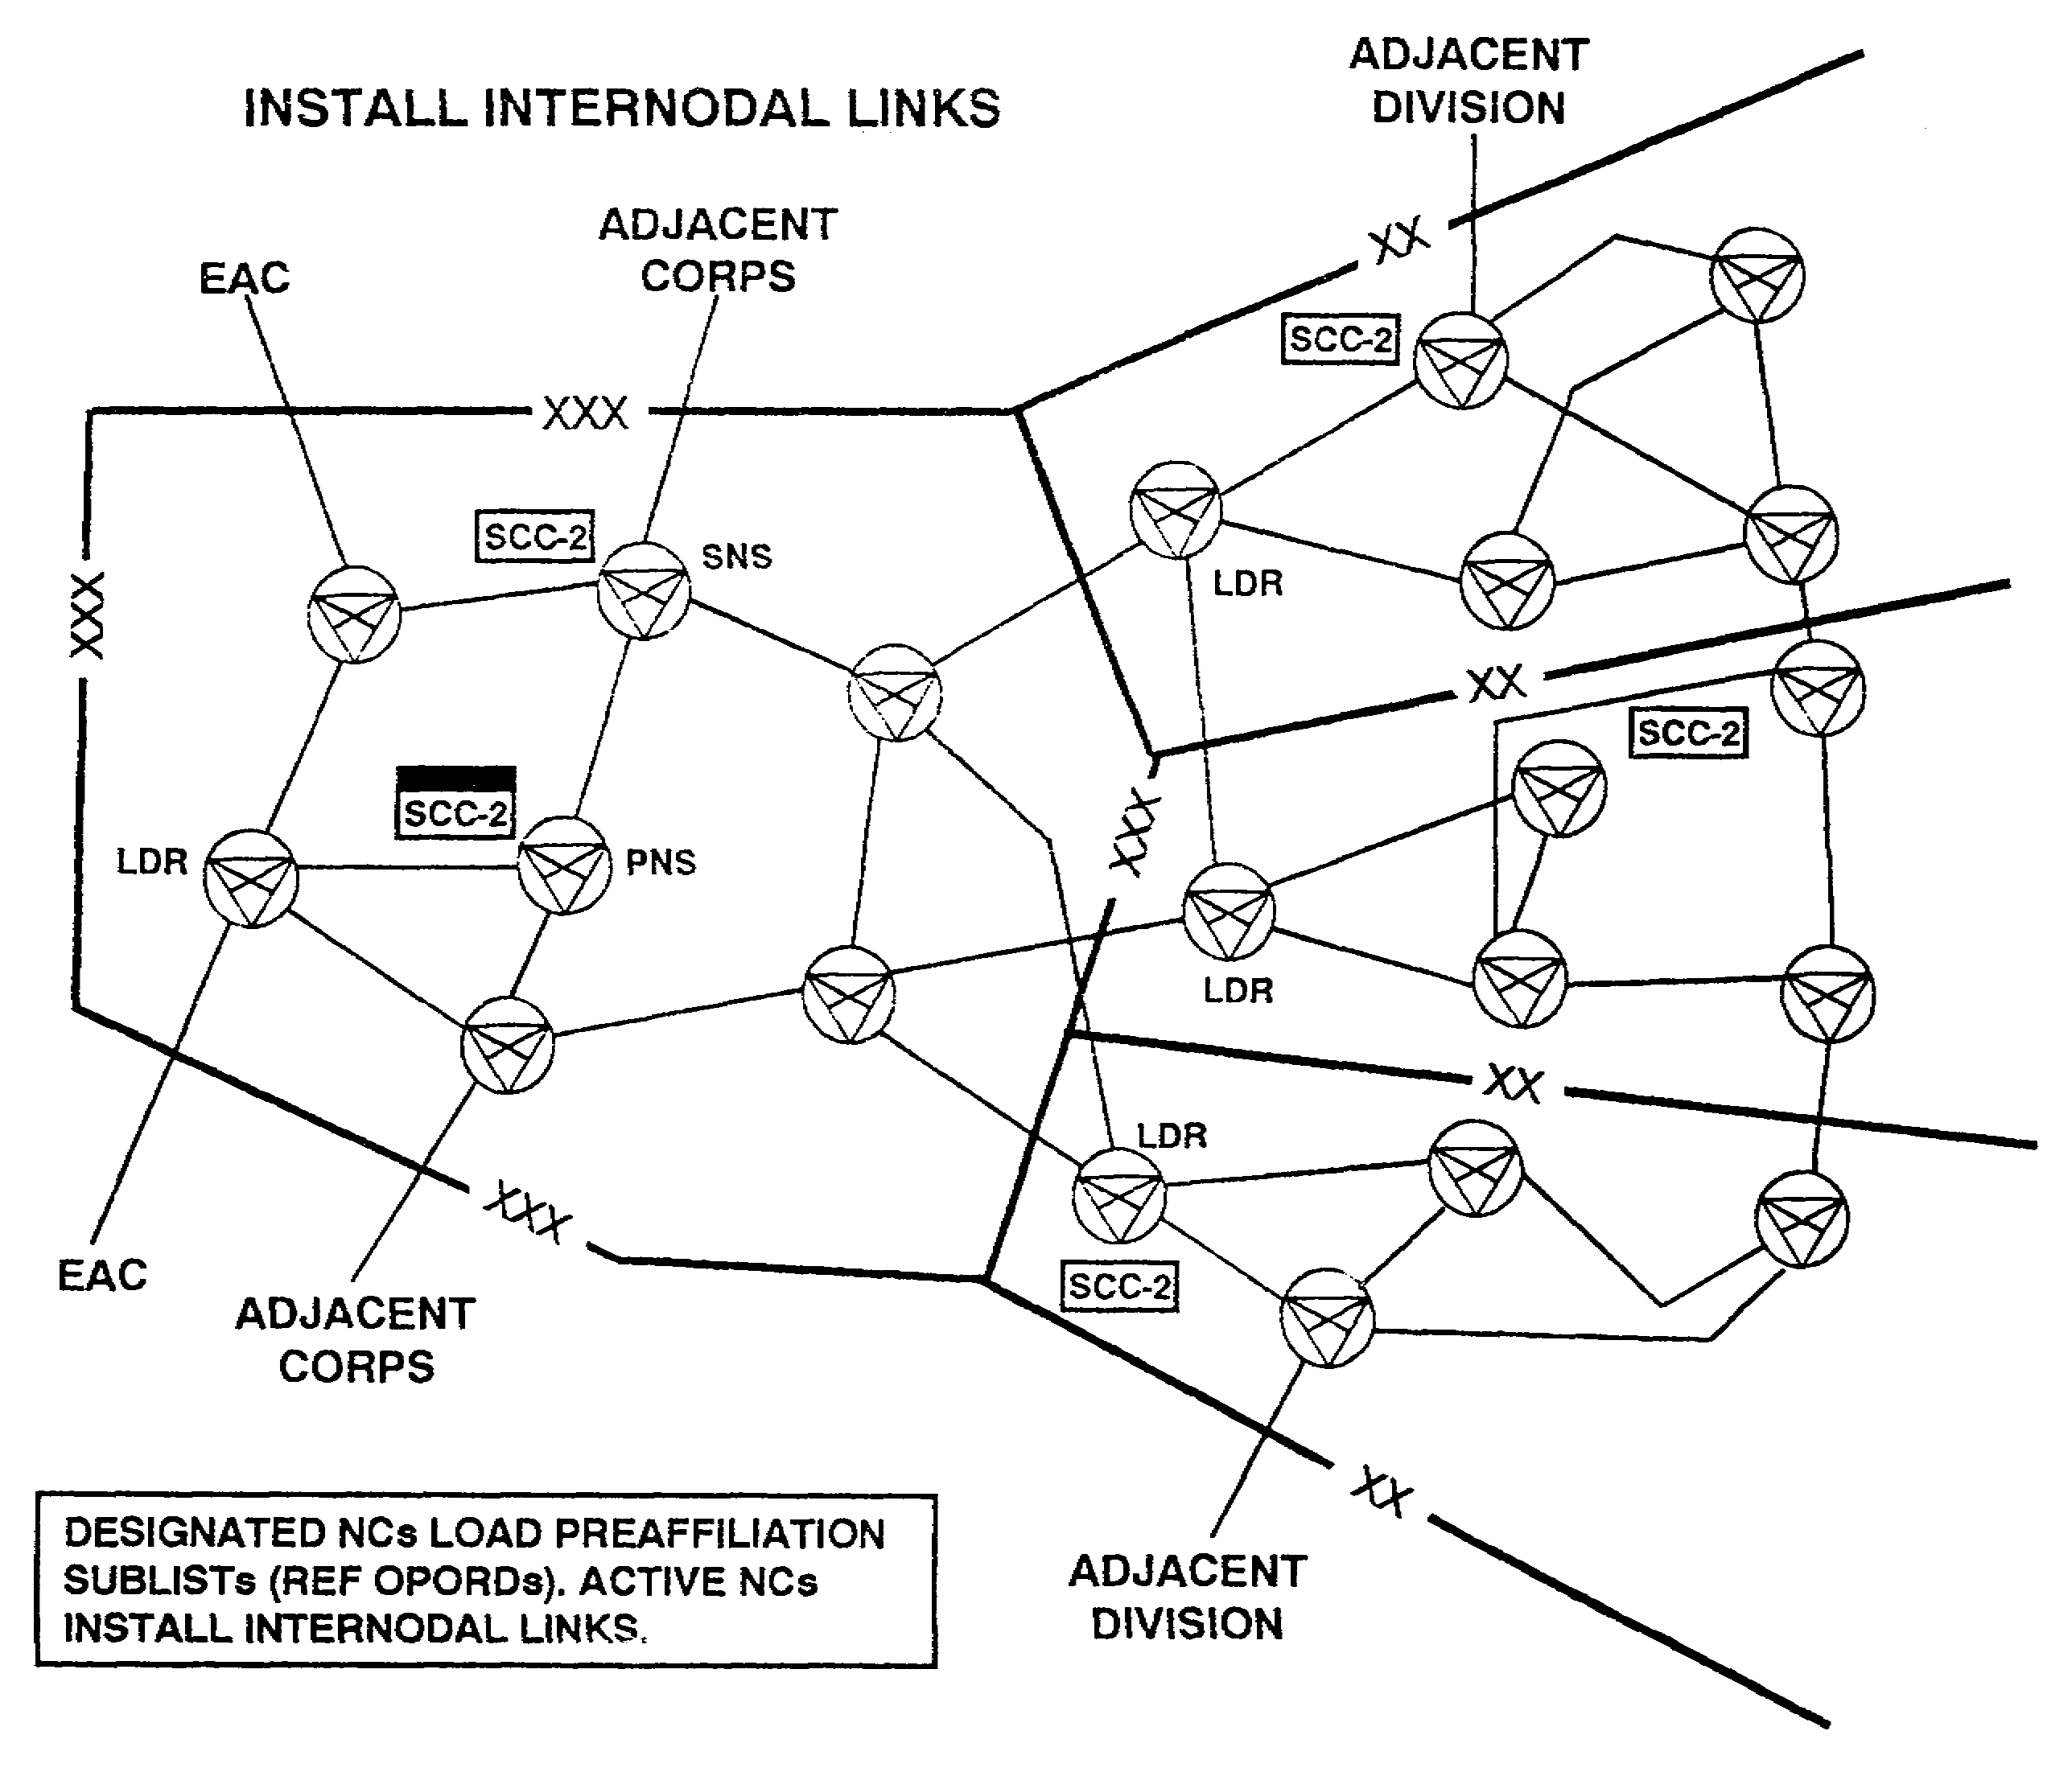

Figure 5-17. Phased deployment, phase II, internodal links.

SS0073 5-28
b. Once deployed, OICs follow OPORD procedures for priority of backbone LOS connectivity. All radio links may be worked at the same time; however, only one link may be engineered into the switch at a time. Duplication and bypass follow the link priority list. At this stage, node OICs inform the SCC/SYSCON of their NCs operation including messages back to the SCC. All NSs/LENSs must keep the duplication and bypass assignment printed and current. This information is vital when nodal links fail, or as NCs move throughout the network, or when redirection of duplication and bypass occur. (See Figure 5-18.)

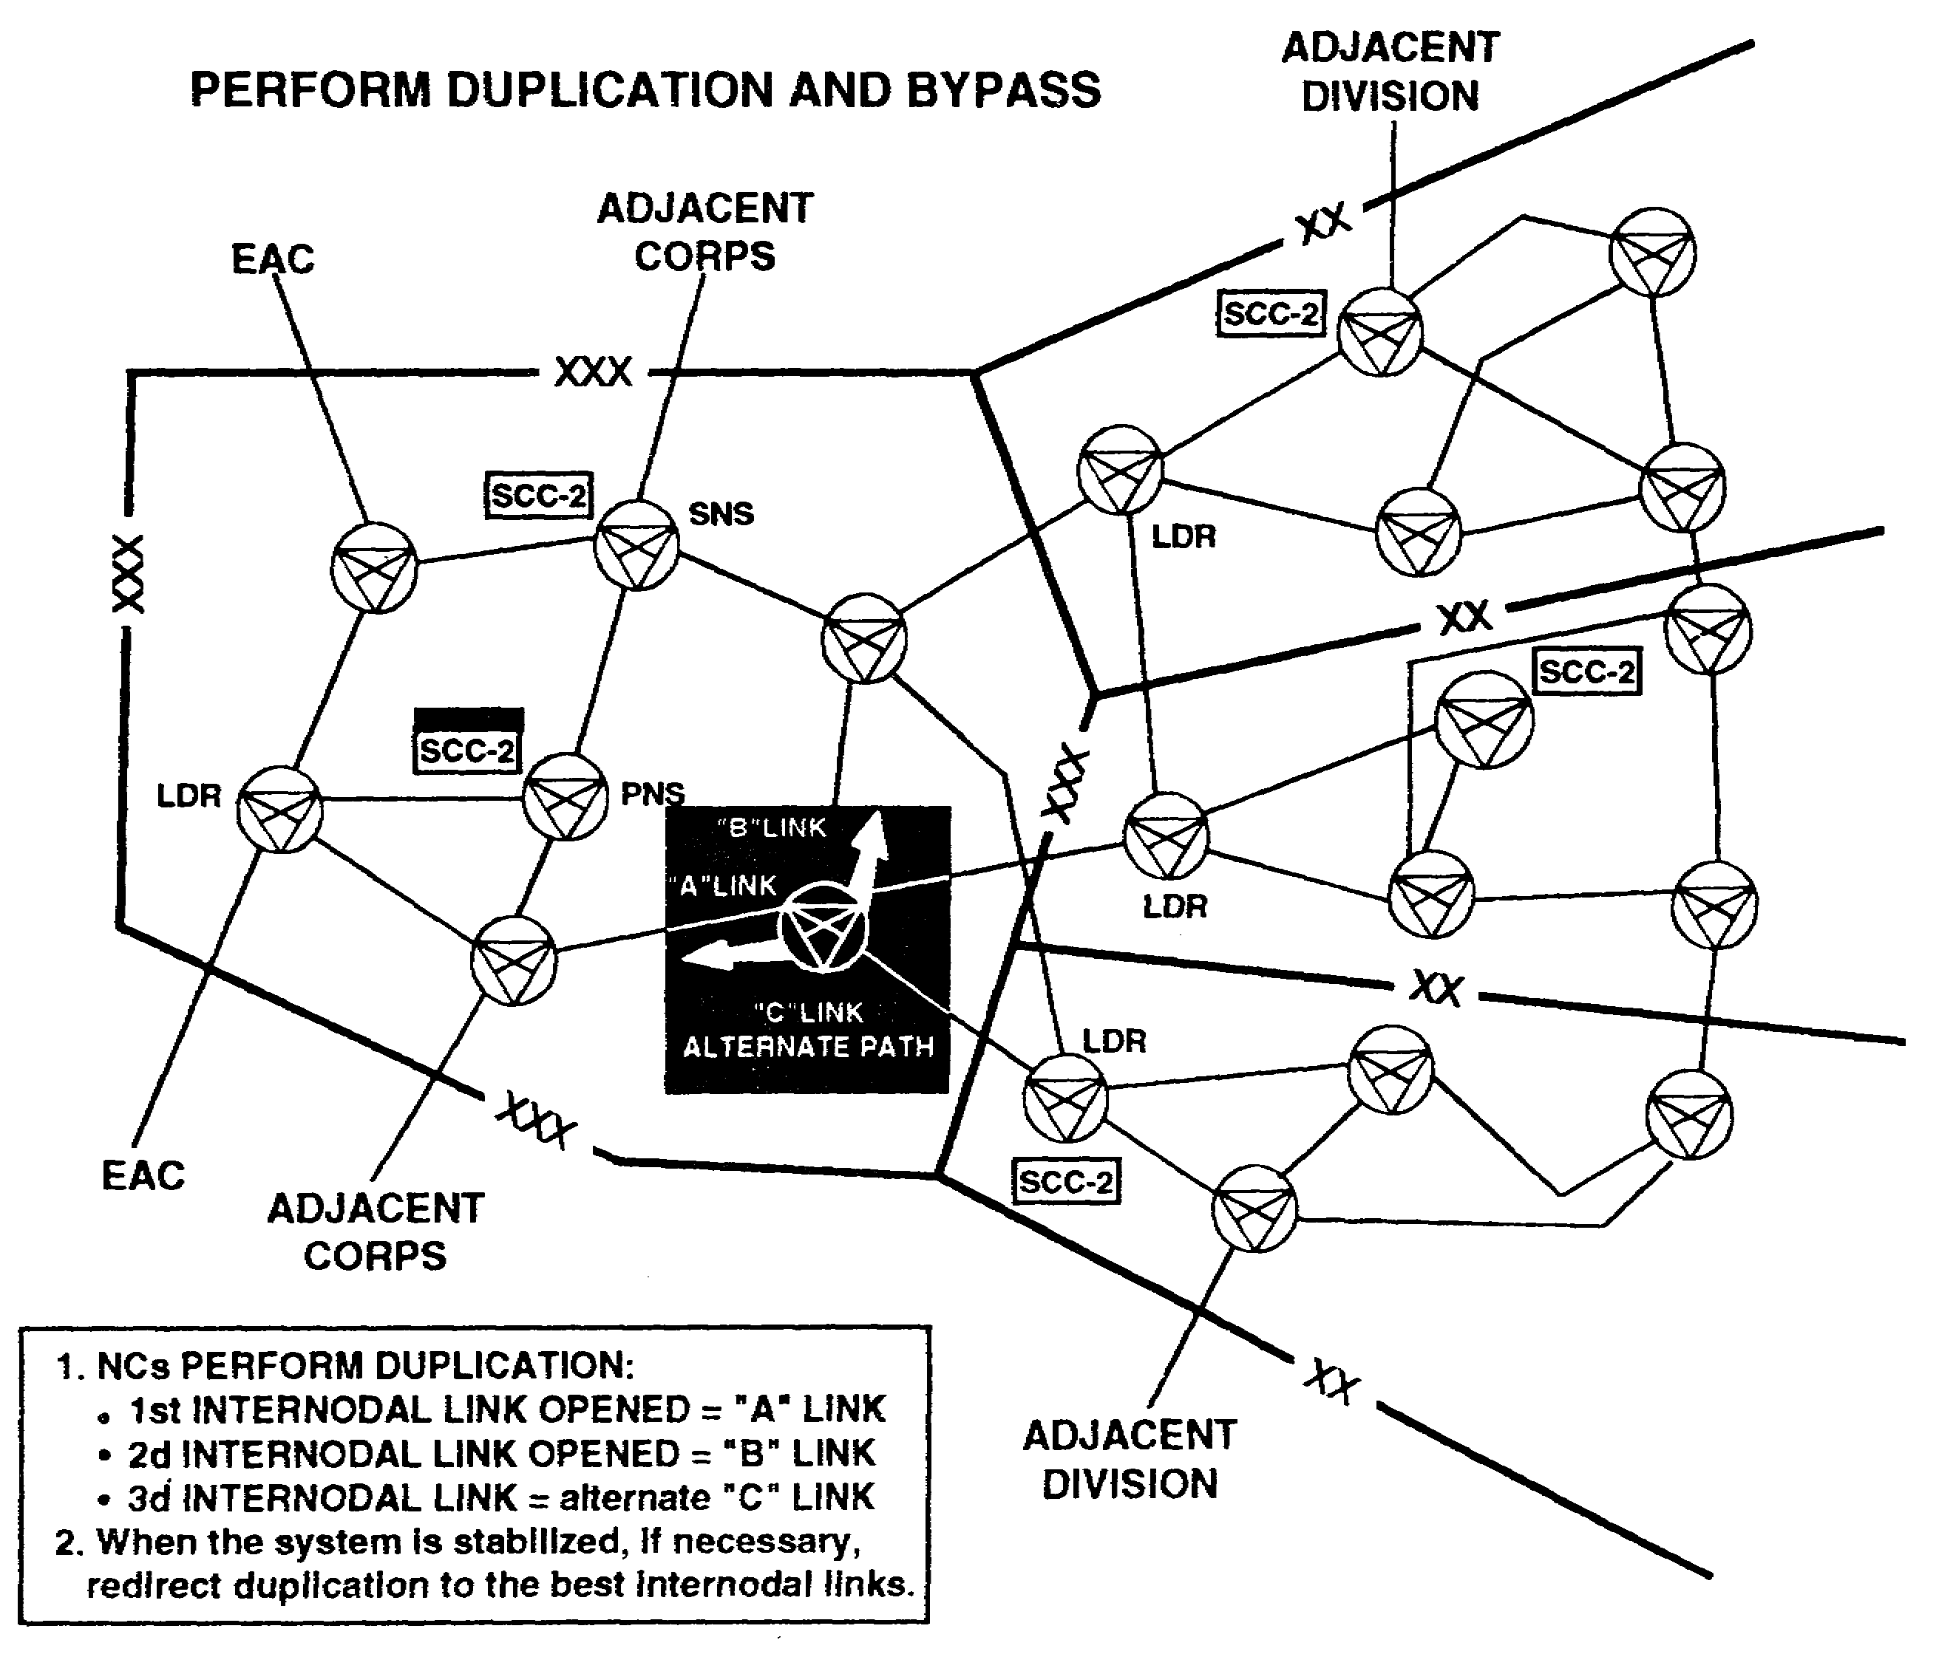

Figure 5-18. Phased deployment, phase 11, duplication and bypass.

5-29 SS0073
(1) As the first backbone link is established, the NS operator \verifies link
status. He uses the display interswitch link (DIL) screen before preparing to send
duplication and bypass to another NS. This ensures the link is initialized and a'
transmission status of 2 is established. Any other status is unacceptable. (See
Figure 5-19.)

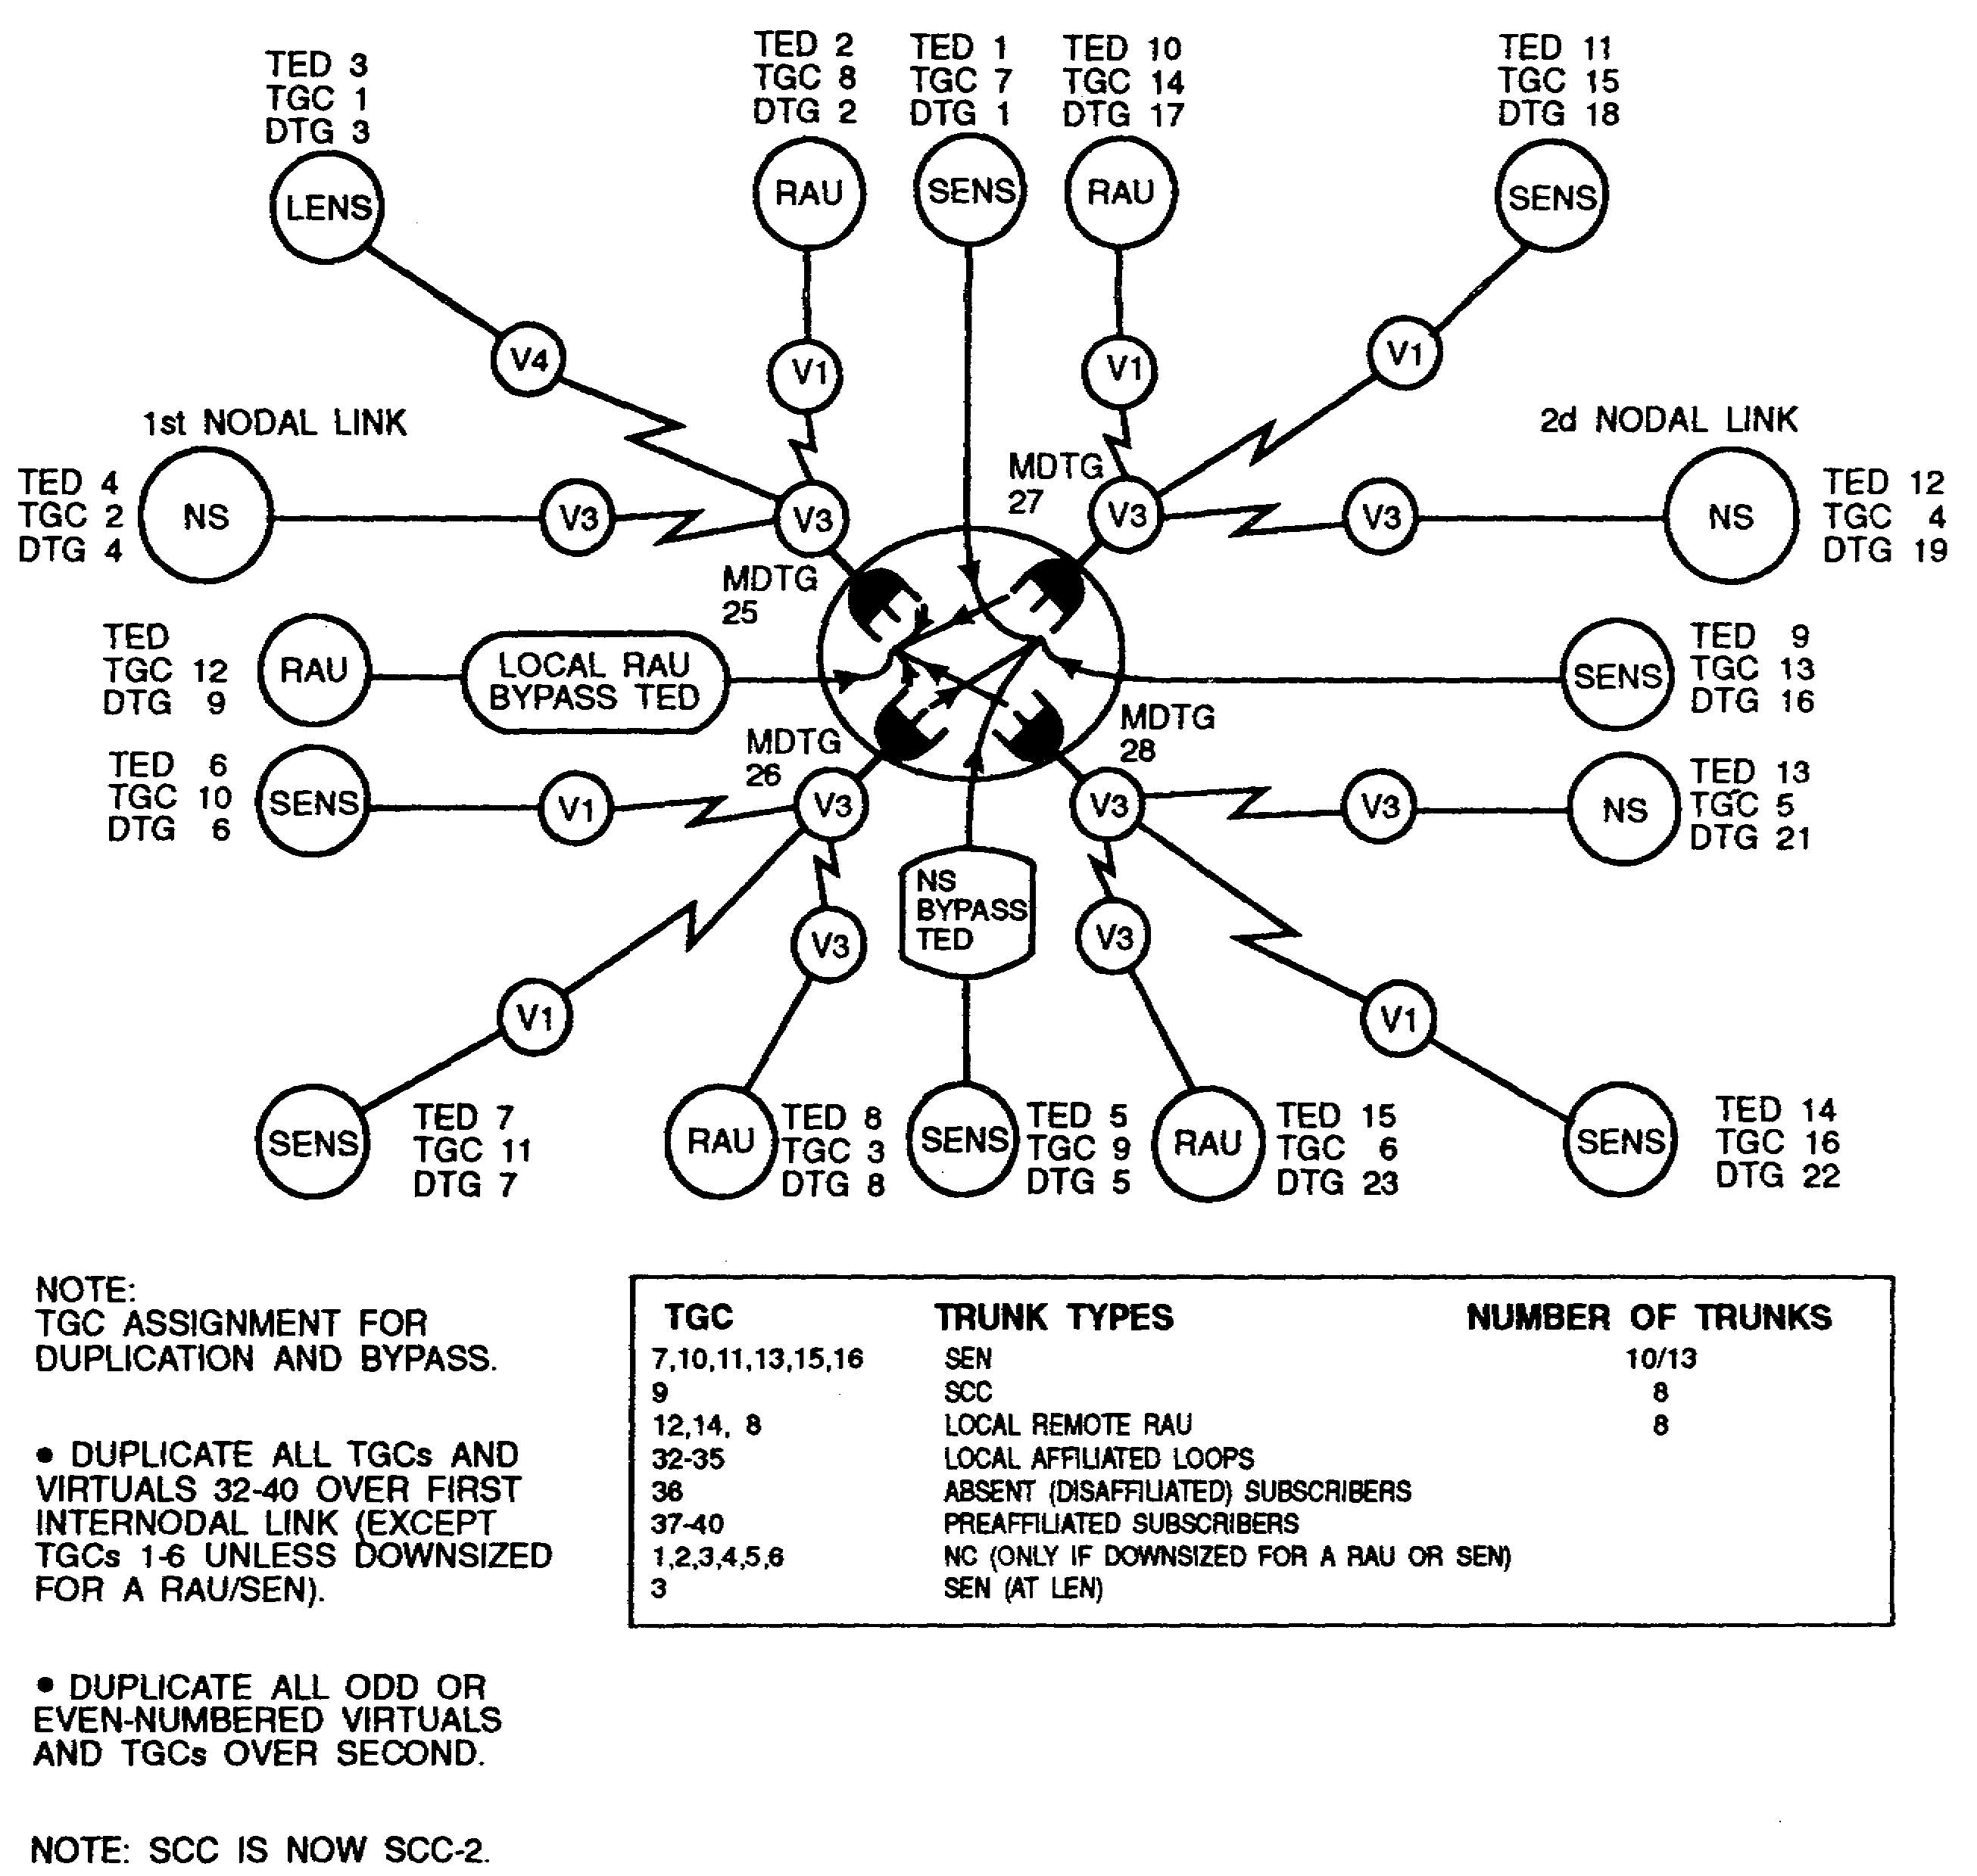

Figure 5-19. Duplication and bypass, first nodal link.

SS0073 5-30
(2) Once established, each NS duplicates all virtual trunk groups (32 to 40) and TGCs over the first backbone link. The exception is TGCs 1 through 6 unless downsized for a SEN/RAU. As the NSs continue to follow their priority list and the second backbone link is established, the NS operator deletes all odd-numbered TGCs and odd virtuals from the first nodal link and duplicates them over the second nodal link. (See Figures 5-20.)

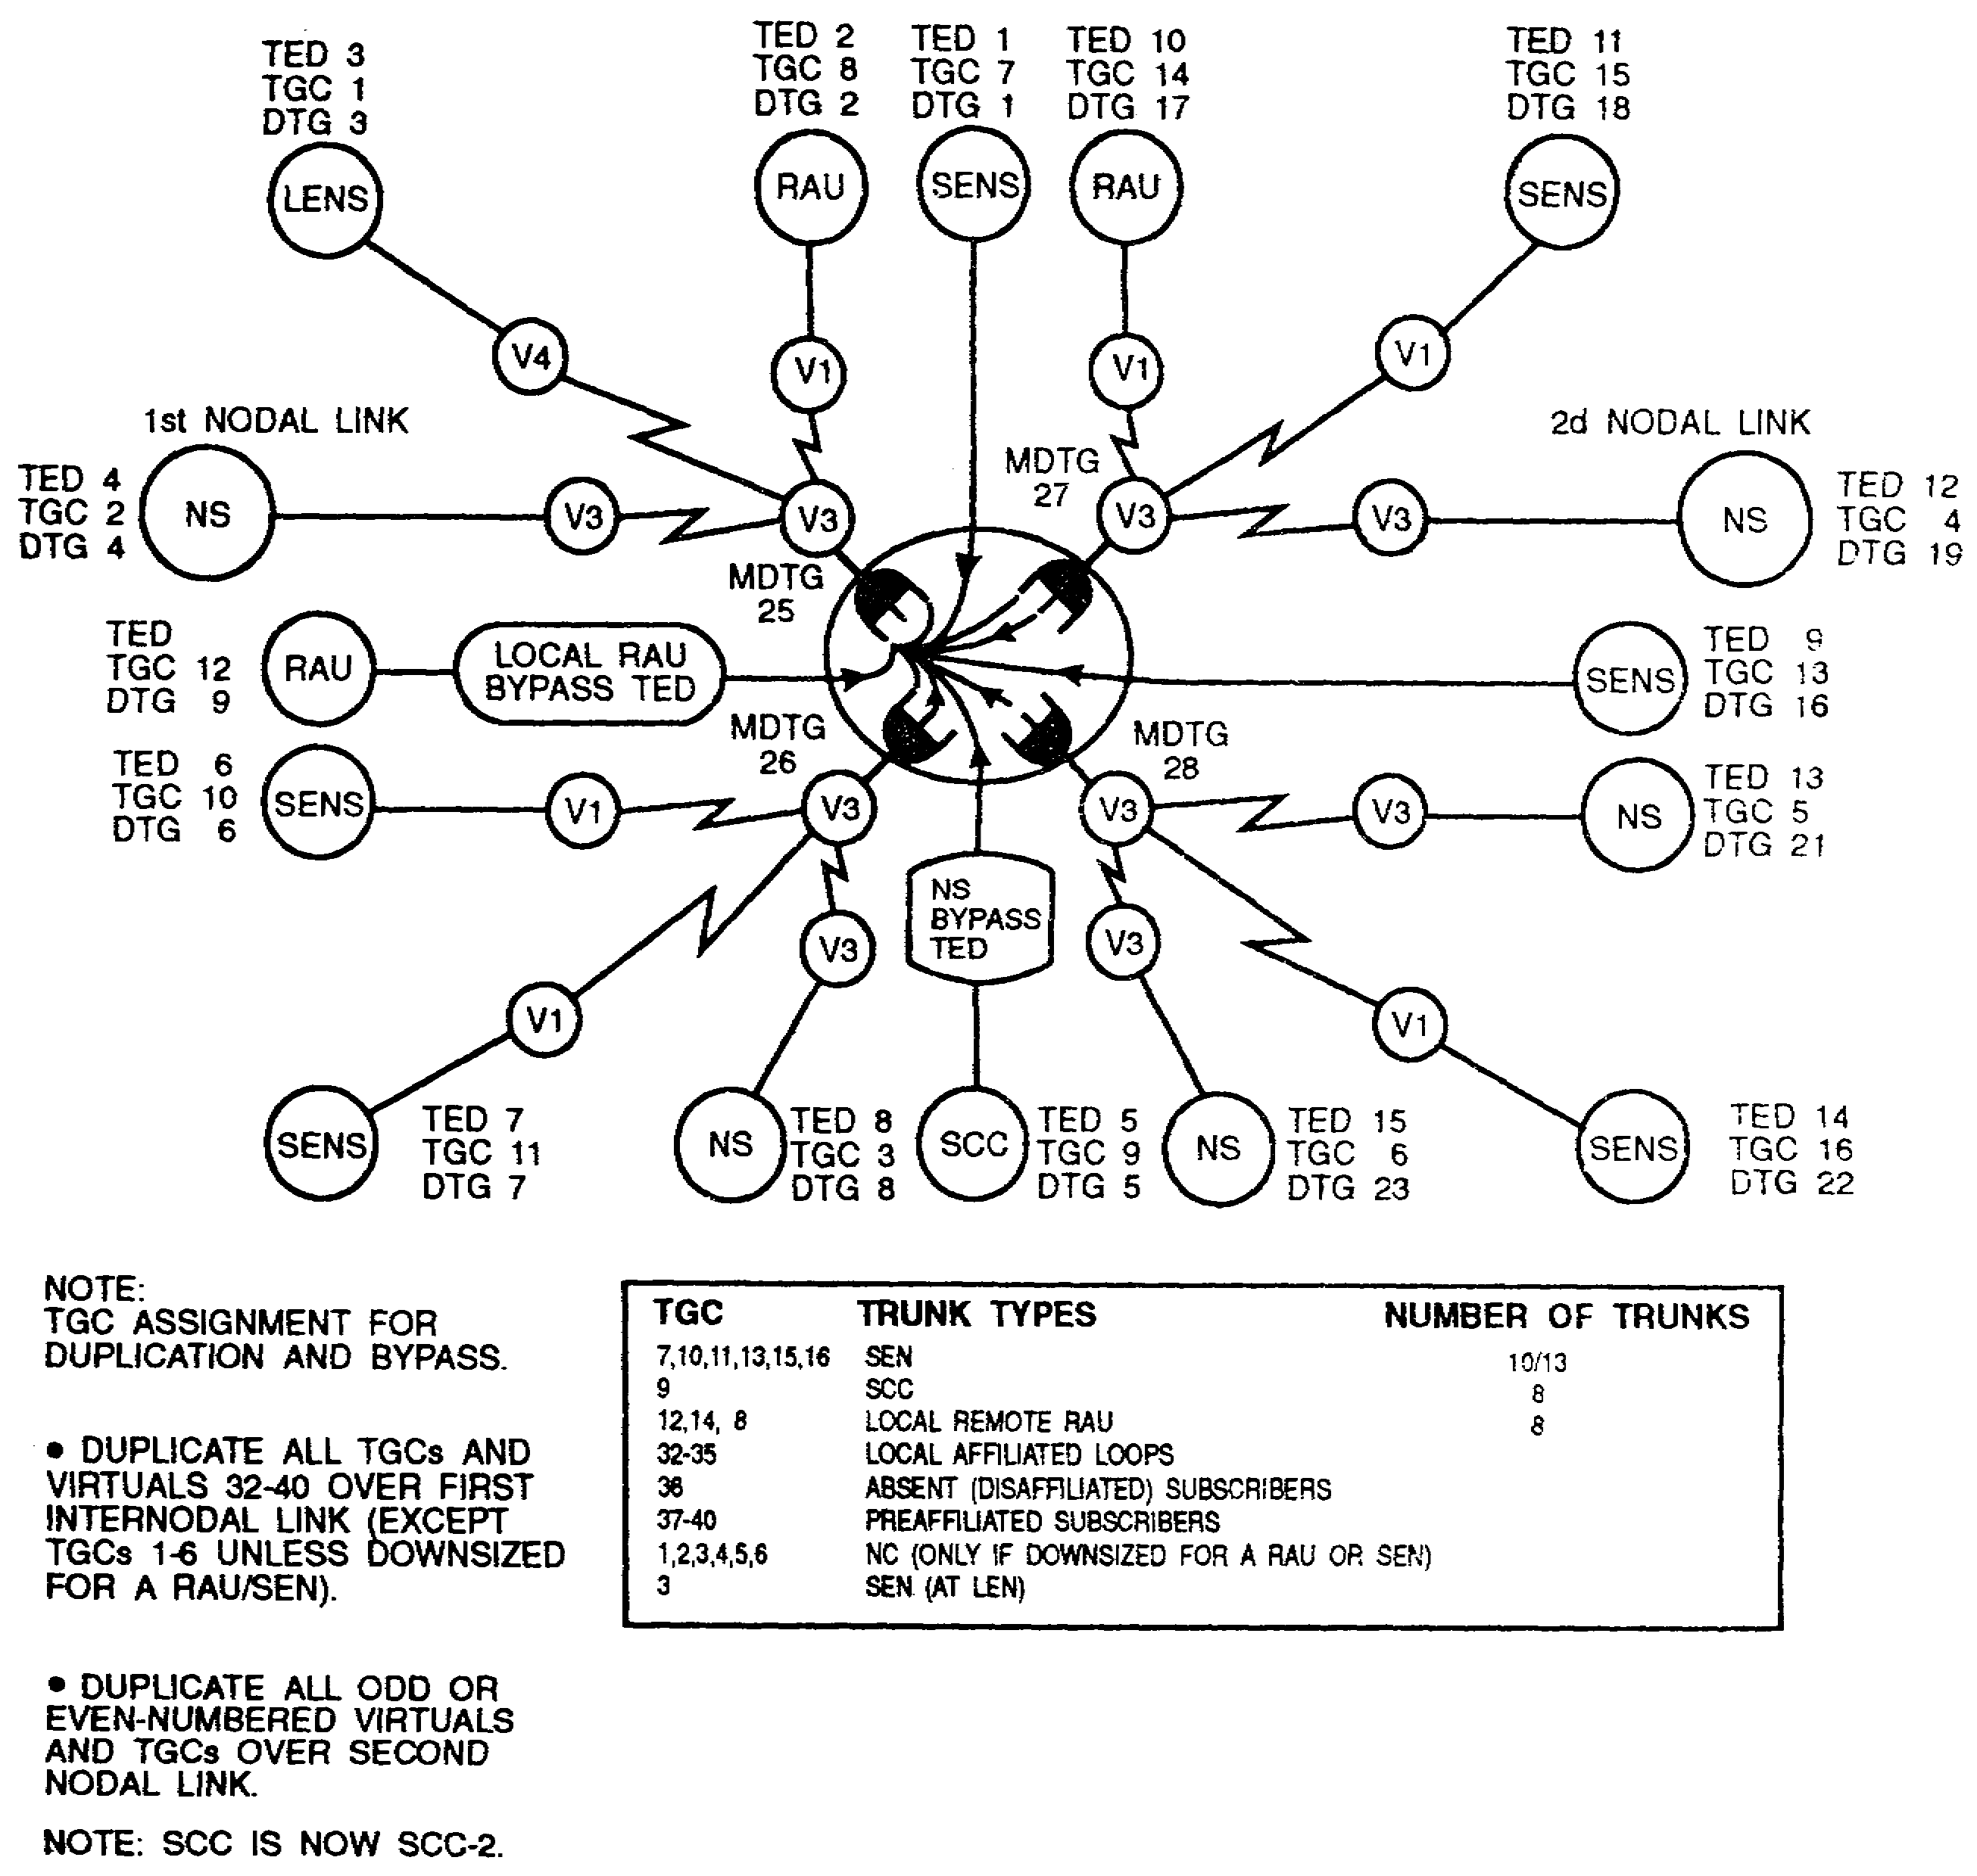

Figure 5-20. Duplication and bypass, second nodal link.

5-31 SS0073
(3) When the duplication and bypass process is complete and the backbone is operational, the NS operator performs bulk transfer of COMSEC keys. To establish a COMSEC error-free network, the bulk transfer of a master key set is sent directly into the correct hardened unique storage (HUS) locations from the leader switch to the subordinate NSs in that NSG. (See Figure 5-21.)

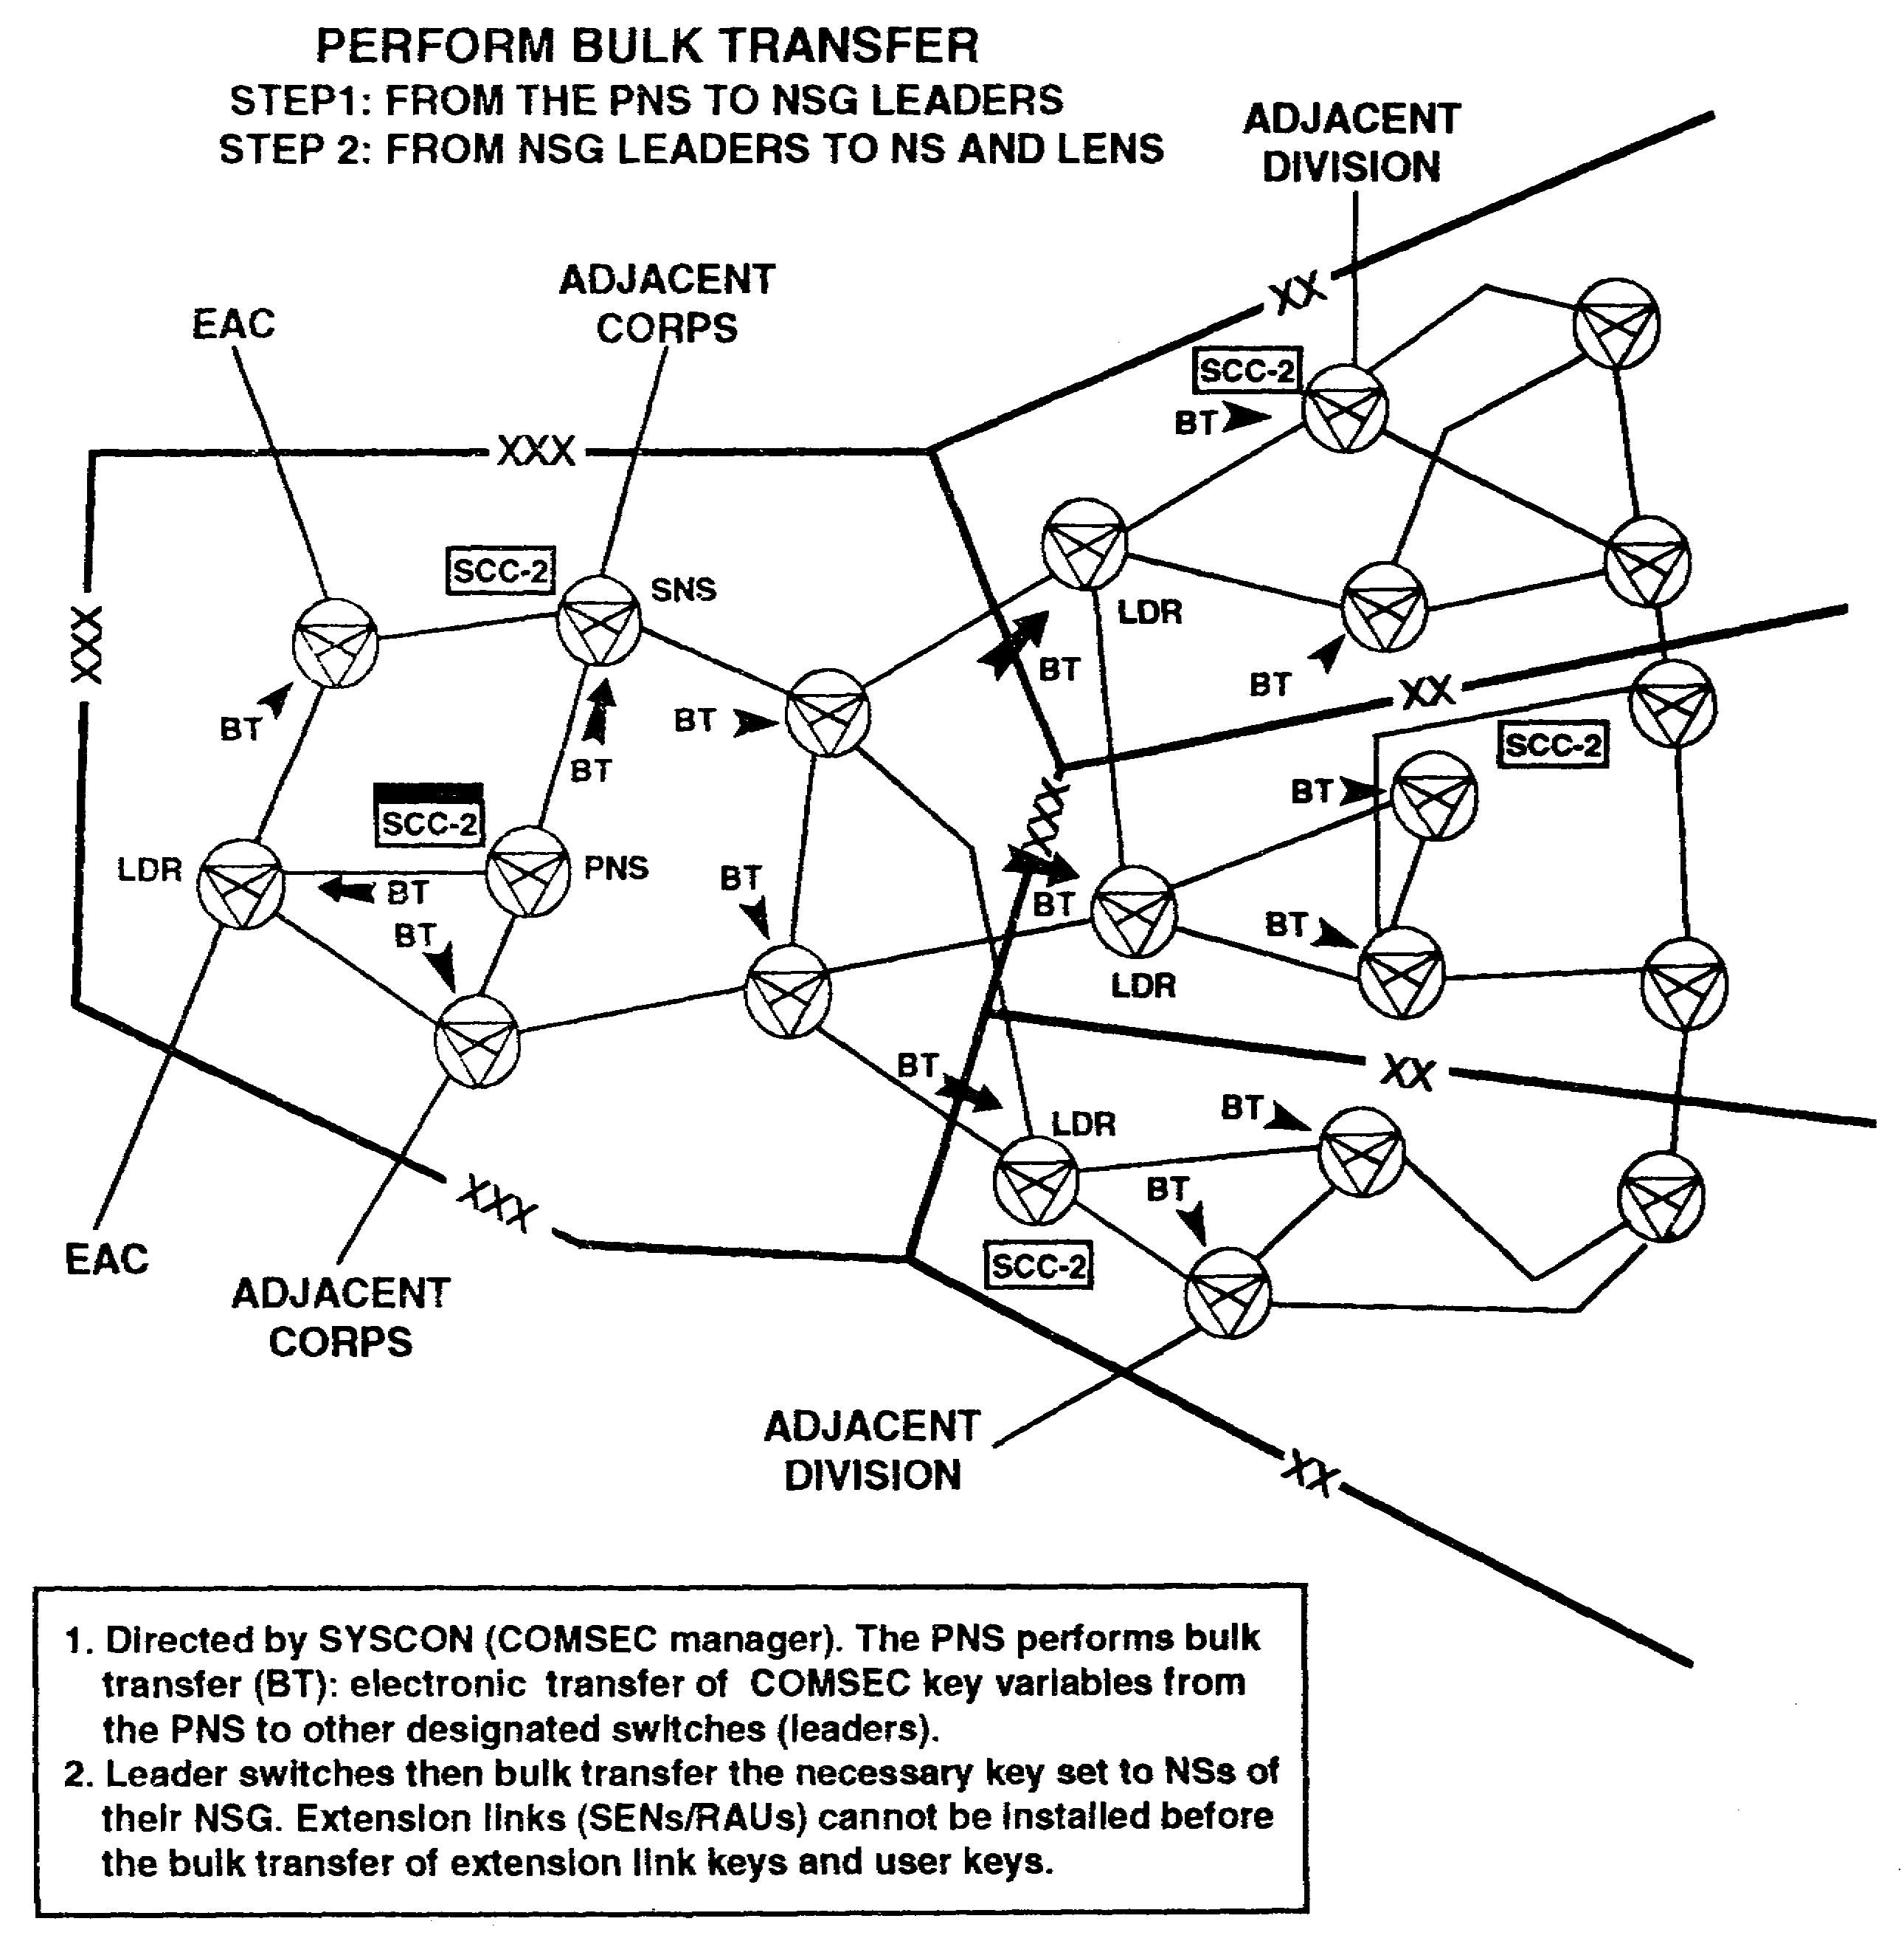

Figure 5-21. Phased deployment, phase 11, bulk transfer.

SS0073 5-32
5. Installing extensions (Phase III). This includes RAUs (local and remote) and SENS.

a. After installing the backbone network, the extension links are installed by priority for each NS. First, install local and remote RAUs to support mobile subscribers. The NMF notifies the RAU operator to affiliate the group logic unit (GLU) and his DSVT. (See Figure 5-22.)

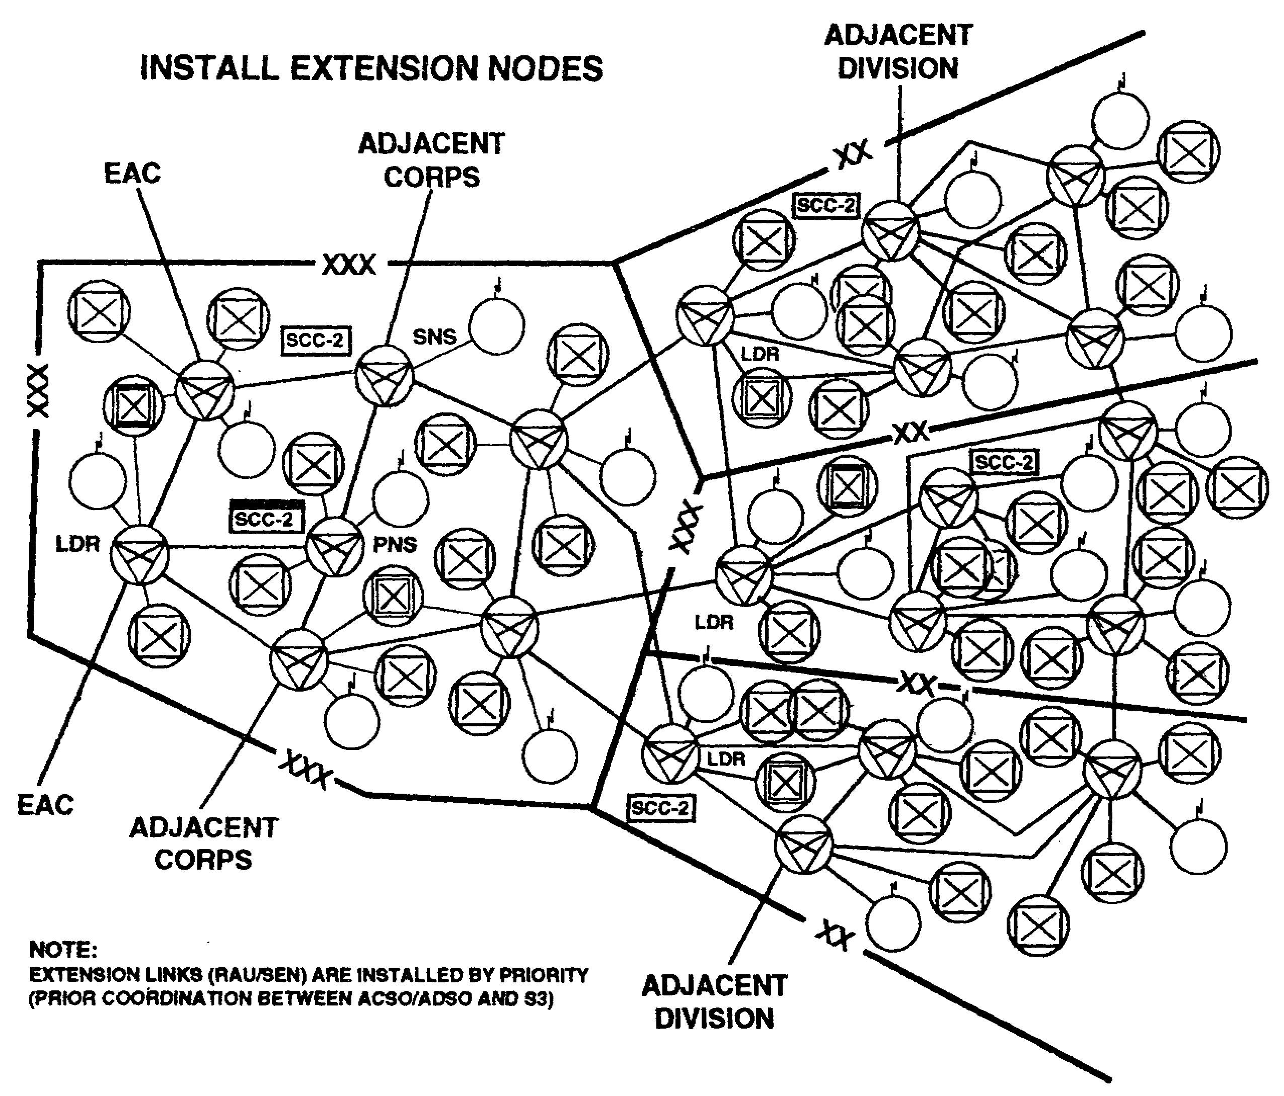

Figure 5-22. Phased deployment, phase III, extension nodes.

5-33 SS0073
(1) Once the GLU is affiliated, the NMF generates a frequency plan request message for each local or remote RAU to the SCC. This is not required if frequency plans are already distributed before deployment. The SCC then automatically sends the frequency plan to the GLU. The RAU operator calls the call service position (CSP) of his NS to ensure the RAU can process calls. This process ensures that the COMSEC keys are in the proper HUS locations before providing mobile subscriber access into the network.

(2) If problems are encountered, the SCC/SYSCON must be notified. These problems must be corrected before the RAUs turn on their beacon. On direction from the SCC/SYSCON, the NMF directs the RAU operator to turn on his marker beacon. However, the NMF must direct the RAU to turn off the marker beacon if the NS fails. Once the NS recovers, the operator verifies his mode of operation and requests permission to turn the marker beacon back on. Modes of operation include automatic, forced, and inhibited.

b. The SEN teams deploy to supported CPs and provide service for static wire subscribers. They install distribution boxes (J-1077) and enforce cable/wire tagging procedures. The SEN operator initializes the SEN switchboard (cold/warm start procedures) used in either a stand-alone or MSE network configuration and loads the COMSEC keys required for operation.

(1) Once connectivity is established, the NS calls the SEN operator over the DVOW and directs him to affiliate his DNVT. The SEN operator affiliates his DNVT and calls the NS's CSP to verify if it can process calls. Then, the operator notifies the BSO who notifies subscribers to affiliate their phones.

(2) The DSVT subscriber of an SEN must load the proper keys (U and M), affiliate his telephone, hang up, and wait for ring busy and nonsecure warning (NSW) lights to flash. The DSVT subscriber is marked out-of-service if he does not wait for ring busy and the NSW lights to flash. This requires the NS/LENS operator to delete the rekey identifier. For individual DSVTs, he keys I+26+NUMBER+R and for all DSVTs, he rekeys P+22+R and has the DSVT subscribers reaffiliate. If the SEN has a KY-90, the NS and SEN operators must ensure it can process calls.

(3) At this stage, NCs are using their priority list to install SENs. NCs must coordinate priority list changes with the SCC/SYSCON.

6. Operational management (Phase IV). This includes network management, COMSEC, subscribers, frequencies, switches, and teams and equipment.

a. Operational management begins after establishing the network. Operational management is maintaining an effective network that best serves the subscribers. Here, the SCC becomes an operations management tool for making additional changes. The information flow between all elements, units, BSOs, the ADSO, the ACSO, and the SCC/SYSCON becomes more important as the network changes and reconfiguration occurs. (See Figures 5-23 and 5-24.)

SS0073 5-34
(1) RAU coverage and frequency plans must be checked continuously. The SCC/SYSCON must be aware of all changes that affect the network. The NC's NMF must report frequency interference, equipment failure, COMSEC, and other problems to the SCC/SYSCON. To identify problems, several management screens at the primary SCC need to be printed periodically. These printed screens aid in making network decisions when subscribers jump and equipment fails.

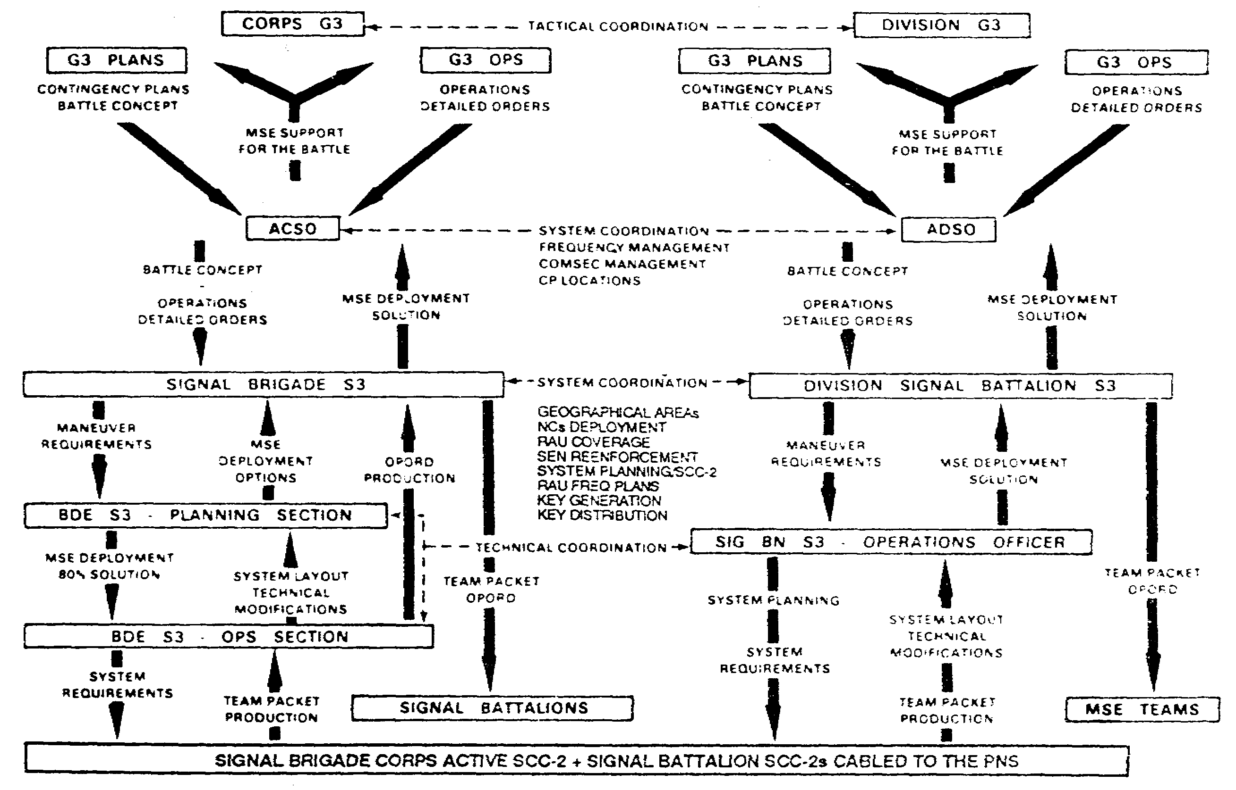

Figure 5-23. MSE planning flow in a corps scenario.

(2) The RECAP screens are printed, reviewed, and stored in the station log book. This log book should contain at least-

- Link data, RECAP of all planned and in-use internodal and extension node links.

- Authorized and restricted LOS/SHF frequencies.

- Current RAU/MSRT frequency plans.

- Current location of all assemblages.

- Subscriber management cell operations.

5-35 SS0073
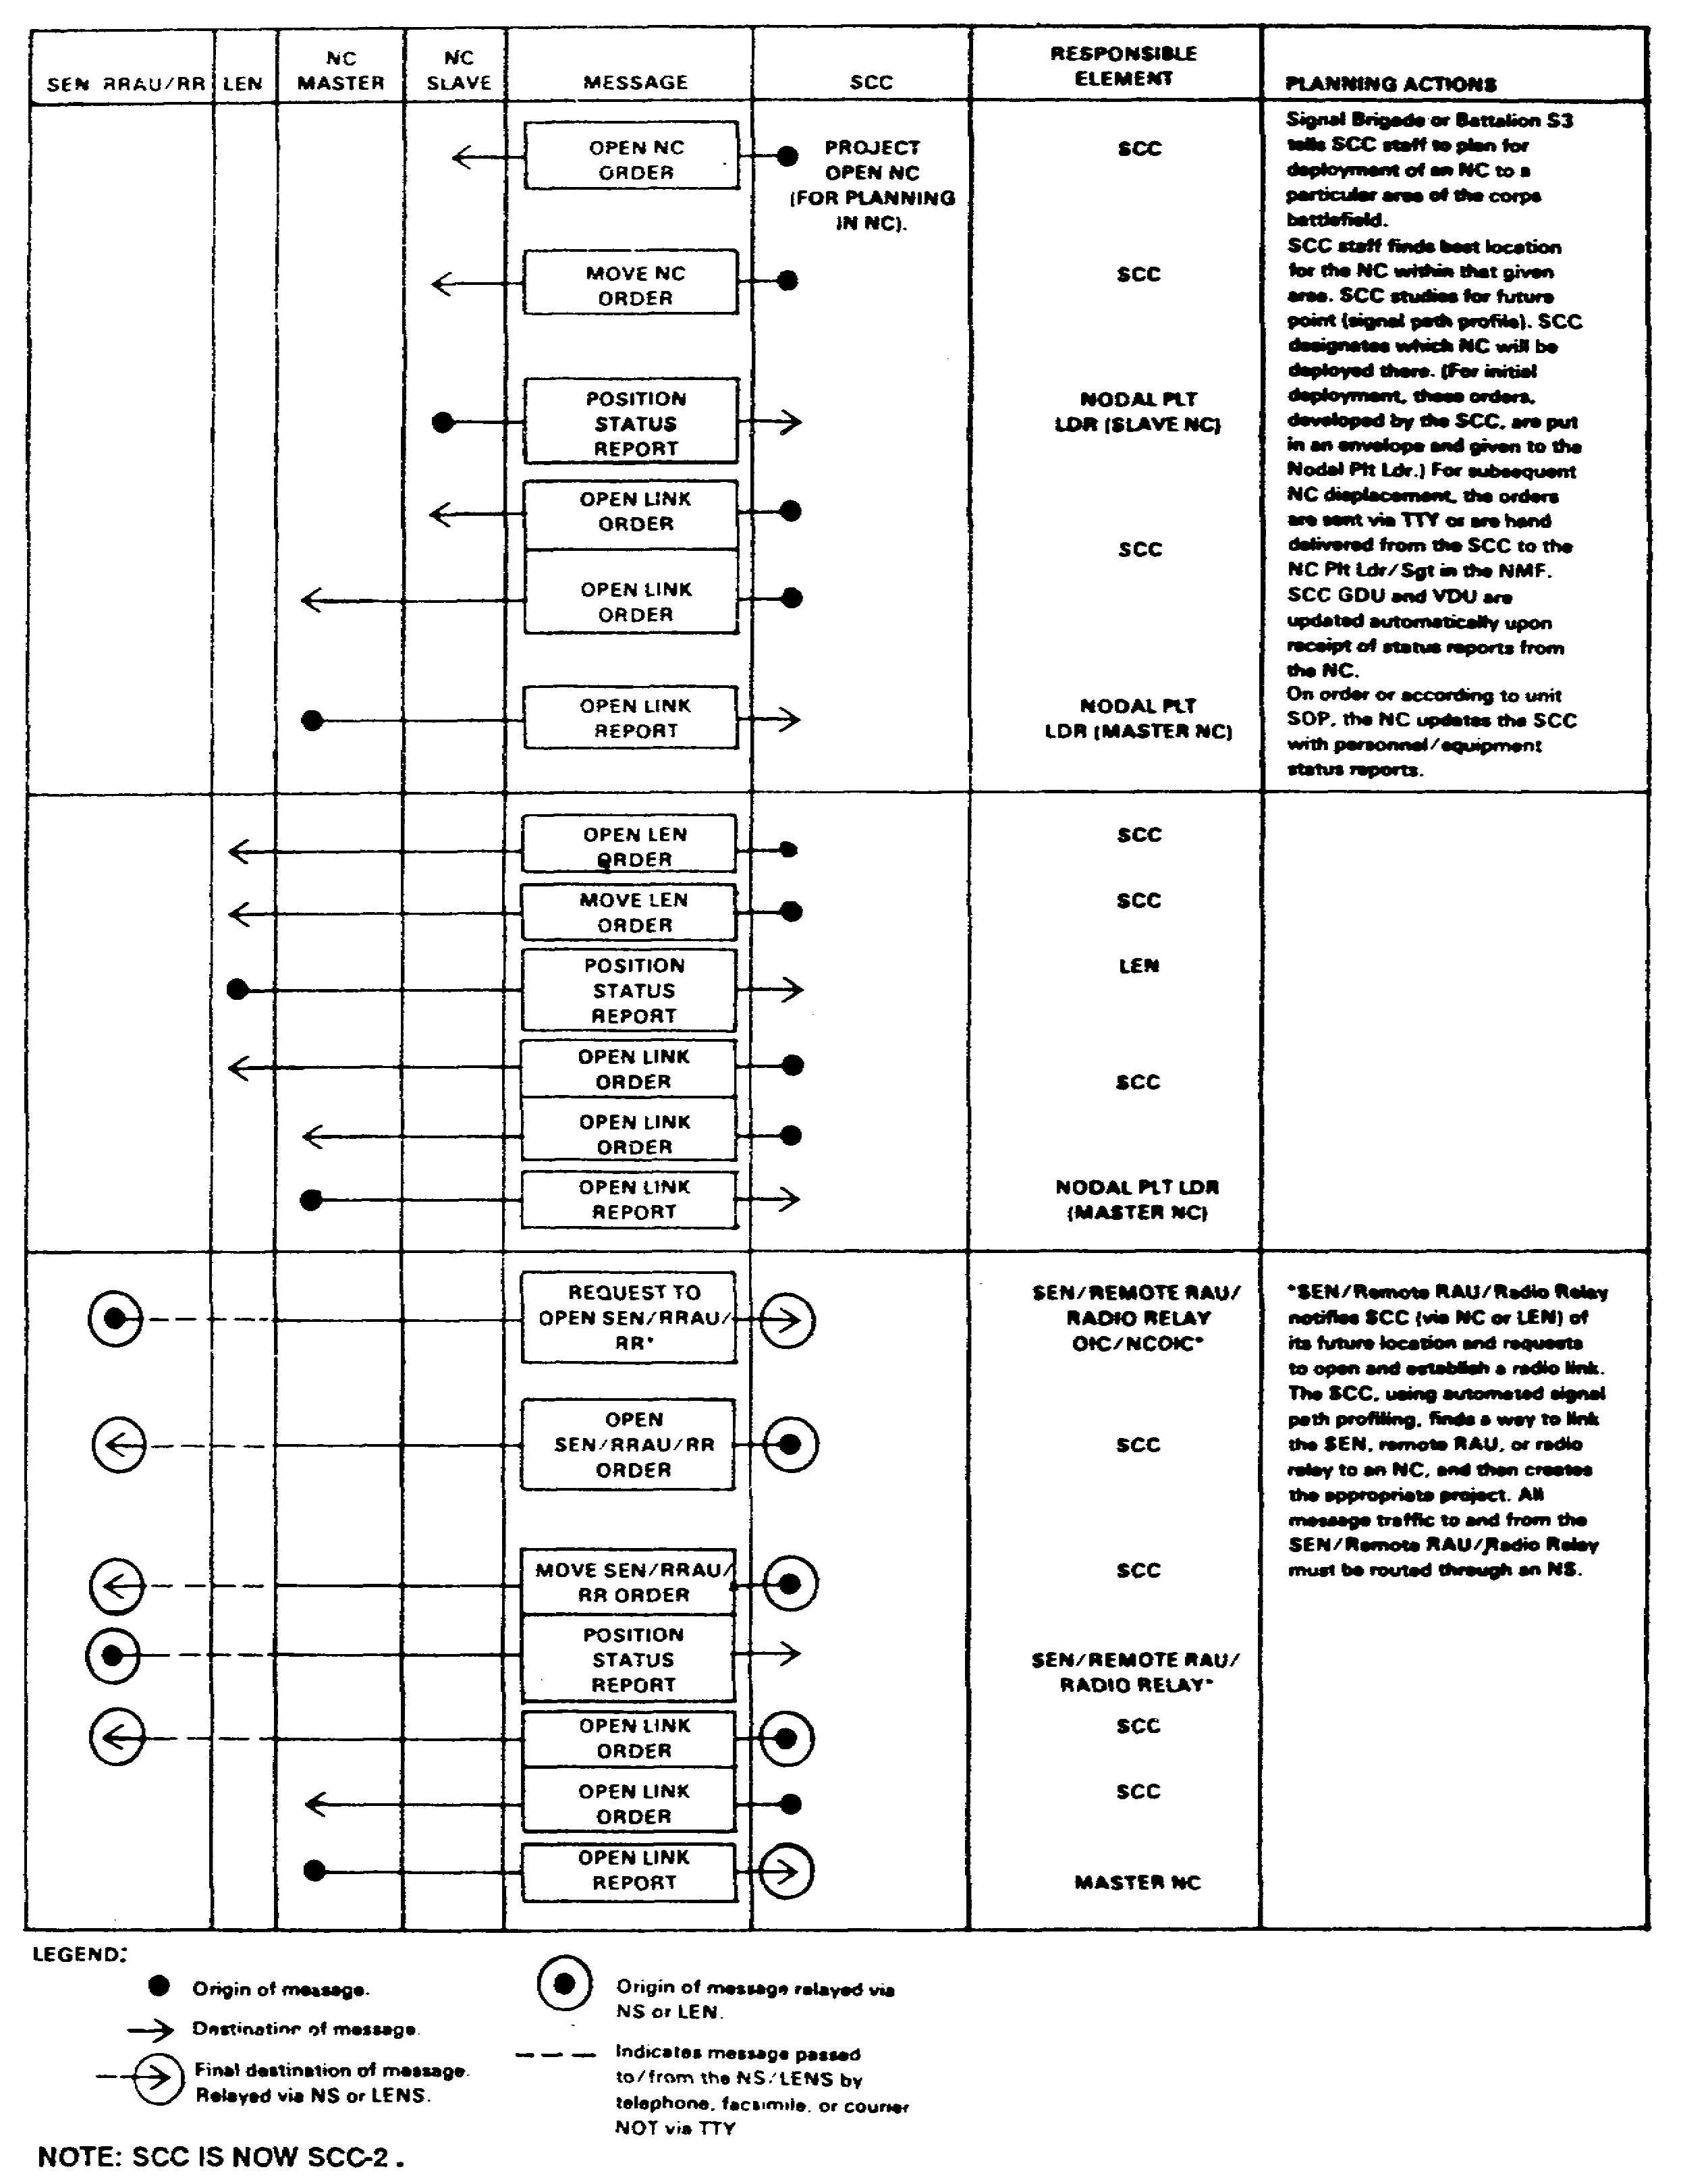

Figure 5-24. Message flow.

SS0073 5-36
b. The primary SCC issues orders to all NMFs. It receives reports from the NMFs upon execution of these orders. Thus, the SCC maintains control of the network. The NMF's OIC/noncommissioned officer in charge (NCOIC) sends reports by the AN/UGC-74B or other electronic means. These are the only means to update SCC files without manual input by SCC operators. All directives and reports for SEN, RAU, NAI, and relay teams are routed to the NMF and passed by orderwire, telephone, CNR, or courier. To ensure a successful network, the SCC must have influence over five major areas: COMSEC, subscribers, frequencies, switches, and teams and equipment. (See Figures 5-25, 5-26, and 5-27.)

(1) COMSEC plans and operations do not change when the network deploys. The SCC/SYSCON directs changes that occur once MSE assets are employed. After installing the network, subscriber key mismatch may occur. COMSEC error messages printed on the NS/LENS teletype identify most problems. COMSEC messages, especially rekey terminated messages, are reported to the SCC/SYSCON to determine if a network COMSEC problem exists.

(2) Subscriber problems are channeled from the extensions to NMFs through the subscriber cell of the SCC/SYSCON. A subscriber cell includes personnel in charge of subscriber problems. The subscriber cell handles subscriber problems and passes information down to the NMF. When the cell manages network problems, it also looks for potential problems and fine tunes the network.

(a) For MSRT subscribers, the SCC/SYSCON requires all NMFs to monitor RAUs using the display group status (DGS) screens. They also report the number of subscribers affiliated to their RAUs. With these reports, the SCC/SYSCON makes evaluations to determine if more RAU coverage is needed.

(b) Loading the same PAL in two different switches can cause the system to fail. However, it is possible to track down one or a few duplicated numbers in the network. If SCC/SYSCON personnel suspect duplicated numbers, they contact several NSs and have them perform a display subscriber location (DSL). This displays the subscriber's status and parent switch its number is associated with. For each NS that has the same number, it performs a display directory number (DDN). This displays the characteristics of a local subscriber. If the number appears in two or more switches, have the number deleted from the NSs where the number is not affiliated using the assign manual affiliation (AMA) for delete.

(3) The SCC/SYSCON manages frequencies for all MSE LOS links and MSRTs/RAUs. Operators will not flip-flop, swing, bootleg, or use unauthorized frequencies. Frequency problems must be reported to the SCC/SYSCON or it cannot accurately perform frequency management. Interference problems occur when node OICs change or use other than SCC assigned frequencies. As the network grows, overriding the SCC's automatic frequency allocation feature will result in interference problems. The SYSCON OIC makes the decision to manually input frequencies and override the SCC. This is only done on an exceptional basis.

5-37 SS0073
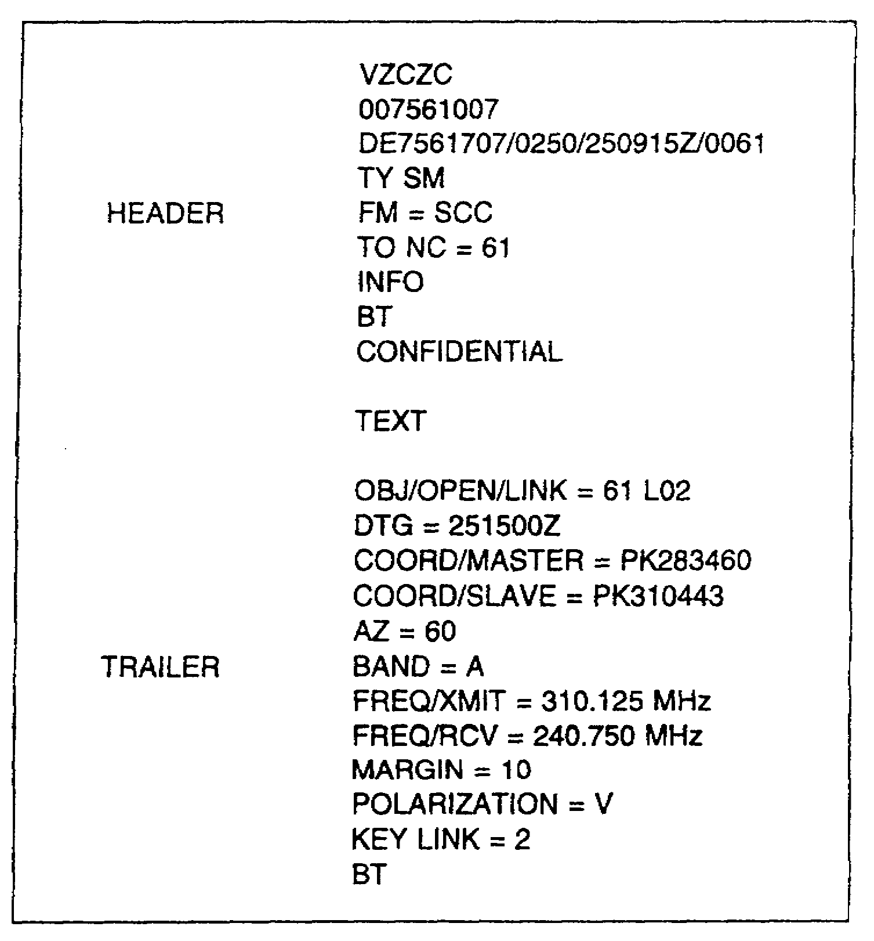

Figure 5-25. Open link order sent to NC 61.

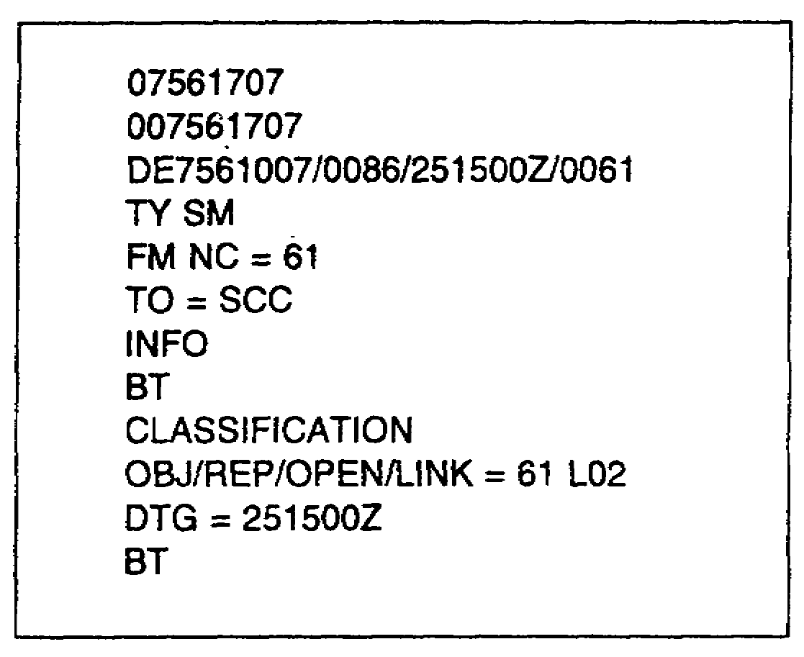

Figure 5-26. Open link report from NC 61.

SS0073 5-38
(a) All decibel (dB) margins should be at least +15 for internodal links and +10 for extension links. These margins are only guidelines and may be altered depending on local conditions. Consider using band I for defense or foliage areas and band III for internodal links. Consider remoting the LOS with SHF to obtain a higher margin.

(b) RAU frequencies should contain as many frequency pairs as possible-up to 96. This is determined by your frequency manager. For RAUs working within the same network, use 20 percent of frequency pairs of the active plan duplicated in the reserve plan. This ensures that MSRT users can reaffiliate in the network during frequency plan changes. RAUs working in different networks and occupying the same area must have zero percent of frequency overlaps between active frequency plans. The dialogue between the MSRTs and RAUs looks for a frequency pair. If they match, there is a crypto alarm on the MSRT because of different M keys.

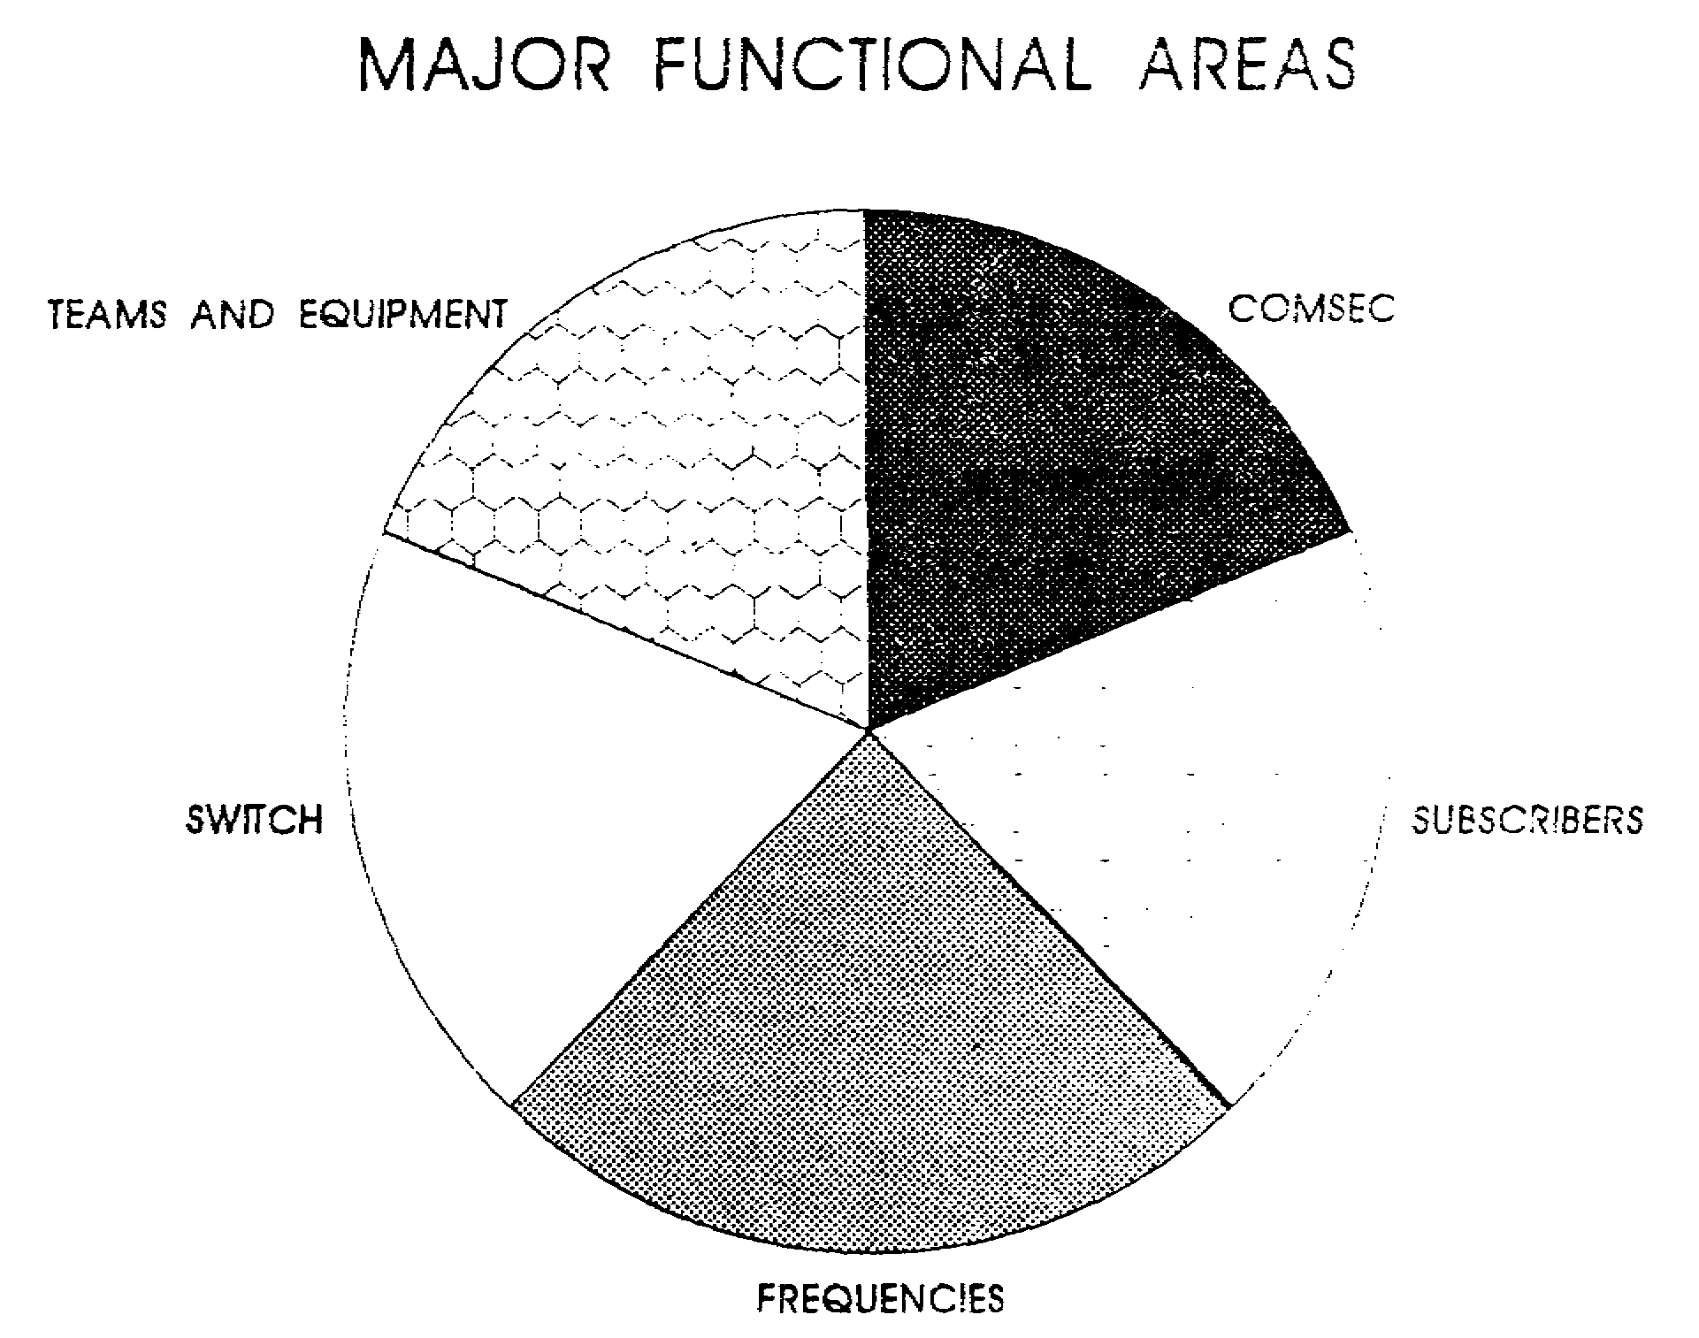

Figure 5-27. Phase IV, operational management, five major areas.

5-39 SS0073
(4) Switches are tools the SCC/SYSCON uses to manage the network. Switches can change subscriber management features as shown below.

(a) Traffic metering reports provide the node OIC a detailed look of his switch's performance. These reports include—

- R1 - switch traffic report.

- R2 - node pair traffic report.

- R3 - summary for TGCs.

- R4 - precedence reports for TGCs.

- R5 - loop traffic report.

- R6 - DTG built-in test (BIT) error rate report.

The R6 is the only viable report the network manager needs from each NS. With this information, the SCC/SYSCON can determine network performance.

(b) Thin layer chromatography (TLC) can be used to limit subscriber access at each switch during periods of low call completion rates, bad or busy trunks, or network/switch congestion. The subscriber's profile contains its TLC level. The TLC levels are—

- 1 - no restrictions.

- 2 - restrict trunk access.

- 5 - restrict switch access.

If TLC 2 or 5 is implemented, telephones can receive calls. However, they will not have a dial tone.

(c) Zone restriction lists may be permissive or restrictive. These either allow a subscriber access anywhere in the network or restricts a subscriber's access to certain areas. The restrictive list should be for routine user only from calling outside corps network (gateway). Changes to this list are made at the SCC and sent by technical message to the NS/LENS.

(d) Subscriber profile assignments can be temporarily changed by NS/LENS operators with approval from SCC/SYSCON. However, the profile assignment defaults back to the original profile if the system is reinitialized. Permanent changes must be sent to the PDSS facility. Profile reassignment is done on an exceptional basis.

SS0073 5-40
(e) When the number of MSRTs affiliated to the RAU exceeds 30, consider more RAU coverage. However, if the number is above 40, the SYSCON should consider distributing the MSRT load to other RAUs. This is frequently called "shaking the blanket." This requires the RAU operator to turn off the marker beacon and report to the NMF when all radios are free. The switch operator then performs an assign SEN/RAU/SCC, automatic send/receive (teletypewriter)(ASR) modify for absent. This forces active MSRTs to automatically transfer affiliation to the strongest available RAU marker and places the remaining subscribers in the absent subscriber mode. SCC/SYSCON notifies the NMF to turn the marker beacon back on and perform another DGS to determine the correct number of MSRTs. However, if the numbers have not changed the SCC/SYSCON must consider the importance of subscribers and the use of modes of operation. Modes of operation include—

- Automatic -Six radios are for routine subscribers and two are reserved for priority users.

- Forced -All radios are used for priority subscribers only.

- Inhibited -No radios are reserved; all subscribers can access any radio.

(f) Data base changes for MSE links are the node OIC/NCOIC responsibility. SCC/SYSCON provides assistance for non-MSE links. If any problems are encountered, notify the SCC/SYSCON. Save tapes, also known as scratch tapes, are not used to store data base changes. All changes are made as they are required.

(g) The SCC/SYSCON normally controls the movement of the SENs or LENs. During the rapid flow of battle, the SENs or LENs may have to displace before notifying the SCC/SYSCON. If this occurs, the BSO should coordinate with the corps or division signal officer or the SCC/SYSCON. Based on the BSO's coordination, the SCC can engineer systems to the extension node's proposed location.

- If time permits, the SEN's NCOIC and the unit BSO reconnaissance the proposed site. The SEN NCOIC notifies the NC of information which is passed to the SCC/SYSCON. The SCC/SYSCON generates team packet fragmentary orders (FRAGOs) and sends them to the gaining and losing NC by AN/UGC-74 or message. The SEN calls the losing NC by telephone for permission to close the link. Before closing the link, the NC gives information from the team packet to the SEN to install a link with the gaining NC. The NC enters ASR/MODIFY/ABSENT before closing the link. The NC closes the link and sends a close link report to the SCC. The SEN team reports it is departing the site to the losing NC by MSRT or FM. Once the SEN team arrives on site, it reports to the gaining NC who notifies the SCC/SYSCON by telephone. Once the link to the SEN is established, the gaining NC sends an open link report to the SCC.

5-41 SS0073
- Unexpected changes such as destroyed or failed NCs require the SCC/SYSCON to take immediate action. The SCC/SYSCON must first determine if the NC is destroyed or has failed. A destroyed NC can be identified if no communications can be made to the NC by FM radio or its internodal links. A failed NC is identified by contact being made from the NMF.

- The SCC/SYSCON directs the extensions to rehome their LOS antennas to provide connectivity if the NC will be inoperable for a long time. For the SENS to regain access into the network, the SCC/SYSCON must find an NC that can handle the additional system. The SEN is contacted by FM to reorient its LOS. It is not always possible to give all the extensions access into the network. The SCC/SYSCON will determine which SEN is given network access.

NOTE: Rehoming links requires the SCC to generate a new project and assign new frequencies.

(5) Teams and equipment files are maintained by the SCC. The files need to be updated before and during each operation. This ensures the SCC has the most current information available. It is important to update these files because without updated information, teams could be committed to a mission they are not equipped to accomplish. While in garrison, use the operational readiness report (ORR) to update the SCC files. Once deployed, the node OIC must feed this information to the SCC by report messages.

SS0073 5-42
LESSON 5

PRACTICE EXERCISE

The following items will test your grasp of the material covered in this lesson. There is only one correct answer for each item. When you complete the exercise, check your answers with the answer key that follows. If you answer any item incorrectly, study again that part of the lesson which contains the portion involved.

1. What are the four main phases of deployment of MSE network?

2. Who is responsible for downloading frequency plans to their units MSRTs?

3. The SCC generates and distributes COMSEC keys.

A. True

B. False

4. Proper DSVT usage requires the user to load which keys?

5. Loading a PAL list more than once in a network is required to ensure phone numbers are not lost.

A. True

B. False

5-43 SS0073
LESSON 5

PRACTICE EXERCISE

ANSWER KEY AND FEEDBACK

Item Correct Answer and Feedback

1. Pre-deployment, installing backbone, installing extensions, operational management. (page 5-17, para b(1) through (4))

2. BSOs

BSOs are responsible for downloading the frequency plans to their unit MSRTs. (page 5-21, para d(4))

3. False

The ACSO and _ADSO coordinates COMSEC key distribution to all corps and division MSRT users. (page 5-25, para g(2))

4. U&M

The DSVT subscriber of an SEN must load the proper keys (U and M), affiliate his telephone, hang up, and wait for ring busy and nonsecure warning (NSW) lights to flash. (page 5-34, para b(2))

5. False

Loading the permissive action link (PAL) can have major impacts on the MSE network. If the same PAL is loaded into two different switches, it can cause switch crashes or lost telephone numbers throughout the network. (page 5-24, para (3))

SS0073 5-44

